**Curriculum Vitae**

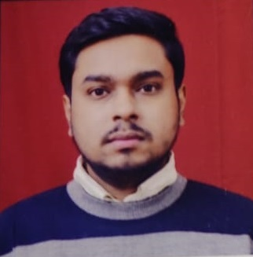

**NAME**: - ANNIRUDH MISHRA

**MOBILE**: - 9711874379, 8512011676

**E-MAIL**: - [annirudh1267@gmail.com](mailto:annirudh1267@gmail.com)

**ADDRESS** - House No- 2615, Block-B, S.G.M Nagar, N.I.T Faridabad, Haryana-121001.

# OBJECTIVE:

To work as an integral part of your organization & contribute professionally to its growth, where I utilize my education, technical skills and practical abilities for company’s progress as well as my personal enhancement.

# EDUCATION:

* **Senior Secondary School (10th**) – Kendriya Vidyalya No 1, Faridabad **(*Completed with 8.2 CGPA)***.
* **Higher Secondary School (12th)** – Kendriya Vidyalya No 1, Faridabad **(*Completed with 71%)***.
* **B.Tech (Mechanical Engineering)** – Rawal Institute of Engineering & **(*Completed with 70%)***.

Technology (affiliated from MDU Rohtak)

# KEY SKILLS:

* **Quality Instruments: -**
* Vernier Caliper
* Digital Vernier Caliper
* Micrometer
* Vernier Height Gauge
* Digital Vernier Height Gauge
* Dial Gauge / Dial Test Indicator

# KNOWLEDGE OF:

* 5s Activity, Reliability, POKA – YOKE, KANBAN, CAPA, KAIZEN, MSA, SPC, FMEA, RPN, Cp & Cpk, R & R, 7QC Tools, Continuous & Continual improvement, PPM, 3M, 8 Types of waste, VA & NVA Activity, PQCDSM, Variation, Control plans, Calibration, 6 Sigma, Cycle Time, Takt Time, Lead Time, Quality Circle, Geometric Dimensioning & Tolerancing (GD&T)

# SKILLS: - MS Excel

# SPECIALITIES:

* Good communication skills.
* Smart working along with hardworking, passionate and determined.
* Flexibility and ability to compromise.
* Willing and eager to learn perform and participate.
* Excellent team player with strong analytical and organizational skills.
* Strong Leadership qualities.

# PERSONAL INFORMATION:

* + **Fathers Name**  : Gopal Jee Mishra
  + **Date of Birth** : 01 March 1997
  + **Gender** : Male
  + **Marital Status**  : Unmarried
  + **Languages** : Hindi, English

**DECLARATION:**

It is certified that the above information is true to the best-off my knowledge. I promise to satisfy my superiors to the best of my ability.