**StarBus\***

**One India One Bus Portal**

**Help Document**

**City Management**

**Version- NIC/2022/OIOB/HD/UMCityMgmt/01**

**National Informatics Centre**

**Government of India**

|  |  |  |  |  |
| --- | --- | --- | --- | --- |
| **Version** | **Description** | **Prepared by** | **Approved by** | **Date** |
|  | **StarBus User Manual** | Sh Arun Sharma Scientist- D  Sh Prite Joshi Scientist –B | Sh K Narayanan, DDG & SIO , NIC UKD | **/01/2022** |

**Definitions & Abbreviations**

|  |  |
| --- | --- |
| **Abbreviation** | **Description** |
| OIOB | One India One Bus |
| STC/D’s | State Transport Corporations/Departments |
| SDD | Solution Design Document |

Table of Contents

Introduction 5

1.1 About StarBus 5

1.2 About City Management 5

1.3 Create a New City 7

1.4 Activate/Deactivate City 8

1.5 Update details of a City 8

1.6 Add Surcharge details a Service Type 9

Annexure-1 9

# Introduction

## About StarBus

Booking a bus is a process where a traveler looks for a specific destination, date, departure and arrival time, available payment options, Route, bus service type, and bus terminus. To book a ticket, the traveler can approach the authorized physical counter at a bus terminus, inquire and gather information related to the journey, and pay in cash. Another way is to utilize an STC/D’s portal offering the service online, including payment and receipt of tickets.

Authorized agents such as Common Service Centers (CSC) and other independent third parties also offer the booking service through a mix of offline and online apparatus. State Transport Corporations own/hire and manage the infrastructure and human resources essential for delivering transport services to travelers.

StarBus is an intuitive online system allowing the STC/D’s to manage the where with all critical to running an efficient transport operation.

## About City Management

This user manual has been compiled for STC/D’s to assist users in generating and configuring backend master data entries necessary for automation of backend workflow. The help document will guide internal users to manage City master data. City Management has been covered in this help document and aims to serve as an end-to-end guide for configuration & digitizing processes of City master management.

The infrastructure required by an STC/D is vast and broadly consists of Crew, Inventory, and Fleet. City management is a component needed for operations and can be defined as per the requirement of an STC/D.

**Details about City Management Processes**

Let us take time and study the processes related to City Management activities. The City Management option is available under the System Admin role of the system, and the login process for accessing it is given in Annexure-1 of SDD.

Upon successful login as System Admin, the user will be presented with the service catalog and can click on explore button of the City Management option.

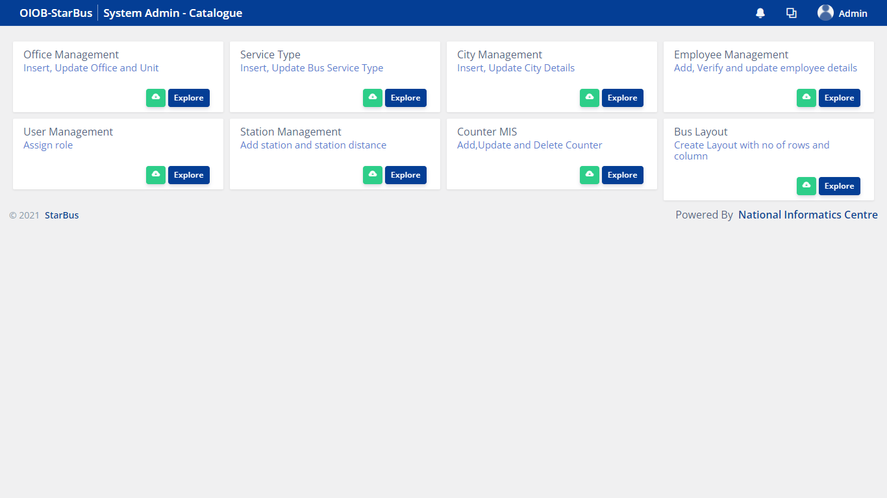

City Management module has following 3 sections:-

i. Summary & Report

This section shows the number of Total Cities, status of Cities, option to ***generate list of Cities,*** important instructions under <Instructions> section, option  to download this user manual and  to view instructions in details

ii. City List

This section present the list of Cities created in the system. Along with viewing information about City, you can ***Activate/Deactivate*** City, Update details by clicking on the update option and Add Surcharge by clicking of Add<  >option.

iii. Details Updation & Add New City

This section allows to add a New City or update an existing record of City.

## Create a New City

To create a new City, first check whether the entry of the same City is already available or not. If not, you can click on ‘Add New City’ button given on the bottom right corner.

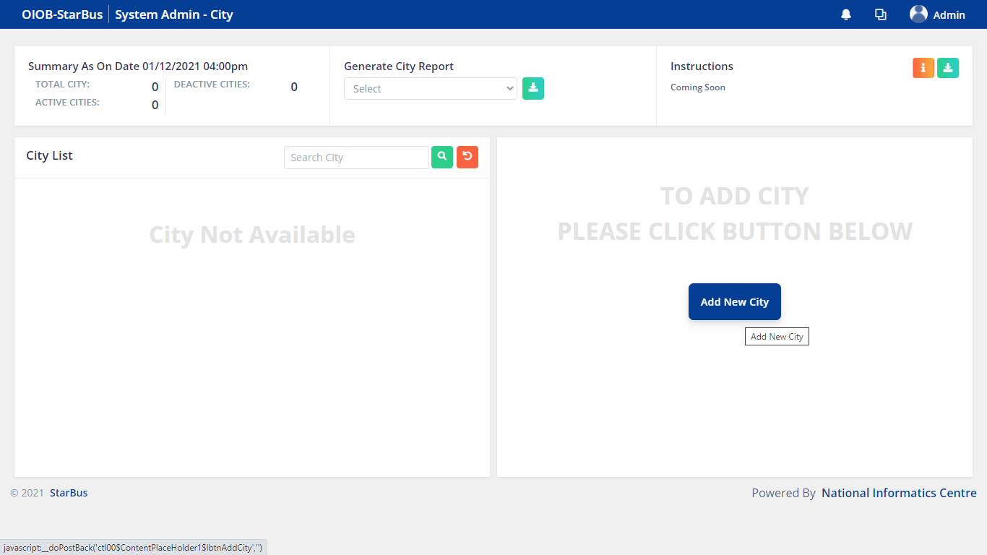

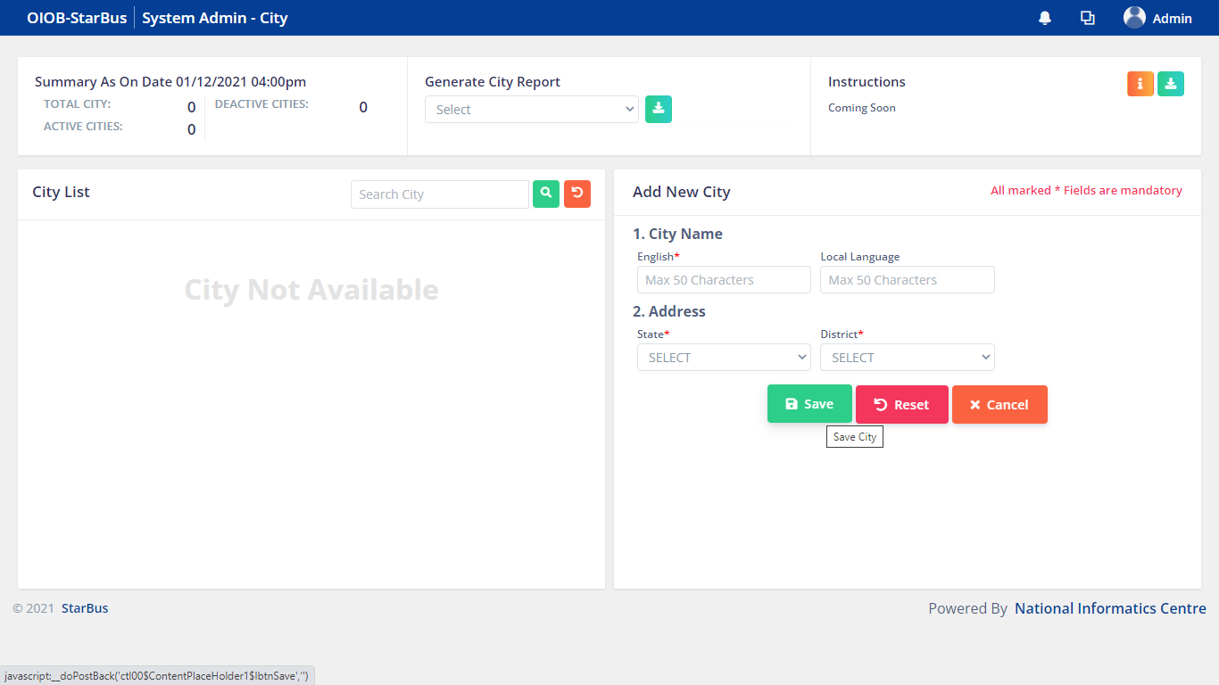

Fill in the details, mandatory fields are required to create a City record, click Save button.

*Additionally, user can click Reset button in order to remove data entered in the input fields and Cancel to abort the Service Type creation process.*

After successfully saving of details system generates a prompt with a confirmation.

***System giving error, City cant be Saved, once the error is resolved, the following sections will be updated with directions and screenshots.***

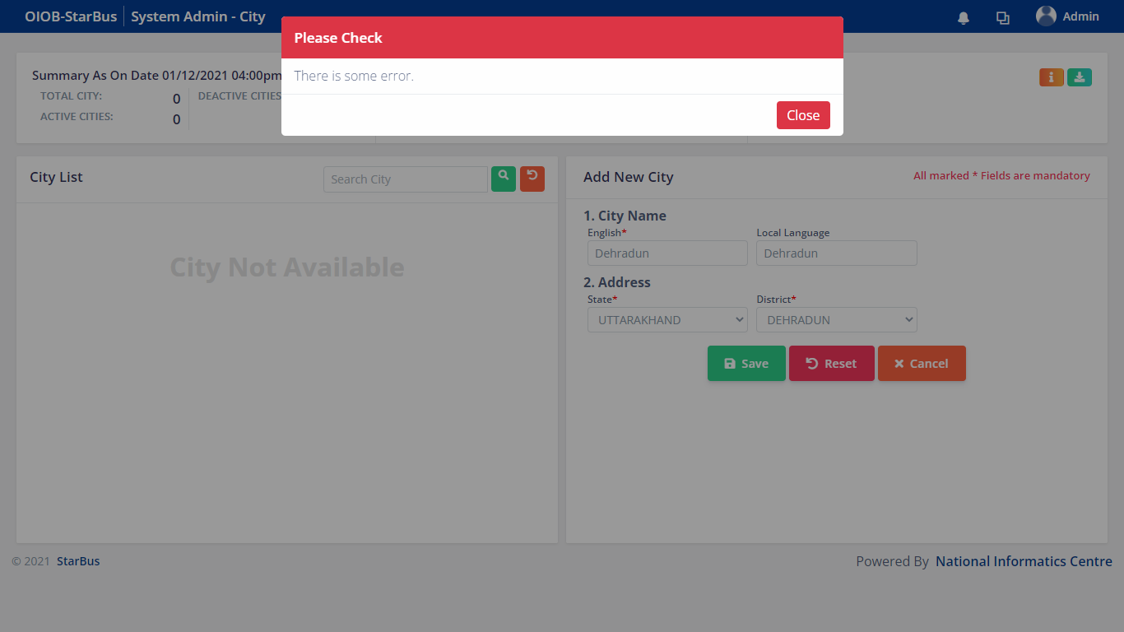

## Activate/Deactivate City

To Activate/ Deactivate an existing record of Service Type, kindly click on Activate/Deactivate button given in the Service Type List .

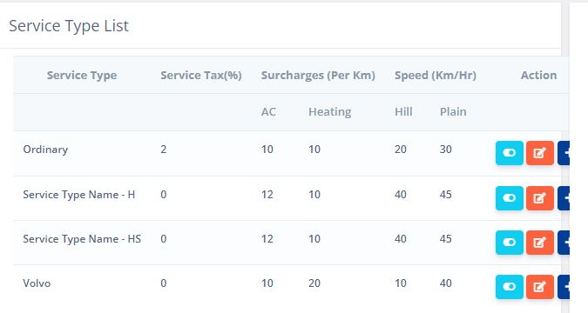

## Update details of a City

To update the details of a Service Type, please click on Update button given in the Service Type List displaying information of the Service Type.



After clicking the update button, details will be loaded in the right hand section(same place on which the new Service Type entry details got opened upon clicking Add New Service button).

After entering the details, click on update button, system will generate a prompt with a confirmation message.

# 

# Annexure-1

**How to login into StarBus system ?**