**StarBus\***

**One India One Bus Portal**

**Help Document**

**Employee Management**

**Version- NIC/2022/OIOB/HD/UMEmployeeMgmt/01**

**National Informatics Centre**

**Government of India**

|  |  |  |  |  |
| --- | --- | --- | --- | --- |
| **Version** | **Description** | **Prepared by** | **Approved by** | **Date** |
|  | **StarBus User Manual** | Sh Arun Sharma Scientist- D  Sh Prite Joshi Scientist –B | Sh K Narayanan, DDG & SIO , NIC UKD | **/01/2022** |

**Definitions & Abbreviations**

|  |  |
| --- | --- |
| **Abbreviation** | **Description** |
| OIOB | One India One Bus |
| STC/D’s | State Transport Corporations/Departments |
| SDD | Solution Design Document |

Table of Contents

Introduction 5

1.1 About StarBus 5

1.2 About Employee Management 5

Details about Employee Management 6

1.3 Add New Employee 7

1.4 Update Employee 9

1.5 Verify Employee 10

1.6 Delete 10

1.7 Search 11

1.8 Update Verified Employee 12

1.9 Update Insurance 13

1.10 Update Weekly Rest 14

Annexure-1 15

# Introduction

## About StarBus

Booking a bus is a process where a traveler looks for a specific destination, date, departure and arrival time, available payment options, Route, bus service type, and bus terminus. To book a ticket, the traveler can approach the authorized physical counter at a bus terminus, inquire and gather information related to the journey, and pay in cash. Another way is to utilize an STC/D’s portal offering the service online, including payment and receipt of tickets.

Authorized agents such as Common Service Centers (CSC) and other independent third parties also offer the booking service through a mix of offline and online apparatus. State Transport Corporations own/hire and manage the infrastructure and human resources essential for delivering transport services to travelers.

StarBus is an intuitive online system allowing the STC/D’s to manage the where with all critical to running an efficient transport operation.

## About Employee Management

This user manual has been compiled for STC/D’s to assist users in generating and configuring backend master data entries necessary for automation of backend workflow. The help document will guide internal users to manage Employee master data. Employee Management has been covered in this help document and aims to serve as an end-to-end guide for configuration & digitizing processes of Employee Management.

The infrastructure required by an STC/D is vast and broadly consists of Crew, Inventory, and Fleet. Employee Management is a component needed for operations and captures all professional aspects of an Employee.

# Details about Employee Management

Let us take time and study the processes related to Employee Management activities. The Employee Management option is available under the System Admin role of the system, and the login process for accessing it is given in Annexure-1 of SDD.

Upon successful login as System Admin, the user will be presented with the service catalog and can click on explore button of the Employee Management option.

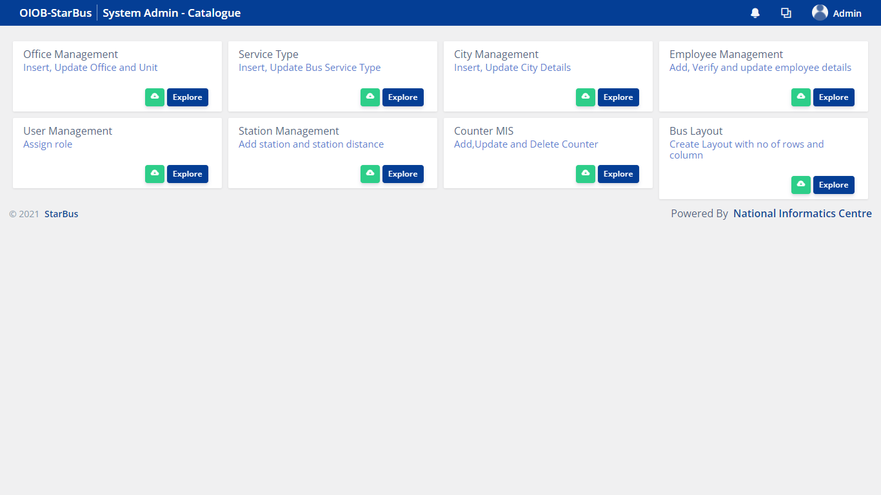

Employee Management module has following 3 sections:-

i. Summary & Report

This section shows the number of Total Employees, Verified and Not Verified.

It also shows Pending License Details, License Expiring Soon, Expired License of drivers and conductors along with important instructions under <Instructions> section, *option  to download this user manual and  to view instructions in details*

ii. Add New Employee

This section allows to create a record of a New Employee.

iii. Update Employee

This section is for updating an existing record of an Employee and Verify.

iv. Update Verified Employee

This section is for updating record of a verified Employee.

## Add New Employee

To add a new Employee, first check whether an entry of the same Employee is already available or not. If not, you can click on ‘Add New Employee’ radio button given on the bottom right corner.

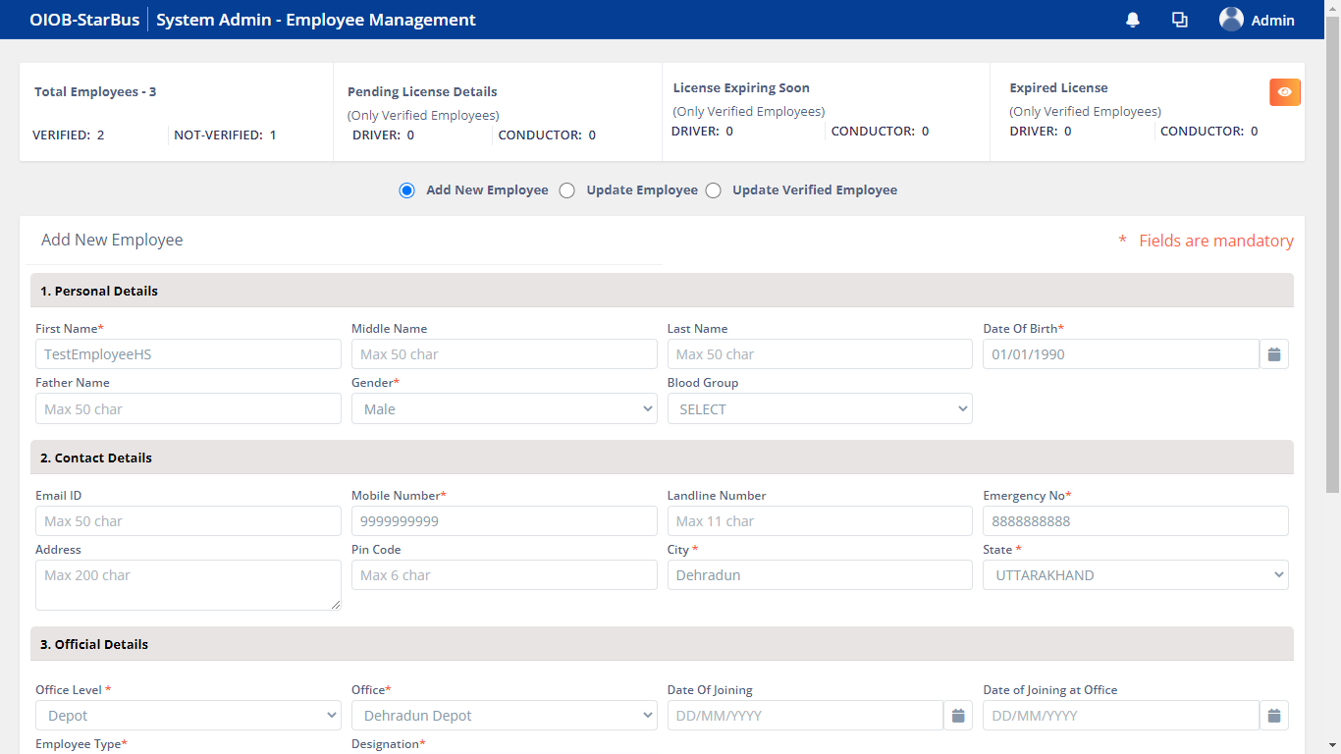

Add New Employee Contd’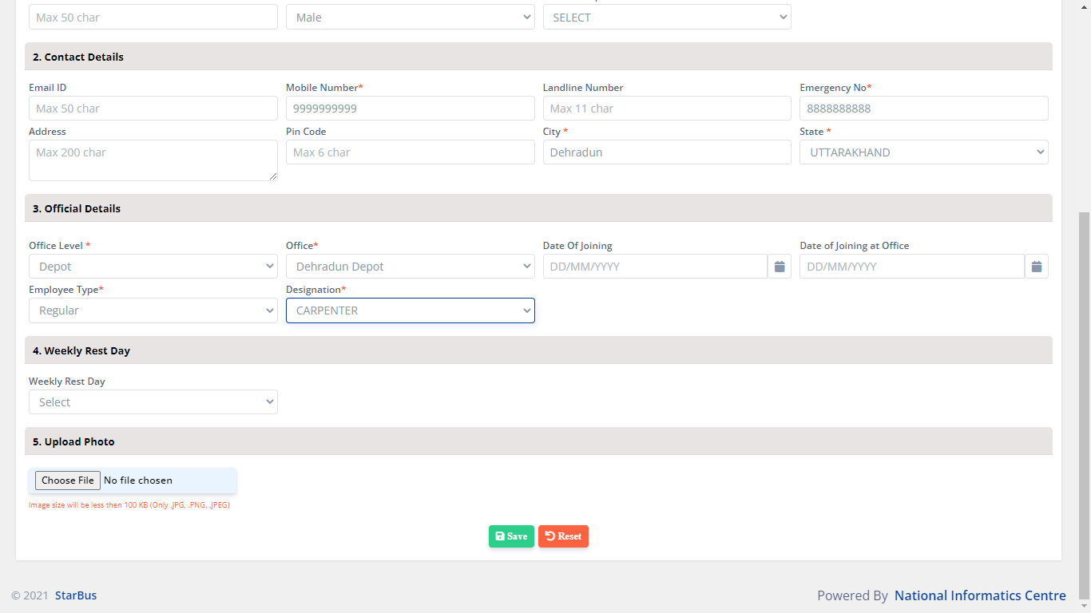

Fill in the details, mandatory fields are required to create a Employee record, click Save button.

*Additionally, user can click Reset button in order to remove data entered in the input fields.*

After successfully saving of details system generates a prompt with a confirmation.

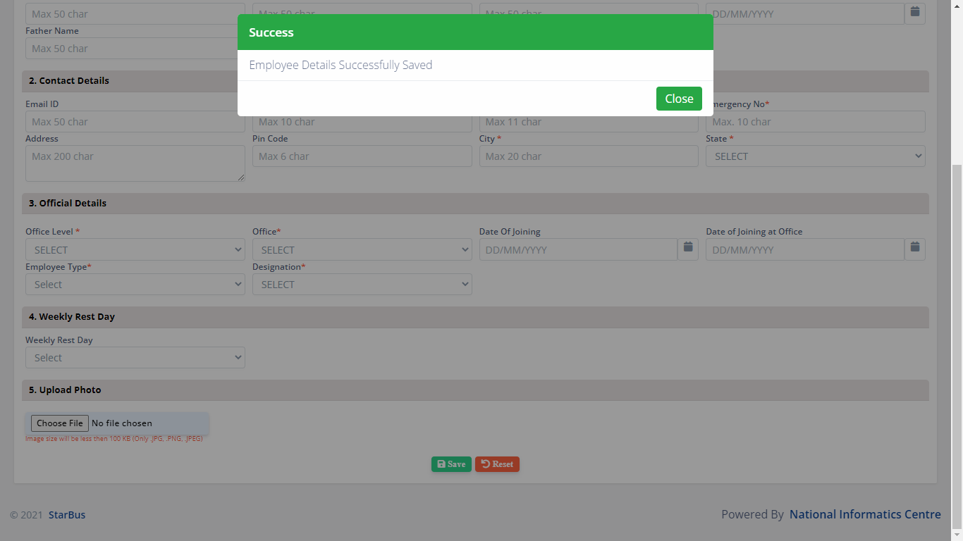

## Update Employee

Here you will find a list of Employees. In order to update existing record of Employee, kindly click on Update Employee button.

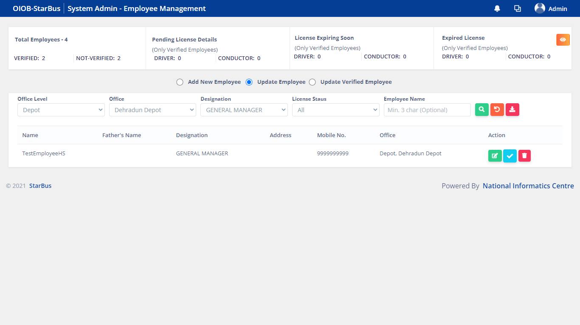

After clicking the Update Employee button, kindly click on Update button next to the list of Employee records.



After entering the details, click on update button, system will generate a prompt with a confirmation message.

## Verify Employee

You can click on the <right> to Verify an Employee.



In order to Verify an existing employee, kindly click on the button, the system will generate a confirmation prompt.

## Delete

In order to Delete an existing record of Employee, click the Delete button.



The system will generate a confirmation prompt.

## Search

You can use the Search functionality to filter Employee based on the following criteria:

* Office Level
* Office
* Designation
* License Status
* Employee Name

Click the  to Search based on above parameters.

Click  to clear the selected parameters for search.

Click  to download a list of Employees to the client machine.

## Update Verified Employee

Click Update Verified Employee button to update. You will find a list of icons next to each record, the last two icons are for Insurance detail and Weekly rest update.

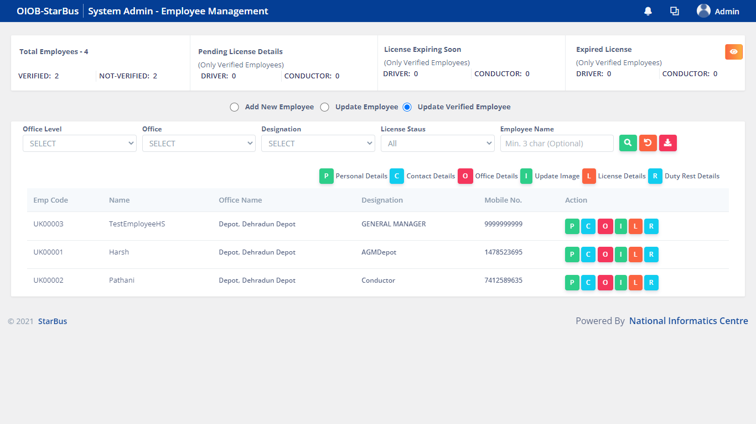

T*he sections which can be updated using the first four icons form part of Add New Employee and Update Employee section.*

## Update Insurance

Upon clicking the  icon you will be taken to the below screen, update details and click Save as Draft to store details as a draft for later. 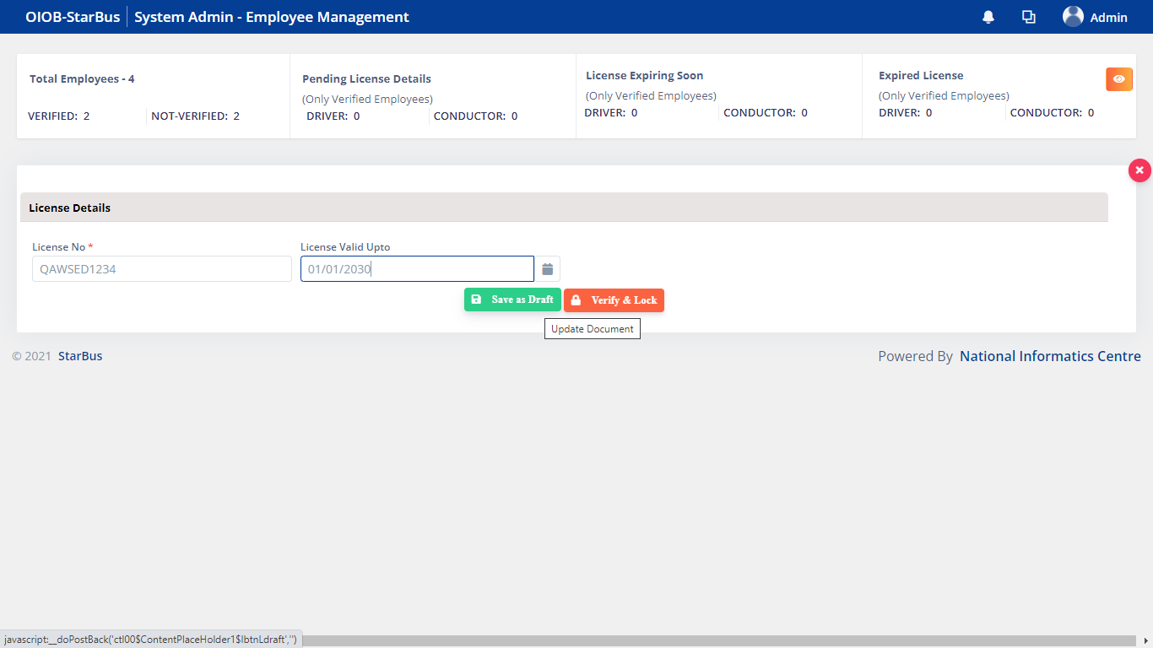

Alternately, you can click Verify & Lock to update and lock the record of an employee.

System will ask for confirmation and generate an acknowledgment prompt upon successful save.

## Update Weekly Rest

You can click the  to define/ update the weekly rest of an employee and click Save as Draft to store details as a draft for later. / Verify & lock> to Save the record.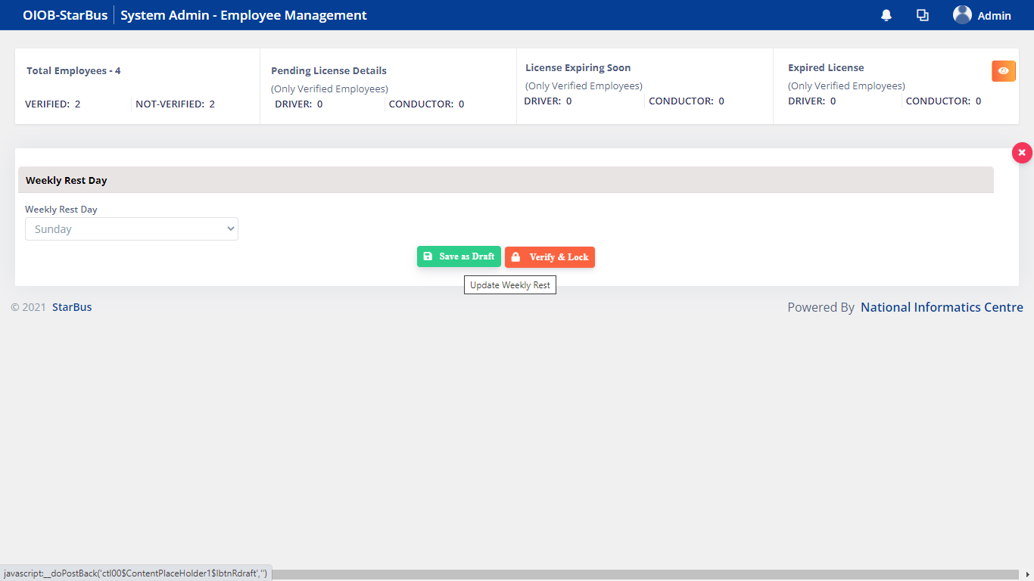

Alternately, you can click Verify & Lock to update and lock the record of an employee.

The system will ask for confirmation and generate an acknowledgment prompt.

# Annexure-1

**How to login into StarBus system ?**