**StarBus\***

**One India One Bus Portal**

**Help Document**

**Station Management**

**Version- NIC/2022/OIOB/HD/UMStationMgmt/01**

**National Informatics Centre**

**Government of India**

|  |  |  |  |  |
| --- | --- | --- | --- | --- |
| **Version** | **Description** | **Prepared by** | **Approved by** | **Date** |
|  | **StarBus User Manual** | Sh Arun Sharma Scientist- D  Sh Prite Joshi Scientist –B | Sh K Narayanan, DDG & SIO , NIC UKD | **/01/2022** |

**Definitions & Abbreviations**

|  |  |
| --- | --- |
| **Abbreviation** | **Description** |
| OIOB | One India One Bus |
| STC/D’s | State Transport Corporations/Departments |
| SDD | Solution Design Document |

Table of Contents

Introduction 5

1.1 About StarBus 5

1.2 About Station Management 5

Details about Employee Management 6

1.3 Add New Station 7

1.4 Deactivate Station 8

1.5 Update Station 9

1.6 Add / Update Station Distance 10

1.7 Delete Station 11

Annexure-1 12

# Introduction

## About StarBus

Booking a bus is a process where a traveler looks for a specific destination, date, departure and arrival time, available payment options, Route, bus service type, and bus terminus. To book a ticket, the traveler can approach the authorized physical counter at a bus terminus, inquire and gather information related to the journey, and pay in cash. Another way is to utilize an STC/D’s portal offering the service online, including payment and receipt of tickets.

Authorized agents such as Common Service Centers (CSC) and other independent third parties also offer the booking service through a mix of offline and online apparatus. State Transport Corporations own/hire and manage the infrastructure and human resources essential for delivering transport services to travelers.

StarBus is an intuitive online system allowing the STC/D’s to manage the where with all critical to running an efficient transport operation.

## About Station Management

This user manual has been compiled for STC/D’s to assist users in generating and configuring backend master data entries necessary for automation of backend workflow. The help document will guide internal users to manage Station master data. Station Management has been covered in this help document and aims to serve as an end-to-end guide for configuration & digitizing processes of the same.

The infrastructure required by an STC/D is vast and broadly consists of Crew, Inventory, and Fleet. Station Management is a component needed for operations as Stations form an integral part of a Route and captures all functional aspects of a Station.

# Details about Employee Management

Let us take time and study the processes related to Employee Management activities. The Employee Management option is available under the System Admin role of the system, and the login process for accessing it is given in Annexure-1 of SDD.

Upon successful login as System Admin, the user will be presented with the service catalog and can click on explore button of the Station Management option.

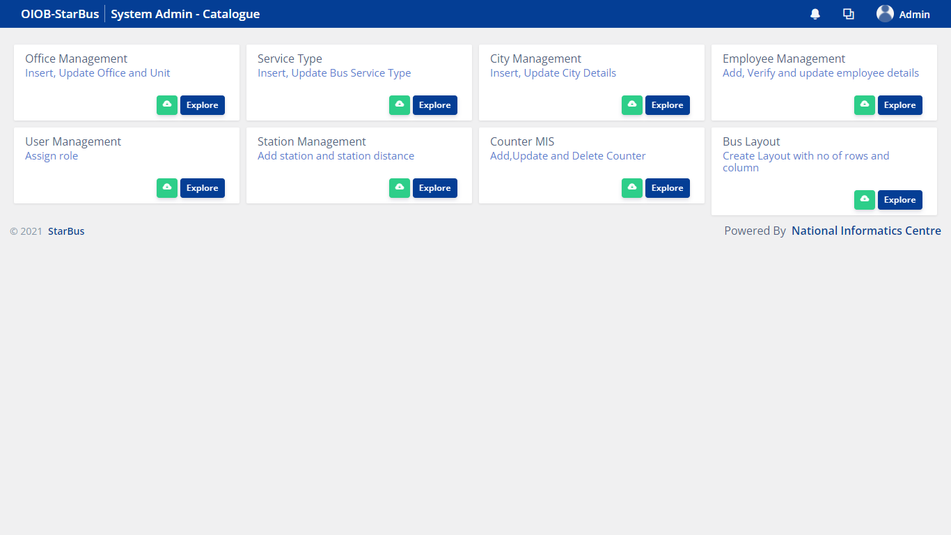

Station Management module has following 3 sections:-

i. Summary & Report

This section shows the number of Total Stations, Status (Active / Discontinued) of Stations and Bus Stand. You can also download a list of Stations with details specific to a Station such as Station Name, State, District, City. It also shows important instructions under <Instructions> section, option  to download this user manual and  to view instructions in details.

ii. Station List

This section present the list of Stations , so far created in the system. Along with viewing information about Station, you can deactivate a Station by clicking on , edit details by clicking on the editing option , add / update Station Distance by clicking of add/update  option or remove by clicking of delete option.

iii. Add New Station

This section is for creating a new record of Station.

## Add New Station

To add a new Station, first check whether an entry of the same Station is already available or not. If not, you can click on ‘Add New Station’ button given on the bottom right corner.

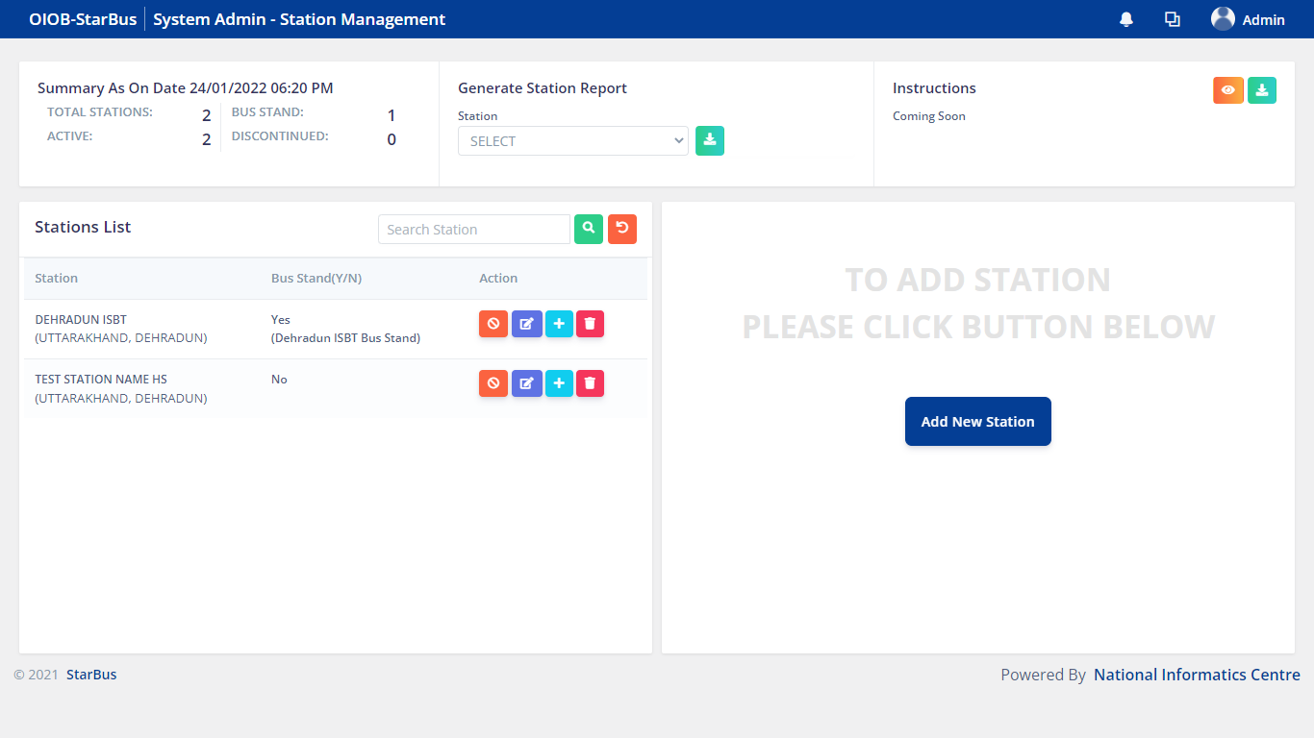

You will land on Add New Station screen shown below

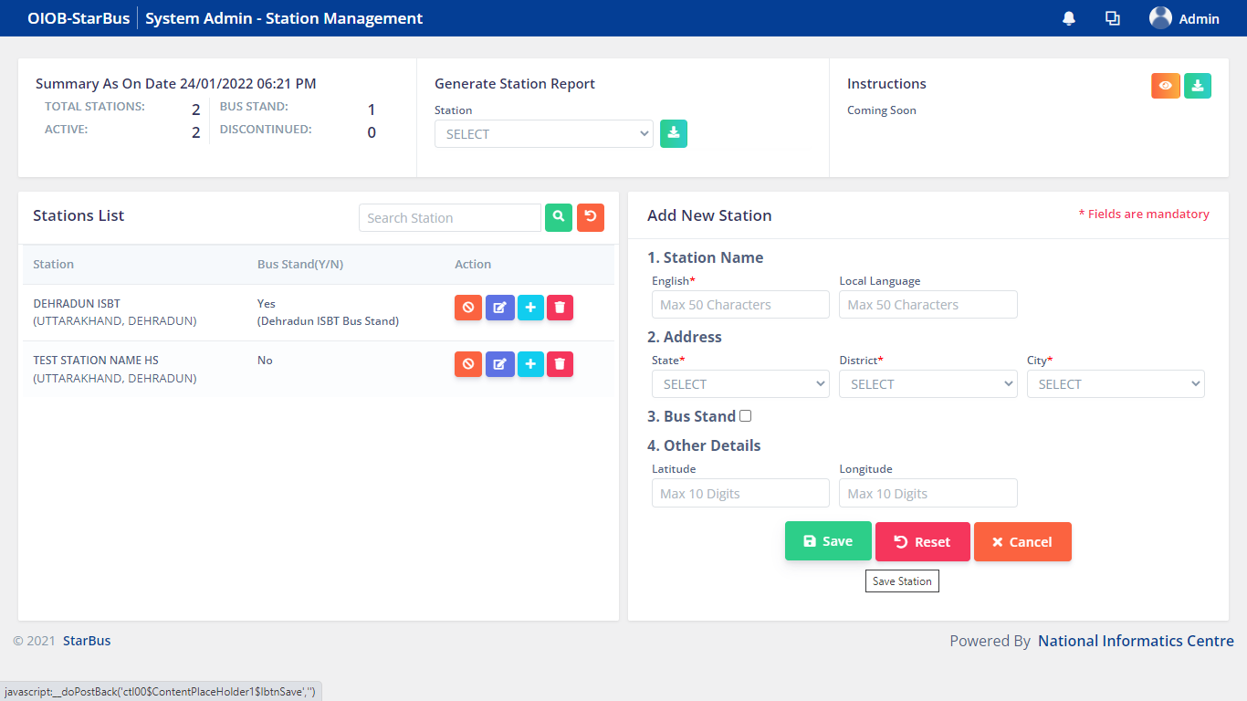

Fill in the details, mandatory fields are required to create a New Station record, click Save button.

*Additionally, user can click Reset button in order to remove data entered in the input fields and Cancel to abort the New Station creation process.*

After successful saving of details system generates a prompt with a confirmation

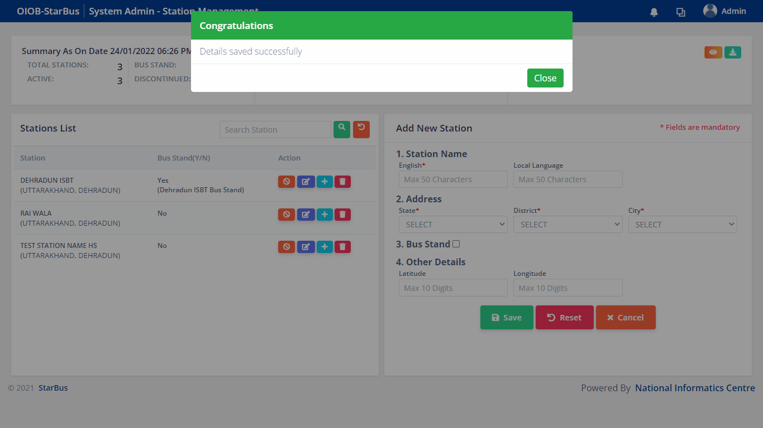

## Deactivate Station

Here you will find a list of existing records of Station. In order to Deactivate Station, kindly click on Deactivate Station button.

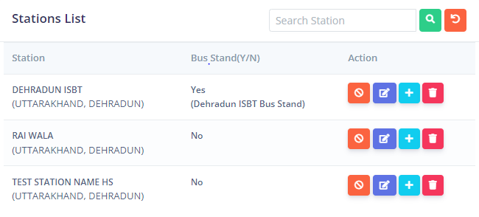

The system will ask for a confirmation, upon clicking yes a notification prompt will be generated by the system.

After entering the details, click on update button, system will generate a prompt with a confirmation message.

## Update Station

You can click on the  to Update Station.



The right hand section will get populated with the existing Station details.

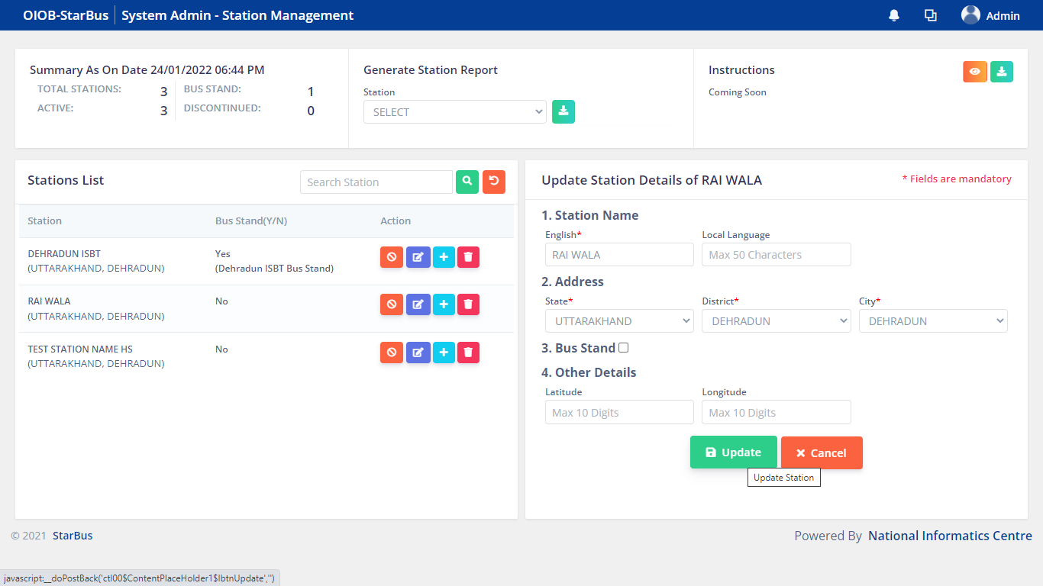

After making changes, to Update a record, kindly click on the Update button, the system will generate a confirmation prompt.

## Add / Update Station Distance

In order to Add/Update Station Distance to an existing record, click the  button.



You will be taken to Station Distance details section

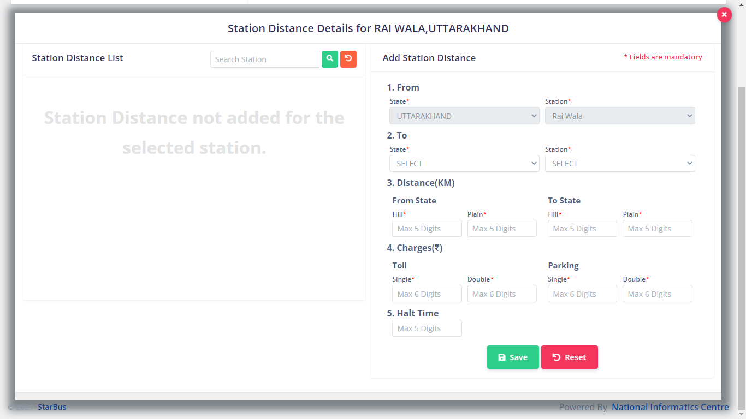

You can add Distance by defining Kms of ‘From’ & ‘To’ Station, the mandatory parameters defined here are Hill, Plain, Toll, Parking.

Click Save button in order to Save the Station Distance entry, system will generate a confirmation prompt.

## Delete Station

In order to Delete an existing record of Station, kindly click the  icon, system will generate a confirmation prompt.



# Annexure-1

**How to login into StarBus system ?**