WEEK 3 TASK
ADVANCED DATA ANALYSIS AND VISUALIZATION IN LOGISTICS
Senior Data Analytics Project Report
Hypothetical Logistics Dataset | Python | Pandas | Matplotlib
September 2026

1. Executive Summary
This project applies a senior-level analytical workflow to a simulated logistics operation containing 1,000 shipments. The analysis evaluates delivery performance, transportation cost, shipment characteristics, operational variability and relationships among key metrics. Overall on-time performance is 42.4%, with mean delivery time of 3.94 days and mean total logistics cost of 11,546.04. Distance is positively associated with total cost (r=0.64), while delivery delay is negatively associated with customer rating (r=-0.82). The analysis indicates that transport-mode selection, distance, weight and delay are important levers for improving logistics performance.

2. Objectives
- Build a realistic hypothetical logistics dataset for analytical practice.
- Perform structured exploratory data analysis using Python.
- Measure central tendency, variability, distributions and correlations.
- Visualize operational efficiency, cost drivers and delivery bottlenecks.
- Translate statistical findings into practical logistics recommendations.
- Document a reproducible analytical process suitable for management review.

3. Dataset Design and Methodology
The dataset is synthetic and intentionally designed to represent a multi-modal logistics network. Each row represents one shipment. Variables cover shipment characteristics, route attributes, service performance, cost components and customer outcome. Random generation uses a fixed seed so the analysis is reproducible.
Variable Group | Representative Fields | Analytical Purpose
Shipment | Shipment_ID, Date | Volume and time trends
Route | Origin, Destination, Distance_km | Network complexity and cost exposure
Load | Weight_kg, Shipment_Volume_m3 | Capacity and handling drivers
Service | Expected_Time_days, Delivery_Time_days, Delay_days | Operational efficiency
Cost | Transportation_Cost, Fuel_Cost, Handling_Cost, Total_Cost | Cost-driver analysis
Outcome | Delivery_Status, Customer_Rating | Service quality

4. Data Quality and EDA
The simulated dataset contains 1,000 records and 17 variables. Missing values: 0. Duplicate rows: 0. Numeric distributions were inspected for skew and extreme observations. Because the data is synthetic, outliers are treated as operational signals rather than automatically removed.

5. Descriptive Statistics and KPI Dashboard
KPI | Result
Total shipments | 1,000
On-time delivery rate | 42.4%
Average delivery time | 3.94 days
Median delivery time | 3.66 days
Average delay | 0.88 days
Average total cost | 11,546.04
Median total cost | 7,810.41
Average customer rating | 4.46/5
Delivery-time SD | 1.59 days
Total-cost SD | 12,661.52

6. Transportation Mode Analysis
Mode | Shipments | Avg Delivery | Avg Delay | Avg Cost | Rating | On-Time %
Air | 143 | 2.59 | 0.75 | 25,516 | 4.53 | 46.9%
Rail | 198 | 4.20 | 0.76 | 6,889 | 4.49 | 49.5%
Road | 559 | 3.84 | 0.99 | 10,594 | 4.41 | 37.4%
Sea | 100 | 5.89 | 0.72 | 6,109 | 4.52 | 50.0%
The fastest mode in the simulation is Air, while Sea has the highest on-time rate. Sea has the lowest average total cost and Air has the highest. Road shows the highest average delay. These differences support using a mode-selection strategy based on service criticality, distance, load characteristics and cost rather than a one-mode-fits-all policy.

7. Visualization Analysis

Figure 1 — Shipment Volume by Transportation Mode
A bar chart is appropriate for comparing categorical shipment counts. It highlights network dependence on specific modes and helps planners identify concentration risk.
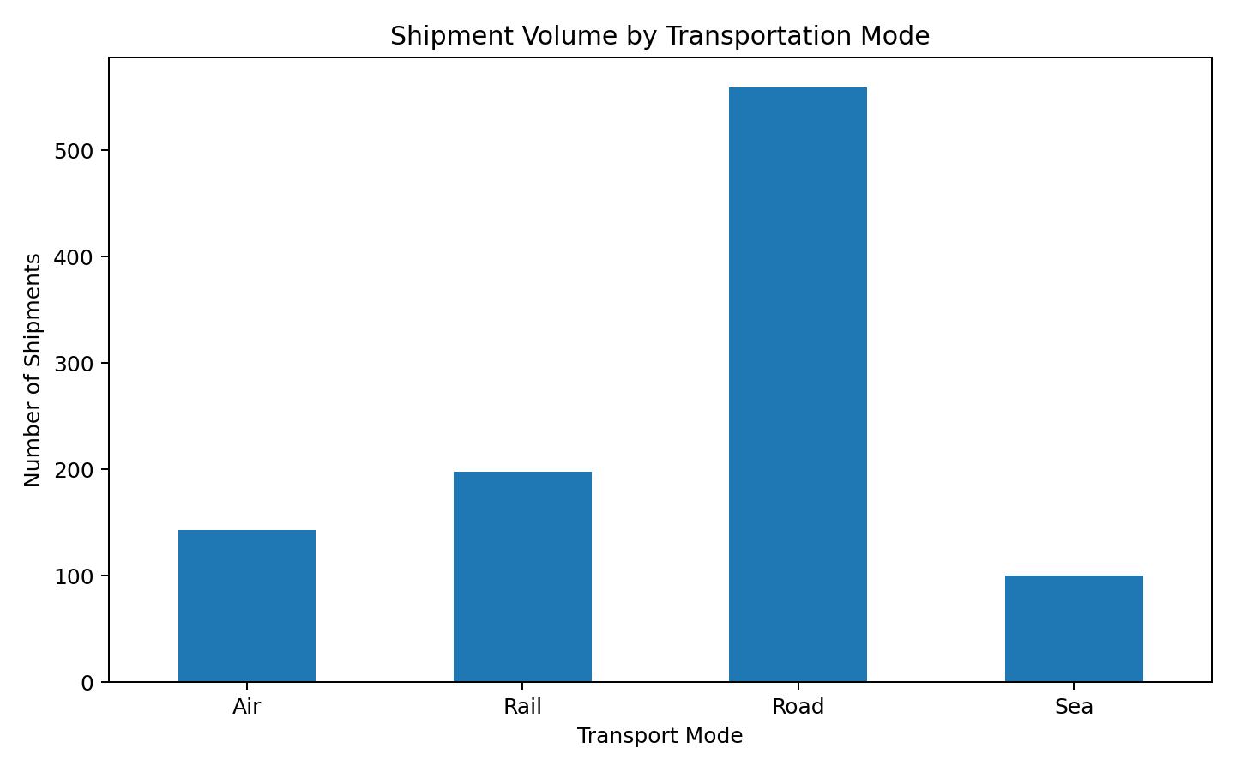

Figure 2 — 7-Day Rolling Average Delivery Time
A line chart is appropriate for time-series monitoring. Rolling averages reduce daily noise and reveal persistent deterioration or improvement in service performance.
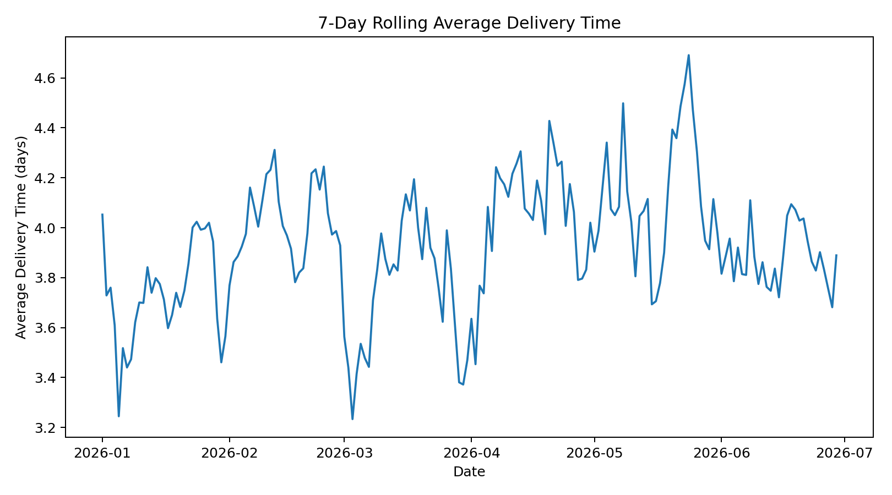

Figure 3 — Distribution of Delivery Time
A histogram shows the shape, spread and potential tail of delivery performance. A long right tail would indicate a smaller group of severely delayed shipments that may disproportionately affect customer experience.
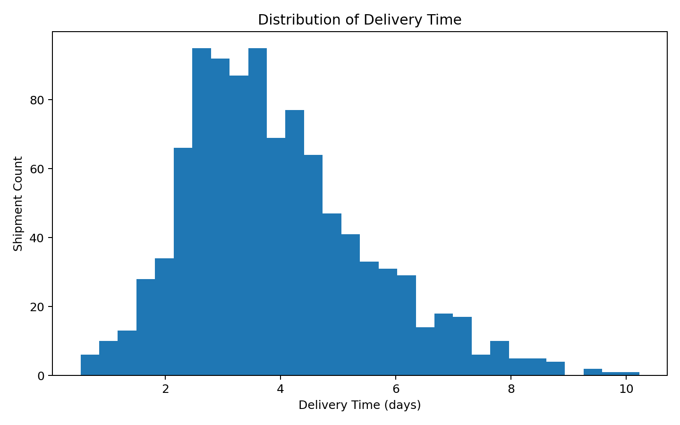

Figure 4 — Total Logistics Cost by Mode
A box plot compares median cost, dispersion and extreme values across transport modes. It is particularly useful for identifying cost volatility, not only average cost.
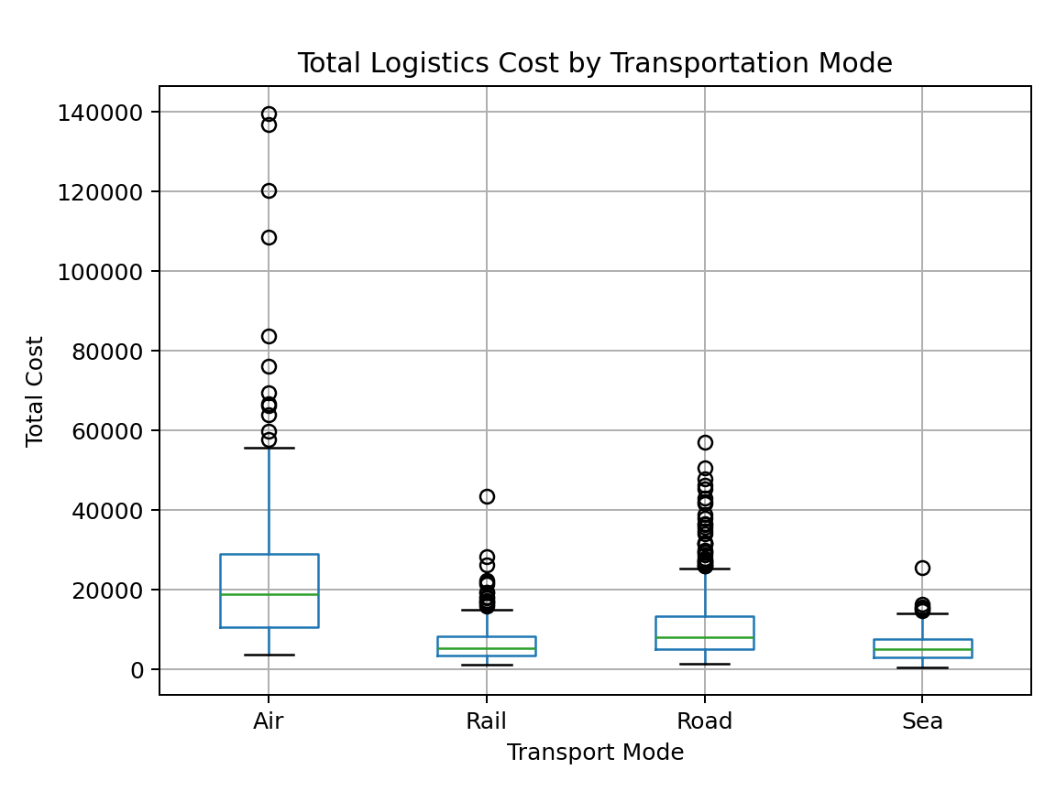

Figure 5 — Distance vs Total Logistics Cost
A scatter plot tests the operational hypothesis that longer routes require greater spend. The relationship is positive in the simulation (r=0.64), making distance a key cost-planning variable.
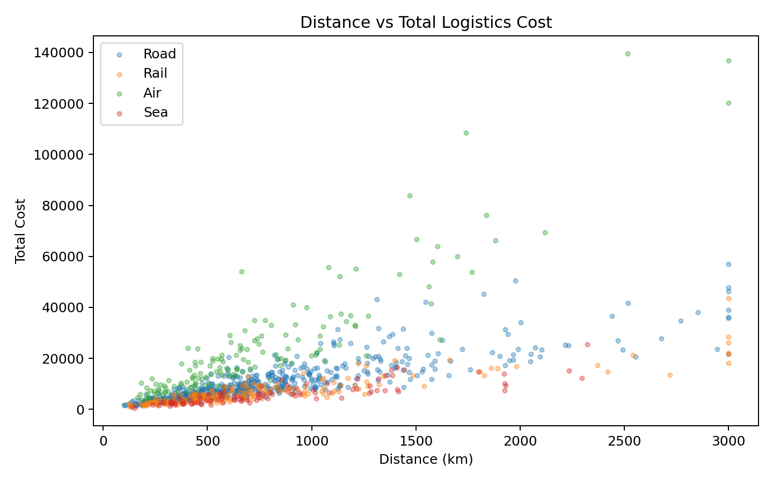

Figure 6 — Correlation Heatmap
A correlation heatmap provides a compact view of linear relationships among operational variables. It helps prioritize variables for deeper modeling and KPI design.
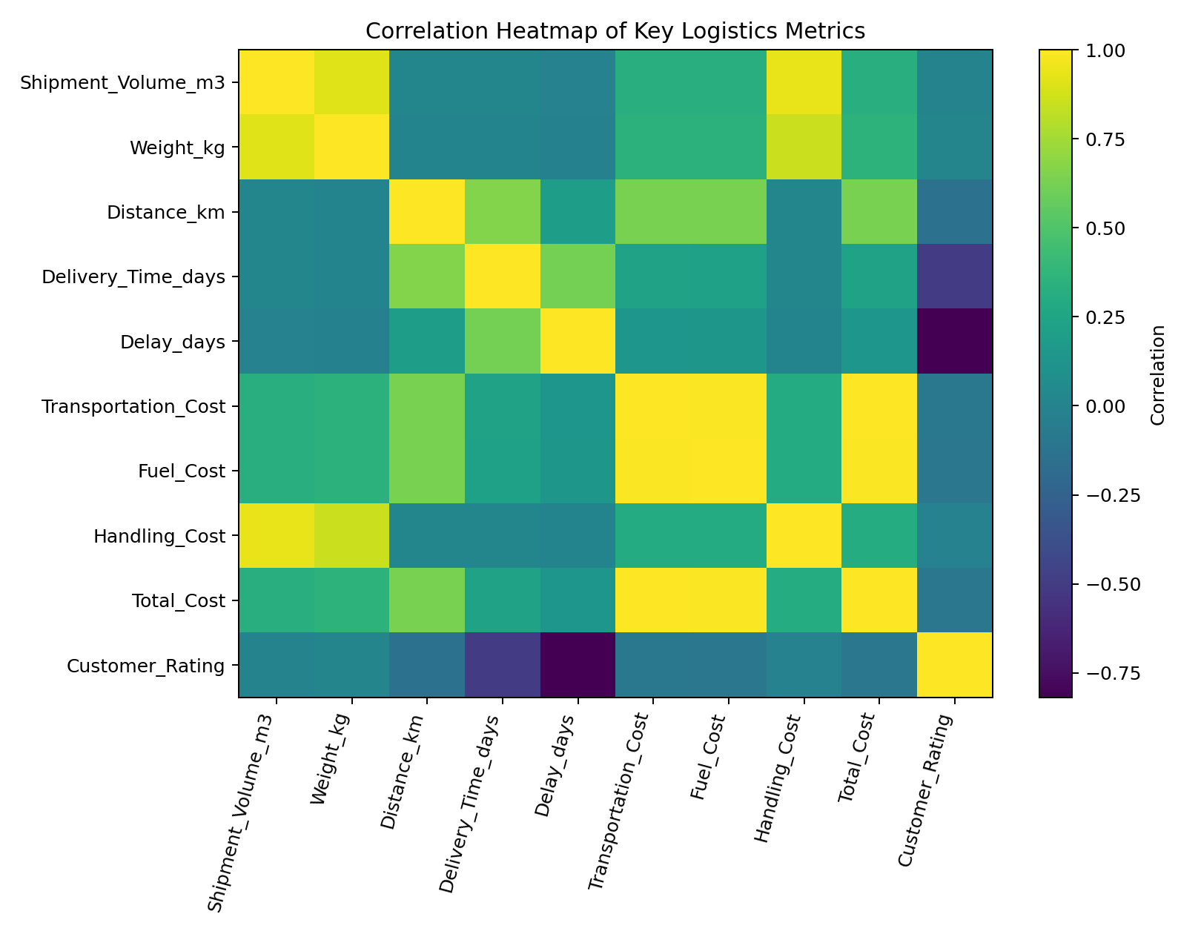

Figure 7 — Average Delivery Time by Mode
A mode comparison directly exposes service-speed differences. It supports segmentation of shipments into urgent versus cost-sensitive flows.
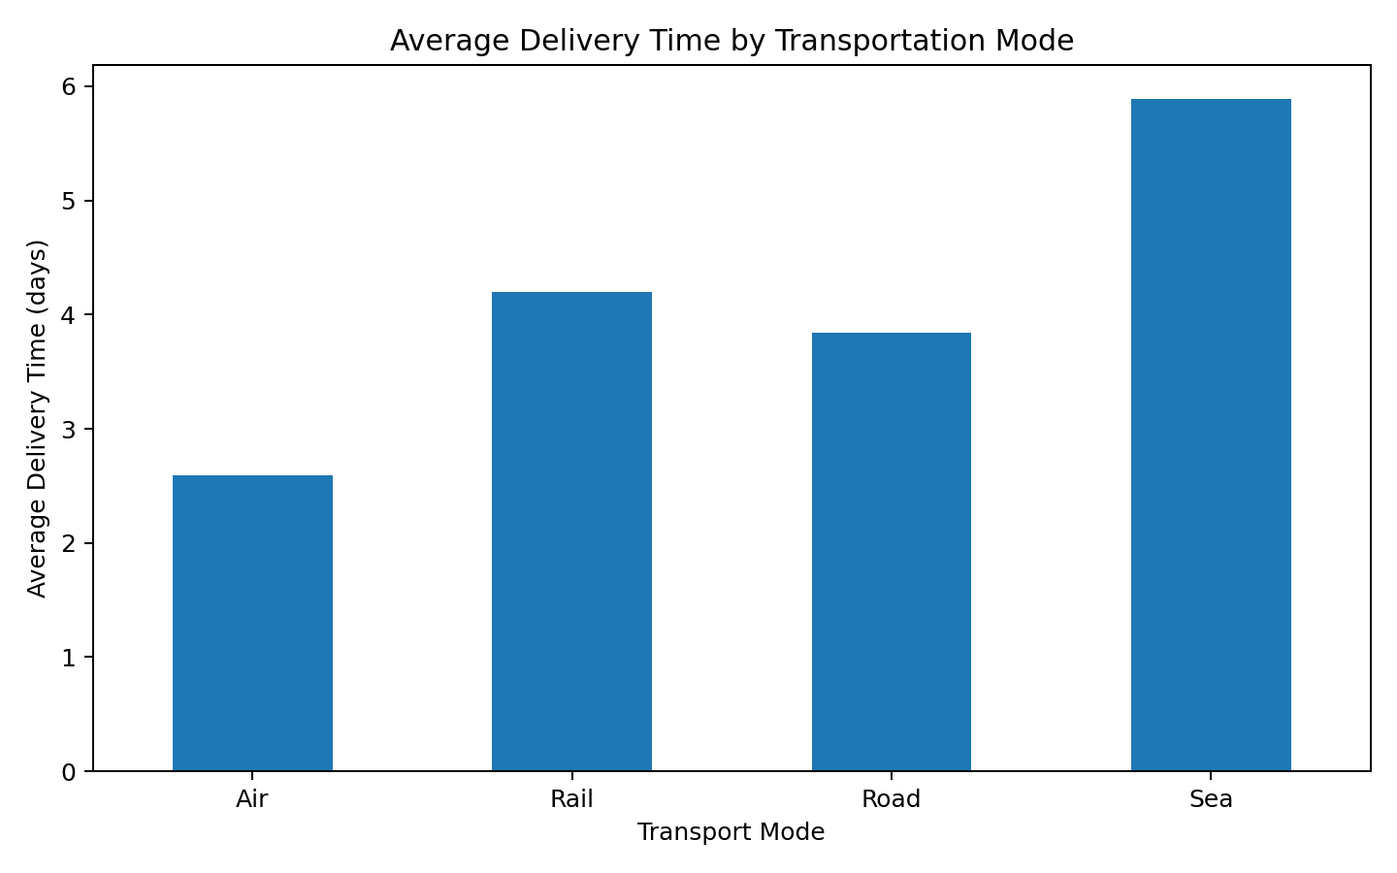

Figure 8 — On-Time vs Delayed Shipments
A proportion chart communicates the headline service outcome quickly to non-technical stakeholders and provides a clear baseline KPI.
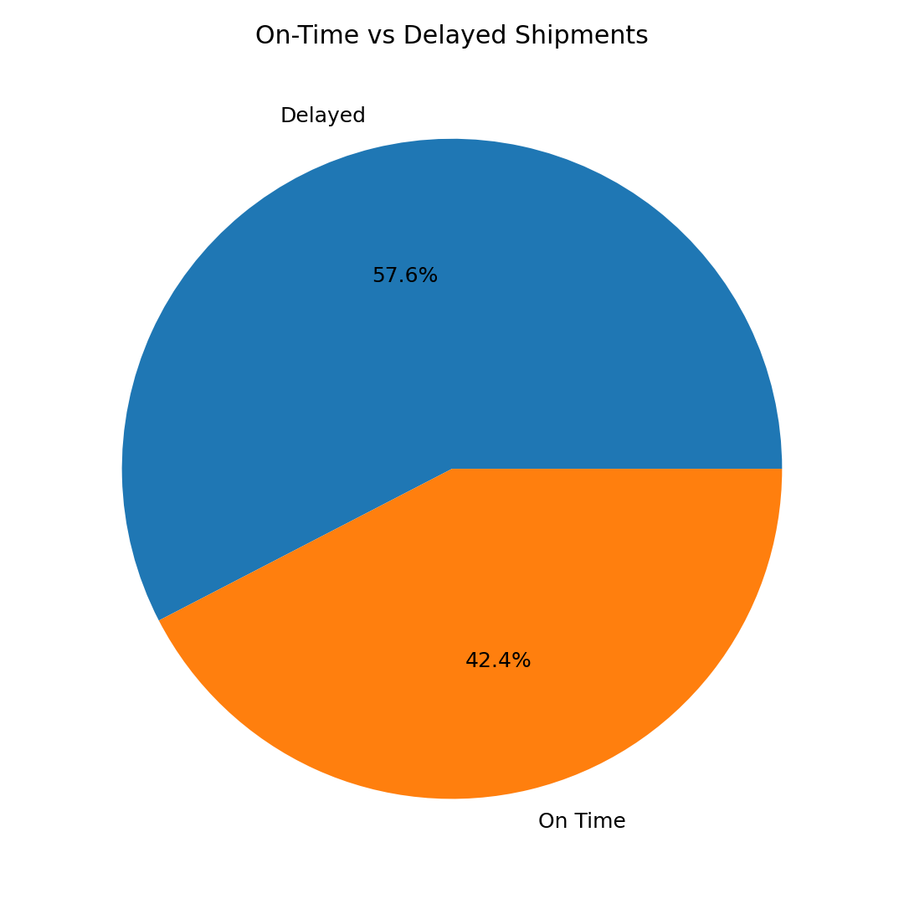

8. Correlation and Driver Analysis
Distance and total cost have a correlation of 0.64; this indicates a meaningful positive relationship. Weight and total cost correlate at 0.36, suggesting heavier shipments generally consume more logistics resources. Delay and customer rating correlate at -0.82, indicating that service failures are associated with lower customer satisfaction. Correlation is not causation, so these relationships should be validated using operational data and, where appropriate, regression or causal analysis.

9. Key Analytical Insights
- Service performance: The overall on-time rate is 42.4%, creating a measurable opportunity for reliability improvement.
- Mode strategy: Air is the fastest mode in the simulated network, while Sea is the lowest-cost mode on average; mode selection should therefore be aligned to shipment priority.
- Cost exposure: Longer routes are associated with higher total cost (r=0.64), making route design and consolidation important cost levers.
- Customer impact: Delay is negatively associated with customer rating (r=-0.82); reducing delay should improve service perception.
- Operational variability: Cost and delivery-time standard deviations indicate that average KPIs alone are insufficient; management should monitor variability and tail-risk.
- Potential bottleneck: High-distance road movements should receive targeted monitoring because distance increases cost exposure and road shipments carry additional delay risk in the simulation.

10. Recommendations
- Implement a mode-selection matrix: use faster modes for high-priority shipments and lower-cost modes for flexible-demand freight.
- Introduce route-level SLA monitoring with alerts for shipments that exceed expected transit time.
- Use shipment consolidation for compatible loads to reduce cost per unit transported.
- Track cost per shipment, cost per kg, cost per km and cost per cubic metre rather than relying only on total cost.
- Create a weekly exception dashboard focused on delayed shipments, high-cost routes and high-variance lanes.
- Investigate the top 10% most expensive and most delayed shipments individually; these exceptions are likely to provide the highest ROI for process improvement.
- Use predictive analytics in a future phase to forecast delay probability and expected transportation cost before dispatch.

11. Senior Analytics Perspective
A mature logistics analytics program should progress from descriptive reporting to diagnostic, predictive and prescriptive analytics. This project establishes the descriptive and diagnostic foundation. The next phase should use historical shipment-level data to build lane-level benchmarks, delay-risk models, cost forecasts and optimization scenarios. KPI definitions should be standardized and governed so operations, finance and customer-service teams work from the same performance measures.

12. Limitations
- The dataset is hypothetical and does not represent actual company performance.
- Relationships are simulated and should not be interpreted as causal evidence.
- External factors such as weather, traffic, customs, holidays and carrier capacity are not modeled.
- Transportation cost is represented in generic monetary units rather than a specified currency.
- Further analysis should use real lane, carrier and warehouse data before operational decisions are made.

13. Conclusion
The analysis demonstrates how Python-based EDA and visualization can turn shipment-level logistics data into actionable management insight. The most important themes are service reliability, transportation-mode trade-offs, distance-driven cost exposure, shipment weight and the relationship between delay and customer satisfaction. A disciplined KPI framework combined with exception monitoring and predictive analytics can help logistics leaders improve delivery reliability while controlling transportation spend.

14. Python Code Appendix
import pandas as pd
import matplotlib.pyplot as plt

df = pd.read_csv("hypothetical_logistics_dataset.csv", parse_dates=["Date"])

# EDA
print(df.info())
print(df.describe())
print(df.isna().sum())
print(df.duplicated().sum())

# KPI calculations
on_time_rate = (df["Delivery_Status"] == "On Time").mean() * 100
print("On-time rate:", round(on_time_rate, 2), "%")
print("Average delivery time:", round(df["Delivery_Time_days"].mean(), 2))
print("Average total cost:", round(df["Total_Cost"].mean(), 2))

# Grouped analysis
mode_summary = df.groupby("Transport_Mode").agg(
Shipments=("Shipment_ID","count"),
Avg_Delivery_Days=("Delivery_Time_days","mean"),
Avg_Delay_Days=("Delay_days","mean"),
Avg_Total_Cost=("Total_Cost","mean"),
Avg_Rating=("Customer_Rating","mean"),
On_Time_Rate=("Delivery_Status",
lambda x: (x == "On Time").mean() * 100)
)

print(mode_summary.round(2))

# Visualizations
df["Date"] = pd.to_datetime(df["Date"])

plt.figure(figsize=(8,5))
df["Transport_Mode"].value_counts().plot(kind="bar")
plt.title("Shipment Volume by Transportation Mode")
plt.xlabel("Transport Mode")
plt.ylabel("Number of Shipments")
plt.tight_layout()
plt.show()

daily = df.groupby("Date")["Delivery_Time_days"].mean().sort_index()
daily.rolling(7, min_periods=1).mean().plot(figsize=(9,5))
plt.title("7-Day Rolling Average Delivery Time")
plt.xlabel("Date")
plt.ylabel("Delivery Time (days)")
plt.tight_layout()
plt.show()

plt.figure(figsize=(8,5))
plt.hist(df["Delivery_Time_days"], bins=30)
plt.title("Distribution of Delivery Time")
plt.xlabel("Delivery Time (days)")
plt.ylabel("Shipment Count")
plt.tight_layout()
plt.show()

df.boxplot(column="Total_Cost", by="Transport_Mode", figsize=(8,5))
plt.suptitle("")
plt.title("Total Logistics Cost by Transportation Mode")
plt.tight_layout()
plt.show()

plt.figure(figsize=(8,5))
plt.scatter(df["Distance_km"], df["Total_Cost"], alpha=0.35)
plt.title("Distance vs Total Logistics Cost")
plt.xlabel("Distance (km)")
plt.ylabel("Total Cost")
plt.tight_layout()
plt.show()

corr = df.select_dtypes("number").corr()
plt.figure(figsize=(10,7))
plt.imshow(corr, aspect="auto")
plt.colorbar(label="Correlation")
plt.title("Correlation Heatmap")
plt.tight_layout()
plt.show()

mode_summary["Avg_Delivery_Days"].plot(kind="bar", figsize=(8,5))
plt.title("Average Delivery Time by Transportation Mode")
plt.ylabel("Days")
plt.tight_layout()
plt.show()

df["Delivery_Status"].value_counts().plot(kind="pie", autopct="%1.1f%%", figsize=(6,6))
plt.title("On-Time vs Delayed Shipments")
plt.ylabel("")
plt.show()

