Points

1) home page background and images

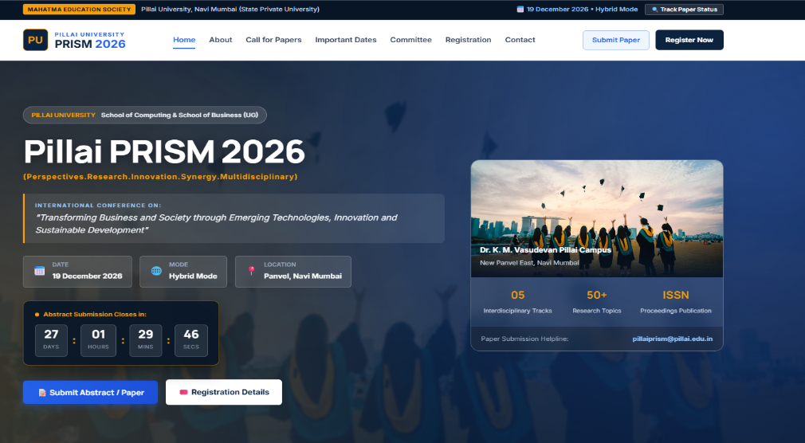

2) Theme and button colors and etc



3) About Section auto

4) faculty photo

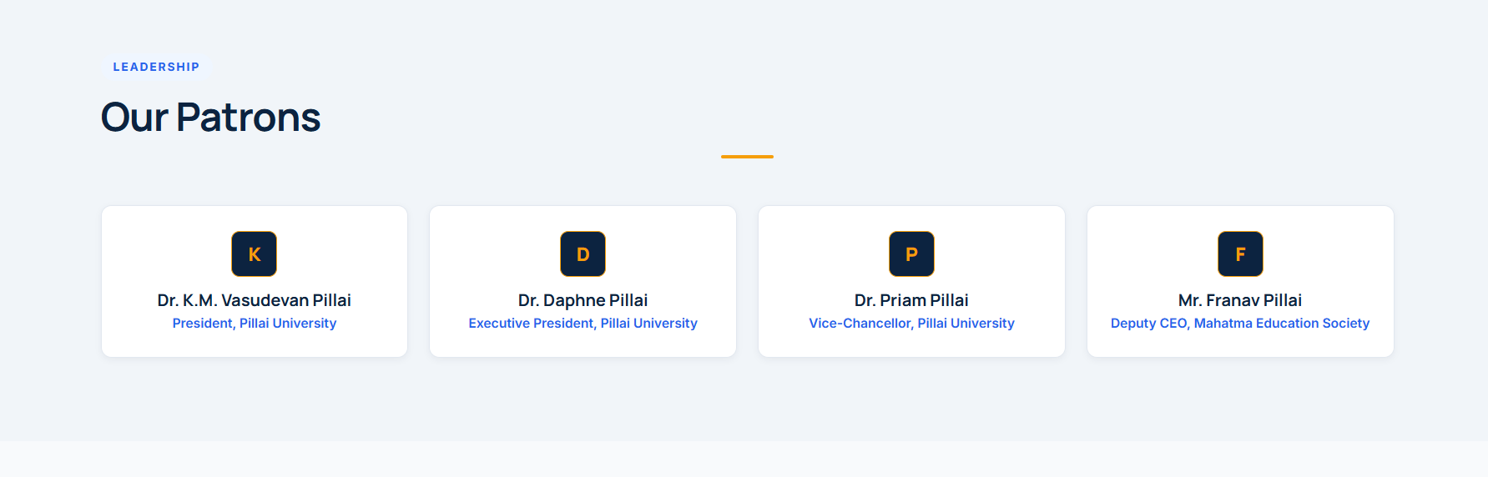

5) registration portal for decluttering

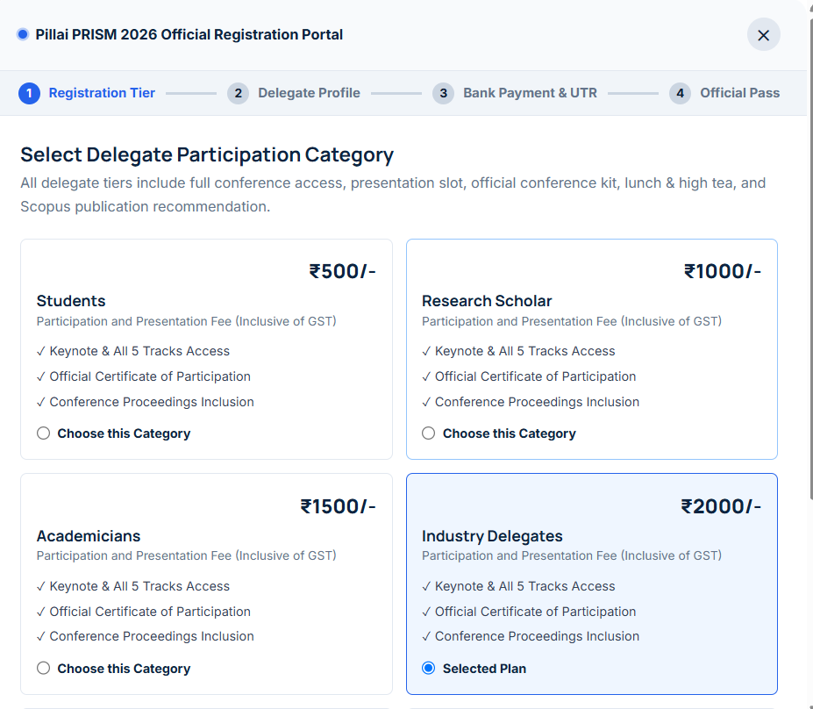

6) reformatting registration and submit page portal

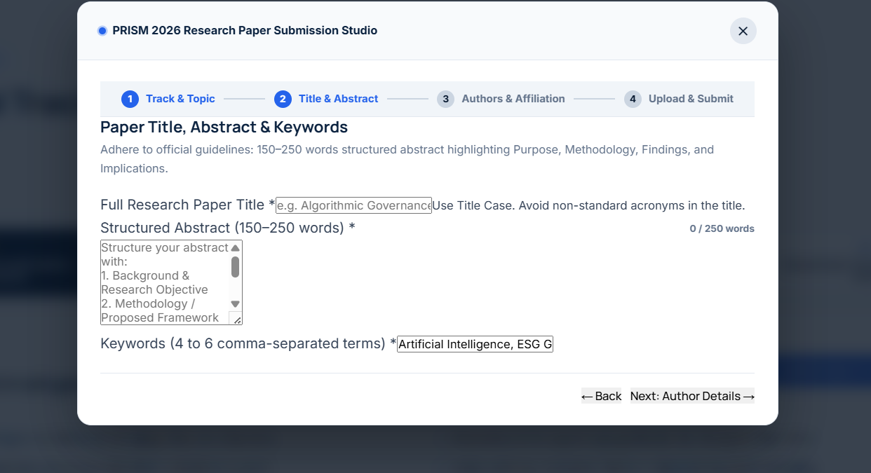
Section : 2

1) Event dates Export into Calenders file

2) directly link to google map

3) track paper status (possible removable)

Section :- 3

- photo

- domain

- backend all

