Bin folder is should be added to the network folder

If the access is denied to the automation scripts,

Try

sudo chmod +x filename.sh

that will make the script executable

1)Start the process by generating certificates

./fabricNetwork.sh generate

2)Start the network by using

./fabricNetwork.sh up

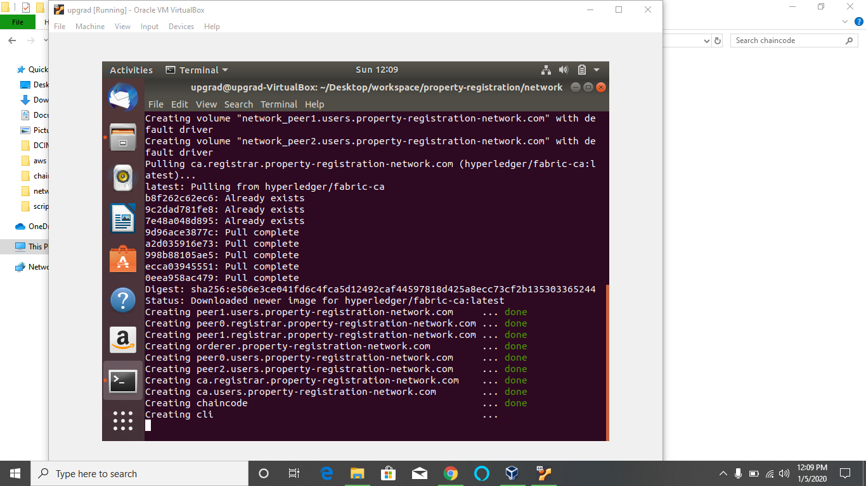

3)once all the containers are up and running, install the certificates by using

./fabricNetwork.sh install

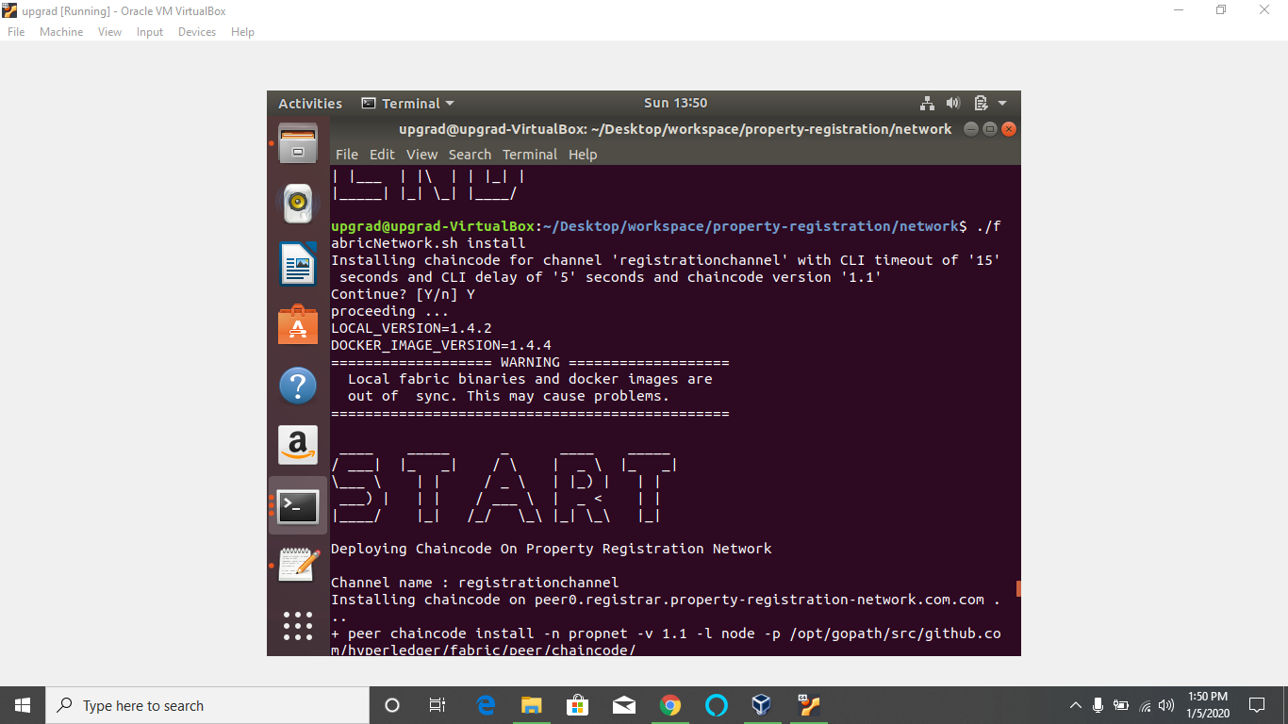

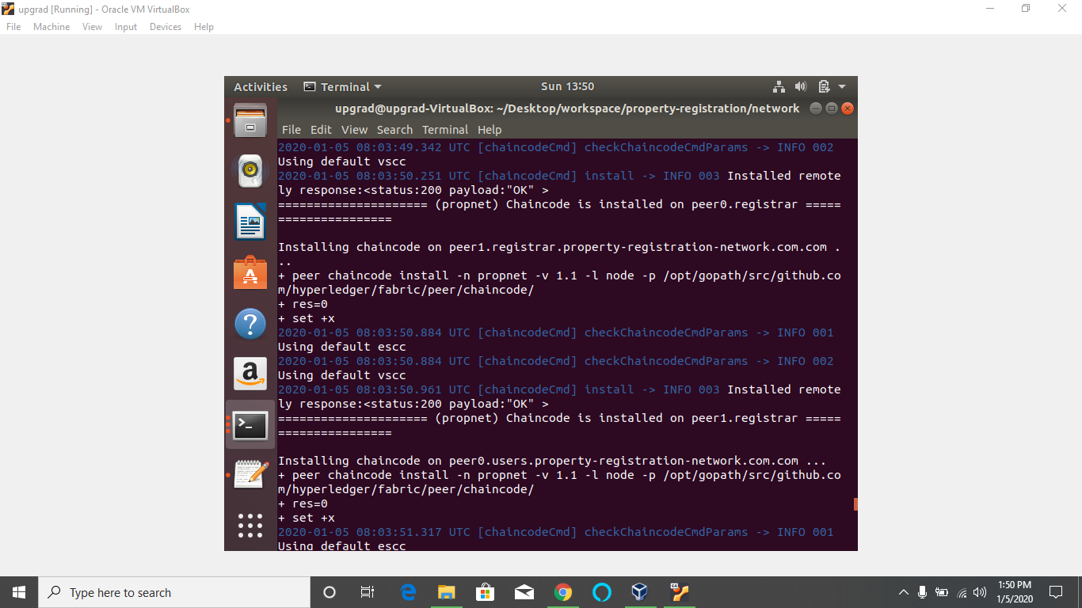

4)if you get error while instantiating, do it manually by using the command

5) now access the functions

6)