Bin folder is should be added to the network folder

If the access is denied to the automation scripts,

Try

sudo chmod +x filename.sh

that will make the script executable

1)Start the process by generating certificates

./fabricNetwork.sh generate

2)Start the network by using

./fabricNetwork.sh up

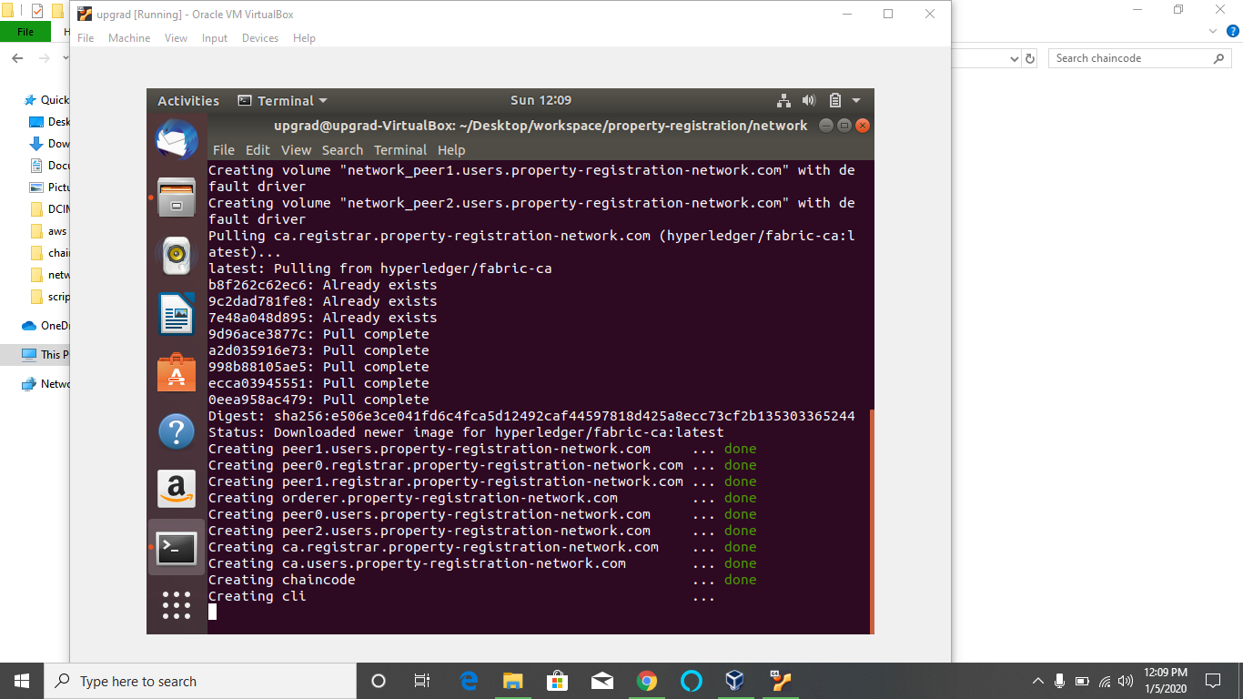

3)once all the containers are up and running, install the certificates by using

./fabricNetwork.sh install

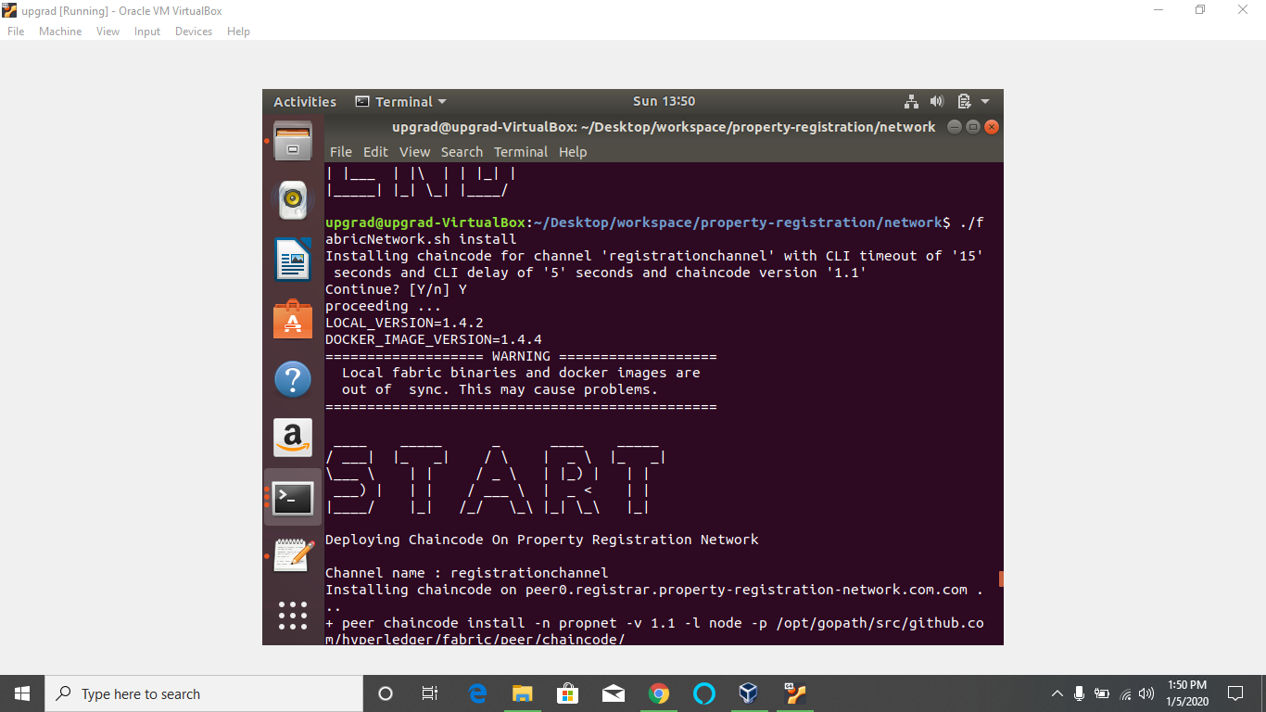

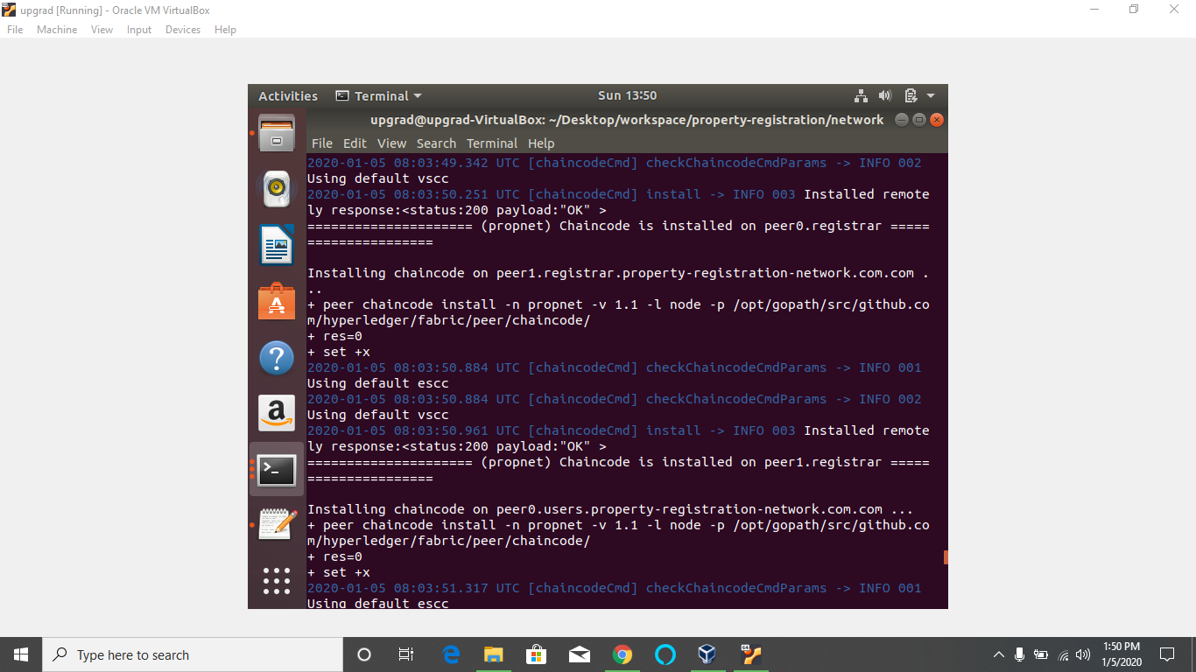

4)if you get error while instantiating, do it manually by using the command

SSH into the CLI container

docker exec -it cli /bin/bash

Update the environmental variables;

CORE_PEER_LOCALMSPID="iitMSP" CORE_PEER_MSPCONFIGPATH=/opt/gopath/src/github.com/hyperledger/fabric/pee r/crypto/peerOrganizations/iit.certification-network.com/users/Admin@iit. certification-network.com/msp

CORE_PEER_ADDRESS=peer0.iit.certification-network.com:7051

Now instantiate using:

peer chaincode instantiate -o orderer.certification-network.com:7050 -C certificationchannel -n certnet -l node -v 1.1 -c '{"Args":["org.certification-network.certnet:instantiate"]}' -P "OR ('iitMSP.member','mhrdMSP.member','upgradMSP.member')"

after running screen should looks as follow



5) now access the functions

Request new users: open a new terminal window and

**docker exec it peer0.users.property-registration-network.com /bin/bash**

peer chaincode invoke -o orderer.property-registration-network.com:7050 -C registrationchannel -n propnet -c '{"Args["org. property-registration-network.propnet:requestNewUser",”JohnSnow","connect@JohnSnow.com",”8392399242”,”12345678911”]}'

peer chaincode invoke -o orderer.property-registration-network.com:7050 -C registrationchannel -n propnet -c '{"Args":["org.property-registration-network.propnet:requestNewUser",”Joe Barnes","connect@Joebarnes.com",”8392399232”,”12345678910”]}'

**approveNewUser:**

Go to peer0 of registrar and invoke the approve user function by typing

open a new terminal window and

**docker exec it peer0.registrar.property-registration-network.com /bin/bash**

peer chaincode invoke -o orderer.property-registration-network.com:7050 -C registrationchannel -n propnet -c '{"Args":["org.property-registration-network.propnet: **approveNewUser**",”Joe Barnes",”12345678910”]}'

peer chaincode invoke -o orderer.property-registration-network.com:7050 -C registrationchannel -n propnet -c '{"Args":["org.property-registration-network.propnet: **approveNewUser** ",”JohnSnow",”12345678911”]}'

**rechargeAccount** :

go to the peer0 of the user and invoke the **rechargeAccount**  function by using

peer chaincode invoke -o orderer.property-registration-network.com:7050 -C registrationchannel -n propnet -c '{"Args":["org.property-registration-network.propnet: **rechargeAccount**  ",”JohnSnow",”12345678911”,”upg1000”]}'

peer chaincode invoke -o orderer.property-registration-network.com:7050 -C registrationchannel -n propnet -c '{"Args":["org.property-registration-network.propnet: **rechargeAccount** ",”Joe Barnes",”12345678910”,”upg1000”]}’

**propertyRegistrationRequest :**

peer chaincode invoke -o orderer.property-registration-network.com:7050 -C registrationchannel -n propnet -c '{"Args":["org.property-registration-network.propnet: **propertyRegistrationRequest**",”10001”,”500”,”onSale”,”JohnSnow",”12345678911”,”upg1000”]}'

**approvePropertyRegistration:**

**to approve the property request again go back to the terminal with peer0 of registrar open and invoke the following function**

peer chaincode invoke -o orderer.property-registration-network.com:7050 -C registrationchannel -n propnet -c '{"Args":["org.property-registration-network.propnet: **approvePropertyRegistration**",”10001”]}'

**updateProperty:**

**go back to the user peer0 to invoke the update property function using**

peer chaincode invoke -o orderer.property-registration-network.com:7050 -C registrationchannel -n propnet -c '{"Args":["org.property-registration-network.propnet: **updateProperty**",”10001”,”JohnSnow",”12345678911”,”onSale”]}'

**purchaseProperty**

**can invoke this function using the user peer0**

peer chaincode invoke -o orderer.property-registration-network.com:7050 -C registrationchannel -n propnet -c '{"Args":["org.property-registration-network.propnet: **updateProperty**",”10001”,”Joe Barnes",”12345678910”]}'

**View user**

**Using this function for viewing a registered user can**

peer chaincode invoke -o orderer.property-registration-network.com:7050 -C registrationchannel -n propnet -c '{"Args":["org.property-registration-network.propnet: **viewUser**",”Joe Barnes",”12345678910”]}'

**viewProperty**

**using this function for viewing approved property**

peer chaincode invoke -o orderer.property-registration-network.com:7050 -C registrationchannel -n propnet -c '{"Args":["org.property-registration-network.propnet: **viewProperty**",”10001"]}'

registrar.property-registration-network.com

6)