VERTEX SOFTWARE
Support Operations & Customer Analytics
Data Analyst Portfolio Project

A practical analysis of 100,000 IT support tickets using Python, MySQL and Power BI. The project follows the full analyst workflow: understanding the raw data, cleaning it, exploring patterns, writing business-focused SQL, and presenting the results in an interactive dashboard.
Tools: Python • Pandas • NumPy • MySQL • Power BI
Portfolio report • September 2026

Contents
- 1. Executive Summary
- 2. Business Problem and Objectives
- 3. Dataset Overview
- 4. Data Understanding and Quality Checks
- 5. Data Cleaning in Python
- 6. Exploratory Data Analysis
- 7. SQL Analysis
- 8. Power BI Dashboard
- 9. Key Findings
- 10. Business Recommendations
- 11. Project Workflow and Technical Skills
- 12. Limitations and Next Steps
- 13. Appendix – Selected SQL Queries

1. Executive Summary
The goal of this project was to turn a large support-ticket dataset into a management-friendly view of service operations and customer experience. I worked through the data in stages rather than jumping directly into the dashboard: first checking the raw structure, then cleaning the data in Python, using MySQL for business questions, and finally building Power BI pages for operations, customers and management.
The full dataset contains 100,000 tickets created between January 2022 and December 2025. The Power BI pages shown in this report focus on 2022–2023, which gives a consistent 49,768-ticket reporting slice and matches the dashboard KPI cards.
Measure | Result
Tickets in dashboard period | 49,768
Resolved tickets | 24,958
Resolved share | 50.15%
Average resolution time | 44.97 hrs
Median resolution time | 29.89 hrs
Reopened tickets | 2,483
Reopened rate | 4.99%
Average CSAT field value | 2.24

A few patterns stand out. Resolution time is right-skewed: the mean is about 45 hours while the median is about 30 hours, showing that a smaller group of long-running tickets pulls the average upward. Priority also matters: in the 2022–2023 slice, urgent tickets have the shortest average resolution time, while low-priority tickets have the longest.
Customer satisfaction needs careful interpretation. The CSAT field contains a value of 0 for about 29.9% of tickets, and the EDA treated those zeros as non-responses when looking at the distribution of actual ratings. That means the dashboard's 2.24 average should be read as the average stored field value, not automatically as the average score among customers who submitted a rating.

2. Business Problem and Objectives
Support teams usually have more ticket data than they have time to review. The business question in this project is simple: where is support demand coming from, how quickly are tickets being handled, and where are customer experience or operational issues worth investigating?

Questions addressed
- How many tickets are being handled, and what is the status mix?
- Which priority levels generate the most tickets?
- Which support channels are used most often?
- Which issue types and product areas create the most support demand?
- How does resolution time vary by priority, issue type and customer segment?
- How does CSAT vary by channel, customer segment, region, product area and issue type?
- How often are tickets reopened?
- How does ticket volume change over time?

3. Dataset Overview
The raw file used for the project is a synthetic IT support-ticket dataset. It contains 100,000 rows and 20 columns covering ticket identifiers, customers, channels, product areas, issue types, priority, status, SLA plan, timestamps, resolution information, sentiment and CSAT.
Area | Details
Rows | 100,000
Columns | 20
Time period | 2022-01-01 to 2025-12-30
Customers | 9,999 unique customer IDs
Customer segments | individual, small_business, education, enterprise, non_profit
Channels | email, in_app, chat, phone_transcript, web_form
Product areas | 7 categories
Issue types | 8 categories
Priority levels | low, medium, high, urgent
Statuses | resolved, closed_no_action, in_progress, on_hold, open
CSAT | 0–5 stored values

The dataset is intentionally broad enough to support several kinds of analyst questions. It also contains realistic data-quality situations such as missing regions and missing resolution information, which made it useful for practising a complete analytics workflow.

4. Data Understanding and Quality Checks
The first Python notebook was used to inspect the structure before making changes. The checks covered data types, column names, unique values, missing values, duplicate rows and basic numerical statistics.
Quality check | Result | Action / interpretation
Duplicate rows | 0 | No exact duplicate rows were found.
Missing region | 19,997 (20.00%) | Region was handled during cleaning using the mode.
Missing resolution time | 39,887 (39.89%) | Kept as missing because these records are open, on_hold or in_progress.
Missing resolution summary | 39,887 (39.89%) | Kept as missing for the same operational reason.
Missing core IDs / categories | 0 | No missing values were found in the main ID/category fields checked.
Resolution-time outliers | 6,108 (6.11%) | Flagged for review; not removed.

One useful data-quality finding was that the missing resolution-time values were not random. The 39,887 missing values line up with tickets in the open, on_hold and in_progress statuses. In an operational dataset, that makes sense: an unresolved ticket may not have a final resolution duration yet.
The resolution-time distribution also contains a long tail. The Python cleaning notebook calculated an IQR upper bound of 106.83 hours and identified 6,108 potential outliers. These were retained rather than deleted because long-running tickets can be operationally meaningful.

5. Data Cleaning in Python
The cleaning stage focused on fixing data quality issues without changing the business meaning of the records.
- Loaded the raw CSV with Pandas.
- Checked categorical values against expected lists.
- Checked for duplicate rows.
- Filled missing region values using the mode.
- Converted created_at from text to a datetime field.
- Checked CSAT and reopened values for their expected ranges.
- Reviewed resolution-time outliers using the IQR method.
- Exported the cleaned dataset for SQL analysis and later dashboard use.

Example cleaning code
df["region"] = df["region"].fillna(df["region"].mode()[0])
df["created_at"] = pd.to_datetime(df["created_at"])
Q1 = df["resolution_time_hours"].quantile(0.25)
Q3 = df["resolution_time_hours"].quantile(0.75)
IQR = Q3 - Q1
upper_bound = Q3 + 1.5 * IQR
The final cleaned dataset was also uploaded into MySQL, creating a bridge between the Python preparation stage and the SQL analysis stage.

6. Exploratory Data Analysis
The EDA stage looked at ticket volume, resolution time, CSAT, reopening behaviour and relationships between operational fields.

Resolution time
For the 2022–2023 dashboard period, the average resolution time is 44.97 hours and the median is 29.89 hours. The difference between the two confirms the right-skewed pattern seen in the Python histogram.

Priority and resolution
Priority | Tickets with resolution time | Average hrs | Median hrs
low | 11,930.0 | 55.37 | 45.30
medium | 10,530.0 | 43.04 | 29.82
high | 5,937.0 | 31.94 | 14.70
urgent | 1,524.0 | 27.61 | 4.99

Customer satisfaction
The raw CSAT field has six stored values: 0 through 5. In the 2022–2023 period, 29.92% of tickets have a CSAT value of 0. The EDA therefore created a separate view using CSAT > 0 to examine actual submitted ratings. Among those rated tickets, the average stored score is about 3.20.

Reopened tickets
The dashboard period contains 2,483 reopened tickets, a rate of 4.99%. The rate is close across priority groups, so reopening does not appear to be isolated to one priority level in this dataset.

Issue mix
Issue type | Tickets | Share % | Avg resolution hrs | Avg CSAT
feature_request | 6,316 | 12.69% | 46.01 | 2.62
account_access | 6,292 | 12.64% | 45.29 | 1.97
how_to | 6,291 | 12.64% | 44.58 | 2.60
other | 6,285 | 12.63% | 45.22 | 2.42
security_concern | 6,276 | 12.61% | 44.65 | 1.96
performance | 6,150 | 12.36% | 44.40 | 1.97
bug | 6,134 | 12.33% | 44.99 | 2.41
billing_problem | 6,024 | 12.10% | 44.58 | 1.96

7. SQL Analysis
MySQL was used to move from descriptive checks into business-oriented questions. The SQL file includes aggregation, filtering, HAVING, CASE expressions, date functions, conditional aggregation and a CTE.

Main SQL techniques used
- COUNT, SUM, AVG, MIN and MAX for KPI calculations.
- GROUP BY and ORDER BY for category-level comparisons.
- WHERE versus HAVING for row-level and grouped filtering.
- CASE expressions to create Fast / Medium / Slow resolution categories.
- YEAR, MONTH, MONTHNAME and HOUR for time-based analysis.
- Conditional aggregation to count resolved, open, high-priority and reopened tickets.
- CTE-based analysis for channel-level filtering.

Example: priority analysis
SELECT
priority,
COUNT(*) AS ticket_count
FROM support_tickets
GROUP BY priority
ORDER BY ticket_count DESC;

Example: issue types taking more than 45 hours on average
SELECT
issue_type,
ROUND(AVG(resolution_time_hours), 2) AS avg_resolution_time
FROM support_tickets
GROUP BY issue_type
HAVING AVG(resolution_time_hours) > 45;

Example: channel analysis with a CTE
WITH channel_analysis AS (
SELECT channel,
COUNT(ticket_id) AS total_tickets,
ROUND(AVG(resolution_time_hours), 2) AS avg_resolution_time
FROM support_tickets
GROUP BY channel
)
SELECT channel, total_tickets, avg_resolution_time
FROM channel_analysis
WHERE total_tickets > 15000
AND avg_resolution_time < 50;

8. Power BI Dashboard
The Power BI report was built as four pages so that the same data can be viewed from different management angles. The pages use slicers for year, month, priority and channel, allowing the user to move from an overall view to a more focused operational question.

Page 1 — Summary
The summary page brings the main KPIs together: ticket volume, average resolution time, YTD tickets and total resolution time. The supporting visuals break the workload down by month, priority, channel and resolution category.
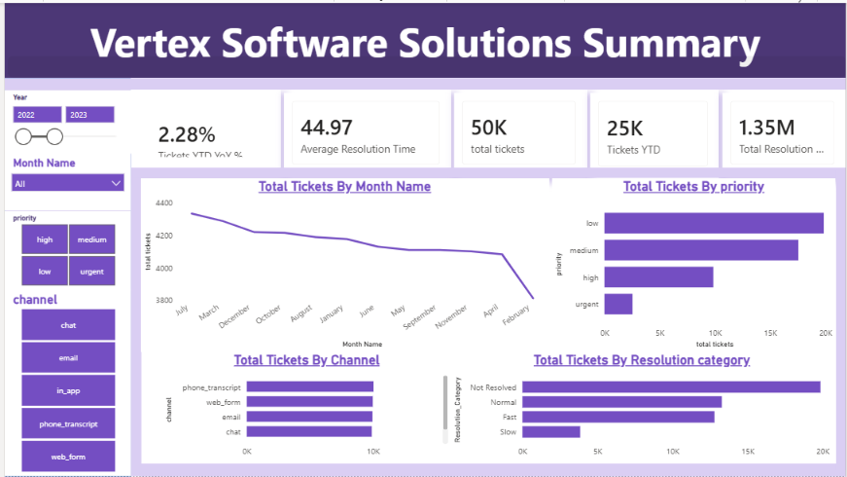
Power BI — Vertex Software Solutions Summary

Page 2 — Support Operations
The operations page focuses on ticket status, issue type, CSAT score distribution and product area. It is useful for understanding where the support queue is concentrated and which product areas are generating demand.
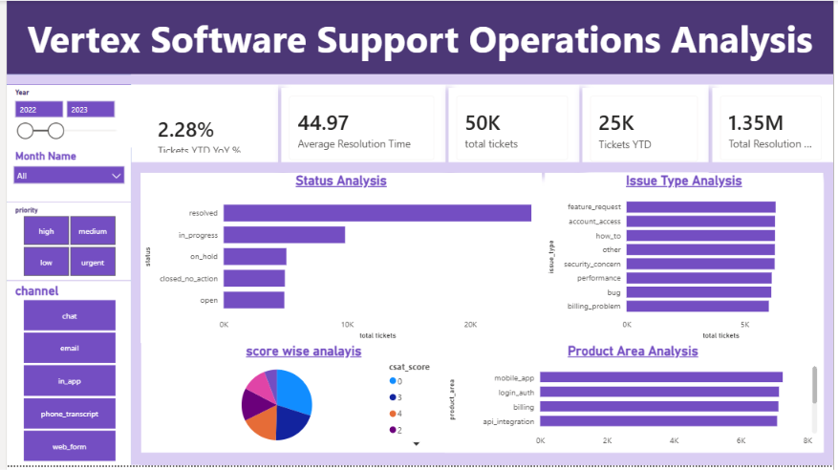
Power BI — Vertex Software Support Operations Analysis

Page 3 — Customer Analysis
The customer page moves the focus from workload to customer experience. It compares CSAT by support channel, customer segment, region and issue type, while also showing the CSAT trend over time and reopened-ticket KPIs.
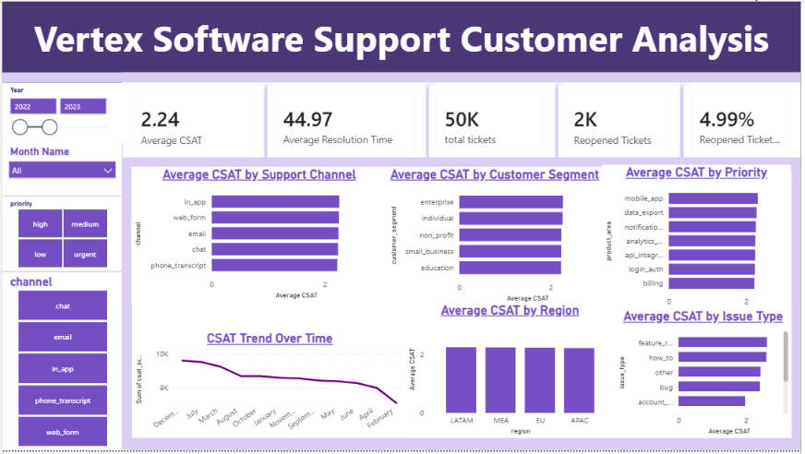
Power BI — Vertex Software Support Customer Analysis

Page 4 — Management Insights
The final page brings operational indicators together for a manager: SLA performance by priority, average resolution time by issue and customer segment, CSAT by priority/product area and reopened-ticket rate by priority.
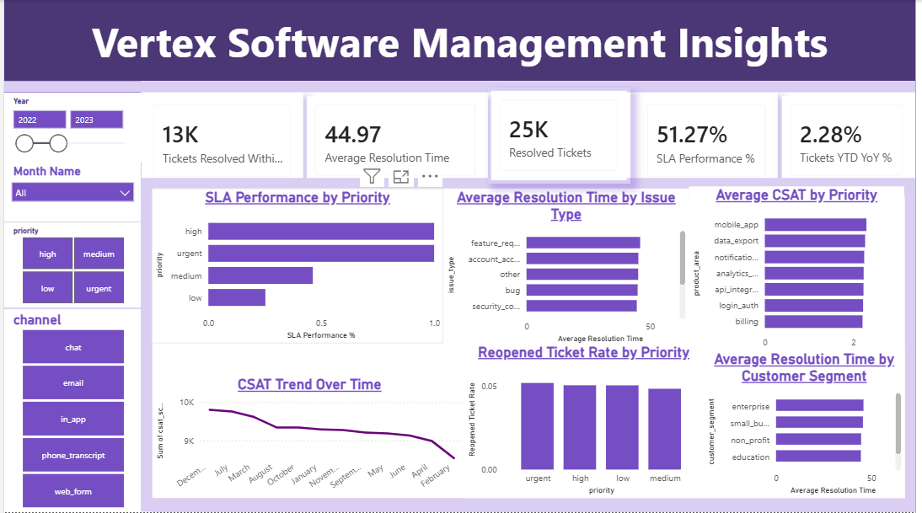
Power BI — Vertex Software Management Insights

9. Key Findings
Large unresolved workload: Only 50.15% of the 49,768 tickets in the dashboard period are marked resolved. The remaining tickets are distributed across in_progress, on_hold, closed_no_action and open statuses.
Low priority carries the largest volume: Low-priority tickets account for 39.89% of the dashboard-period workload, followed by medium priority at 35.23%.
Resolution time has a long tail: The average is 44.97 hours versus a 29.89-hour median. This means the average alone hides a meaningful group of long-running tickets.
Urgent tickets are resolved faster on average: Urgent tickets have an average resolution time of 27.61 hours, compared with 55.37 hours for low priority.
Issue types are evenly distributed: No single issue type dominates the workload. Each of the eight categories contributes roughly 12%–13% of tickets in the dashboard period.
Customer experience differs by issue type: Feature requests and how-to tickets have average CSAT values of 2.62 and 2.60, while security, billing, performance and account-access tickets are around 1.96–1.97.
Reopening is a measurable quality signal: 2,483 tickets were reopened, giving a reopening rate of 4.99%.

10. Business Recommendations
The recommendations below are tied directly to the patterns found in the dataset. They are framed as actions a support team could investigate rather than as assumptions about the real-world organisation.
Focus queue reviews on aging low-priority tickets — Low-priority tickets have the highest average resolution time. A weekly aging report could identify low-priority tickets that have remained open beyond an agreed internal threshold.
Separate unresolved workload from resolved workload — Because resolution time is missing for open, on_hold and in_progress tickets, management reporting should keep 'current queue' and 'completed ticket performance' as separate views.
Investigate low-CSAT issue types — Security concern, billing problem, performance and account access show lower CSAT averages than feature-request and how-to tickets. These categories are good candidates for root-cause analysis, knowledge-base improvements or process review.
Track reopened tickets as a quality KPI — A reopening rate of about 5% is visible in the dashboard. Breaking reopened tickets down by issue type, product area and agent/team would help identify recurring resolution-quality problems.
Use median as well as average resolution time — The large gap between the mean and median shows why a single average can hide the long tail. A management page should ideally show both.
Document the CSAT=0 rule — Because nearly 30% of records contain a zero CSAT value, the reporting definition should clearly state whether zero means 'no response' or a genuine score. This prevents misleading comparisons.

11. Project Workflow and Technical Skills
The project follows a practical analyst workflow that can be explained clearly in an interview or portfolio review:
Step | Stage | What was done
1 | Raw CSV | 100,000 support-ticket records
2 | Python / Pandas | Profiling, missing-value checks, duplicate checks, type conversion and EDA
3 | Cleaned dataset | Validated categories and handled missing region values
4 | MySQL | Business questions, aggregations, filtering, CASE logic, date analysis and CTE
5 | Power BI | Data model, DAX measures, slicers, KPI cards and interactive visuals
6 | Business output | Operations, customer and management views with actionable findings

Skills demonstrated
- Python data analysis with Pandas and NumPy
- Data cleaning and quality validation
- Exploratory data analysis and outlier analysis
- SQL aggregation, filtering and business logic
- CTEs and date-based analysis in MySQL
- Power BI dashboard development
- DAX KPI calculations and time-based measures
- Business storytelling and insight generation

12. Limitations and Next Steps
This is a synthetic dataset, so the findings should be presented as a portfolio case study rather than as verified performance of a real support organisation.
- The dashboard screenshots focus on 2022–2023, while the raw dataset extends through 2025.
- Resolution-time analysis uses only records where resolution_time_hours is available. Missing values correspond to unresolved workflow statuses.
- CSAT=0 appears frequently and was treated as a non-response in a separate EDA view. The dashboard average still reflects the stored 0–5 field.
- The source data does not provide a clear SLA target field. The dashboard contains an SLA performance visual, but the exact business definition of that measure should be documented before using it as a formal SLA-compliance KPI.
- The next useful enhancement would be a drill-through page for reopened tickets and a root-cause view by product area, issue type and status.

13. Appendix – Selected SQL Queries
The project SQL file contains the full set of checks and analysis queries. The examples below represent the main patterns used.

Overall KPI check
SELECT
COUNT(ticket_id) AS total_tickets,
ROUND(AVG(resolution_time_hours), 2) AS avg_resolution_time,
MIN(resolution_time_hours) AS lowest_time,
MAX(resolution_time_hours) AS highest_resolution,
ROUND(AVG(csat_score), 2) AS avg_score
FROM support_tickets;

Status counts
SELECT
status,
COUNT(*) AS total_tickets
FROM support_tickets
GROUP BY status;

Resolution by priority
SELECT
priority,
ROUND(AVG(resolution_time_hours), 2) AS avg_resolution_time
FROM support_tickets
GROUP BY priority;

Resolved percentage
SELECT
ROUND(
SUM(CASE WHEN status = "resolved" THEN 1 ELSE 0 END)
* 100 / COUNT(*), 2
) AS resolved_percentage
FROM support_tickets;

Monthly ticket volume
SELECT
MONTH(created_at) AS month_number,
MONTHNAME(created_at) AS month_name,
COUNT(*) AS total_tickets
FROM support_tickets
GROUP BY MONTH(created_at), MONTHNAME(created_at)
ORDER BY month_number;

Portfolio note
For GitHub, this report can sit alongside the raw/cleaned dataset, Python notebooks, SQL file and Power BI screenshots. For LinkedIn, the strongest story is the workflow: raw support data → Python cleaning and EDA → MySQL business analysis → Power BI dashboard → operational recommendations.

