! DOCUMENTATION !

Customized Virtual File System..

Name of the Project :-
Customized Virtual File System.

User Interface Used :-
It is Command User Interface Based Project.

Platform required :-
We can use(run) this project on windows,linux as well
as macos but the command given in my project is based
on linux operating system, so run my project is more
preferable on linux operating system.

Hardware Requirement :-
i] RAM :Minimun 2 GB Ram can be used to get the
effect of creating Inode.
ii] Hard Disk :- Minimum 2 GB

Description of the Project :-
By using these project, we can use our self terminal.
I implement my project own on the basis of, code
used to create terminal on linux. So that we can use
our terminal. I implement my own created system
calls i.e. open(), close(), create(), etc.....

Data Structure Used in the Project :-
I implement data structure concept to create Inode
by using the concept of singly linear linked List.

Diagram of that structures ,that i implement im my project :-

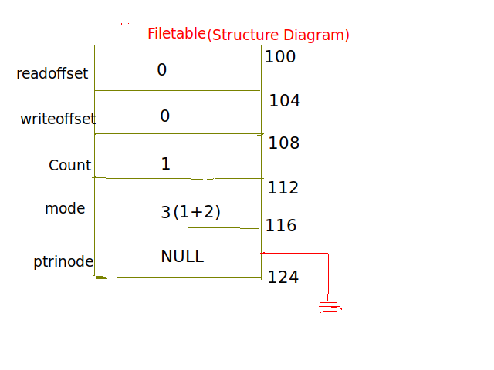
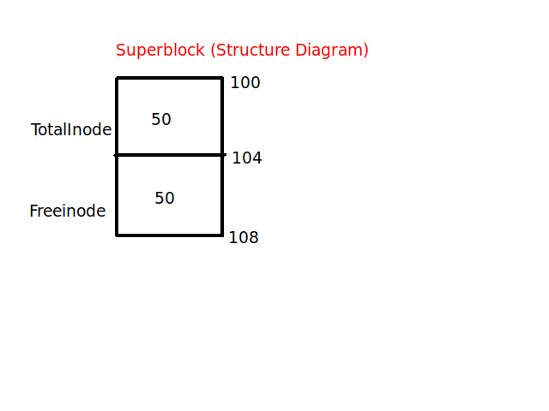

Actual Project Diagram :-
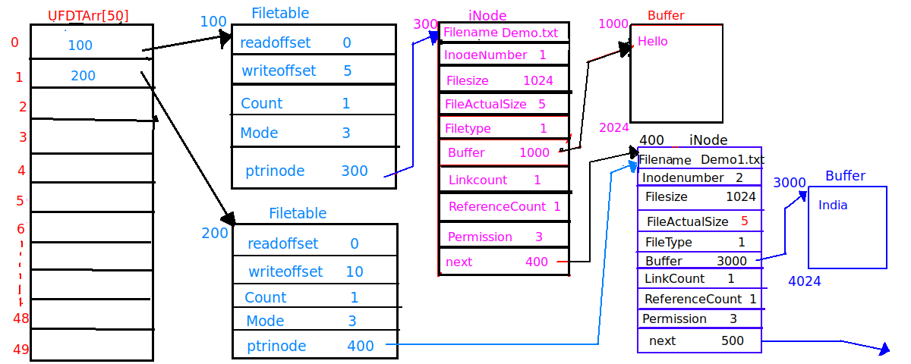
Flow Of The Project :-

In these project first I write entry point function i.e. main function so that our compiler finds these main function after that control goes in the main function. In main function I decalre some local variables so that we can use some values by using these local variables i.e. str is variable of type character array , iRet is variable of type integer and so on.
Now, I call the InitalizeSuperBlock function so that this function can create node in our Ram, so that we can create one of the file
and each file has one separate node. Now, I write infinite loop and each time accept on string and tokanize that string with one white space by using sscanf function, which are used to tokanized the string and we count the words on that string. By rule of liux commands every command has maximum three or four words. So,we count that words and by using ladder else if condition we can call appropriate function means each if condition I call a particular function.
That set , this is the small overview of flow of a project.

Functions Used In The Project :-

1] Name of the function : InitaliseSuperBlock
Input parameters : Nothing
return value : void
Description of the function : No
Use : It is used to initalise super block i.e. store the information about
blocks and inodes .

2] Name of the function : CreateDILB
Input parameters : Nothing
return value : void
Description of the function : No
Use : It is used to create Disk iNode List Block in that block all inode object are present

3] Name of the function : Get_Inode
Input parameters : character pointer
return value : structure Inode pointer
Description of the function : No
Use : It gives a remaining one of the node on hard disk to our file
4] Name of the function : CreateFile
Input parameters : character pointer and Integer
return value : Integer
Description of the function : No
Use : It is used to create one of the new File(Directory)

5] Name of the function : OpenFile
Input parameters : character pointer and One Integer
return value : Integer
Description of the function : No
Use : It is used to open the file which are created by user.

6] Name of the function : WriteFile
Input parameters : character pointer and Two Integers
return value : Integer
Description of the function : No
Use : It's used write the contents to file.

7] Name of the function : ReadFile
Input parameters : character pointer and two Integers
return value : Integer
Description of the function : No
Use : Read the contents of file which are which are created by user.

8] Name of the function : man
Input parameters : character pointer
return value : void
Description of the function : No
Use :

9] Name of the function : DisplayHelp
Input parameters : Nothing
return value : void
Description of the function : No
Use : It Displays(help) the information of used commands.

10] Name of the function : GetFDFromName
Input parameters : character pointer
return value : Integer
Description of the function : No
Use :

11] Name of the function : rm_file
Input parameters : character pointer
return value : Integer
Description of the function : No
Use : These function is used to delete the file.

12] Name of the function : CloseFileByName
Input parameters : One Integer
return value : Void
Description of the function : No
Use : Used to Close the opened file by File Descriptor.

13] Name of the function : CloseFileByName
Input parameters : One character pointer
return value : Integer
Description of the function : No
Use : Used to Close the opened file by
File Name

14] Name of the function : CloseAllFile
Input parameters : No
return value : Void
Description of the function : No
Use : Used to Close the all opened files

15] Name of the function : LseekFile
Input parameters : Three Integers
return value : Integer
Description of the function : No
Use : used to shift the offset according to the user.

16] Name of the function : ls_file
Input parameters : Nothing
return value : Void
Description of the function : No
Use : Used to Display the information. eg.File size,Inode number,etc..
17] Name of the function : fstat_file
Input parameters : One Integer
return value : Integer
Description of the function : No
Use : Used to Display the information of File according to file Descriptor .

18] Name of the function : stat_file
Input parameters : One character Pointer
return value : Integer
Description of the function : No
Use : Used to Display the information of File according to file Name .

19] Name of the function : truncate_file
Input parameters : One Integer Pointer
return value : Integer
Description of the function : No
Use : Used to Display the information of File according to file Descriptor.

