Setting up UDP blocks in both Simulink and RTMaps to enable data transfer between software programs
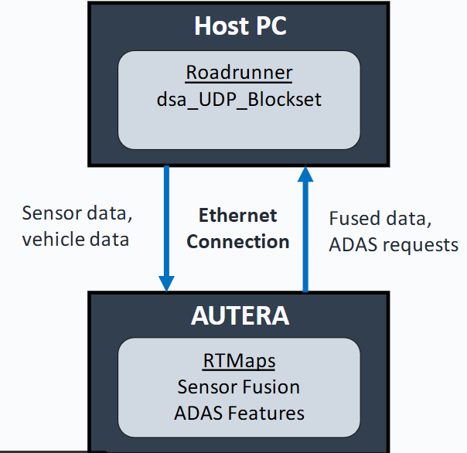
- Cosimulation between Simulink and RTMaps is possible if sending information using UDP blocks in both programs
- C:\Program Files\Intempora\RTMaps 4\tools\simulink\RTMaps_Simulink_dSPACE_cosimulation
  - This path contains the Simulink and RTMaps blocks and an example model for setting up the UDP connection between the two programs
- In RTMaps we use the ‘UDPSocket 2.5.6’ block
- Path for the python bridge documentation in RTMaps install folder
  - C:\Program Files\Intempora\RTMaps 4\packages\rtmaps_python_bridge\doc
- Path to Simulink RTMaps TLC documentation in RTMaps install folder
  - C:\Program Files\Intempora\RTMaps 4\tools\simulink\rtmaps_tlc_target\doc

