1. INTRODUCTION

The Flight Operations Hub is designed to be an all-in-one airline management system that automates and manages essential tasks such as ticket booking, flight scheduling, passenger data handling, and cancellations. With the growing demand in air travel, manual systems are no longer efficient. Airlines need a robust and scalable solution to handle multiple user operations concurrently, minimize delays, and enhance customer satisfaction. By implementing a Java-based application backed by an SQL database, this system provides a real-time platform for both users and administrators to interact with airline services efficiently.
  - 1.1 Objective
- To develop a centralized platform for managing airline operations efficiently.
- To automate flight bookings and cancellations, reducing manual intervention.
- To enable real-time flight scheduling and updates for both passengers and admins.
- To maintain a secure and reliable SQL database for storing sensitive information.
- To provide role-based access for users and administrators.
- To enhance user experience with a clean, easy-to-use interface.
- To reduce operational costs by replacing paper-based or legacy systems.
- To ensure data accuracy and consistency across all modules.
- To lay the foundation for future integration with payment gateways and mobile apps.
1.2 Scope of the project

- User Registration and Authentication: Secure login system for passengers and airline staff.
- Flight Management: Admins can schedule, update, and cancel flights.
- Ticket Booking System: Passengers can search for flights, check availability, and book tickets.
- Payment Integration: Secure payment processing via credit/debit cards, UPI, and online banking.
- Boarding Pass Generation: Automated boarding pass generation for passengers.
- Cancellation and Refund System: Manage ticket cancellations and process refunds.
- Admin Dashboard: Airline staff can monitor bookings, manage flights, and generate reports.
- Notification System: Sends email/SMS alerts for flight updates, cancellations, and booking confirmations.
- Reports and Analytics: Generates detailed reports on flight occupancy and revenue.

2. Literature Survey

- 2.1 Overview of existing work
Existing systems like Amadeus, Sabre, and Galileo provide full-fledged airline booking and scheduling services but are generally commercial, expensive, and overly complex for small-to-medium scale implementations or academic projects.
- 2.2 Project or product reviewed
- Real-time data synchronization
- Admin-user separation
- Modular structure for upgrades
Commercial portals like Indigo, SpiceJet, MakeMyTrip are feature-rich but not open for development or customization.

- 2.3 Identification of gaps
- Lack of modularity and scalability in open-source systems
- Poor UI/UX for admin-side operations
- Absence of role-based access control
- Insufficient data security in free or low-cost systems

3. System Analysis

- 3.1 Requirement Specification

Functional Requirements:
- User registration/login
- Flight search by source, destination, and date
- Ticket booking and cancellation
- Flight scheduling (Admin)
- Ticket and flight status viewing

Non-Functional Requirements:
- System reliability and performance under load
- Data security and integrity
- User-friendly interface
- Scalability for large number of users

- 3.2 Tools and Technologies
Hardware Resources:
Intel Pentium Higher Version
Ram: 8GB
Disk Space: 1GB

Software Resources:

Programming Language: Java
Database: SQL (MySQL)
IDE: Eclipse
Connectivity: JDBC (Java Database Connectivity)

- 3.3 Feasibility Study
Technical Feasibility
- Evaluates the existing hardware, software, and system infrastructure to determine if they can support the new system.
- Checks whether the current system has enough capacity to accommodate additional applications or requires hardware upgrades.
- Considers financial constraints and technical enhancements needed to support the project.
- Assesses whether the project is feasible within the given technical and financial limits
Operational Feasibility
- Assesses if the system can meet the organization's operational requirements after development and installation.
- Tests if the system will function effectively when deployed.
- Identifies potential barriers to implementation, such as:
  - Resistance to change.
  - Training requirements
  - Compatibility with existing processes.

Economic Feasibility
- Increased customer satisfaction.
- Improved accuracy of operations.
- Better documentation and record-keeping.
- Faster retrieval of information.

4. Design

- 4.1 System architecture
Block Diagram:
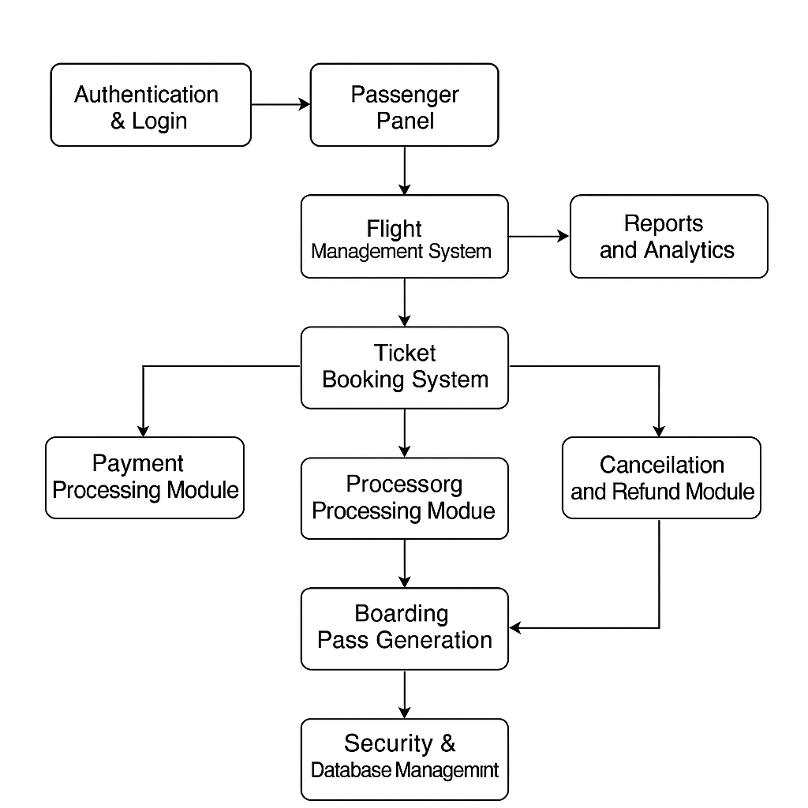
Sequence Diagram:
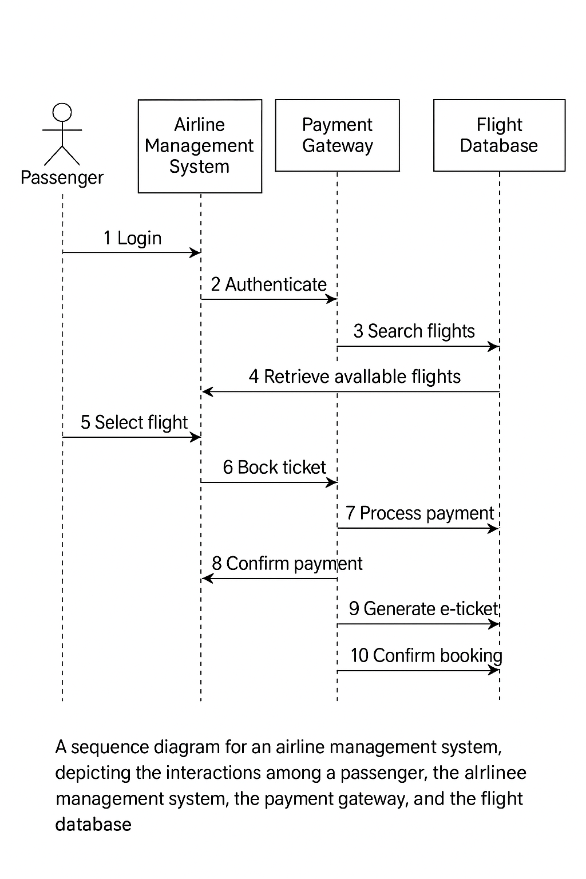
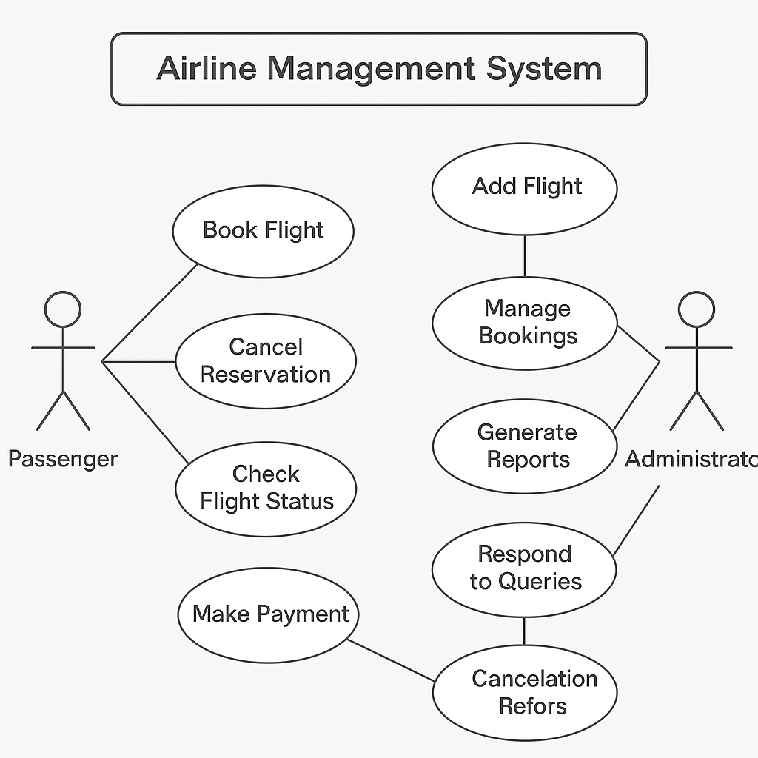
Use Case:

Activity Diagram:
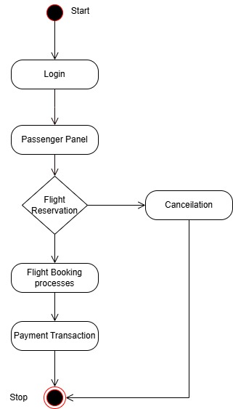

Class Diagram:

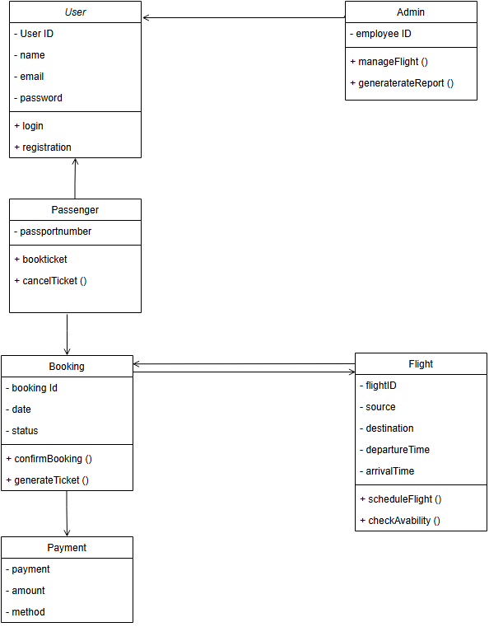

5. Implementation
- 5.1 Description of Modules
- User Module:
Register, login, book tickets, view tickets, cancel bookings.
- Admin Module:
Add/update/delete flights, manage users, view reports.
- Flight Management Module:
Schedule flights, view status, handle delays or cancellations.
- Booking Module:
Search flights, confirm availability, generate ticket details.
- Database Module:
Manages data for users, bookings, payments, and flight details.
- Security Module:
Role-based access control, secure login, and session management.

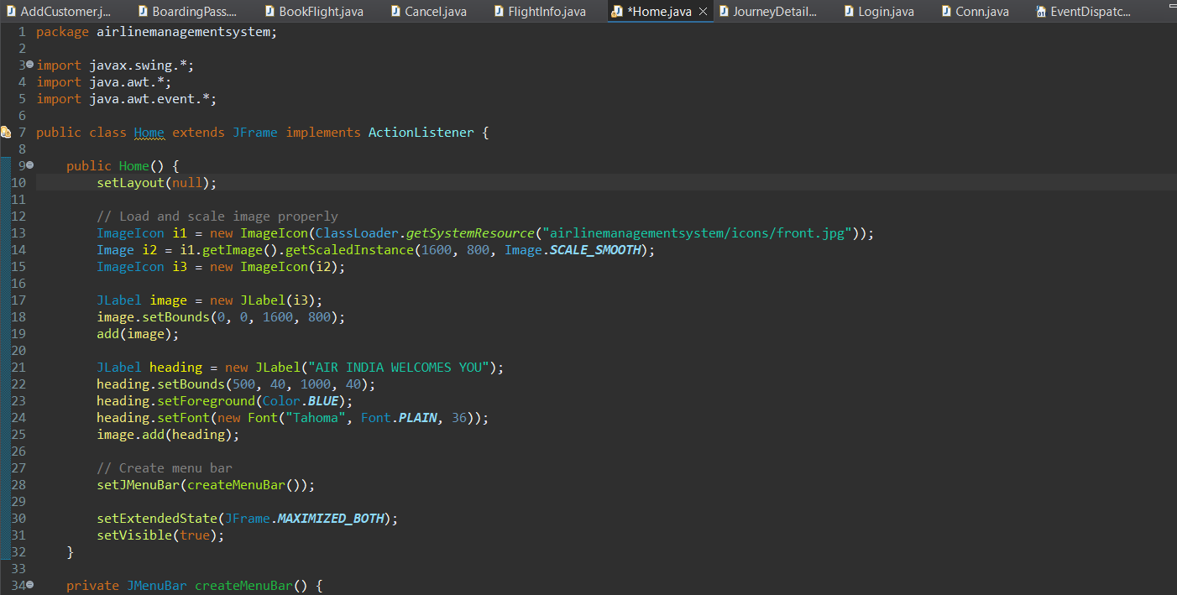
- 5.2 Code Snippets

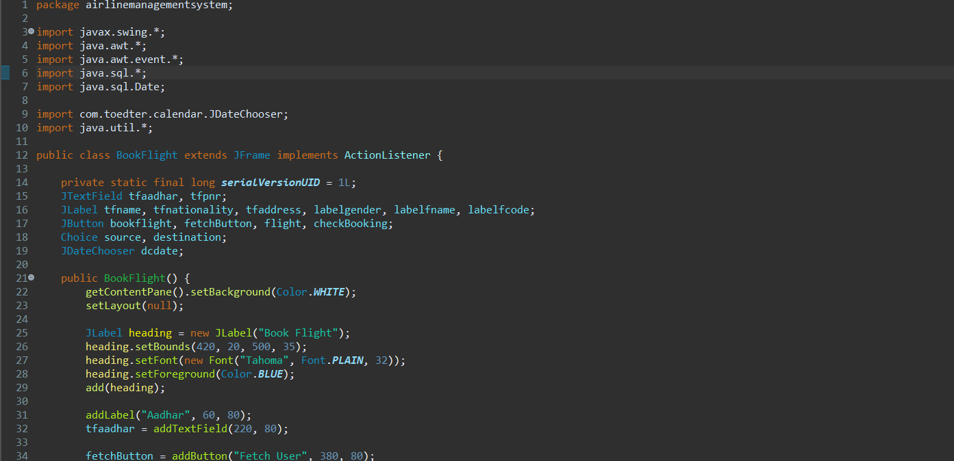

Database:

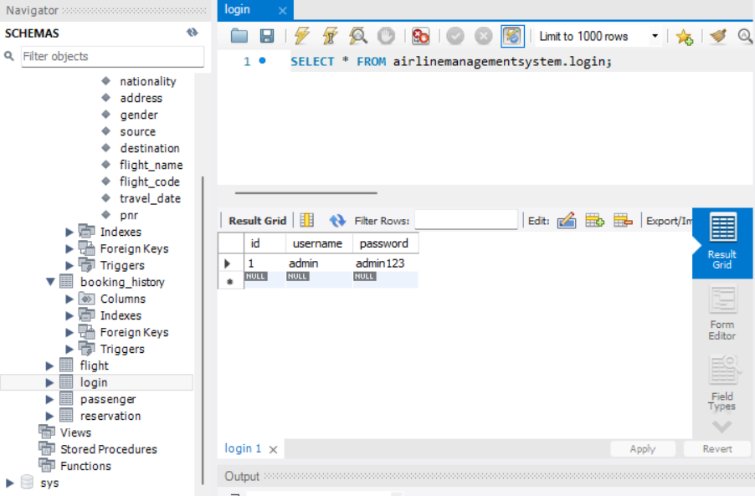

6. Testing
- 6.1 Test Case and Test Methodology

1. User Authentication Test
- Tests whether users can securely log in or register using correct credentials.
- Ensures error messages appear for incorrect login attempts.
- Validates role-based access for admins and passengers.
2. Flight Slot Availability Test
- Checks if flights are shown based on source, destination, and date inputs.
- Displays relevant flights or a “No Flights Found” message accordingly.
- Ensures search logic and database query results are accurate.
3. Booking and Cancellation Test
- Verifies the complete flow of flight booking and ticket generation.
- Ensures passengers can cancel tickets and get status updates.
- Confirms ticket availability updates after each operation.
4. Admin Dashboard Test
- Tests admin functionalities like adding, editing, or deleting flight details.
- Ensures admin can view reports, users, and system metrics.
- Validates restricted access only for admin users.
5. Load and Performance Test
- Simulates multiple users accessing the system simultaneously.
- Measures system responsiveness and checks for crashes or lags.
- Ensures the application remains stable under high traffic.
6. Security and Data Privacy Test
- Validates protection against SQL injection and unauthorized access.
- Checks if passwords are encrypted and data is stored securely.
- Ensures only authorized users access sensitive admin features.

Test Case ID | Test Case | Procedure / Input Data | Expected Output | Actual Output | Test Status
TC_01 | User Login | User info (Username, Password) | Logging in successfully | Logged in successfully | Pass
TC_02 | Flight Search | Source: Delhi, Destination: Mumbai, Date: 2025-04-10 | Display flights matching criteria | Flights displayed correctly | Pass
TC_03 | Ticket Booking | Select flight, enter passenger details, confirm booking | Ticket booked and stored in system | Ticket booked and ID generated | Pass
TC_04 | Ticket Cancellation | Select ticket from "My Bookings", click "Cancel" | Ticket canceled, seat count updated | Cancellation successful | Pass
TC_05 | Admin Add Flight | Admin enters flight number, route, timing, seats info | Flight added to database and visible in listings | Flight added and listed successfully | Pass
TC_06 | Unauthorized Access Check | Attempt to access admin panel with user login | Access Denied message displayed | Access Denied | Pass
TC_07 | Flight Update (Admin) | Admin edits flight time or capacity | Changes reflected in database and user view | Flight updated successfully | Pass
TC_08 | Load Test | 100 users login and book tickets simultaneously | System handles load with no crash or significant delay | System responsive | Pass
TC_09 | Data Privacy | Check if passwords are stored encrypted in the database | Passwords are encrypted | Encrypted values stored | Pass
TC_10 | Invalid Login | Enter incorrect username/password | Show error: "Invalid credentials" | Error shown correctly | Pass

7. Results and Discussion

- 7.1 Outcomes of the project

- Login Page:

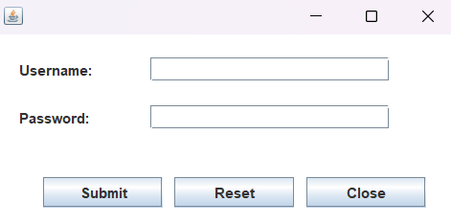

- Home Page:


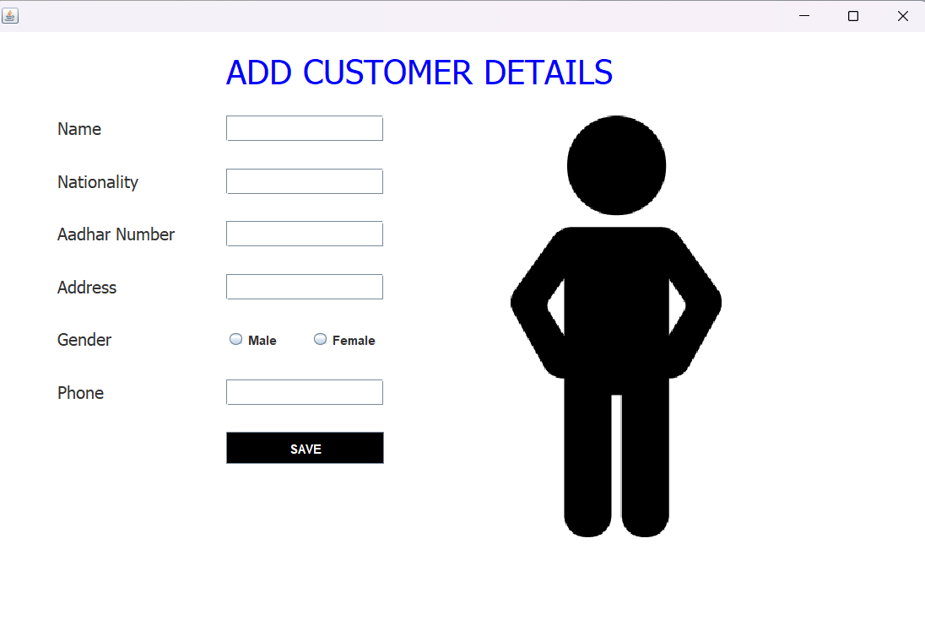
- User Data Page:
- Fetching User Data for Flight Booking:
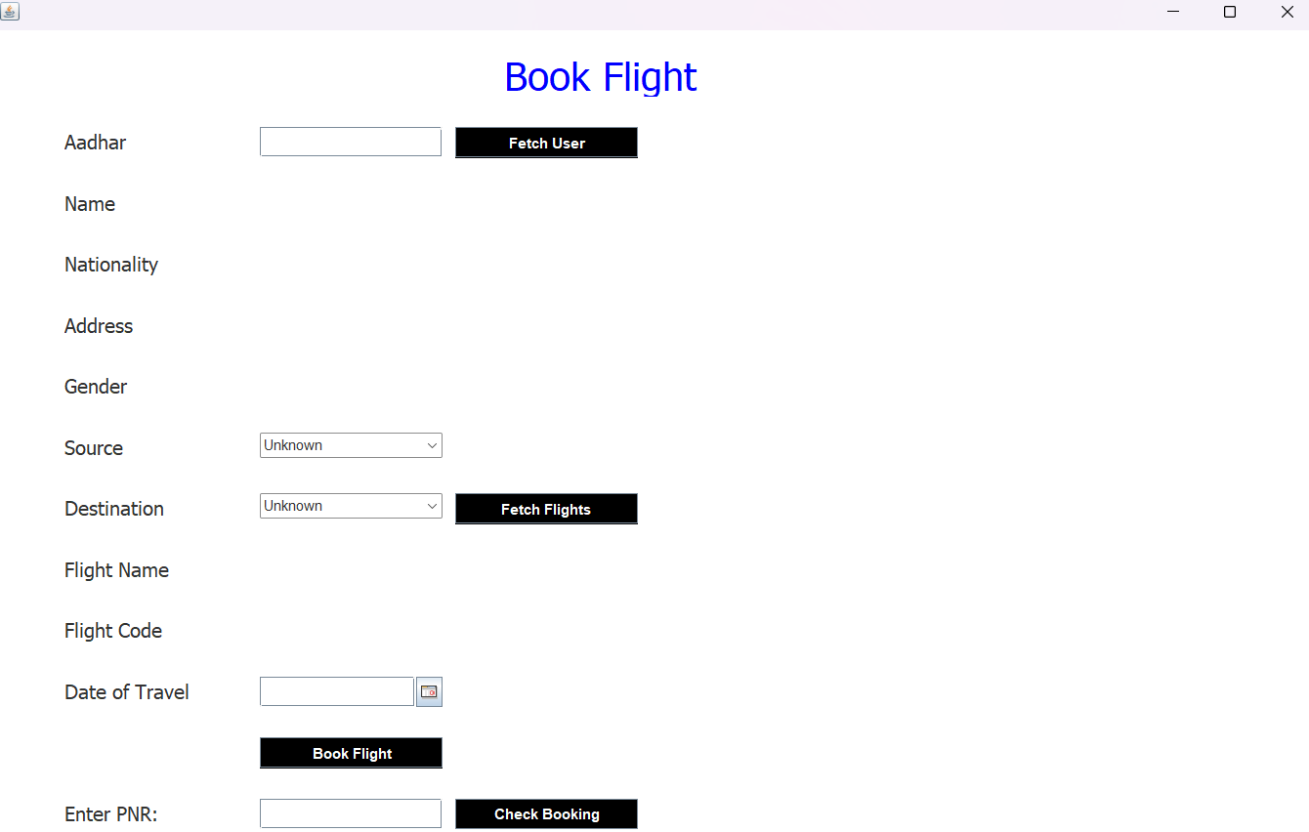

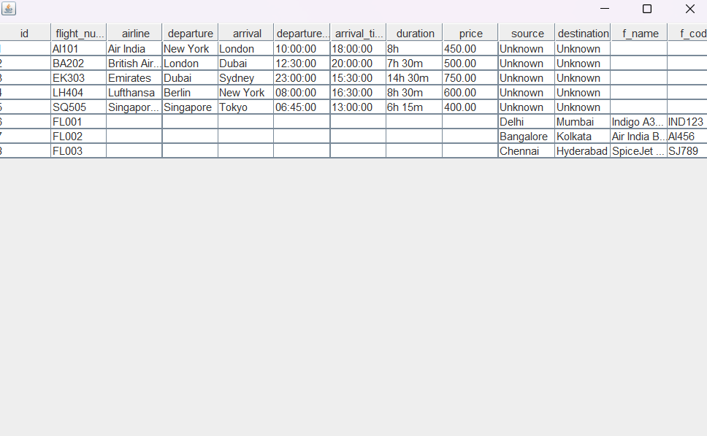
- Flight Details:

- PNR Checking UI:

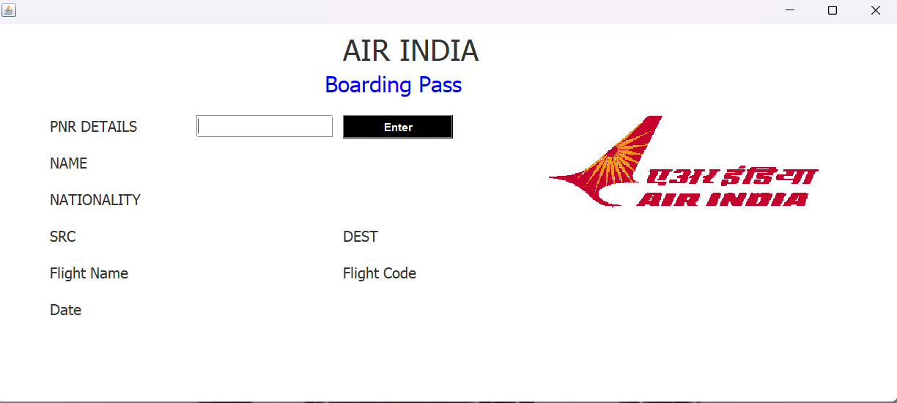

- 7.2 Challenges Faced
- Designing a clean and intuitive UI that works for both users and admins.
- Ensuring proper database connectivity and query performance with SQL.
- Handling real-time updates without data conflict or redundancy.
- Implementing role-based authentication securely.
- Managing data integrity during booking and cancellation processes.
- Testing under simulated high user load to ensure performance stability.
- Debugging and resolving logical errors in modules during integration.

8. Conclusion and Future Scope
- 8.1 Summary of the work
The Flight Operations Hub was developed as a Java-based application with SQL database support to manage airline operations like ticket booking, flight scheduling, and passenger management.
The system was designed with modules for users and administrators, featuring real-time updates, secure authentication, and a user-friendly interface.
Through systematic development and testing, the application meets its core objectives of improving efficiency, accuracy, and ease of operation in airline management.
- 8.2 Limitations
- No payment gateway integration for real-time transactions.
- Limited to desktop usage; lacks a mobile-friendly version or mobile app.
- No SMS/email notification system for ticket confirmations or updates.
- Flight delay prediction or weather-based scheduling is not implemented.
- Basic reporting; lacks advanced analytics or graphical dashboards.

- 8.3 Future Enhancements
- Integration with secure online payment systems.
- Development of a mobile app version for Android/iOS users.
- Implementation of SMS/email notifications for bookings and updates.
- Adding AI features like flight delay prediction or passenger preference tracking.
- Real-time seat selection, dynamic pricing, and multi-language support.
- Improved reporting with charts, analytics, and export features.

9. References
- 9.1 Website:
https://www.goindigo.in/
https://www.emirates.com/in/english/destinations/flights-to-united-arab-emirates/
https://www.airindia.com/en-in/book-flights/

- 9.2 Research Paper:
https://www.researchgate.net/publication/374391896_Airline_Reservation_System

