***BEEE LAB EVALUATION***

**Q. Design an automatic night lighting system such as the system is only activated when the master control switch is pressed. a) Below 50% value of full brightness led blinks with a freq. of 500 msec. b) Above 50% value of full brightness led blinks with a freq. of 100 msec.**

**Circuit Diagram**

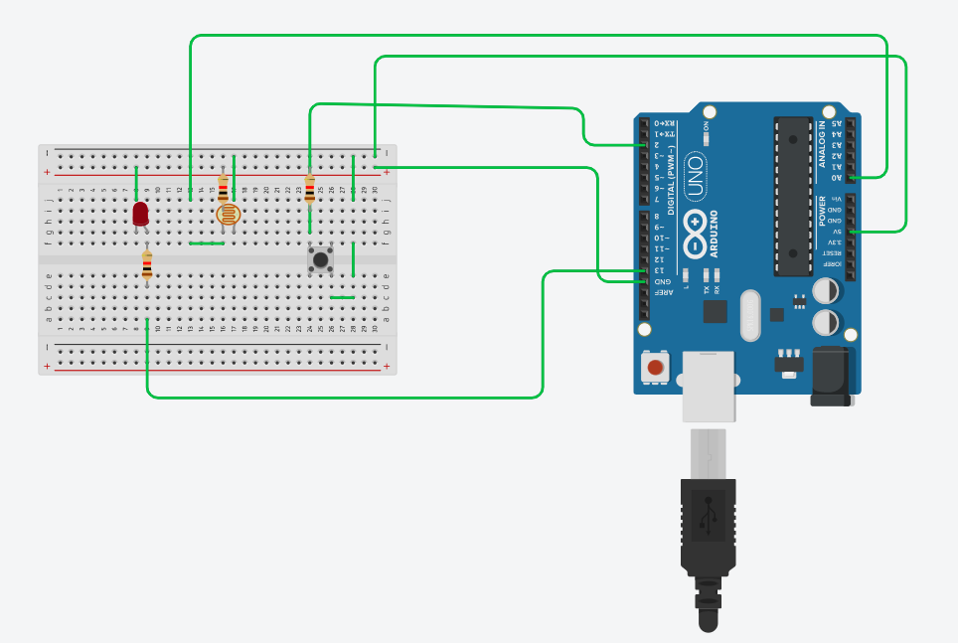

***THEORY***

***Concept Used :-***

In this Question given for the BEEE Evaluation, the concepts used are the perfect blend of LDR and the use of Master control switch.

Basic Concepts used were like use of making Electric connection and basic understanding of them.

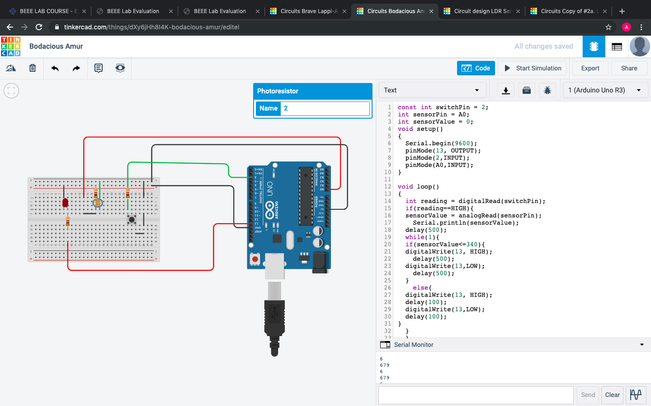

One of the most important concepts was how does the LDR(light dependent resistor) varies the power w.r.t the light incident upon it.

Using the Arduino and making connections to it to execute the program. And other concepts of Electric circuit and button.

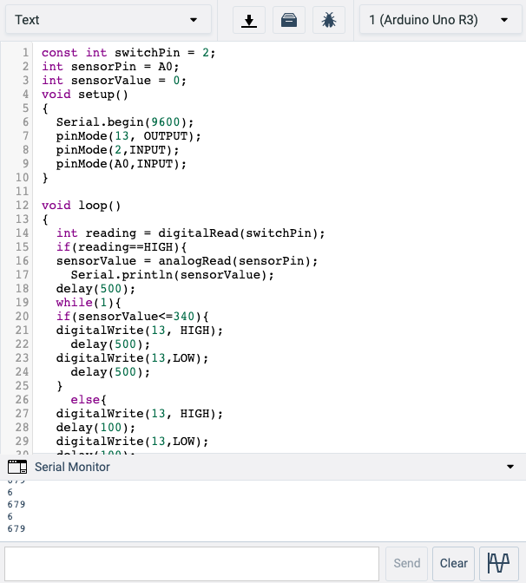

The the Max reading in Serial Monitor show 679(when in Light) and the lowest reading is 6(when in Dark), so the %50 would be approx. 340, and hence condition is “sensorValue<=340”.

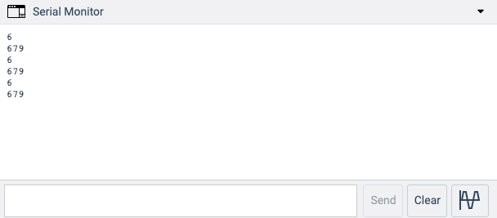

***Learning & Observations:-***

1. Basic Concepts of Electric Circuits.
2. Understanding of how button Works.
3. Most of all working of LDR, and how does the functions varies.
4. All basic connections need to be grounded.
5. Working of Arduino.
6. Programing of Arduino.
7. Use of digitalRead, and other functions.

***Problems & Troubleshooting***

No problems occurred during the execution of the provided task.

const int switchPin = 2;

int sensorPin = A0;

int sensorValue = 0;

void setup()

{

Serial.begin(9600);

pinMode(13, OUTPUT);

pinMode(2,INPUT);

pinMode(A0,INPUT);

}

void loop()

{

int reading = digitalRead(switchPin);

if(reading==HIGH){

sensorValue = analogRead(sensorPin);

Serial.println(sensorValue);

delay(500);

while(1){

if(sensorValue<=340){

digitalWrite(13, HIGH);

delay(500);

digitalWrite(13,LOW);

delay(500);

}

else{

digitalWrite(13, HIGH);

delay(100);

digitalWrite(13,LOW);

delay(100);

}

}

}

}

***Precautions***

1. Use of Safety measures.
2. Using a multimeter to test whether the appliances used are in right condition.
3. Making correct Electric circuit and connections
4. Selection the correct port for the Arduino.
5. Making tight connections.

***Learning & Outcomes***

In this task I learned the basic working of LDR and how does the resistance varies with amount of light incidents on the LDR.

I learned how the the Arduino works, and also the coding that is needed to be done to execute the task. And also the use of basic instruments.

Thank You!

-Name :- Abhi Kulshrestha

-UID :- 19BCS6023

-AIML-1, GROUP - A