**Abhimanyu Kumawat // CS 288-02**

**Homework #06**

*Q. You are at the beach with two empty, unmarked plastic buckets. One bucket is red and the other is green. The red bucket holds a maximum of four pounds of sand, and the green a maximum of three pounds. How can we get exactly 2 pounds of sand in the red bucket?*

**1. Define the problem as state space search (initial state, goal states, and operators).**

->Initial State: (0,0)

->Goal States: (2,3) / (2,0) / (2,1) / (2,2)

-> 6 Operators: Fill Bucket Red, Fill Bucket Green, Empty Bucket Red, Empty Bucket Green, Transfer Bucket Green, Transfer bucket Red.

**2. Draw the complete state space. You must explicitly declare the size of the state space (total number of states and total number of arcs).**

->Graph:

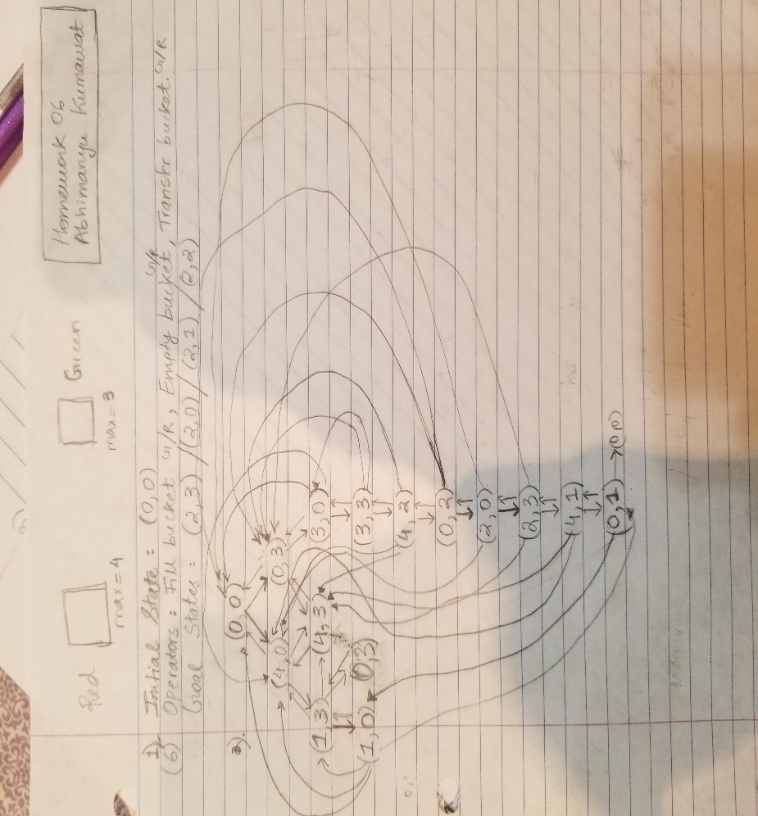

***14 States in total!***

***Do not include the extra (0, 3) - the right child of (1,3)* It’s for creating right # of arcs and completing the graph.***

->Matrix:

|  |  |  |  |  |  |  |  |  |  |  |  |  |  |  |  |
| --- | --- | --- | --- | --- | --- | --- | --- | --- | --- | --- | --- | --- | --- | --- | --- |
|  | **(0,0)** | **(4,0)** | **(0,3)** | **(1,3)** | **(1,0)** | **(4,3)** |  | **(3,0)** | **(3,3)** | **(4,2)** | **(0,2)** | **(2,0)** | **(2,3)** | **(4,1)** | **(0,1)** |
| **(0,0)** |  | **X** | **X** |  |  |  |  |  |  |  |  |  |  |  |  |
| **(4,0)** | **X** |  |  | **X** |  | **X** |  |  |  |  |  |  |  |  |  |
| **(0,3)** | **X** |  |  | **X** |  | **X** |  | **X** |  |  |  |  |  |  |  |
| **(1,3)** |  | **X** | **X** |  | **X** | **X** |  |  |  |  |  |  |  |  |  |
| **(1,0)** | **X** | **X** |  | **X** |  |  |  |  |  |  |  |  |  |  | **X** |
| **(4,3)** |  | **X** | **X** |  |  |  |  |  |  |  |  |  |  |  |  |
| **(3,0)** | **X** | **X** | **X** |  |  |  |  |  | **X** |  |  |  |  |  |  |
| **(3,3)** |  |  | **X** |  |  |  |  | **X** |  | **X** |  |  |  |  |  |
| **(4,2)** |  | **X** | **X** |  |  | **X** |  |  | **X** |  | **X** |  |  |  |  |
| **(0,2)** | **X** |  | **X** |  |  |  |  |  |  | **X** |  | **X** |  |  |  |
| **(2,0)** | **X** | **X** |  |  |  |  |  |  |  |  | **X** |  | **X** |  |  |
| **(2,3)** |  |  | **X** |  |  | **X** |  |  |  |  |  | **X** |  | **X** |  |
| **(4,1)** |  | **X** |  |  |  | **X** |  |  |  |  |  |  | **X** |  | **X** |
| **(0,1)** | **X** |  |  |  | **X** |  |  |  |  |  |  |  |  | **X** |  |

***(Number of arcs) – 50 \****

**3. Find all solutions having the shortest sequence of operators.**

*Two possible solutions as listed: (Note: arrows are not arcs here, it’s just for demonstrating the states followed to the solution buckets)*

1. (0,0) -> (0,3) -> (3,0) -> (3,3) -> (4,2) -> (0,2) -> (2,0)

2. (0,0) -> (4,0) -> (1,3) -> (1,0) -> (0,1) -> (4,1) -> (2,3)

**4. What is the shortest sequence of operators required to reach the goal state where both buckets have 2 pounds of sand each?**

It is not possible to have (2,2) i.e. both buckets having 2 pounds of sand each. Refer to the graph or matrix created.