Genrl Downloader: System Design
Oct 12, 2026 · @Senpai

Goals and design principles
Genrl Downloader is a Linux desktop app (Flutter UI, Rust core) that reads your MAL list, finds the right torrent on Nyaa for each missing episode, downloads it through qBittorrent, and files it with a synopsis and a folder icon. The hard part is not downloading; it is picking the right thing and never getting stuck, banned or confused.
Six rules the whole design follows:
- Never guess silently. When the title match or the torrent choice is uncertain, the app queues a question for you instead of downloading something wrong.
- Every external call is budgeted. MAL, Jikan, Nyaa and qBittorrent each get a rate limiter, a cache and a backoff, so the app cannot get you banned.
- Everything survives a crash. All state is in SQLite; on restart the app resumes from the last known state and re-checks qBittorrent rather than trusting memory.
- One source of truth per fact. The MAL id is the identity of a show. Names, synonyms and folders all hang off it.
- Automation is optional and visible. Every automatic action appears in the activity log, and one switch pauses everything.
- Degrade, don't die. If MAL, Jikan or Nyaa is down, the app keeps using its cache, keeps already-running downloads going, and shows what is stale.

System architecture
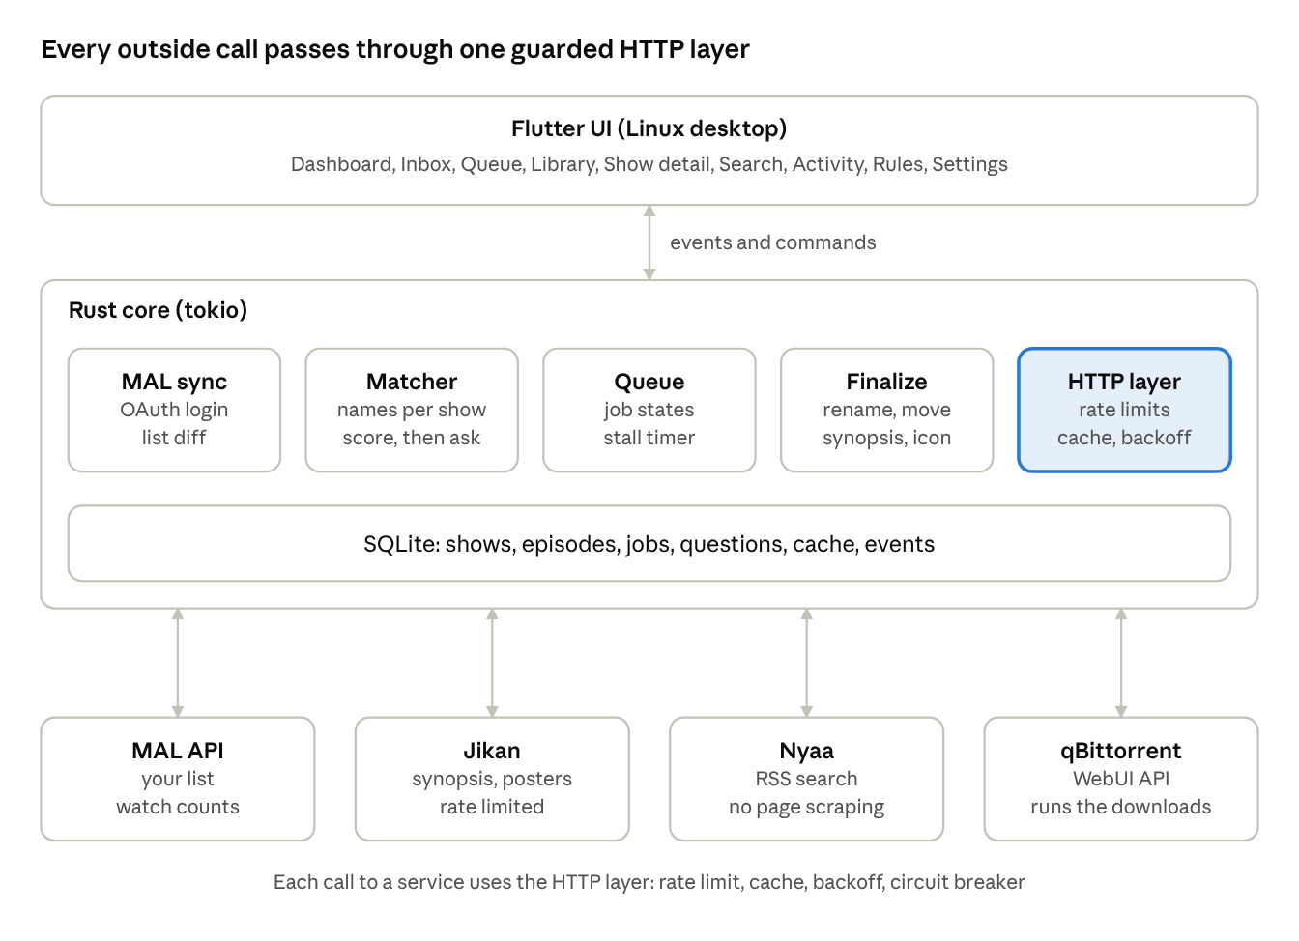
architecture · UI, Rust core, 4 services
The UI never touches the network or the disk. It sends commands to the Rust core and receives progress events. The core owns the database and every call to MAL, Jikan, Nyaa and qBittorrent, which also lets it keep working from the system tray while the window is closed.

Title matching engine
The app resolves every show to a MAL id first, then searches Nyaa with names that belong to that id. Nyaa uploaders use romaji, English, abbreviations or typos, so one title is never enough. "Your Name" and "Kimi no Na wa" are the same movie; "Kimi no Todoke" is a different show that a loose search will also return.
Step 1: build a name set per show. From MAL and Jikan collect the main title, English title, Japanese title and all synonyms. Normalize each: lowercase, strip punctuation and season words, convert full-width characters, and expand known abbreviations (for example "Kimi no Na wa." becomes "kimi no na wa"). Store the set in show_names. Let you add manual aliases.
Step 2: search every name, not one. Query Nyaa RSS once per name in priority order (romaji first, since most fansubs use it), stopping as soon as a name returns enough good candidates. This keeps request count low.
Step 3: score each result against the show.
Signal | Effect
Parsed title matches a name in the set (fuzzy ratio 0.92 or higher) | +50
Parsed title matches only a name belonging to a different MAL entry | reject
Episode number matches the one wanted | +30
Type matches (TV episode vs movie vs OVA) | +10, mismatch rejects
Season or part number conflicts with the show | reject
Year in the release name differs from the MAL start year by more than 1 | -20
Release is a batch and the show is fully aired | +15
Step 4: decide.
- Best score 80 or higher and at least 15 points ahead of the runner-up: proceed automatically.
- Otherwise: pause the job as needs_input and show a Match Review card with the top candidates, their posters and why each scored as it did. The user picks one, or says "none of these". The choice is saved as a permanent alias so the same confusion never asks twice.
Known traps the engine must handle
- Sequels sharing a prefix ("Kimi no Na wa" vs "Kimi no Todoke", "Re:Zero" vs "Re:Creators").
- Absolute vs per-season numbering: episode 27 of a long show is episode 3 of season 2. Store an episode_offset per show; the matcher tries both numbers.
- Movies listed with episode 1 of 1, and OVAs with decimals such as 6.5.
- Same title, different years (remakes). The MAL start year breaks the tie.
- Release names with group tags, CRC hashes and resolutions, which the filename parser strips before scoring.
Season and watch-status rules (decided from your MAL list)
The MAL id is the identity of a show, and each season is its own MAL entry. The app decides what to download from your MAL status and episodes watched, never from the release name alone. A pure decision function takes the season chain, the parsed release and the wanted episode, and returns one of: download, skip (with a reason), ask (queue a question), or not found.
- Status decides. Completed means skip the whole entry. Watching with N episodes watched means download from episode N+1; episodes you have already watched are never downloaded. A missing watched count is treated as 0 and shown in the first-sync preview.
- Fully watched. Watching with watched equal to the entry's total episodes is skipped as "fully watched", never an error, and the app suggests marking it Completed.
- Manual statuses. Plan to watch is manual by default; it downloads only with the auto_plan_to_watch setting or a per-show override. On hold, dropped and not on your list are always skipped.
- Next season. The season chain is built from MAL sequel and prequel relations, ordered. If season 1 is Completed and season 2 is Watching or Plan to watch (with the override), the next download is season 2. The walk stops at the first entry that is not Completed.
- Season markers. The parser reads S2, S02E05, "Season 2", "2nd Season", "3rd Season" and a trailing II or III. "Part 2" is a cour, not a season, and is kept as a separate field. The parser returns the season as optional, so "no season marker" is its own case.
- No marker and absolute numbering. With no marker, use the first Watching entry. If the episode number is higher than that entry's episode count, treat it as absolute and subtract the cumulative counts of earlier entries (episode 17 when season 1 has 12 episodes becomes season 2, episode 5). If it still does not fit, ask.
- Never substitute. If the requested season has no release on Nyaa, the result is not found, shown as such in the activity log. The app never substitutes another season. An episode beyond the entry's count also asks.
- Visible. Every skip, ask and not-found result is written to the activity log with its reason, and every ask creates an Inbox question object.

Torrent selection and seed health
Once the right show is matched, the app ranks the torrents and checks whether they are healthy enough to download. The numbers below are defaults you can change in Settings.
Hard filters (a result failing any of these is dropped)
- Wrong episode, wrong show, or wrong type (see matching).
- Resolution below your minimum, or a codec you excluded.
- Size outside the sane range for the episode length (for example under 100 MB or over 4 GB for a 24-minute episode), which catches fakes and mislabeled batches.
- Seeders at 0.
- Uploader on your blocklist.
Ranking among what remains
Factor | Default weight
Fansub group in your priority list | highest
Resolution matches your preference (1080p) | high
Seeders, using log scale so 500 vs 50 matters less than 5 vs 0 | medium
Trusted or remake flag from Nyaa | medium
Dual audio or subtitle language you asked for | medium
Newer upload (fixes and v2 releases) | low
Seed health check and the question flow
- Read seeders and leechers from the RSS result. They are a few minutes old, which is fine for a decision.
- Healthy (10 or more seeders): download automatically.
- Thin (1 to 9 seeders): if the show is on your auto list, download but flag it. If it is a manual add, ask: "Only 4 seeders. Download anyway, wait for a better release, or pick another?"
- Dead (0 seeders): never download. Offer alternatives (other groups, other resolution, batch instead of single) and the option to retry later.
- Stalled after adding: if qBittorrent shows no progress for 20 minutes, mark the torrent stalled, remove it, and try the next candidate. After three failed candidates ask the user.
Questions the app asks, and when
Situation | Question | Choices
Match score unclear | Which of these is the show? | candidate cards, none of these
Few seeders | Download anyway? | download, wait 24 h, pick another
Episode already exists on disk | Replace it with this version? | keep, replace, keep both
Only a batch is available | Download the whole batch? | batch, wait for singles
Disk space low | Free space is under the limit | pause, change folder
All candidates failed | What next? | retry later, manual search, skip episode
Questions never block other jobs. Each one sits in the Inbox page until answered, and the rest of the queue keeps moving. Unanswered questions expire after a configurable time and return the episode to missing.

Limit-proofing
Every outside service is wrapped in one shared client layer with a token-bucket limiter, a response cache, retry with backoff, and a circuit breaker. No module talks to the network directly.
Service | Risk | Protection
MAL API | Rate limits; token expiry; list changes while syncing | Sync at most every 30 minutes, ETag or last-updated checks, refresh the OAuth token 5 minutes before expiry, store the refresh token in the system keyring
Jikan (synopsis, posters) | About 3 requests per second and 60 per minute; occasional 429 or 5xx | Limiter at 2 per second, cache every show for 7 days, fetch only when a show first completes an episode, honor Retry-After
Nyaa RSS | Throttling or temporary bans if hammered; site outages; mirrors | One request per 2 seconds globally, cache each query for 10 minutes, jitter, a configurable base URL with a mirror fallback list, never scrape HTML pages
qBittorrent WebUI | Not running; wrong password; session cookie expiry; version differences | Health check on launch, auto re-login on a 403, start qbittorrent-nox if allowed, clear setup instructions if WebUI is disabled
Poster and image hosts | Slow or missing images | Download once, store locally, use a placeholder icon on failure
Backoff rule. Retry after 5 s, 30 s, 2 min, 10 min, 1 hour, each with random jitter. A 429 with Retry-After uses that value instead. After five failures the circuit breaker opens for that service for 15 minutes; jobs needing it wait in blocked instead of failing.
Queue-level limits.
- Search jobs run at most 2 at a time, since they share the Nyaa budget.
- Active downloads are capped by a setting (default 2) so bandwidth and disk are not swamped.
- A daily cap on new torrents added (default 30) stops a bad sync from queuing hundreds of episodes at once. Hitting the cap raises one Inbox notice.
- A first sync of a large MAL list shows a preview ("This will queue 214 episodes") and needs one confirmation.
Local resource limits.
- Check free disk space before adding each torrent; pause the queue below the configured floor.
- Cap the log database and the cache by size, pruning oldest first.
- Keep the UI responsive by running all work in the Rust core and sending only progress events to Flutter.
Offline behavior. With no internet, the app shows an Offline banner, keeps the cache readable, lets you browse the library, and queues new work without running it. It resumes automatically when the connection returns.

Data model
One SQLite database in the app's data folder, opened in WAL mode, with versioned migrations. The MAL id is the key everything hangs off.
Table | Key fields | Purpose
shows | mal_id, title, english_title, type, status, total_episodes, start_year, synopsis, poster_path, folder_path, auto (bool), episode_offset | One row per anime
show_names | mal_id, name, normalized, source (mal, jikan, user) | All titles and aliases used for matching
mal_entries | mal_id, list_status, watched_count, score, updated_at | Your MAL list as last synced
episodes | mal_id, number, state, file_path, size, torrent_id, last_checked | One row per episode wanted or owned
torrents | id, info_hash, name, magnet, seeders, size, group, resolution, source_url, score | Candidates found and the one chosen
jobs | id, episode_id, kind (search, add, monitor, finalize), state, attempts, next_run_at, last_error | The work queue
questions | id, job_id, kind, payload (JSON), answer, created_at, expires_at | Inbox items waiting for you
rules | group priorities, min resolution, blocked uploaders, seed thresholds | Download preferences, global and per show
http_cache | service, key, body, fetched_at, ttl | Cached MAL, Jikan and Nyaa responses
events | at, level, job_id, message | Activity log shown in the app
settings | key, value | App configuration
Two constraints prevent the worst bugs: episodes is unique on (mal_id, number), and torrents is unique on info_hash, so the same episode or torrent can never be queued twice.

Job state machine and queue
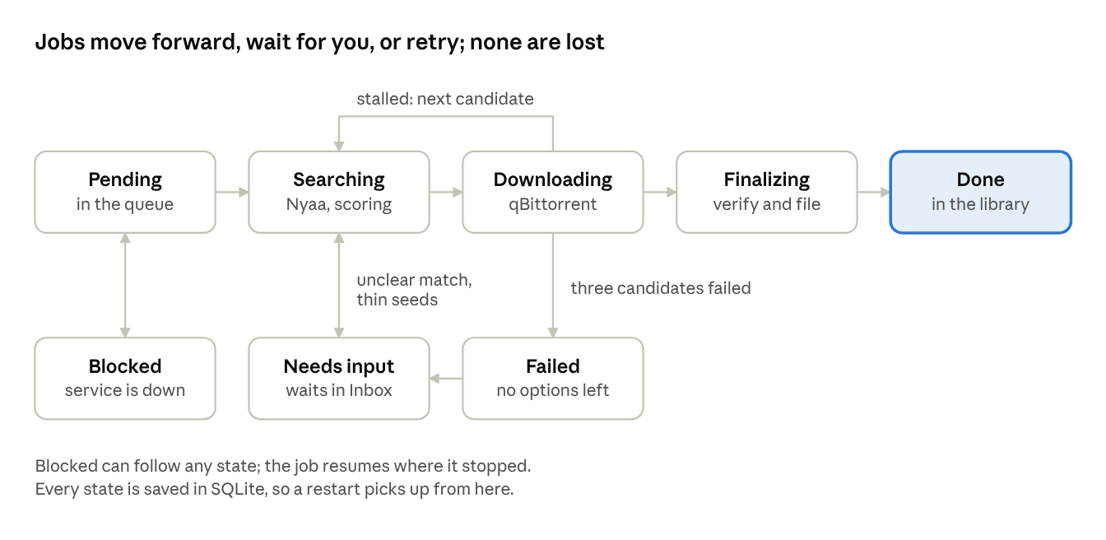
job states · 5 main steps, 3 side states
A job runs left to right. Unclear matches and thin seeds pause it in Needs input without blocking other jobs, and a failed job also raises a question. A stalled torrent loops back to Searching for the next candidate. Each state change is written to SQLite before the work continues, so on restart the app compares its jobs with qBittorrent by info hash and carries on. Retries use the backoff rule from the limit-proofing section.

App pages
A left navigation rail holds nine pages. A status strip at the bottom shows automation on or off, the qBittorrent connection, total speed, free disk space and the last MAL sync time.
Page | What it shows | Main actions
1. Dashboard | Automation switch, next sync time, counts (downloading, queued, needs input, failed), live speed graph, today's finished episodes | Sync now, pause all, resume all
2. Inbox | Every question waiting for you: match review, low seeds, replace file, disk space, batch choice | Answer inline; "always do this" checkbox saves a rule
3. Queue | All jobs with state, progress, ETA, seeders, chosen release name | Pause, retry, skip, reorder, cancel, open torrent details
4. Library | Poster grid of your shows with episode completion bars; filters for watching, planned, completed, incomplete | Open a show, toggle auto per show, rescan folders
5. Show detail | Poster, synopsis, MAL status, episode list with state per episode, aliases, folder path | Manual search, change match, edit aliases, set episode offset, per-show rules, open folder
6. Search | Manual Nyaa search with the same scoring and filters, shown with seeders and sizes | Add a torrent to a chosen show
7. Activity | The event log, filterable by show, job and level | Export, clear old entries
8. Rules | Fansub group priority, resolution, codec, size limits, seed thresholds, blocked uploaders | Edit global rules and per-show overrides
9. Settings | MAL login, qBittorrent connection test, folders, naming pattern, concurrency and daily cap, rate limit overrides, folder icon method, notifications, autostart, theme | Test each connection, back up and restore the database
First-run wizard (shown once, reachable again from Settings): connect MAL, connect or start qBittorrent, choose the library folder, choose quality and groups, review the preview of what the first sync will queue, then turn automation on.
Match Review card (inside the Inbox): the show you expected on the left with poster and year; up to four candidate releases on the right, each with its parsed title, group, resolution, seeders and a one-line reason for its score. Buttons: use this one, none of these, search again.
System tray and notifications: the tray menu offers pause, resume, open and quit. Desktop notifications fire only for things that need you (a new Inbox question, a failure) and for a finished episode, and each type can be muted.

Library output
When a torrent finishes, the finalize job files it in a predictable layout and decorates the folder.
Anime/
Kimi no Na wa (2016)/
synopsis.txt
folder.png
.directory
Kimi no Na wa (2016).mkv
Show Title (2024)/
synopsis.txt
folder.png
.directory
Show Title - S01E01.mkv
Show Title - S01E02.mkv
Finalize steps
- Verify the file: size matches the torrent, the extension is a video type, and the torrent state in qBittorrent is complete.
- Move or hardlink it from the download folder to the show folder (hardlink keeps seeding working; the choice is a setting). Use the naming pattern from Settings, never overwriting an existing file without a recorded answer.
- Write synopsis.txt the first time a show gets a file, and refresh it when MAL data changes.
- Download the poster once, convert it to a square folder.png, and set the folder icon.
- Mark the episode done, remove the torrent from qBittorrent if "remove when finished" is on, and log the result.
synopsis.txt contents
- Title, English title and Japanese title
- Type, episode count, airing status and dates
- MAL score and genres
- The synopsis text
- MAL link and the date the file was written
If the synopsis is unavailable (Jikan down), the app writes the file with a placeholder and queues a refresh instead of failing the download.
Folder icon, per desktop
Desktop | Method
KDE Plasma and most file managers reading .directory | Write Icon=folder.png into the .directory file
GNOME (Nautilus) | gio set -t string <folder> metadata::custom-icon file://<path>/folder.png
Cinnamon, XFCE, others | Detect the desktop from XDG_CURRENT_DESKTOP; fall back to .directory, and show a note if neither works
The icon image can be the plain poster or the poster composited onto a folder shape, like the icon pack in your screenshot; this is a setting. Icons are rebuilt from the stored poster, so a failed or missing icon never blocks a download.
Edge cases: illegal filename characters are replaced, long titles are truncated at 120 characters, folders are matched by MAL id stored in a hidden marker file so renaming a folder does not lose the show, and existing folders you already have are adopted by a rescan, not duplicated.

Failure modes and mitigations
Each row is something that will happen eventually, and what the app does about it.
What goes wrong | What the app does
Title is ambiguous (Your Name / Kimi no Na wa / Kimi no Todoke) | Score against the MAL id's own names, reject other entries, ask in the Inbox when unclear, save the answer as an alias
Torrent has 0 or very few seeders | Drop dead torrents, ask on thin ones, try the next candidate, retry later
Fake or mislabeled torrent (wrong size, wrong show) | Size sanity range, trusted flag, verify the file after download, blocklist the uploader on request
Torrent stalls at 99% or never starts | 20-minute no-progress timer, remove and try the next candidate, ask after three failures
qBittorrent closed, crashed or WebUI disabled | Health check, auto-start if allowed, jobs wait in blocked, setup help shown in the app
qBittorrent password changed or session expired | Re-login once, then raise one Inbox notice
Nyaa down, slow or rate limiting | Cache, backoff, circuit breaker, mirror list, jobs wait instead of failing
MAL token expired or revoked | Refresh automatically; on failure show "Reconnect MAL" and keep working from the cached list
Jikan returns 429 or no data | Limiter plus cache; write a placeholder synopsis and retry later
Disk full or folder missing (external drive unmounted) | Check before every add, pause the queue, notify, resume when space or the drive returns
App killed or power loss mid-download | Reconcile with qBittorrent on launch by info hash, resume from jobs state
Duplicate episode already on disk | Check files and hashes first, ask replace or keep both
Episode numbering differs (absolute vs per season) | Per-show offset, matcher tries both numbers
Batch released instead of singles, or the reverse | Prefer batch for finished shows, ask when the choice is unclear
Long-running or unreleased show | Only queue episodes up to the aired count; re-check weekly for new ones
First sync would queue hundreds of episodes | Preview and one confirmation; daily cap on new torrents
Release name has odd characters, brackets or hashes | Filename parser strips them before scoring and renaming
Folder icon fails on a desktop environment | Skip silently, log it, try the fallback method
Database corruption | WAL mode, nightly backup copy, restore button in Settings
Wrong download chosen despite everything | Show detail has "wrong release": delete the file, blocklist the torrent, search again

Settings, security, logging and testing
Settings. Everything above that has a default number is a setting: seed thresholds, stall timeout, concurrency, daily cap, disk floor, quality, groups, naming pattern, cache lifetimes, rate limits and the folder icon style. Settings live in SQLite, export to a JSON file, and each page that uses one links to it.
Security and privacy.
- MAL and qBittorrent credentials go in the system keyring (libsecret), never in plain files or logs.
- The MAL OAuth redirect uses a local loopback port with PKCE, so no client secret is stored.
- The app talks to qBittorrent on localhost by default; a remote URL needs an explicit warning acknowledgment.
- File paths from release names are sanitized so a malicious name cannot write outside the library.
- No telemetry. Network calls go only to MAL, Jikan, Nyaa (or your mirror) and qBittorrent.
Logging. Every job transition and every question is written to events with the show, job and reason, so you can always see why the app chose a release. Debug logging is an optional switch and rotates by size.
Testing.
- Unit tests for the filename parser and scorer using a fixture list of real Nyaa release names, including the Kimi no Na wa, Kimi no Todoke, Re:Zero and long-running-show cases.
- Mock servers for MAL, Jikan, Nyaa and qBittorrent to test rate limits, 429s, timeouts and token expiry without touching the real services.
- Queue tests that kill the process at each state and verify recovery.
- A dry-run mode that runs the whole pipeline and prints what it would queue, without adding any torrent.
- Manual test on at least KDE and GNOME for folder icons and the tray.

Threat model: security and abuse
The biggest risk is not the app itself but what it downloads and what it trusts. Everything from Nyaa, torrents, MAL and release names is untrusted input. The rows are ordered by how likely and how damaging they are.
1. Malicious downloads
Risk | How it happens | Mitigation
Executable disguised as an episode | A torrent named like an episode contains .exe, .scr, .lnk, .sh, .desktop, .jar or an installer "codec pack" | Extension allowlist (mkv, mp4, avi, srt, ass, ssa, sub, png, jpg); reject or quarantine any torrent containing anything else; never run or open a download automatically
Booby-trapped video or subtitle file | A crafted file exploits a bug in ffmpeg, a player or a thumbnailer | Don't generate thumbnails or probe media with libraries inside the app process; if probing is needed, run it in a separate low-privilege process; keep players updated
Wrong size or fake torrent | Declared size is tiny or huge, or the file is an archive with a password and a "read me" | Size sanity range per episode, reject archives, delete the torrent and blocklist the uploader
Path traversal in the torrent | File names like ../../.bashrc or absolute paths or symlinks inside the torrent | Resolve every final path and check it sits inside the library root; refuse symlinks; qBittorrent saves to a staging folder first, never directly into the library
Disk filling | A torrent declares or sparse-allocates far more than expected, or has thousands of tiny files | Read metadata first, check free space against the real size before starting, cap file count and total size
Leftover permissions | Downloaded files arrive executable | Strip execute bits (chmod 644) at finalize, and mount the staging folder noexec where possible
2. Injection from untrusted text
Risk | How it happens | Mitigation
Shell command injection | A title like Show; rm -rf ~ reaches a command such as gio set or xdg-open | Never use a shell; call programs with an argument list; validate paths
.directory or synopsis.txt injection | A newline or control character in a title or synopsis adds extra lines such as another Icon= entry | Strip control characters and newlines from every value written to files; write synopsis as plain text only
Odd Unicode in names | Right-to-left override characters make episode.mkv look like something else, or names reach 255+ bytes | Normalize to NFC, drop control and bidi characters, cap length by bytes, replace /, : and leading dots or dashes
Malicious magnet or link | A feed item with a non-magnet link, or a link to localhost or a LAN address | Accept only magnet:?xt=urn:btih: and https .torrent links; block private IP ranges (SSRF); cap redirects at 3; always verify TLS
Hostile XML or JSON | Huge RSS feed, nested XML bomb, external entities | Response size cap (for example 5 MB), timeouts, no external entity loading, reject malformed feeds
Rendering untrusted text in the UI | A synopsis or release name with markup or a link | Show as plain text; open links only with an explicit click, https only
3. Accounts, tokens and network
Risk | How it happens | Mitigation
qBittorrent WebUI exposed | Default admin password, bound to 0.0.0.0, auth bypass for localhost enabled | Warn on default credentials, require a strong password, bind to 127.0.0.1, require HTTPS plus a warning for any remote URL
Stolen MAL tokens | Tokens in plain files, logs or backups | Keyring only; redact tokens from logs, crash reports and exports; backups exclude secrets
OAuth redirect hijack | Another local process grabs the loopback callback | Random port, state parameter, PKCE, listener closes after one request
Fallback when no keyring exists | Minimal distros lack libsecret | Encrypted file with a passphrase, never plain text, with a clear warning
Another user on the machine | Library, database or config readable by others | Data folder and database mode 700 and 600; refuse to start if the config is world-writable
Fake group names | Anyone can write [SubsPlease] in a title | Never treat the group name in the title as trust; use the Nyaa trusted flag and your own blocklist
Alias or rule poisoning | A wrong answer saved as "always do this" keeps repeating | Show saved aliases and rules in Rules, with undo and a way to delete
4. Privacy and legal
- Torrenting exposes your IP address to every peer. The app should read qBittorrent's network interface setting and warn when no VPN interface is bound, and never hide this from you.
- Local law and your ISP's rules apply to what you download. The app only automates searching and a torrent client; make sure you have the right to the content you fetch.
- Follow the terms of MAL and Jikan: use your own MAL client ID, respect rate limits, and don't redistribute their data.
- No telemetry and no remote logging; crash reports stay local until you choose to share them.
5. Supply chain and updates
- Commit Cargo.lock and the Flutter lockfile; run cargo audit and cargo deny in CI; keep the dependency list small.
- Sign release builds and publish checksums. Never auto-update from an unsigned source.
- Check that AppImage or Flatpak builds do not request more permissions than they need (no full home access if a library folder is enough).

Other problems that will happen (not security)
Problem | Why it happens | What the app does
Two app instances running | Autostart plus a manual launch | Single-instance lock; the second window just focuses the first
Move across disks fails midway | Library on another drive, power loss or full disk | Copy, verify size and hash, only then delete the source; resume or roll back on restart
External drive path changes | /media/user/DISK becomes DISK1 after remount | Identify folders by marker file with the MAL id, and warn instead of creating a new folder
NTFS or exFAT library drive | No permissions or hardlinks, slow, case rules differ | Detect filesystem, switch to copy or move, skip chmod, warn once
Extras counted as episodes | Batches include NCOP, NCED, creditless, PV, specials | Filter by name patterns; list extras separately in Show detail
Re-releases (v2) and early or late releases | Fansubs fix errors or release a day later, in other time zones | Prefer the newest valid version, ask before replacing, use a grace window before marking an episode missing
MAL entry merged, split or renamed | MAL moderators change ids and titles | Keep the old id as an alias, flag "entry changed" in the Inbox, never auto-delete data
qBittorrent version differences | API changes between 4.x and 5.x (for example pause and resume became stop and start) | Read the API version on connect and use a small compatibility layer
Tray icon missing on GNOME or Wayland | No tray support without an extension | Detect it; fall back to a normal window and notifications
Sandboxed packaging limits | Flatpak or Snap cannot reach qbittorrent-nox, gio or your library folder | Document required permissions; offer AppImage or .deb as the full-featured build
Suspend, sleep or clock changes | The laptop sleeps mid-download; wrong clock breaks OAuth token timing | Treat resume as a restart check; compare qBittorrent state; warn on large clock drift
Filesystem watchers run out | Too many inotify watches on a big library | Scan on a schedule and on demand instead of watching every folder
Log or cache growth | Months of events and cached responses | Size caps and pruning, shown in Settings

Build roadmap and open decisions
Each phase ends with a check that must pass before the next one starts.
- Foundation. Rust workspace, SQLite schema and migrations, settings, logging, shared HTTP layer with limiter, cache and backoff. Check: mock-server tests for 429 and timeout pass.
- qBittorrent and Nyaa. Client for qBittorrent, RSS search, filename parser, scorer. Check: a command-line tool downloads one chosen episode end to end.
- Matching and seed logic. Name sets, scoring, thresholds, question objects. Season and watch-status decision function with a fake MAL list (rules above). Check: the fixture suite resolves Kimi no Na wa, Kimi no Todoke and sequel cases correctly or asks, and the season fixtures pass: S1 Completed plus S2 Watching gives S2 next; "Show - 05" with no marker resolves to the active season; absolute "- 17" becomes S2 episode 5; watched episodes are skipped; a missing season gives not found, never another season; PlanToWatch is skipped by default.
- Queue and workers. Job states, retries, stall handling, crash recovery. Check: killing the process at every state recovers cleanly.
- MAL sync. OAuth, list diff, episode generation, first-sync preview with a hard cap (default 25 queued jobs on the first run), a dry run that prints the queue before anything downloads, and building the season chain from the real MAL response. Check: dry run on your real list shows a sensible queue.
- Library step. Rename and move, synopsis.txt, posters, folder icons on KDE and GNOME. Check: ten real shows are filed correctly.
- Flutter UI. Pages in this order: Dashboard, Queue, Inbox, Library, Show detail, Settings, then Search, Rules, Activity and the wizard. Check: a full automated run is watchable from the UI.
- Polish and release. Tray, autostart, notifications, backup and restore, AppImage and .deb, crash reports kept local. Check: clean install on a fresh Linux user account works.
Open decisions (defaults in brackets)
- Move or hardlink finished files? [hardlink, so seeding continues]
- Remove torrents from qBittorrent when done? [keep until seed ratio 1.0]
- Seed threshold for auto-download? [10 seeders; ask between 1 and 9]
- Preferred groups and resolution? [1080p, groups chosen by you in the wizard]
- Should the app start qBittorrent itself? [yes, if installed]
- Which MAL statuses are automatic? [watching on; plan to watch off, manual per show]
- Auto-download Plan to watch? [off; per-show override only, so 73 plan-to-watch shows are never queued at once]
- First-sync cap? [25 jobs, then you approve the rest in batches]
- Watching show fully watched? [skip and suggest marking Completed]
- Keep the existing Genrl-downloader code, or rewrite? [decide after I can read it; this doc assumes a rewrite of the core]

Stitch prompts for each page
Paste the shared style prompt first (or at the start of each prompt), then one page prompt. Ask Stitch for desktop at 1440 x 900. Generate Dashboard first and reuse its look for the rest, so all pages match.
Shared style (put this in every prompt)
Desktop app for Linux called "Genrl Downloader", an anime library manager. Dark theme, near-black blue-grey background, one violet accent color, rounded cards with 12px radius, soft borders, no heavy shadows. Clean sans-serif font, compact and information-dense like a media manager. Fixed left navigation rail (icons with labels): Dashboard, Inbox (with a red count badge), Queue, Library, Search, Activity, Rules, Settings. Fixed thin status strip at the bottom: automation status, qBittorrent connection dot, total download speed, free disk space, last MAL sync time. Anime poster thumbnails are 2:3 portrait.
1. Dashboard
Dashboard screen. Top row: a large Automation toggle card (On/Off, text "Next MAL sync in 18 min"), and buttons "Sync now" and "Pause all". Below, four stat cards: Downloading 2, Queued 11, Needs input 3, Failed 1. Middle: a live download speed line graph for the last 10 minutes. Below it two columns: left "Downloading now" list with poster thumbnails, episode label, progress bar, speed and ETA; right "Finished today" list with small posters and episode numbers. Keep it calm and scannable.
2. Inbox
Inbox screen listing questions that need the user. Each question is a card with an icon for its type, a title, a short reason, and action buttons. Show five cards: (1) Match review: "Which one is Kimi no Na wa?" with the expected show poster on the left and three candidate releases on the right, each with group name, resolution, seeders and a score bar, buttons "Use this one", "None of these", "Search again". (2) Low seeds: "Only 4 seeders. Download anyway?" with buttons "Download", "Wait 24 h", "Pick another". (3) File already exists: "Replace episode 5?" with Keep, Replace, Keep both. (4) Batch only: "Download whole batch?". (5) Disk space low with a free-space bar. Each card has an "Always do this" checkbox. Filter tabs at the top: All, Matches, Seeds, Files, Disk.
3. Queue
Queue screen as a dense table with a toolbar (search box, state filter chips: All, Searching, Downloading, Finalizing, Blocked, Failed, Needs input; buttons Pause all, Retry failed). Columns: poster thumbnail with show name, episode, state badge with color, chosen release name (truncated), seeders, progress bar, speed, ETA, and a row menu (Pause, Retry, Skip, Cancel, Details). Show 12 rows with a mix of states. Clicking a row opens a right side panel with torrent details, candidates that were considered with their scores, and the job's recent log lines.
4. Library
Library screen with a poster grid of anime. Top bar: search, filter chips (Watching, Plan to watch, Completed, Incomplete), sort dropdown, grid size slider, and a "Rescan folders" button. Each card shows the poster, title, a thin episode completion bar (e.g. 8/12), small badges for "Auto" and "Airing", and a red dot if an episode is missing or failed. Show 18 cards. On hover show quick actions: Open folder, Toggle auto.
5. Show detail
Show detail screen for the anime "Kimi no Na wa". Left column: large poster, MAL score, type, year, status, buttons "Open folder", "Manual search", "Change match". Right: title in English and Japanese, synopsis text, genre chips, then tabs: Episodes, Aliases, Rules. Episodes tab is a list with episode number, state badge (Done, Queued, Downloading, Missing, Failed), release name, size, and a "Wrong release" button. Aliases tab shows chips of alternate names with an add field and an "Episode offset" number input. Rules tab shows per-show overrides for resolution, group priority and the Auto toggle.
6. Search
Manual Nyaa search screen. A large search field at the top with a "Show" dropdown to assign the result to a show, filters for resolution, group, minimum seeders and size range. Results table: release name, group, resolution, size, seeders (colored green, yellow, red by health), leechers, upload date, a match score pill, and an "Add" button. Highlight the best match row. Empty state and loading skeleton included.
7. Activity
Activity log screen. Top filters: show dropdown, level chips (Info, Warning, Error), date range, search. Below, a timeline list of events grouped by day. Each event has a time, a colored level dot, a sentence like "Chose [SubsPlease] 1080p for episode 7 because it scored 92 and had 140 seeders", and a link to the job. Buttons: Export, Clear old entries.
8. Rules
Rules screen. Sections as cards: (1) Preferred fansub groups as a drag-to-reorder list with add button. (2) Quality: resolution segmented control (720p, 1080p, 2160p), codec checkboxes, size limits as a range slider. (3) Seed thresholds: two number inputs, "Auto-download at or above" 10 and "Ask between" 1 and 9, with a small visual scale. (4) Blocked uploaders list with remove buttons. (5) A dropdown at the top to switch between Global rules and a specific show override.
9. Settings
Settings screen with a left sub-menu: Accounts, qBittorrent, Folders, Downloads, Rate limits, Appearance, Notifications, Backup. Show the Accounts and qBittorrent sections: MAL account card with avatar, username, "Connected" green badge, and a Reconnect button; qBittorrent card with URL, username, password field, a "Test connection" button and a success state; folder pickers for the Anime library folder and download folder; a naming pattern text field with a live preview; a "Move or hardlink" segmented control; concurrency stepper (default 2) and daily cap stepper (default 30); a folder icon method dropdown (Auto, KDE, GNOME, Off).
10. First-run wizard
First-run setup wizard as a centered modal with a 5-step progress indicator: Connect MAL, Connect qBittorrent, Choose library folder, Quality and groups, Review. Show step 5: a summary list of what the first sync will queue ("This will queue 214 episodes across 31 shows") with an expandable preview list, a daily cap warning, and buttons "Back" and "Start with automation off" and "Turn automation on".
11. Tray menu and notifications
Two small components on a dark desktop: a system tray popup menu with items (Open Genrl Downloader, Pause all, Resume, Sync now, a line showing "2 downloading, 3 need input", Quit), and three desktop notification toasts: "Episode 7 of Show Title finished", "3 questions need your input", "qBittorrent is not reachable" with a Retry action.
Tips for Stitch
- If a screen comes out too sparse, add "fill with realistic example data for 12 anime".
- To keep the look identical, after the Dashboard is good, say "use the same layout, colors and components as the Dashboard screen" at the start of every other prompt.
- Ask for "empty state" and "error state" variants of Queue, Library and Inbox as separate prompts.

