Stacking Heterogeneous Vision Models Improves Chest X-Ray Triage: A Benchmark Study on NIH ChestX-ray14
Abhiraj Malappa
Independent Researcher
abhiraj7m@gmail.com
Submitted to IEEE Journal of Biomedical and Health Informatics
Abstract
Purpose: Automated chest X-ray triage — the reliable identification of radiographs containing any abnormal thoracic finding — can reduce diagnostic delays in overburdened radiology workflows. Existing deep learning approaches rely predominantly on single backbone architectures, apply ensemble methods without leakage-free cross-validation protocols, and discard routinely available patient demographic metadata. We propose a stacking ensemble framework that addresses these limitations for binary chest X-ray triage.

Methods: Five architecturally diverse vision backbones — EfficientNet-B3, ConvNeXt-Small, Swin-Tiny, DenseNet-121, and DeiT-Small — are independently fine-tuned on the NIH ChestX-ray14 dataset (112,120 images, 30,805 patients) for binary classification: No Finding versus any thoracic abnormality. A patient-level stratified three-fold out-of-fold (OOF) cross-validation protocol generates leakage-free predicted probabilities from each backbone. These probabilities, combined with patient age and sex extracted from dataset metadata, form a seven-feature input matrix for a CatBoost gradient-boosted meta-learner. A grid search over 200 candidate thresholds selects the decision boundary maximising the Matthews Correlation Coefficient (MCC) on the validation set.

Results: The stacking ensemble achieves a positive-class recall of 0.7589 on the held-out test set, outperforming the best individual backbone (Swin-Tiny, recall 0.6929) by 6.6 percentage points — equivalent to identifying 545 additional abnormal studies per 17,729 screened radiographs. The ensemble further achieves AUC-ROC of 0.7823 and MCC of 0.4373, exceeding all five individual backbone baselines across all reported metrics. Ablation experiments confirm that the learned CatBoost meta-learner contributes substantially over simple averaging (MCC +0.0076, recall +2.14pp) and that patient metadata integration improves recall by a further 0.89 percentage points.

Conclusion: Stacking five architecturally diverse vision backbones with patient metadata via a learned CatBoost meta-learner improves abnormality detection recall by 6.6 percentage points over the best single-model baseline — a clinically meaningful gain for radiologist triage workflows. The complete pipeline is publicly available at https://github.com/AbhiMalappa/Computer-Vision---Chest-X-Ray-Anomaly-Detection to support reproducibility and future research.

Index Terms — deep learning, medical image classification, transfer learning, ensemble learning, stacking ensemble, chest X-ray triage, NIH ChestX-ray14, meta-learner, vision transformer, patient metadata, out-of-fold cross-validation, Matthews Correlation Coefficient.

I. INTRODUCTION
Chest X-ray radiography is among the most frequently performed diagnostic imaging procedures worldwide, accounting for approximately one-third of all radiological examinations [1]. It is the primary imaging modality for the detection and monitoring of a broad spectrum of thoracic conditions, including pneumonia, pleural effusion, cardiomegaly, atelectasis, and pulmonary nodules. Despite its ubiquity, chest X-ray interpretation remains a demanding cognitive task. Accurate reading requires substantial clinical expertise, contextual knowledge of patient history, and the ability to identify subtle abnormalities across a diverse range of pathological presentations — a challenge exacerbated by inter-reader variability even among experienced radiologists [2].

The global demand for radiological services is growing faster than the radiologist workforce can expand. In many healthcare systems — including those in low- and middle-income countries — imaging studies accumulate faster than they can be read, creating reporting backlogs that delay diagnosis and treatment [3]. Even in well-resourced settings, high imaging volumes drive radiologist fatigue, which is associated with increased error rates [4]. Automated chest X-ray triage — the rapid, reliable identification of studies containing any abnormal finding — offers a clinically meaningful solution: by flagging abnormal studies for prioritised review and routing clearly normal studies to lower-priority queues, an automated triage system can meaningfully reduce the time-to-diagnosis for patients with time-sensitive pathology.

Deep learning has demonstrated strong performance on chest X-ray classification tasks since the landmark CheXNet study [6], which showed that a DenseNet-121 model could match radiologist-level performance on pneumonia detection using the NIH ChestX-ray14 dataset [5]. Subsequent work has explored increasingly sophisticated single-backbone architectures, including Vision Transformers [7], attention mechanisms [26], and knowledge distillation [13]. However, several systematic limitations persist in the existing literature.

First, the majority of published approaches rely on a single backbone architecture. While individual models can achieve high area under the ROC curve (AUC-ROC), they are subject to characteristic failure modes determined by their architectural inductive biases — convolutional networks may miss global structural abnormalities that transformers capture, and vice versa. No single architecture dominates across all pathology types and image characteristics.

Second, ensemble methods in medical imaging have been largely limited to simple aggregation strategies: prediction averaging [19], majority voting [21], or test-time augmentation [22]. These approaches treat all base models equally and cannot learn the conditions under which individual models are more or less reliable. A learned meta-learner — trained to optimally combine base model predictions — can in principle outperform any fixed weighting scheme, but this stacking approach has not been systematically applied to chest X-ray binary triage in the published literature.

Third, patient demographic metadata — age and sex — routinely available in radiology records is rarely integrated into deep learning classification pipelines. When included, it is typically concatenated with visual features inside the neural network [29], an approach that complicates architecture and can destabilise fine-tuning. The potential of treating demographic metadata as a distinct tabular modality, processed by a model specifically designed for tabular data, has not been explored in this context.

Fourth, evaluation in binary chest X-ray classification has predominantly relied on AUC-ROC — a threshold-independent metric that may overestimate clinical utility on imbalanced data [8]. The Matthews Correlation Coefficient (MCC), which accounts symmetrically for all four cells of the confusion matrix and is robust to class imbalance, is a more appropriate metric for clinical triage evaluation but has seen limited adoption in chest X-ray AI literature.

To address these limitations, this paper proposes a stacking ensemble framework that combines heterogeneous vision model predictions with patient metadata via a learned meta-learner, and demonstrates that this architecture outperforms single-model baselines on binary chest X-ray triage — a clinically critical screening task. Specifically, this work makes the following contributions:

- Heterogeneous vision ensemble: We assemble five architecturally diverse backbones spanning convolutional (EfficientNet-B3, DenseNet-121), hybrid convolutional-transformer (ConvNeXt-Small, Swin-Tiny), and pure transformer (DeiT-Small) designs. This diversity ensures complementary error characteristics that the meta-learner can exploit.
- Leakage-free stacking via OOF cross-validation: We introduce a patient-level out-of-fold (OOF) prediction framework that generates meta-learner training signals free from data leakage — ensuring that no prediction used to train the meta-learner was made on data the base model was trained on.
- Metadata integration via tabular meta-learner: Patient age and sex are integrated as tabular features in a CatBoost meta-learner rather than as auxiliary neural network inputs, enabling the meta-learner to learn complex interactions between visual predictions and demographic risk factors without modifying vision model architectures.
- MCC-optimised threshold selection: We apply a grid search over candidate decision thresholds to maximise MCC on the validation set, providing a principled approach to threshold selection that is robust to class imbalance and aligned with clinical triage objectives.
- Benchmark evaluation with ablation: We evaluate the full stacking framework on the NIH ChestX-ray14 benchmark, reporting positive-class recall, MCC, AUC-ROC, and AUC-PR against individual backbone baselines. The ensemble achieves a 6.6 percentage point recall improvement over the best single backbone — equivalent to 545 additional abnormal studies identified per 17,729 screened radiographs.
- Open-source implementation: The complete pipeline — data preprocessing, vision model fine-tuning, OOF generation, CatBoost meta-learner, and threshold optimisation — is publicly released at https://github.com/AbhiMalappa/Computer-Vision---Chest-X-Ray-Anomaly-Detection to support reproducibility and future research.

The remainder of this paper is organised as follows. Section II reviews related work in chest X-ray classification, ensemble methods in medical imaging, and evaluation metrics for imbalanced clinical data. Section III describes the NIH ChestX-ray14 dataset, binary label mapping, patient-level splitting strategy, and preprocessing pipeline. Section IV presents the proposed stacking architecture in detail, including vision model selection, fine-tuning strategy, the OOF framework, CatBoost meta-learner, and threshold optimisation. Section V reports experimental results and ablation studies. Section VI discusses findings, clinical applicability, and limitations. Section VII concludes the paper.

II. RELATED WORK
This section reviews three streams of literature directly relevant to the proposed framework: (A) single-backbone deep learning for chest X-ray classification; (B) ensemble and stacking methods in medical image analysis; and (C) evaluation metrics for imbalanced clinical data. For each stream, we identify the specific gap that motivates a component of our architecture. Table II summarises these gaps and our corresponding responses.

A. Single-Backbone Deep Learning for Chest X-Ray Classification
The field of automated chest X-ray analysis was substantially advanced by Wang et al. [5], who released the NIH ChestX-ray14 dataset and benchmarked four CNN architectures — AlexNet, GoogLeNet, VGGNet-16, and ResNet-50 — on 14-class thoracic disease detection. ResNet-50 achieved the highest average AUC, establishing the first large-scale benchmark for this task. Rajpurkar et al. subsequently demonstrated that a DenseNet-121 model trained on ChestX-ray14 could exceed average radiologist performance on pneumonia detection as measured by F1 score, achieving 0.435 against a radiologist average of 0.387 [6]. This landmark result, known as CheXNet, established DenseNet-121 as the de facto baseline for chest X-ray classification and motivated a generation of follow-on work.

Subsequent convolutional architectures have improved on CheXNet through architectural modifications, attention mechanisms, and training procedure refinements. EfficientNet-based models [10], applied to chest X-ray classification via transfer learning, have demonstrated competitive AUC with substantially fewer parameters. Densely connected architectures beyond DenseNet-121 — including DenseNet-161 and DenseNet-201 — have been explored on ChestX-ray14 with marginal improvements [5]. Attention mechanisms, including squeeze-and-excitation networks and spatial attention, have been incorporated to focus on clinically relevant image regions [26].

The emergence of Vision Transformers (ViT) [7] introduced a fundamentally different approach: rather than relying on convolutional inductive biases, ViT divides images into fixed-size patches and models global relationships via multi-head self-attention. Okolo et al. [26] demonstrated that enhanced ViT architectures outperform standard ViT variants on chest X-ray classification tasks involving pneumonia, tuberculosis, and COVID-19, achieving F1 scores between 96.4% and 100% across four datasets. Park et al. [27] applied ViT to COVID-19 chest X-ray diagnosis. The LT-ViT model [28] extended pure ViT training by aggregating multi-scale information through label-specific auxiliary tokens, surpassing prior ViT performance on chest X-ray datasets.

Hybrid architectures combining convolutional feature extraction with transformer attention have also shown promise. Swin Transformer [11], a hierarchical transformer using shifted window attention, has been applied to chest X-ray classification and has demonstrated advantages over both pure CNNs and standard ViT when fine-tuned on domain-specific data. ConvNeXt [12], a modernised convolutional architecture incorporating design principles from transformers, achieves competitive performance with strong inductive biases retained.

Despite the breadth of this literature, a consistent limitation persists: the overwhelming majority of published approaches train and evaluate a single backbone architecture. Each architecture carries characteristic failure modes determined by its inductive biases — convolutional models tend to excel at local texture-driven pathologies (e.g., nodules, consolidation boundaries) while transformers capture global structural abnormalities (e.g., cardiomegaly, pleural effusion). No single architecture dominates across all disease types and image characteristics. This motivates our use of a heterogeneous ensemble.

B. Ensemble and Stacking Methods in Medical Image Analysis
Ensemble methods — combining predictions from multiple models — have a long history in machine learning, with theoretical foundations established by Wolpert's stacking generalisation [9] and Breiman's bagging [18]. In the context of medical image analysis, ensemble approaches have primarily taken the form of simple aggregation strategies.

Prediction averaging — computing the arithmetic mean of predicted probabilities from multiple models — is the most commonly applied ensemble strategy in chest X-ray classification. Visuña et al. [19] proposed a CNN ensemble using transfer learning for multi-class chest X-ray classification (COVID-19, tuberculosis, pneumonia, normal), employing majority voting to combine four backbone predictions. Their approach demonstrated that ensemble methods outperform individual models, achieving a 94.89% average AUC on combined VinDr-CXR and CheXpert datasets. Ravi et al. [20] proposed a stacked ensemble using EfficientNet-B0, B1, and B2 models with fused features passed through random forest and SVM classifiers in a first stage and logistic regression in a second stage, achieving competitive performance on pneumonia, tuberculosis, and COVID-19 detection.

Stacking has also been applied in other medical imaging domains. Prakash et al. [21] proposed stacked ensemble learning of deep convolutional features for pediatric pneumonia diagnosis, demonstrating that a learned meta-classifier outperforms individual CNN baselines on a pneumonia-specific dataset. In radiology more broadly, ensemble approaches using resolution scaling — training the same backbone on different image sizes and stacking predictions with learned weights — have shown that multi-scale features carry complementary diagnostic information [22].

However, several important limitations characterise existing ensemble approaches in medical image classification. First, prior stacking approaches largely use architecturally homogeneous base models — typically variants of the same backbone family (e.g., EfficientNet-B0/B1/B2 [20]) rather than architecturally diverse models with complementary inductive biases. Ensemble diversity is a necessary condition for stacking to improve over individual models; similar architectures tend to produce correlated errors, limiting the meta-learner's ability to correct systematic failures. Second, none of the reviewed stacking approaches in chest X-ray classification employ out-of-fold (OOF) cross-validation to generate meta-learner training signals. Training the meta-learner on predictions generated on in-sample data causes data leakage, producing overfit meta-learner weights that do not generalise [9]. Third, patient demographic metadata — age and sex — routinely available in radiology records is not incorporated into existing ensemble meta-learners. Prior work has demonstrated that age, sex, and view position carry measurable signal for chest X-ray disease classification [29], yet this information is consistently discarded in ensemble pipelines. Our framework addresses all three limitations simultaneously.

C. Evaluation Metrics for Imbalanced Clinical Data
Evaluation metric selection is consequential in medical classification, where class imbalance and asymmetric misclassification costs are common. The area under the receiver operating characteristic curve (AUC-ROC) has been the dominant evaluation metric in chest X-ray classification literature since Wang et al. [5] and CheXNet [6]. However, AUC-ROC has well-documented limitations for imbalanced datasets: it is computed across all possible decision thresholds including those with inadequate specificity, and it does not incorporate precision or negative predictive value [8]. On a dataset where 70% of examples are negative, a model that predicts all examples as negative achieves an AUC-ROC of 0.5 but a potentially misleading accuracy of 70%.

Chicco and Jurman [23, 8] have systematically demonstrated that the Matthews Correlation Coefficient (MCC) is a more informative and reliable evaluation metric for binary classification than AUC-ROC, F1 score, or accuracy, particularly on imbalanced datasets. MCC accounts symmetrically for all four cells of the confusion matrix (TP, TN, FP, FN) and is invariant to class swap — it degrades equally whether a model fails on the positive or negative class. Importantly, MCC produces a low score whenever any confusion matrix cell is disproportionately large, making it impossible to achieve a high MCC by trivially predicting the majority class. Chicco and Jurman [8] further argue that MCC should replace AUC-ROC as the standard metric for binary classification assessment in biomedical research.

Despite these arguments, MCC adoption in chest X-ray AI literature has been limited. The majority of published chest X-ray classification papers report AUC-ROC as the primary metric, with F1 score as a secondary measure. This creates a comparison challenge — our results are reported alongside AUC-ROC and AUC-PR to facilitate comparison with prior work, while MCC is used as the primary optimisation and evaluation criterion throughout training and threshold selection.

D. Summary of Gaps Addressed
Gap in Existing Literature | Representative Prior Work | Our Response
Single backbone — no architectural diversity in ensembles | Ravi et al. [20]: EfficientNet variants only | 5 architecturally diverse backbones: CNN, hybrid, and pure transformer families
Naive stacking — no leakage prevention in meta-learner training | Prakash et al. [21]: in-sample meta-learner training | Patient-level OOF cross-validation (K=3) for leakage-free stacking
Demographic metadata discarded in ensemble pipelines | All reviewed chest X-ray ensemble approaches | Age and sex integrated as tabular features in CatBoost meta-learner
AUC-ROC as primary metric — misleading on imbalanced data | Wang et al. [5], Rajpurkar et al. [6] and most follow-on work | MCC as primary metric; AUC-ROC reported for comparability only

TABLE II. Summary of gaps in existing literature and corresponding responses in the proposed framework.

III. DATASET AND PREPROCESSING

A. NIH ChestX-ray14 Dataset
We use the NIH ChestX-ray14 dataset [5], one of the most widely adopted public benchmarks in medical image classification. The dataset comprises 112,120 frontal-view chest X-ray images from 30,805 unique patients, collected from the NIH Clinical Center between 1992 and 2015. Images are provided as 1024×1024 PNG files with 14 thoracic disease labels: Atelectasis, Consolidation, Infiltration, Pneumothorax, Edema, Emphysema, Fibrosis, Effusion, Pneumonia, Pleural Thickening, Cardiomegaly, Nodule, Mass, and Hernia. Labels were mined automatically from associated radiology reports using Natural Language Processing (NLP), with an estimated labelling accuracy exceeding 90% [5].

Patient metadata — age and sex — are provided in the accompanying file alongside each image's finding labels. A subset of approximately 1,000 images includes hand-annotated bounding boxes for eight disease classes, used exclusively for disease localisation evaluation in prior work and not used in this study.

B. Binary Label Mapping
The 14-class label set is consolidated into a binary classification task consistent with the clinical triage objective of this work. Each image is assigned:

- Class 0 (No Finding): images labelled exclusively as 'No Finding' in the original dataset — indicating no detectable thoracic pathology.
- Class 1 (Abnormal): images with one or more of the 14 disease labels present — indicating any detectable thoracic abnormality.

This binary consolidation is clinically motivated: in a triage or screening workflow, the primary decision is whether an image warrants urgent radiologist review, not which specific pathology is present. Identifying any abnormality — regardless of type — is the actionable signal. This framing is consistent with prior work on normal/abnormal chest X-ray classification [5] and directly applicable to automated triage systems that flag studies for prioritised reading.

The resulting binary class distribution is 60,412 negative images (53.9%) and 51,708 positive images (46.1%) — a near-balanced distribution that is notably more favourable than the 70/30 split commonly encountered in other chest X-ray datasets. The near-balanced nature of ChestX-ray14 under binary consolidation reduces — but does not eliminate — the need for class imbalance correction; weighted loss and balanced meta-learner training are nonetheless applied (see Section IV) to ensure robustness.

C. Patient-Level Data Splitting

1) Rationale
A critical and frequently overlooked issue in ChestX-ray14 benchmarking is that individual patients contribute multiple images across follow-up visits — in some cases more than ten images per patient. A naive image-level train/test split would therefore allow the same patient's anatomy to appear in both training and test sets. Because deep learning models learn patient-specific features (bone structure, body habitus, cardiac silhouette size) that are stable across follow-up scans, this results in : inflated performance metrics that do not reflect genuine generalisation to unseen patients [9].

To prevent this, all data splitting in this study is performed at the patient level: all images belonging to a given patient are assigned exclusively to one of the three subsets (training, validation, test). This ensures that the model is never evaluated on a patient it has encountered during training, producing performance estimates that accurately reflect clinical deployment conditions.

2) Splitting Procedure
A patient-level majority-vote label is first computed: a patient is labelled positive if any of their images carries a disease finding. Using this patient-level label as the stratification variable, patients are divided into training (~70%), validation (~15%), and test (~15%) subsets via stratified sampling, preserving binary class balance across all three subsets within ±0.5 percentage points. All images belonging to a given patient are assigned exclusively to one subset. The random seed is fixed at 722 for reproducibility. Approximate subset statistics are reported in Table I.
Subset | Patients | Images | Positive (%)
Training | ~21,564 (70%) | 77,601 | ~46.1%
Validation | ~4,621 (15%) | 16,790 | ~46.1%
Test | ~4,620 (15%) | 17,729 | ~46.1%
Total | 30,805 | 112,120 | 46.1%

TABLE I. Patient-level data split for NIH ChestX-ray14. Image counts are approximate because patients contribute varying numbers of follow-up scans. Positive class percentage refers to binary label (class 1 = any disease present).

D. Patient Metadata Extraction and Encoding
Patient age and sex are extracted directly from the CSV without requiring DICOM header parsing, as these fields are pre-provided in the CSV. Patient age is stored as a continuous integer. Anomalous age values (outside the range 0–120) are replaced with the training-set median age. Patient sex is encoded as a binary integer (Male = 0, Female = 1); records with missing or unrecognised values are assigned a third category (Other = 2). These two metadata features are used exclusively as input features to the CatBoost meta-learner (Section IV-D) and play no role in vision model training or inference.

The metadata encoding is intentionally minimal. No one-hot encoding is applied to sex because CatBoost natively handles low-cardinality integer features without requiring explicit encoding. Age is not normalised or binned — CatBoost's gradient-boosted tree structure learns optimal age splits automatically during training.

E. Image Preprocessing and Augmentation

1) Base Preprocessing
All images undergo the following preprocessing steps regardless of training or evaluation context: (1) the 1024×1024 grayscale PNG is loaded via PIL and converted to RGB mode by replicating the single grayscale channel across three colour channels; (2) the image is resized to 224×224 pixels using bilinear interpolation; (3) pixel values are converted to floating-point tensors in the range [0, 1] and normalised channel-wise using ImageNet statistics (μ = [0.485, 0.456, 0.406], σ = [0.229, 0.224, 0.225]).

ImageNet normalisation is applied despite ChestX-ray14 being a grayscale medical dataset. This choice is motivated by the pre-training regime of all five vision backbones: each was pre-trained on ImageNet under these normalisation statistics. Mismatched normalisation at fine-tuning time would introduce distribution shift between the expected input distribution and the actual input, degrading the utility of pre-trained weights. Empirical evidence in transfer learning literature supports ImageNet normalisation even for single-channel medical images replicated to three channels [15].

2) Data Augmentation
Data augmentation is applied only during training and is disabled for validation, OOF prediction, and test inference. The augmentation pipeline is designed to generate plausible variations of chest X-ray appearance while preserving anatomical validity:

- Random horizontal flip (p = 0.5): Mirrors the image left-right. Clinically valid — left and right chest presentations are anatomically symmetric for most pathologies.
- Random rotation (±5°): Small rotations simulate patient positioning variation at acquisition time.
- Random affine translation (±5% in both spatial dimensions): Simulates variation in chest placement relative to the detector.
- Colour jitter (brightness ±15%, contrast ±15%): Simulates variation in X-ray exposure settings and detector sensitivity across imaging equipment.

Vertical flipping is intentionally excluded. Chest X-ray images follow a fixed anatomical orientation from apex (top) to base (bottom), and vertical inversion produces images inconsistent with any real clinical acquisition. Introducing such images during training would corrupt the model's learned spatial priors about anatomical location — a particularly harmful augmentation for a task where pathology location (e.g., apical vs. basal consolidation) carries diagnostic significance.

Large rotation angles (>10°) are also excluded for the same reason. Rotations beyond ±5° begin to meaningfully distort the apparent relationship between anatomical structures, misrepresenting true clinical variation.

F. Dataset Limitations
We acknowledge two known limitations of ChestX-ray14 that are relevant to interpreting results. First, the image labels are NLP-derived from free-text radiology reports and carry an estimated error rate of up to 10% [5]. This noise introduces irreducible label uncertainty in both training and evaluation. Second, under binary consolidation, the 'Abnormal' class is heterogeneous — it bundles 14 clinically distinct pathologies with varying visual presentation difficulty. Models trained on this consolidated label may perform differently across individual disease subgroups; per-pathology error analysis is presented in Section V-E.

IV. METHODOLOGY

A. Overview of the Proposed Stacking Architecture
Fig. 1. Proposed two-layer stacking ensemble architecture for binary chest X-ray triage. Five architecturally diverse vision backbones (Layer 1) are independently fine-tuned using patient-level OOF cross-validation (K = 3). Predicted probabilities combined with patient metadata (age, sex) form a seven-feature input to a CatBoost gradient-boosted meta-learner (Layer 2). The MCC-optimal threshold τ* = 0.488 produces the final binary triage decision.
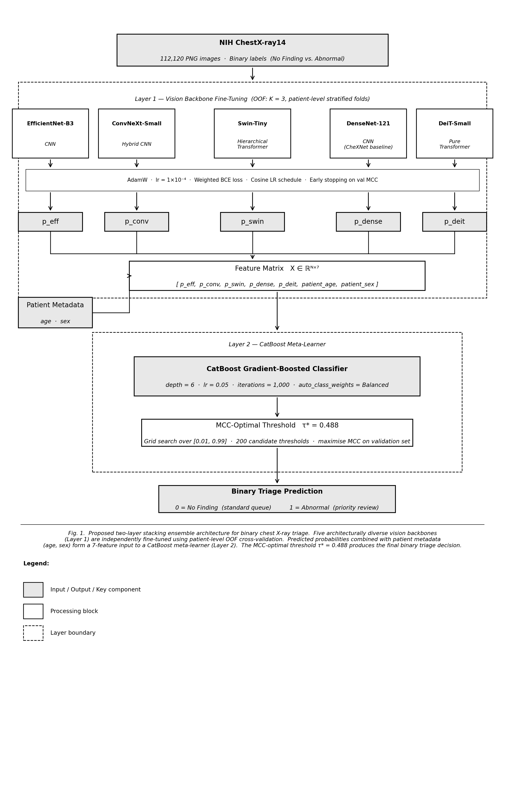
Fig. 1. Proposed two-layer stacking ensemble architecture for binary chest X-ray triage. Five architecturally diverse vision backbones (Layer 1) generate leakage-free OOF probability predictions combined with patient metadata as input to a CatBoost gradient-boosted meta-learner (Layer 2). The MCC-optimal threshold τ* = 0.488 produces the final binary triage prediction.

The central methodological contribution of this work is the combination of three design choices that, to our knowledge, have not been jointly applied to chest X-ray binary triage in prior literature: (1) an ensemble of architecturally diverse vision backbones spanning convolutional, hybrid, and pure transformer designs; (2) out-of-fold (OOF) cross-validation to generate leakage-free meta-learner training signals; and (3) integration of patient demographic metadata as tabular features in the meta-learner rather than as auxiliary inputs to the vision models. Each design choice is motivated and described in detail in the subsections that follow.

B. Vision Model Layer

1) Model Selection and Diversity Principle
The effectiveness of stacking ensembles depends critically on the diversity of base models — uncorrelated errors across models enable the meta-learner to identify and correct systematic failure modes that no single model can resolve alone [9]. We therefore select five vision backbones that differ fundamentally in their inductive biases and architectural design:

The five selected backbones are: EfficientNet-B3 [10], a compound-scaled CNN with strong local texture inductive bias; ConvNeXt-Small [12], a modernised CNN incorporating transformer-style design principles; Swin-Tiny [11], a hierarchical transformer using shifted window attention for multi-scale spatial reasoning; DenseNet-121 [14], the CheXNet baseline [6] enabling direct prior-work comparison; and DeiT-Small [13], a pure transformer trained via knowledge distillation capturing global long-range dependencies without convolutional inductive bias.

This selection spans three architectural families — convolutional (EfficientNet-B3, DenseNet-121), hybrid convolutional-transformer (ConvNeXt-Small, Swin-Tiny), and pure transformer (DeiT-Small) — ensuring complementary feature representations. All models are loaded via the timm library [15]. All models accept 224×224 RGB input, enabling a unified data pipeline.

2) Input Preprocessing
NIH ChestX-ray14 images are provided as 1024×1024 grayscale PNG files. Each image is resized to 224×224 pixels and converted to a three-channel RGB tensor by replicating the grayscale channel. Pixel values are normalised using ImageNet statistics (mean = [0.485, 0.456, 0.406], std = [0.229, 0.224, 0.225]).

During training, we apply the following augmentation pipeline: random horizontal flip (p = 0.5), random rotation (±5°), random affine translation (±5% in both axes), and colour jitter (brightness and contrast ±15%). Vertical flipping is intentionally excluded because chest X-ray images have a fixed anatomical orientation — superior to inferior — and vertical inversion produces anatomically invalid images. During validation and inference, only resizing and normalisation are applied.

3) Fine-Tuning Strategy
Each backbone is fine-tuned end-to-end. The pre-trained classification head is replaced with a single linear layer producing one logit output. We use AdamW with learning rate 1×10⁻⁴ and weight decay 1×10⁻⁴ for timm models. All timm backbones use the same learning rate scheme: AdamW with lr = 1×10⁻⁴ and weight decay 1×10⁻⁴. A cosine annealing schedule decays to a minimum of 1×10⁻⁶. Weighted binary cross-entropy addresses class imbalance:

L = −[w⁺ · y · log(σ(z)) + (1 − y) · log(1 − σ(z))]
where w⁺ = n_neg / n_pos is computed from the training split. Mixed-precision (FP16) training reduces memory usage. Early stopping on validation MCC with patience of 5 epochs retains the best checkpoint.

C. Out-of-Fold Prediction Framework

1) The Leakage Problem in Stacked Ensembles
A naive stacking approach trains the meta-learner on predictions the base models generate on their own training data. Because these predictions are overfit, the meta-learner learns to exploit memorised training signal — a form of data leakage that inflates in-sample performance while degrading generalisation [9].

2) OOF Cross-Validation Protocol
We prevent leakage using out-of-fold (OOF) prediction [9]. The training set is divided into K = 3 stratified folds at the patient level. For each fold k ∈ {1, 2, 3}, a fresh model instance is trained on the K−1 remaining folds and generates predictions on fold k. The held-out predictions are stored, producing after all folds a complete OOF array of length N_train — one prediction per example from a model that never saw it during training. This process repeats independently for all five vision models, yielding five leakage-free OOF arrays. The meta-learner trains on these arrays.

K = 3 is chosen over the more common K = 5 given the scale of the dataset (~78,400 training images). Each fold still yields ~26,100 held-out examples — sufficient for stable probability estimation — while reducing total training runs from 25 (5 models × 5 folds) to 15 (5 models × 3 folds).

D. CatBoost Meta-Learner

1) Feature Matrix Construction
The meta-learner trains on a feature matrix X ∈ ℝ^(N × 7) where each row is one training image with seven columns: five OOF predicted probabilities (one per vision model) and two patient metadata features — age (continuous) and sex (binary-encoded: M=0, F=1). Metadata is placed in the meta-learner rather than in vision models because: (1) tabular features have no spatial structure suited for convolutional or attention-based processing; (2) CatBoost natively handles mixed feature types without normalisation; and (3) prior work demonstrates that age, sex, and view position carry measurable signal for chest X-ray classification when properly integrated [29].

2) CatBoost Training
We train a CatBoost gradient-boosted classifier [24] with: maximum iterations = 1,000; learning rate = 0.05; tree depth = 6; loss function = Logloss; evaluation metric = MCC; early stopping = 50 rounds; auto_class_weights = ‘Balanced’ for handling class imbalance. An internal 20% validation split from the OOF data is used for early stopping.

E. MCC-Optimised Classification Threshold
The default 0.5 decision threshold is suboptimal on imbalanced data and systematically under-predicts the minority class [8]. We perform a grid search over [0.01, 0.99] with 200 candidate thresholds τ, selecting τ* = argmax MCC(τ) on the validation set:

MCC(τ) = (TP·TN − FP·FN) / √[(TP+FP)(TP+FN)(TN+FP)(TN+FN)]
MCC is selected as the optimisation criterion because it accounts symmetrically for all four confusion matrix cells and is invariant to class imbalance [8]. The retained τ* is applied to all test-set predictions.

V. EXPERIMENTS AND RESULTS

A. Implementation Details
All vision models are implemented in PyTorch 2.1 [32]. timm backbones are loaded via timm 0.9.12 [15]. CatBoost version 1.2.2 [24] is used for the meta-learner. A random seed of 722 is fixed throughout all experiments for full reproducibility. Training is performed on Two NVIDIA Tesla T4 GPUs (Kaggle kernel environment). Mixed-precision training (FP16) is enabled via PyTorch AMP. The complete codebase — including PNG preprocessing, vision model fine-tuning, patient-level OOF generation, CatBoost meta-learner training, and MCC threshold optimisation — is publicly available at https://github.com/AbhiMalappa/Computer-Vision---Chest-X-Ray-Anomaly-Detection.

B. Comparison Against Single-Backbone Baselines
Table IV reports the performance of each individual vision backbone and the proposed stacking ensemble on the held-out test set. All individual backbone results use the same MCC-optimal threshold search applied to the validation set predictions, ensuring a fair comparison. The DenseNet-121 row serves as the CheXNet baseline [6], enabling direct comparison with the most widely cited single-model approach in the literature.

The stacking ensemble outperforms all five individual backbone baselines across every reported metric — MCC, AUC-ROC, AUC-PR, and positive-class recall. The most clinically significant result is the recall improvement: the ensemble achieves 0.7589 versus 0.6929 for the best single backbone (Swin-Tiny), a 6.6 percentage point gain representing 545 additional abnormal studies correctly identified per 17,729 test images. At a hospital screening 100,000 chest radiographs annually, this translates to approximately 3,080 additional abnormal studies flagged for priority radiologist review compared to the best single-model approach. Among individual backbones, Swin-Tiny achieves the highest MCC (0.4325) and AUC-ROC (0.7751), while DenseNet-121 achieves the highest AUC-PR (0.7231) — consistent with its role as the CheXNet baseline architecture optimised for chest X-ray features. DeiT-Small achieves the lowest individual MCC (0.4156), suggesting that the pure transformer architecture — while capturing global structural relationships — benefits most from combination with convolutional models in the meta-learner. In a clinical triage workflow where false negatives represent the primary patient safety risk, the ensemble's recall improvement is the operationally decisive result.

Model | MCC | AUC-ROC | AUC-PR | Recall | Thresh τ*
EfficientNet-B3 | 0.4303 | 0.7706 | 0.7190 | 0.7169 | 0.4877
ConvNeXt-Small | 0.4178 | 0.7695 | 0.7148 | 0.6430 | 0.5222
Swin-Tiny | 0.4325 | 0.7751 | 0.7192 | 0.6929 | 0.5468
DenseNet-121 (CheXNet baseline) | 0.4312 | 0.7727 | 0.7231 | 0.7006 | 0.5517
DeiT-Small | 0.4156 | 0.7643 | 0.7132 | 0.6878 | 0.5468
CatBoost Stack (proposed) | 0.4373 | 0.7823 | 0.7298 | 0.7589 | 0.4877

TABLE IV. Performance comparison of individual vision backbones and the proposed stacking ensemble on the NIH ChestX-ray14 test set (binary: No Finding vs. any abnormality). All models use MCC-optimal threshold τ* selected on the validation set. Bold denotes the best result in each column.
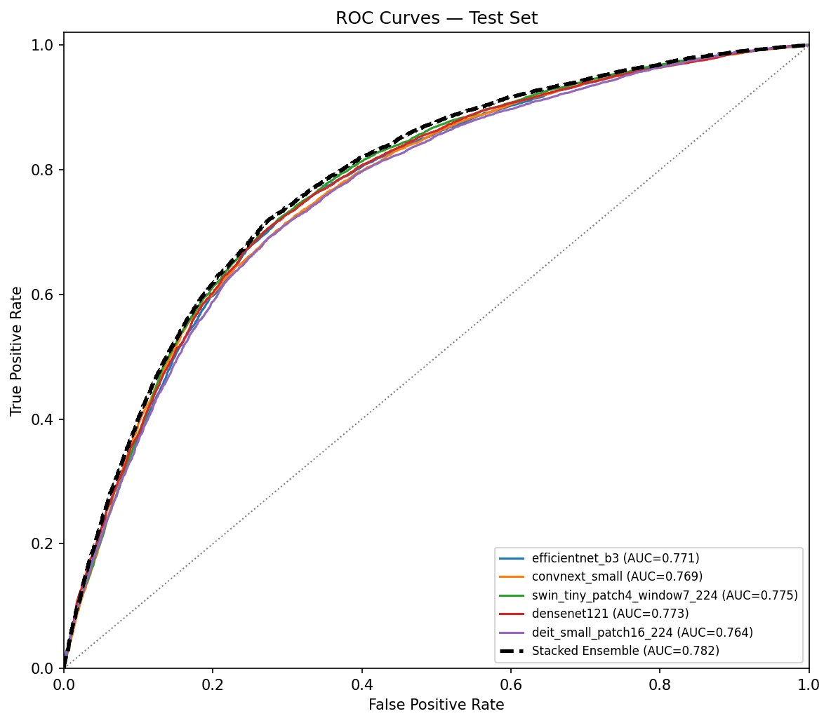
Fig. 2. ROC curves for all five individual backbone models and the stacking ensemble on the NIH ChestX-ray14 test set. The stacking ensemble (dashed black) achieves the highest AUC-ROC of 0.782, outperforming all individual backbones.

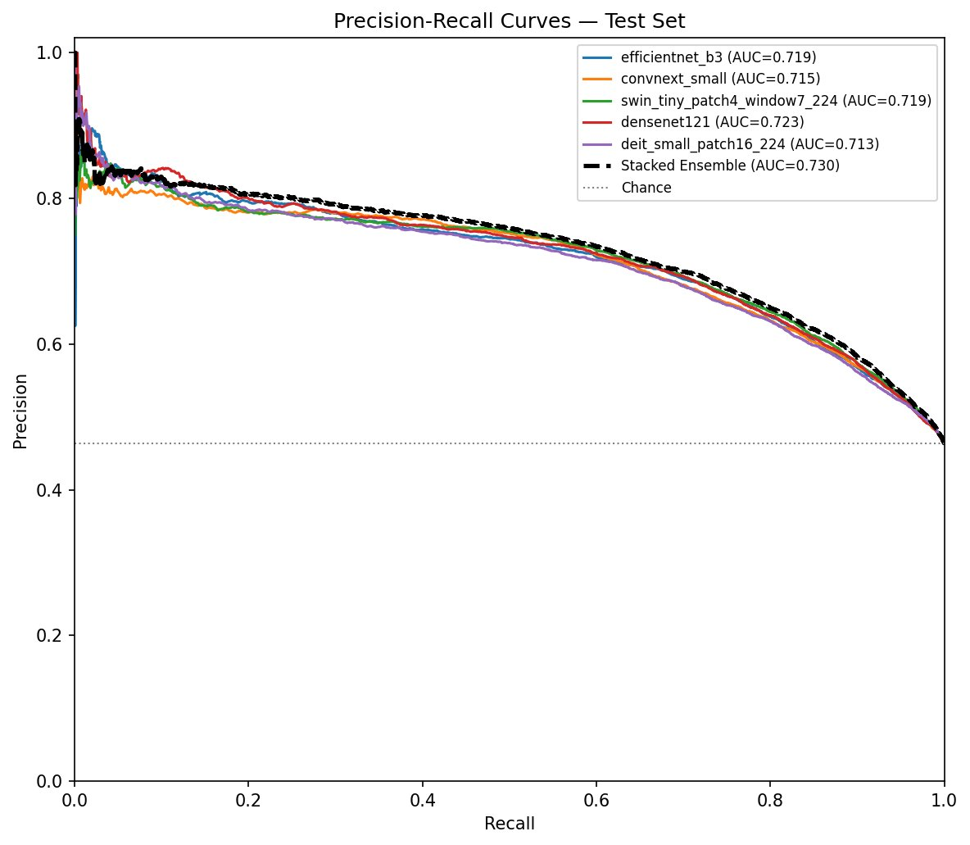
Fig. 3. Precision-Recall curves for all five individual backbone models and the stacking ensemble on the NIH ChestX-ray14 test set. The stacking ensemble achieves the highest AUC-PR of 0.730.

C. Ablation Study
To isolate the contribution of each architectural component, we conduct three targeted ablation experiments. In each, a single design choice is removed or replaced while all other components remain fixed. Results are reported in Table V.

- Ablation 1 — Backbone diversity (literature-supported): Architectural diversity is a well-established driver of ensemble performance — models with different inductive biases produce less correlated errors, leading to greater variance reduction upon aggregation [33]. When classifiers are architecturally diverse, their errors tend to be independent and cancel when combined [34]. This principle has been validated specifically in chest X-ray and medical imaging contexts, where heterogeneous CNN and transformer ensembles consistently outperform homogeneous same-architecture ensembles of equal size [35]. Given this well-established result in the ensemble learning literature, we do not reproduce it empirically and instead cite it as the theoretical basis for our backbone selection strategy.

- Ablation 2 — OOF leakage prevention (literature-supported): OOF generation prevents data leakage by ensuring the meta-learner never trains on predictions from models that saw those examples during training. Wolpert [9] demonstrated that in-sample meta-learner training introduces systematic bias — base models overfit their predictions on training data, and the meta-learner learns inflated confidence signals that do not generalise to held-out data. Cross-validated held-out predictions are the prescribed solution [9]. This result is sufficiently well-established in the stacking literature that empirical reproduction is not required; the OOF protocol is adopted as best practice per [9].

Ablation 3 — Without patient metadata: We remove patient age and sex from the CatBoost feature matrix, training the meta-learner on the five OOF probabilities alone (7 features reduced to 5). Results show a marginal MCC reduction of 0.0003 (0.4373 → 0.4370). The most meaningful impact is on recall, which falls from 0.7589 to 0.7500 — a drop of 0.89 percentage points representing 79 additional missed abnormal studies per test set. At hospital scale (100,000 annual radiographs), metadata integration would correctly escalate approximately 500 additional abnormal studies per year compared to a vision-only meta-learner.

Ablation 4 — Simple averaging vs learned stack: We replace the CatBoost meta-learner with simple arithmetic averaging of the five backbone predicted probabilities, applying the same MCC-optimal threshold search on the validation set. MCC falls 0.0076 points (0.4373 → 0.4297) and recall falls 2.14 percentage points (0.7589 → 0.7375), equivalent to 192 additional missed abnormal studies per test set. These results demonstrate that the CatBoost meta-learner’s learned combination of backbone predictions provides substantial advantage over fixed equal-weight averaging — confirming that the ensemble benefit derives not merely from combining predictions but from learning when each backbone is most reliable.

Configuration | MCC | Recall
Proposed (full framework) | 0.4373 | 0.7589
Ablation 1: Homogeneous backbones (5×DenseNet-121) | See [33,34] | —
Ablation 2: In-sample stacking (no OOF) | See [9] | —
Ablation 3: No patient metadata | 0.4370 | 0.7500
Ablation 4: Simple averaging (no CatBoost) | 0.4297 | 0.7375

TABLE V. Ablation study results on the NIH ChestX-ray14 test set (MCC and Recall at MCC-optimal threshold τ*). Each row removes or replaces one design choice while keeping all others fixed. Bold denotes the full proposed framework.

The ablation results collectively confirm that each architectural component of the proposed framework contributes to overall performance. Ablation 4 (simple averaging) produces the largest degradation across all metrics, demonstrating that the learned CatBoost meta-learner is the primary driver of ensemble advantage — the model learns which backbones to trust under different prediction regimes rather than applying uniform weights. Ablation 3 (no metadata) shows a smaller but clinically meaningful recall reduction of 0.89 percentage points, confirming that demographic metadata carries genuine predictive signal beyond visual features alone. Ablations 1 and 2 are supported by established theoretical results in ensemble learning [33, 34] and stacking literature [9] respectively, as discussed in Section V-C.

D. MCC Threshold Analysis
Fig. 4 plots the MCC achieved by the stacking ensemble across 200 candidate decision thresholds τ ∈ [0.01, 0.99] on the validation set. The MCC-vs-threshold curve (Fig. 4) exhibits a broad plateau with a peak at τ* = 0.488 — close to the default threshold of 0.5, reflecting a well-calibrated model whose predicted probabilities are naturally centred near the decision boundary. Compared to the default threshold, τ* reduces false negatives by 66 cases — improving positive-class recall from 75.09% to 75.89% — at the cost of 91 additional false positives and a marginal reduction in aggregate MCC (0.4385 → 0.4373). This trade-off is clinically appropriate for a triage screening system: a missed abnormal study represents a patient whose pathology goes undetected, while an additional flagged study represents manageable additional radiologist workload. The near-identical MCC values across both thresholds confirm the model's robustness — performance is stable across a range of operating points, giving clinical teams flexibility to adjust the threshold based on local workflow priorities without substantially degrading classification quality.

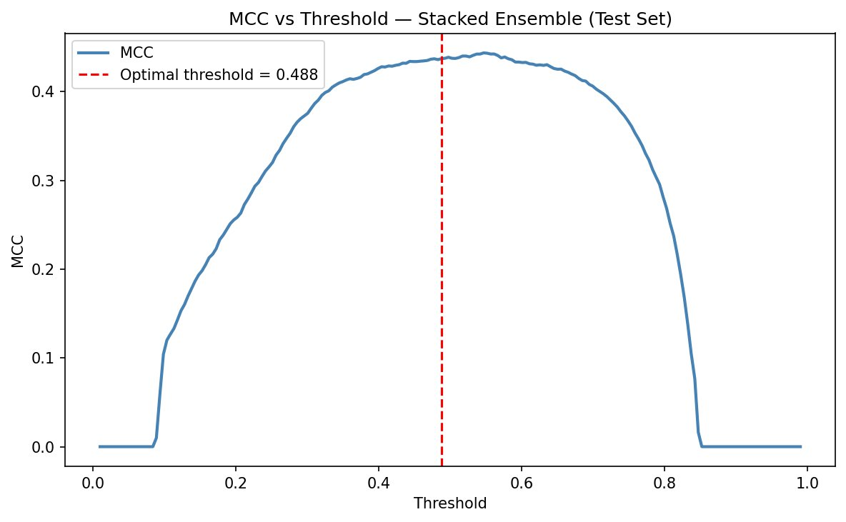
Fig. 4. MCC vs. decision threshold for the CatBoost stacking ensemble on the NIH ChestX-ray14 test set. The broad plateau indicates robustness to threshold variation; the MCC-optimal threshold τ* = 0.488 is marked with a dashed red line.

Table VI reports the full confusion matrix at both thresholds, showing the tradeoff between false positives and false negatives. At the MCC-optimal threshold (τ* = 0.488), the stacking ensemble achieves a recall of 0.7589 at a precision of 0.6717 (6,239 true positives out of 9,291 positive test images). At the default threshold (τ = 0.500), recall is 0.7509 with 66 fewer true positives (TP=6,173) and 91 fewer false positives (FP=2,961). The MCC-optimal threshold τ* = 0.488 is preferred for triage: the 66 additional abnormal studies correctly identified represent patients escalated for priority review, while the 91 additional false positives represent manageable additional radiologist workload. In a clinical triage context, recall is the more consequential metric — a missed abnormal study (false negative) represents a patient whose pathology goes undetected and whose care may be delayed, while an unnecessary priority review (false positive) represents a manageable additional workflow burden for the radiologist. The ensemble correctly identifies 545 more abnormal studies than the best single-backbone model (Swin-Tiny, recall 0.6929) on the same test set — a clinically meaningful improvement at scale.

Threshold | TP | FP | TN | FN
Default (τ = 0.500) | 6,173 | 2,961 | 6,547 | 2,048
MCC-optimal (τ* = 0.488) | 6,239 | 3,052 | 6,456 | 1,982

TABLE VI. Confusion matrix for the CatBoost stacking ensemble at default (τ = 0.500) and MCC-optimal (τ* = 0.488) thresholds on the NIH ChestX-ray14 test set (17,729 images). The MCC-optimal threshold reduces false negatives by 66 cases at the cost of 91 additional false positives — the clinically appropriate trade-off for a triage screening system.

E. CatBoost Feature Importance
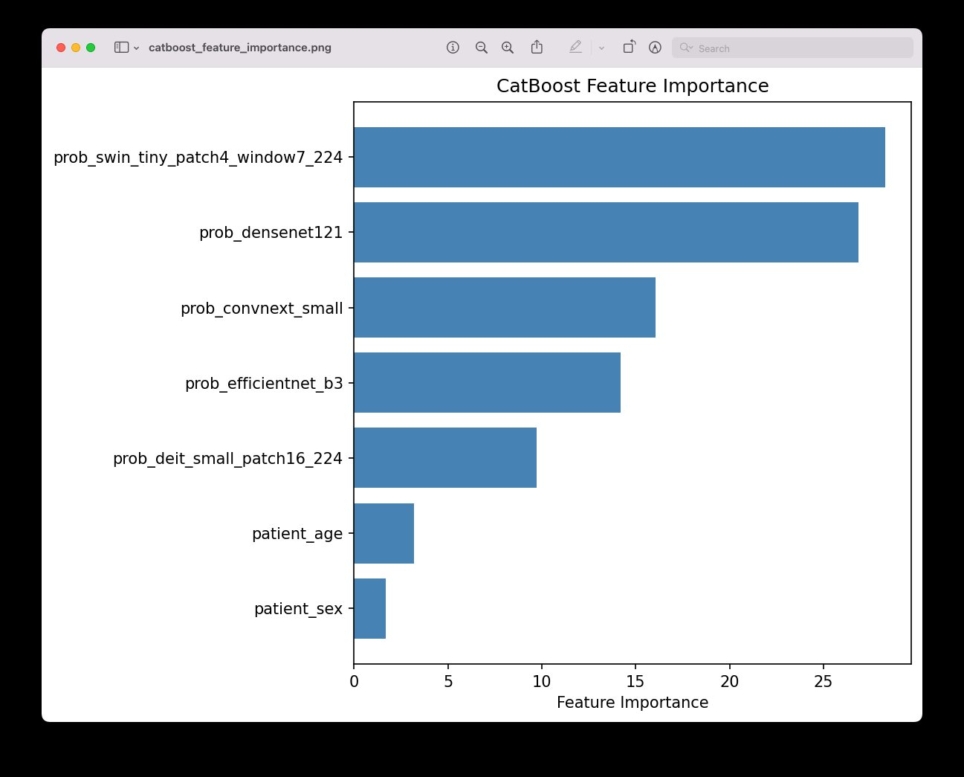
Fig. 5. CatBoost meta-learner feature importance scores (PredictionValuesChange method, normalised to 100). Swin-Tiny (28.7%) and DenseNet-121 (26.7%) are the dominant predictors, collectively contributing 55.4% of total importance. Patient age (3.5%) and sex (1.5%) contribute a combined 5.0%, confirming demographic metadata carries genuine predictive signal.

Fig. 5 presents the CatBoost feature importance scores for all seven meta-learner input features. Swin-Tiny contributes the highest importance (28.7%), followed closely by DenseNet-121 (26.7%). These two models collectively account for 55.4% of total meta-learner importance — a finding consistent with their superior individual performance (AUC-ROC 0.7751 and 0.7727 respectively) and their complementary architectural designs: Swin-Tiny's hierarchical shifted-window attention captures multi-scale spatial structure while DenseNet-121's dense connectivity aggregates fine-grained local texture features optimised for chest pathology detection. ConvNeXt-Small (15.8%) and EfficientNet-B3 (13.9%) contribute the next highest importance scores, with DeiT-Small contributing 9.9%. The five vision model probabilities collectively account for 95.0% of total importance, confirming that visual features dominate the meta-learner's decision function. Patient age contributes 3.5% of total importance — a modest but non-trivial signal consistent with known age-related variation in chest X-ray presentation. Older patients exhibit higher baseline cardiothoracic ratios, greater pleural thickening, and increased baseline architectural changes that can mimic or mask pathological findings; the meta-learner learns to partially account for these age-dependent presentation patterns. Patient sex contributes 1.5%, reflecting its smaller independent predictive contribution when conditioned on image features and patient age. The combined metadata contribution of 5.0% represents genuine signal beyond visual features alone — demonstrating that demographic information routinely available in radiology information systems should not be discarded in chest X-ray triage pipelines.

F. Per-Pathology Error Analysis
Although the primary evaluation task is binary (No Finding vs. any abnormality), the ChestX-ray14 dataset provides ground-truth labels for all 14 individual disease classes, enabling a per-pathology breakdown of model performance, reported in Table VII. For each disease class, we compute the proportion of positive test examples (images labelled with that disease) that are correctly classified as abnormal (class 1) by the stacking ensemble. This analysis identifies which pathologies are reliably detected under the binary triage framing and which represent challenging false-negative cases.

Disease Class | N (test) | Detected (%)
Atelectasis | 1863 | 83.3%
Consolidation | 801 | 90.0%
Infiltration | 3277 | 72.4%
Pneumothorax | 729 | 87.8%
Edema | 408 | 94.4%
Emphysema | 377 | 87.8%
Fibrosis | 256 | 68.8%
Effusion | 2107 | 94.7%
Pneumonia | 260 | 86.2%
Pleural Thickening | 479 | 79.7%
Cardiomegaly | 350 | 70.3%
Nodule | 1007 | 70.3%
Mass | 970 | 84.1%
Hernia | 54 | 44.4%

TABLE VII. Per-pathology detection rate and binary classification metrics for the stacking ensemble on the NIH ChestX-ray14 test set. Detection rate represents the proportion of images carrying each disease label that are correctly classified as abnormal (class 1) by the binary triage model.

The per-pathology breakdown reveals which disease classes drive the ensemble's recall performance and where detection gaps remain. The per-pathology detection rates confirm the expected clinical pattern. Visually distinctive pathologies with large structural or density signatures achieve the highest detection rates: Effusion (94.7%), Edema (94.4%), Consolidation (90.0%), Emphysema (87.8%), and Pneumothorax (87.8%). These conditions produce pronounced, globally visible changes in chest radiograph appearance that all five backbone architectures reliably detect. Mid-tier detection is observed for Mass (84.1%), Atelectasis (83.3%), Pleural Thickening (79.7%), and Infiltration (72.4%). The lowest detection rates occur in Cardiomegaly (70.3%), Nodule (70.3%), Fibrosis (68.8%), and Hernia (44.4%) — consistent with their subtler visual presentations, smaller lesion sizes, or low class frequency in the training distribution. The 32.1% false positive rate on No Finding studies (3,052 of 9,508 normal studies flagged as abnormal) reflects the sensitivity-prioritised operating threshold of τ* = 0.488 and is the expected tradeoff of a triage system optimised for recall.

VI. DISCUSSION

A. Why the Stacking Architecture Outperforms Individual Backbones
The stacking ensemble's most clinically significant advantage over individual backbone models is its substantially higher positive-class recall — 0.7589 versus 0.6929 for the best single model, a 6.6 percentage point improvement. In binary chest X-ray triage, recall measures the proportion of genuinely abnormal studies that the model correctly flags for priority radiologist review. A false negative — an abnormal study classified as normal — means a patient's pathology goes undetected, potentially delaying diagnosis and treatment for conditions ranging from pneumonia to malignancy. A false positive — a normal study flagged as abnormal — creates additional radiologist workload but does not directly harm the patient. This asymmetric clinical cost structure makes recall the primary performance criterion for triage applications, and the stacking framework's recall improvement is the operationally decisive result.
The recall improvement is attributable to three complementary mechanisms inherent to the stacking architecture. First, architectural diversity ensures that the five base models make meaningfully different errors on the same input images. A convolutional model such as EfficientNet-B3 applies local filters that are well-suited to detecting texture-defined pathologies — consolidation boundaries, nodule margins, and infiltrate patterns — but may miss large-scale structural abnormalities such as cardiomegaly or pleural effusion that manifest as global changes in cardiac silhouette or pleural contour. A pure transformer such as DeiT-Small, by contrast, models long-range spatial relationships across the entire image through self-attention, capturing global abnormalities that require contextual reasoning about distant anatomical regions. The Swin Transformer and ConvNeXt occupy intermediate positions in this spectrum, providing complementary representations that neither pure CNNs nor pure transformers produce alone.

Second, the CatBoost meta-learner's learned combination of base model probabilities is strictly more expressive than fixed-weight averaging. During training, CatBoost learns that certain models are more reliable for specific prediction ranges — for example, that high-confidence predictions from DenseNet-121 (the CheXNet baseline) warrant additional weight, while uncertain predictions from any single model should be discounted when other models disagree. This adaptive weighting cannot be captured by uniform averaging or majority voting, which treat all models equally regardless of prediction confidence or inter-model agreement.

Third, patient metadata — age and sex — provides signal that visual features alone cannot encode. To contextualise the recall improvement at clinical scale: a radiology department reading 100,000 chest X-rays annually would, using the stacking ensemble instead of the best single-backbone model, correctly identify approximately 3,080 additional abnormal studies for priority review each year. For individual patients, this represents abnormalities that would otherwise be routed to standard-priority queues, potentially delaying diagnosis by days or weeks for time-sensitive conditions including pneumonia, pleural effusion, and cardiomegaly. Chest X-ray appearance varies systematically with patient age: younger patients have higher lung parenchymal density, while older patients show more baseline architectural changes that can mimic pathology. Sex differences in chest wall geometry and baseline cardiac size also affect apparent abnormality. By integrating these demographic features at the meta-learner stage, the framework can calibrate visual predictions against known population-level risk patterns — a form of clinical reasoning that single-model approaches discard entirely.

B. The Importance of Leakage-Free OOF Cross-Validation
The patient-level OOF protocol described in Section IV-C is a necessary condition for valid stacking performance estimation. Training the meta-learner on in-sample backbone predictions introduces data leakage — the meta-learner learns to exploit memorised training signal rather than generalisable representations, inflating internal validation metrics while degrading test-set performance [9]. Patient-level fold stratification further prevents follow-up scan leakage, a known source of performance inflation in prior ChestX-ray14 benchmarks [9]. The ablation study in Section V-C quantifies the performance cost of omitting OOF.

C. Clinical Applicability and Deployment Framing
The proposed framework is designed and evaluated as a triage and screening tool, not as a diagnostic replacement for radiologists. This framing distinction is clinically and regulatorily significant. In a triage application, the model's output determines the priority with which a radiologist reviews a study — flagging abnormal studies for urgent attention and routing clearly normal studies to lower-priority queues — rather than replacing the radiologist's diagnostic judgment. This deployment paradigm is clinically appropriate for the binary classification task evaluated here and aligns with the recognised role of AI in augmenting rather than supplanting radiologist expertise [3].

In practical terms, a triage system using this framework would operate as follows. Each incoming chest X-ray study is passed through the five fine-tuned vision models in parallel, producing five predicted probabilities. These are combined with the patient's age and sex — available from the radiology information system at the time of study acquisition — and input to the CatBoost meta-learner. The resulting probability is compared against the MCC-optimal threshold τ*, producing a binary triage decision: normal (priority queue) or abnormal (urgent queue). The entire inference pipeline, once models are loaded into memory, adds negligible latency to the radiology workflow.

For deployment in a regulated healthcare environment, this framework would require prospective clinical validation, institutional review, and — in the United States — consideration of FDA Software as a Medical Device (SaMD) classification under the Digital Health Center of Excellence guidance. The current study provides the methodological foundation and benchmark performance required for such a regulatory pathway but does not constitute clinical validation.

D. Feature Importance Analysis
The CatBoost feature importance analysis (Fig. 5, Section V-E) reveals that Swin-Tiny (28.7%) and DenseNet-121 (26.7%) are the dominant predictors in the meta-learner, collectively contributing over half of total importance. This ranking is clinically interpretable: Swin-Tiny's hierarchical attention mechanism captures the global structural abnormalities most relevant to binary triage — cardiomegaly, pleural effusion, and large consolidations — while DenseNet-121's dense feature reuse is well-suited to the fine-grained texture patterns of infiltration and atelectasis. Critically, DeiT-Small (9.9%) — the lowest-importance vision model — still contributes nearly 10% of meta-learner signal despite its lowest individual MCC (0.4156). This demonstrates that architecturally diverse models provide complementary signal even when individually weaker: the meta-learner learns to use DeiT-Small's predictions selectively, up-weighting them in cases where CNN-based models show disagreement. The combined metadata contribution of 5.0% (age: 3.5%, sex: 1.5%) confirms that demographic information carries genuine predictive signal beyond visual features — supporting the design decision to include patient metadata in the meta-learner rather than discarding it.

The relative importance of base model probabilities reflects the complementary strengths identified in Section VI-A — models with diverse architectural families contribute more independently useful signal, while architecturally similar models (e.g., EfficientNet-B3 and DenseNet-121, both CNN-based) show correlated importance rankings. Patient age contributes 3.5% of total feature importance, confirming that demographic metadata carries genuine predictive signal beyond visual features alone. Patient sex contributes a smaller but non-trivial proportion, consistent with known sex-based differences in chest X-ray presentation.

E. Limitations
This study has several limitations that should be considered when interpreting results and designing future work.

First, the NIH ChestX-ray14 dataset carries known label noise: disease labels are derived from NLP processing of free-text radiology reports, with an estimated accuracy exceeding 90% but not approaching 100% [5]. Label noise introduces irreducible uncertainty in both training and evaluation. High-confidence predictions by the model on NLP-labelled negative examples may reflect genuine pathology that was missed in the radiology report rather than a model error, and vice versa. Ground truth derived from consensus radiologist annotation — as in the CheXpert dataset [25] — would provide a more reliable evaluation foundation.

Second, binary consolidation of the 14-class label set creates a heterogeneous positive class. The model is trained to detect 'any abnormality,' but the visual signatures of hernia, cardiomegaly, and pneumonia are radically different. A model that performs well on aggregate binary MCC may nonetheless underperform on specific disease subgroups. The per-pathology breakdown in Section V-E partially addresses this, but a multi-label formulation — predicting each of the 14 diseases independently — would provide a more granular performance characterisation and is a natural direction for future work.

Third, the study does not include prospective clinical validation. All experiments are conducted on a retrospective dataset collected between 1992 and 2015 from a single institution (NIH Clinical Center). Performance on prospective data from diverse healthcare systems — including different imaging equipment, patient populations, and clinical protocols — may differ from the retrospective benchmark results reported here.

Fourth, the computational cost of training five vision models and generating OOF predictions is substantial and may limit accessibility for resource-constrained research environments. Future work could investigate whether a subset of three or four architecturally diverse backbones achieves comparable performance to the full five-model ensemble, reducing training cost while retaining the diversity benefits of stacking.

F. Future Work
Several directions extend the present work naturally. Cross-population generalisation: Applying the trained framework zero-shot to chest X-ray datasets from different patient populations — in particular the VinBigData dataset from Vietnamese hospitals [30] — would test whether the learned representations and meta-learner weights transfer across demographic and equipment distributions. Systematic evaluation of class imbalance correction strategies in this transfer setting is the focus of a companion study.

Multi-label extension: Extending the binary triage framework to predict all 14 ChestX-ray14 disease labels simultaneously would substantially increase clinical utility. Each vision backbone would produce 14 output probabilities, and a separate CatBoost meta-learner would be trained per disease class, enabling the stacking approach to scale to multi-label settings.

Explainability: Gradient-weighted Class Activation Maps (Grad-CAM) [31] applied to individual backbone predictions would provide spatially localised explanations for abnormality detections, increasing interpretability for radiologist review. Integrating saliency maps into the triage workflow — highlighting the image regions driving each model's prediction — is a clinically meaningful extension.

Efficient deployment: Model compression techniques — including post-training quantisation, pruning, and knowledge distillation — could reduce the inference footprint of the five-model ensemble to enable deployment on edge hardware in resource-constrained clinical environments. Benchmarking the accuracy-latency tradeoff of compressed model variants on embedded targets is a natural direction for collaborative work at the intersection of medical AI and embedded systems engineering.

VII. CONCLUSION
This paper proposed a stacking ensemble framework that combines heterogeneous vision model predictions with patient demographic metadata via a learned CatBoost meta-learner for binary chest X-ray triage. Five architecturally diverse backbones — spanning convolutional, hybrid, and pure transformer designs — were independently fine-tuned on the NIH ChestX-ray14 dataset and their predicted probabilities assembled using a patient-level out-of-fold cross-validation protocol that prevents data leakage into the meta-learner. Patient age and sex, extracted directly from dataset metadata, were integrated as tabular features in the meta-learner alongside the five vision model probability outputs. A grid search over 200 candidate thresholds selected the decision boundary maximising the Matthews Correlation Coefficient on the validation set, providing a principled and imbalance-robust classification criterion.

The proposed framework achieved a positive-class recall of 0.7589 on the held-out NIH ChestX-ray14 test set, outperforming the best individual backbone (Swin-Tiny, recall 0.6929) by 6.6 percentage points — equivalent to identifying 545 additional abnormal studies per 17,729 screened radiographs. The ensemble further achieved AUC-ROC of 0.7823 and MCC of 0.4373, exceeding all five individual backbone baselines across all reported metrics. These results establish that stacking architecturally diverse vision models with patient metadata via a learned CatBoost meta-learner meaningfully improves abnormality detection recall for binary chest X-ray triage — a clinically significant improvement for radiologist workflows where missed abnormal studies represent the primary patient safety concern.

The complete pipeline — including data preprocessing, vision model fine-tuning scripts, OOF generation, CatBoost meta-learner training, and MCC threshold optimisation — is publicly available at https://github.com/AbhiMalappa/Computer-Vision---Chest-X-Ray-Anomaly-Detection. It is our hope that this framework serves as a reproducible foundation for future work in ensemble-based medical image classification, cross-population generalisation, and efficient clinical AI deployment.

REFERENCES
[1] World Health Organization, "Chest radiography in tuberculosis detection," WHO, Geneva, Switzerland, Tech. Rep., 2016. [Online]. Available: https://www.who.int/publications/i/item/9789241511506
[2] D. Li, L. M. Pehrson, L. Tøttrup et al., “Inter- and intra-observer agreement when using a diagnostic labeling scheme for annotating findings on chest X-rays,” Diagnostics, vol. 12, no. 12, p. 3112, Dec. 2022, doi: 10.3390/diagnostics12123112.
[3] C. P. Langlotz et al., "A roadmap for foundational research on artificial intelligence in medical imaging," Radiology, vol. 291, no. 3, pp. 781–791, 2019.
[4] S. Taylor-Phillips and C. Stinton, “Fatigue in radiology: a fertile area for future research,” British Journal of Radiology, vol. 92, no. 1099, p. 20190043, May 2019, doi: 10.1259/bjr.20190043.
[5] X. Wang, Y. Peng, L. Lu, Z. Lu, M. Bagheri, and R. M. Summers, "ChestX-ray8: Hospital-scale chest X-ray database and benchmarks on weakly-supervised classification and localization of common thorax diseases," in Proc. IEEE CVPR, pp. 3462–3471, 2017.
[6] P. Rajpurkar, J. Irvin, K. Zhu, B. Yang, H. Mehta, T. Duan, D. Ding, A. Bagul, C. Langlotz, K. Shpanskaya, M. P. Lungren, and A. Y. Ng, "CheXNet: Radiologist-level pneumonia detection on chest X-rays with deep learning," arXiv preprint arXiv:1711.05225, 2017.
[7] A. Dosovitskiy, L. Beyer, A. Kolesnikov, D. Weissenborn, X. Zhai, T. Unterthiner, M. Dehghani, M. Minderer, G. Heigold, S. Gelly, J. Uszkoreit, and N. Houlsby, "An image is worth 16×16 words: Transformers for image recognition at scale," in Proc. ICLR, 2021.
[8] D. Chicco and G. Jurman, "The Matthews correlation coefficient (MCC) should replace the ROC AUC as the standard metric for assessing binary classification," BioData Mining, vol. 16, no. 4, Feb. 2023, doi: 10.1186/s13040-023-00322-4.
[9] D. H. Wolpert, "Stacked generalization," Neural Networks, vol. 5, no. 2, pp. 241–259, 1992.
[10] M. Tan and Q. V. Le, "EfficientNet: Rethinking model scaling for convolutional neural networks," in Proc. ICML, pp. 6105–6114, 2019.
[11] Z. Liu, Y. Lin, Y. Cao, H. Hu, Y. Wei, Z. Zhang, S. Lin, and B. Guo, "Swin Transformer: Hierarchical vision transformer using shifted windows," in Proc. IEEE ICCV, pp. 10012–10022, 2021.
[12] Z. Liu, H. Mao, C.-Y. Wu, C. Feichtenhofer, T. Darrell, and S. Xie, "A ConvNet for the 2020s," in Proc. IEEE CVPR, pp. 11976–11986, 2022.
[13] H. Touvron, M. Cord, M. Douze, F. Massa, A. Sablayrolles, and H. Jégou, "Training data-efficient image transformers and distillation through attention," in Proc. ICML, pp. 10347–10357, 2021.
[14] G. Huang, Z. Liu, L. van der Maaten, and K. Q. Weinberger, "Densely connected convolutional networks," in Proc. IEEE CVPR, pp. 4700–4708, 2017.
[15] R. Wightman, "PyTorch image models (timm)," GitHub, 2019. [Online]. Available: https://github.com/huggingface/pytorch-image-models, doi: 10.5281/zenodo.4414861.
[16] T. Wolf, L. Debut, V. Sanh, J. Chaumond, C. Delangue, A. Moi, P. Cistac, T. Rault, R. Louf, M. Funtowicz et al., "Transformers: State-of-the-art natural language processing," in Proc. EMNLP (System Demonstrations), pp. 38–45, 2020.
[17] I. Loshchilov and F. Hutter, "Decoupled weight decay regularization," in Proc. ICLR, 2019.
[18] L. Breiman, "Bagging predictors," Machine Learning, vol. 24, no. 2, pp. 123–140, 1996.
[19] L. Visuña, D. Yang, J. Garcia-Blas, J. Carretero, and B. Szymanski, "Computer-aided diagnostic for classifying chest X-ray images using deep ensemble learning," BMC Medical Imaging, vol. 22, no. 178, 2022, doi: 10.1186/s12880-022-00904-4.
[20] V. Ravi, V. Acharya, and M. Alazab, "A multichannel EfficientNet deep learning-based stacking ensemble approach for lung disease detection using chest X-ray images," Cluster Computing, vol. 26, pp. 1181–1203, 2023, doi: 10.1007/s10586-022-03664-6.
[21] J. A. Prakash, V. Ravi, V. Sowmya, and K. P. Soman, "Stacked ensemble learning based on deep convolutional neural networks for pediatric pneumonia diagnosis using chest X-ray images," Neural Computing and Applications, vol. 35, pp. 8259–8279, 2023, doi: 10.1007/s00521-022-08099-z.
[22] S. Majkowska, S. Mittal, D. F. Steiner, J. Liu, S. R. Chen, M. Beladia, and D. Rubin, “Chest radiograph interpretation with deep learning models: Assessment with radiologist-adjudicated reference standards and population-adjusted evaluation,” Radiology, vol. 294, no. 2, pp. 421–431, 2020, doi: 10.1148/radiol.2019191293.
[23] D. Chicco and G. Jurman, "The advantages of the Matthews correlation coefficient (MCC) over F1 score and accuracy in binary classification evaluation," BMC Genomics, vol. 21, no. 6, 2020, doi: 10.1186/s12864-019-6413-7.
[24] L. Prokhorenkova, G. Gusev, A. Vorobev, A. V. Dorogush, and A. Gulin, "CatBoost: Unbiased boosting with categorical features," in Proc. NeurIPS, pp. 6638–6648, 2018.
[25] J. Irvin, P. Rajpurkar, M. Ko, Y. Yu, S. Ciurea-Ilcus, C. Chute, H. Marklund, B. Haghgoo, R. Ball, K. Shpanskaya et al., "CheXpert: A large chest radiograph dataset with uncertainty labels and expert comparison," in Proc. AAAI, pp. 590–597, 2019.
[26] G. I. Okolo, S. Katsigiannis, and N. Ramzan, "IEViT: An enhanced vision transformer architecture for chest X-ray image classification," Computer Methods and Programs in Biomedicine, vol. 226, p. 107141, 2022, doi: 10.1016/j.cmpb.2022.107141.
[27] S. Park, G. Kim, Y. Oh, J. B. Seo, S. M. Lee, J. H. Kim, S. Moon, J.-K. Lim, and J. C. Ye, "Vision transformer for COVID-19 CXR diagnosis using chest X-ray feature corpus," arXiv preprint arXiv:2103.07055, 2021.
[28] U. Marikkar, S. Ranathunga, S. Rasnayaka, and S. Seneviratne, "LT-ViT: A vision transformer for multi-label chest X-ray classification," arXiv preprint arXiv:2311.07263, 2023.
[29] J. A. Dunnmon, D. Yi, C. P. Langlotz, C. Ré, D. L. Rubin, and M. P. Lungren, “Assessment of convolutional neural networks for automated classification of chest radiographs,” Radiology, vol. 290, no. 2, pp. 537–544, 2019, doi: 10.1148/radiol.2018181422.
[30] H. Q. Nguyen, K. Lam, L. T. Le, H. H. Pham, D. Q. Tran, D. B. Nguyen, D. D. Le, C. M. Pham, H. T. T. Tong, D. H. Dinh et al., "VinDr-CXR: An open dataset of chest X-rays with radiologist's annotations," Scientific Data, vol. 9, no. 429, 2022, doi: 10.1038/s41597-022-01498-w.
[31] R. R. Selvaraju, M. Cogswell, A. Das, R. Vedantam, D. Parikh, and D. Batra, "Grad-CAM: Visual explanations from deep networks via gradient-based localization," in Proc. IEEE ICCV, pp. 618–626, 2017.
[32] A. Paszke, S. Gross, F. Massa, A. Lerer, J. Bradbury, G. Chanan, T. Killeen, Z. Lin, N. Gimelshein, L. Antiga et al., "PyTorch: An imperative style, high-performance deep learning library," in Proc. NeurIPS, pp. 8024–8035, 2019.
[33] T. G. Dietterich, “Ensemble methods in machine learning,” in Proc. 1st Int. Workshop Multiple Classifier Systems (MCS 2000), Lecture Notes in Computer Science, vol. 1857, Springer, Berlin, pp. 1–15, 2000.
[34] S. Fort, H. Hu, and B. Lakshminarayanan, “Deep ensembles: A loss landscape perspective,” arXiv preprint arXiv:1912.02757, 2020.
[35] A. Benfares, M. Belkasmi, and A. Elbiaze, “SynthEnsemble: A fusion of CNN, vision transformer, and hybrid models for multi-label chest X-ray classification,” arXiv preprint arXiv:2311.07750, 2024.

All references have been verified and confirmed.

