Ans 1:-

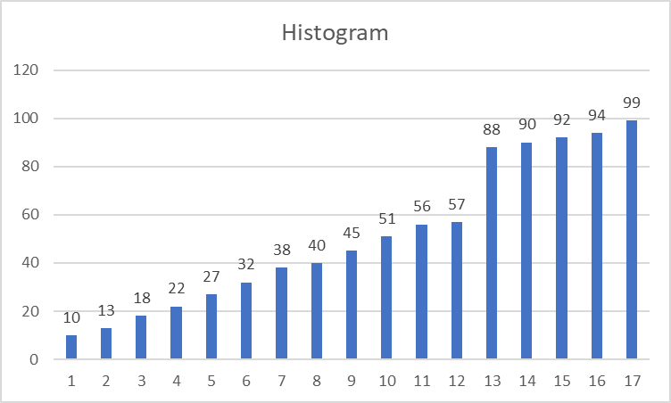

Ans 2:- Population Standard Deviation :- µ = 100

No of Sample :- n = 25

Sample of Mean:- X̄ = 520

CI:- CI= 80%

Significance Value:- α = 1-CI = 20%

Here we will use Z-test to 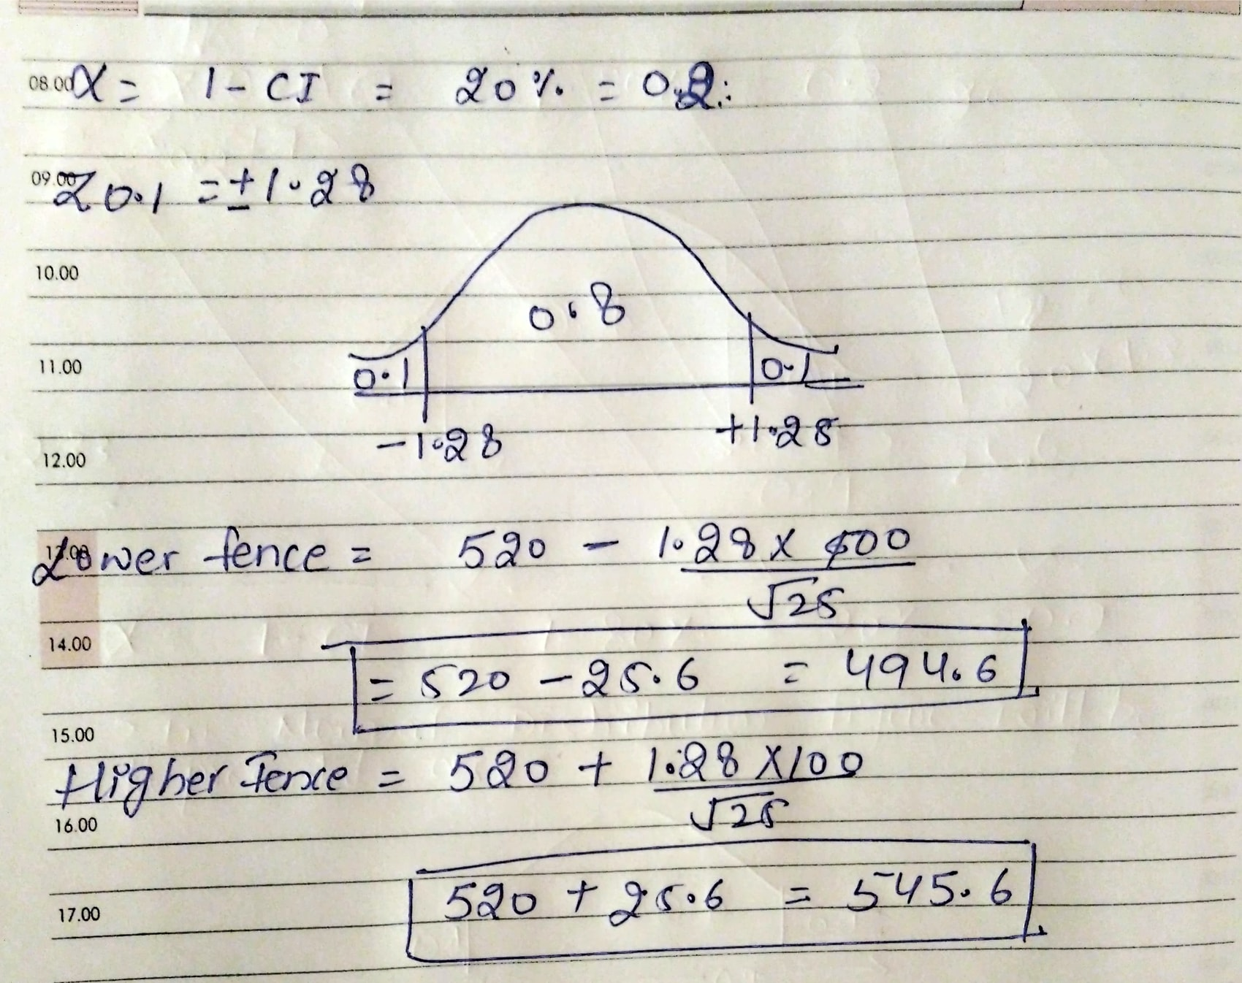

Ans 3:- Sample Popolation:- n = 250

People owning Car:- 170

Signifiance Level:- α = 10% or 0.1

i) Null & Alternate hypothesis:-

According to the quest:-

H0 <= 60% ( People owning vechile equal or less than 60 %)

H1 > 60% ( People owning vechile greater than 60 %)

ii) Hypothesis Testing (One Tail Z-test with proportion)

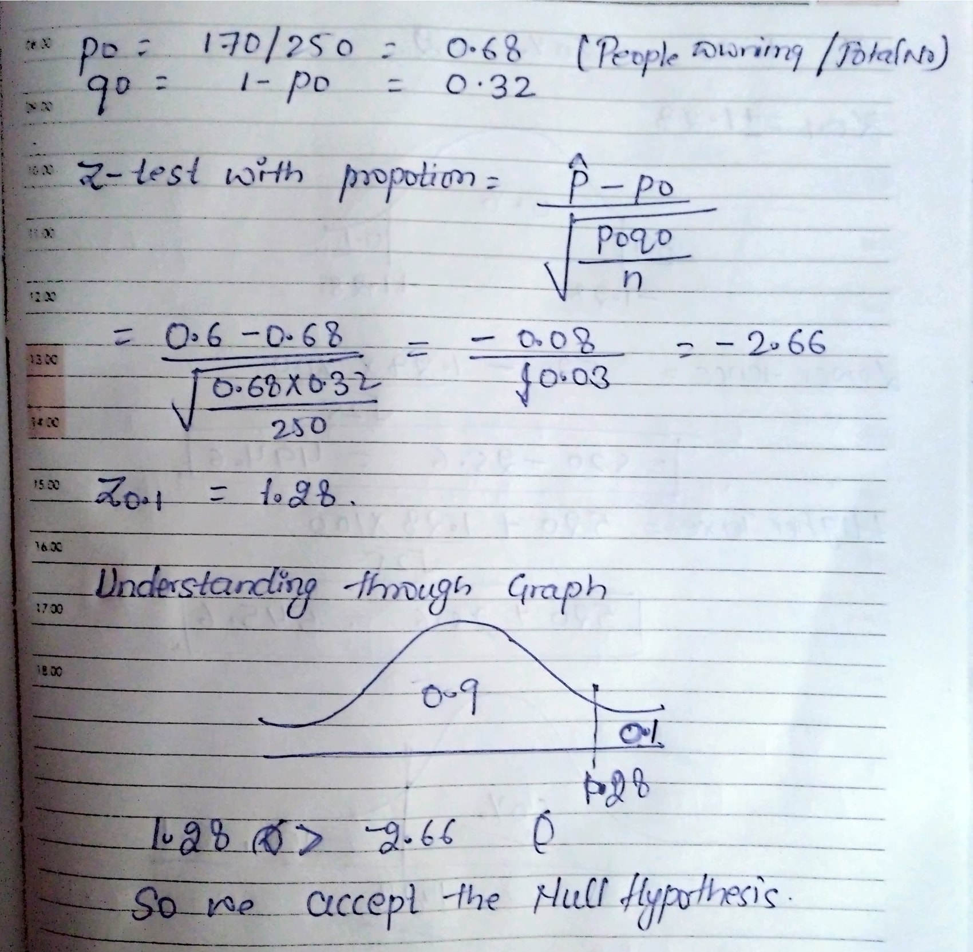

Ans 4:- Total No of Values:- N = 20

Percentile to be calculated:- % = 99%

Value (n) = Percentile \* N

= 0 .99\*20

= 19.8

Checking 19.8 ~ 20, we will consider value of 12

Ans 5:-

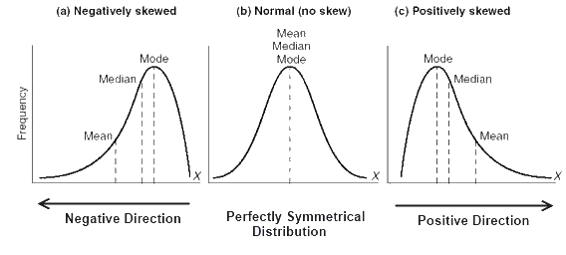

In Left Skewed:- Mean<Median<Mode

In Right Skewed:- Mean>Median>Mode