**Naive Bayesian: with the following training dataset, find the prediction.**

Predict:

Outlook=sunny, Temperature=Cool, Humidity=High, Wind=True

===🡺Play golf or NOT?

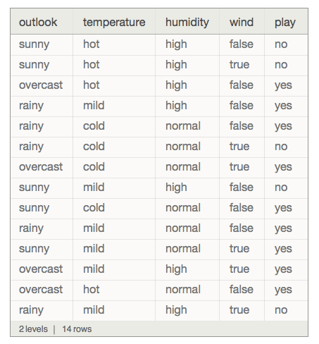

Will find the answer according to following equation: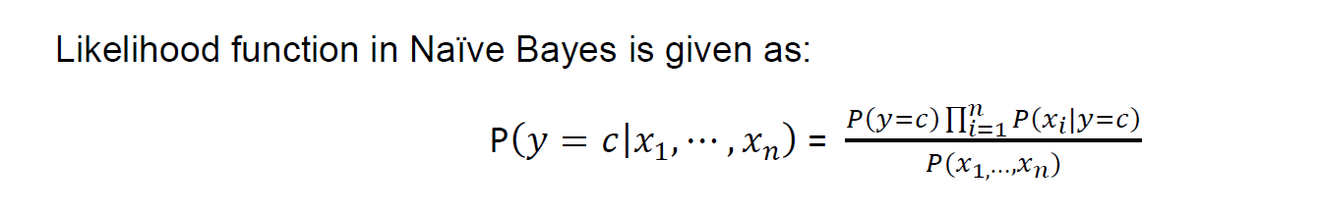

Step 1: create the sub tables based on the all exiting attributes in dataset.

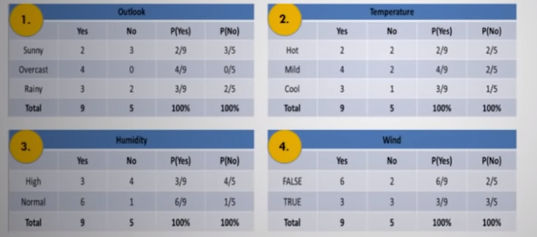

Step 2: Find the probability of the “Yes” and “No “based on the training dataset.

P(Yes)=9/14

P(No)=5/14

Step 3: the result will be:

P(Yes|Xi)= P(yes)*P(sunny|yes)*p(Cool|yes)*P(High|yes)*P(True|yes) / p(Suuny,cool,high,True)

P(Yes|Xi)=(9/14*2/9*3/9*3/9*3/9)/ (5/14*4/14*7/14*6/14)= 0.2424 This is the likelihood of YES- And the probability of YES is around 20%.

0.2424/(0.2424+0.9421)=0.2046 ~ 20%

----------------------------------------

P(No|Xi)= P(No)*P(sunny|No)*p(Cool|No)*P(High|No)*P(True|No) / p(Suuny,cool,high,True)

P(No|Xi)=(5/14*3/5*1/5*4/5*3/5)/ (5/14*4/14*7/14*6/14)= 0.9421 This is the likelihood of NO- And the probability of NO is around 80%.

0.9421/(0.2424+0.9421)=0.7953 ~ 80%

Step 4:

So, the result of the predict is “NO”. They are not allowed to play golf, when the Outlook=sunny, Temperature=Cool, Humidity=High, Wind=True.

P(No|Xi) > P(Yes|Xi)

0.9421>0.2424