Algonquin College Logo

# SCHOOL OF ADVANCED TECHNOLOGY

### ICT - Applications & Programming

### Computer Engineering Technology – Computing Science



A11

Game Interface

Team:

Abhi Patel - Id: 041048533 / [Student Name] - Id: [Student Id]

Game Proposal - Battleship

***This template is suggested (not mandatory) to answer A11 Specification.***

|  |  |
| --- | --- |
| **Part**  **1** | **GUI Definition** |

**EXPLANATION**

*The purpose of this assignment is to define the elements of the GUI application to be used in your game implementation.*

* ***Example (Prof. suggestion)****:*

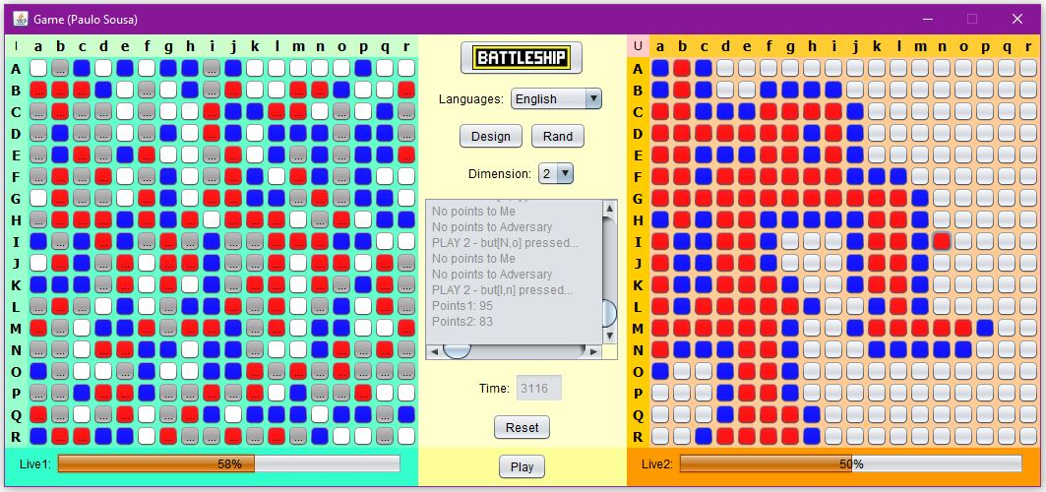

* ***Note****: The professor interface is also a proposal. It means that your own implementation can be different. What does matter is that the game functionality will be respected.*
  1. **Defining the Functionalities**

**Main Behavior**

*The game will be written using Java Swing. The game will consist of three panels. One is Left Board Panel, second is Right Board Panel and third is Center Panel. The Panels will be JPanels. The Board Squares will be JButtons. There will be a a message box in the center of the screen which will be a JTextArea. The user interface buttons will also be JButtons. JLables will be used to label the board squares. JComboBox will be used to select the anguage and the dimension and two JProgressBars*

*will be used to indicate what percentage of the computer’s and user’s ships have been selected. Two GridLayout, layout managers and a BoxLayout, layout manager will be used to organize the components that are the game’s user interface.*

**Functionalities and Behaviors**

*Check, for example, on-line examples (*[*https://www.battleshiponline.org/*](https://www.battleshiponline.org/)*):*

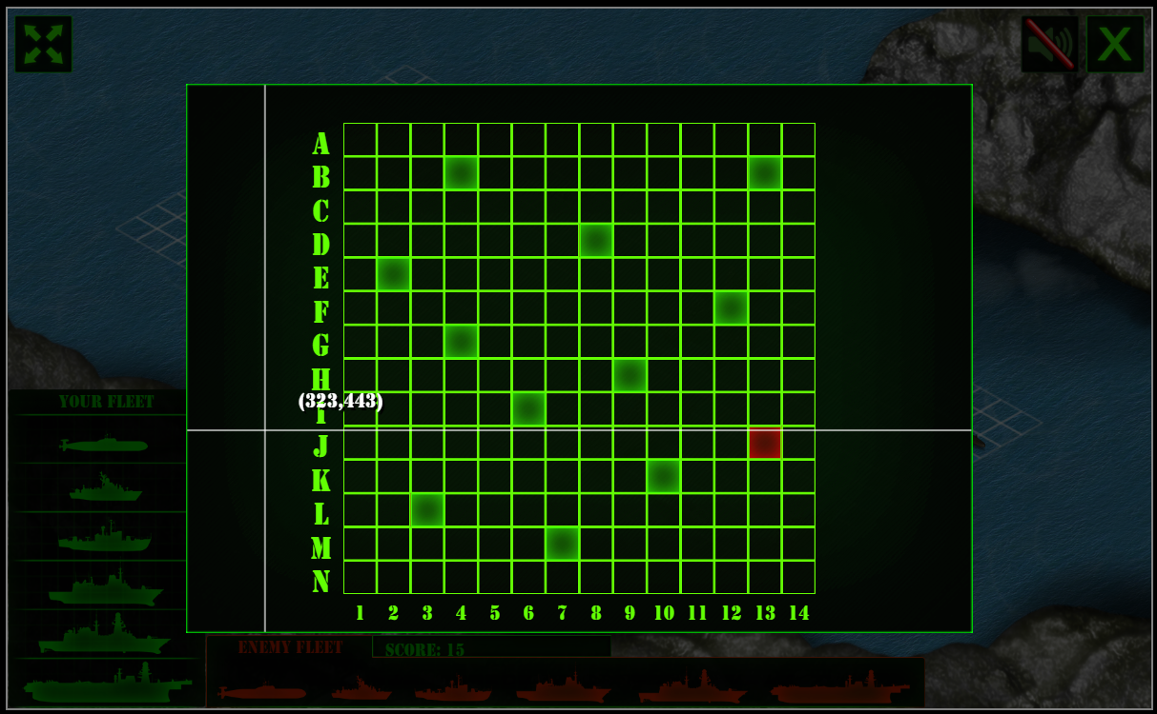

*What are the behaviors and functionalities that you will provide? How these elements are related with functionalities.*

***Example****: Answer these questions:*

* *Who are the actors (who can design / play the game)?*

*This game can be played with one player and one computer. The player can place ships manually or they can be placed randomly by the computer. The computer ships are placed randomly when the game starts.*

* *What are the preconditions (requirements) for some functionalities?*

*A board size between 4 to 9 must be selected by the user. The user needs to press the design button or random button. The user presses the play button to start the game.*

* *And the post-conditions / results?*

*If the user presses the design button, then the user can click on the user board to place his ships, if the user presses the rand button the computer should place the ships for the user, If the user presses the play button the game should begin with the user and computer selecting squares and trying to find ships on the other player’s board. When the player or the computer has found all the ships the player or the computer wins. Two progress bars keep track of how many correct squares have been selected by the user and computer and the progress bar are updated as the user and the computer select squares.*

**Languages**

*This game can be played in two different languages one is English and another one is French.*

**Details**

* 1. **User Manual**

**Basic cycle**

*The user presses a square on the right side of the screen to select a square on the computer’s board. If the user selects a square with a ship on it the square becomes red if the user selects a square without a ship on it the square becomes blue. The computer then selects a square on the left side of the screen to select a square on the user’s board. If the computer selects a square with a ship on it, the square becomes red. If the computer selects a square without a ship on it, the squares become blue. If the user selects all the computer ships or the computer selects all the user ships the game is over and the user or computer has won. There is a timer that keeps track of how much time the game has been played and when the game is over the timer stops.*

**FINAL SUGGESTIONS**

*Here some ideas to think about your language....*

* *Try to create a game whose execution can be very intuitive (easy to be played).*
* *Remember that this game will be in fact implemented only in the next assignment.*

**References**

<https://drawio-app.com/blog/uml-use-case-diagrams-with-draw-io/>

[*https://www.battleshiponline.org/*](https://www.battleshiponline.org/)

*.*

Algonquin College

Summer, 2023