Organic Agro Processing Unit

Location: Anantapur, Andhra Pradesh

Currency: INR

Capacity: 500

Short Description: Establishing a small-scale agro processing unit for producing organic millet-based snacks and flours.

# Executive Summary

**Executive Summary**

This Detailed Project Report (DPR) outlines the establishment of a small-scale organic agro processing unit in Anantapur, Andhra Pradesh. The primary objective is to produce high-quality, value-added products derived from organic millet, catering to the growing demand for healthy and sustainable food options. The project aims to contribute to the local economy by creating employment opportunities, supporting organic farming practices, and promoting the consumption of nutritious millet-based products.

**Project Overview:**

The project encompasses the entire value chain, from sourcing organic millet grains to processing and packaging finished products. The processing unit will focus on producing a range of millet-based snacks and flours, targeting both local and regional markets. The unit's operational efficiency will be prioritized by incorporating modern processing techniques, ensuring consistent product quality, and adhering to organic certification standards.

**Products and Target Market:**

* **Products:** The initial product range will include various millet flours (e.g., ragi, jowar, bajra), and organic millet snacks such as cookies and extruded products. Product diversification will be explored based on market feedback and consumer preferences.

* **Target Market:** The primary target market includes health-conscious consumers, individuals seeking gluten-free alternatives, and those interested in supporting sustainable food systems. The products will be marketed through various channels, including local retail stores, health food stores, online platforms, and potentially direct sales at farmers' markets.

**Financial Projections and Sustainability:**

The financial projections for the project, detailed further in the report, are based on a comprehensive market analysis and estimated production costs. The unit is designed to be financially sustainable, generating revenue through product sales and creating a profitable business model. The project's sustainability relies on the following factors:

* **Sourcing Organic Millet:** Establishing strong relationships with local organic farmers to secure a consistent supply of raw materials.

* **Efficient Processing:** Implementing optimized processing techniques to minimize waste and maximize yield.

* **Effective Marketing:** Building brand awareness and promoting the health benefits of millet-based products.

The project is designed to contribute to sustainable agricultural practices and promote environmental responsibility. Through the use of organic farming practices and efficient processing methods, the unit aims to minimize its environmental footprint and promote ecological balance.

# Project Description

**Project Description**

This document outlines the establishment of a small-scale organic agro processing unit in Anantapur, Andhra Pradesh, focusing on the production of organic millet-based snacks and flours. The project aims to capitalize on the growing demand for healthy and locally sourced food products while contributing to the economic development of the region.

**Project Goals and Objectives:**

The primary goal of this project is to create a sustainable and profitable agro-processing unit. Key objectives include:

* Establishing a dedicated facility for processing organic millet.

* Producing high-quality, organic millet-based snacks and flours that meet consumer demand.

* Procuring organic millet from local farmers, supporting their livelihoods and promoting organic farming practices.

* Creating employment opportunities within the local community.

* Achieving a sustainable and profitable business model.

**Product Details:**

The unit will focus on processing various types of millet, including but not limited to, finger millet (ragi), pearl millet (bajra), and foxtail millet. The product portfolio will comprise of:

* **Millet Flours:** Finely milled flours suitable for baking and cooking. Variations might include single-grain flours and blended options.

* **Ready-to-eat Snacks:** Organic millet-based snacks such as cookies, biscuits, and extruded snacks (e.g., puffed millet snacks) with various flavors and nutritional profiles.

* **Other Value-Added Products:** Depending on market demand, this could include breakfast cereals, millet-based porridge mixes, and specialized nutritional products.

**Operational Process:**

The agro-processing unit will implement a streamlined and efficient operational process. This includes:

* **Sourcing:** Establishing a reliable supply chain with local organic farmers, ensuring consistent access to high-quality raw materials.

* **Cleaning & Grading:** Millet will undergo rigorous cleaning and grading processes to remove impurities and ensure uniform particle size.

* **Processing:** This stage involves various processes depending on the product, including milling, extrusion, baking, and packaging. All processes will be designed to maintain the organic integrity of the millet.

* **Quality Control:** Stringent quality control measures will be implemented at every stage of production, from raw material inspection to final product testing.

* **Packaging & Distribution:** Products will be packaged in eco-friendly and attractive packaging, ensuring product freshness and shelf life. Distribution will focus on local markets, health food stores, and online platforms.

# Market Analysis

**Market Analysis**

This section details the market landscape for organic millet-based snacks and flours, focusing on the target market and competitive environment in Anantapur, Andhra Pradesh.

**Subtitle: Target Market Identification**

The primary target market for this organic agro processing unit consists of health-conscious consumers, particularly those seeking natural, nutritious, and convenient food options. This includes:

* **Health-conscious individuals:** Individuals actively seeking healthy alternatives to conventional snacks and flours, driven by concerns about artificial ingredients, preservatives, and refined carbohydrates.

* **Consumers with dietary restrictions:** Individuals with gluten intolerance, diabetes, or other dietary needs that benefit from millet-based products.

* **Parents of young children:** Parents increasingly prioritize healthy snacks for their children, looking for options that are free from artificial additives and sugars.

* **Urban and semi-urban populations:** Considering the convenience and availability of processed foods, initial market penetration will likely be strongest within the urban and semi-urban centers of Anantapur.

Secondary target markets include local retail stores, health food shops, supermarkets, and online platforms. The unit will also explore partnerships with institutional buyers, such as schools and hospitals, to tap into a wider customer base.

**Subtitle: Market Demand and Growth Potential**

The market for organic food products, including millet-based snacks and flours, is experiencing significant growth both nationally and regionally. Several factors contribute to this growth:

* **Rising consumer awareness:** Increasing awareness of the health benefits of organic food, coupled with growing concerns about pesticide residues and the environmental impact of conventional agriculture, drives demand.

* **Favorable government policies:** Government initiatives promoting organic farming and healthy eating habits further stimulate market growth.

* **Changing lifestyles:** Busy lifestyles necessitate convenient, ready-to-eat snack options. Millet-based snacks, which are naturally nutritious and easily digestible, perfectly suit this need.

* **Growing disposable income:** Anantapur, along with other parts of Andhra Pradesh, is witnessing a rise in disposable incomes, empowering consumers to purchase premium and health-conscious products.

**Subtitle: Competitive Analysis**

The competitive landscape in Anantapur includes:

* **Existing food manufacturers:** Local and regional food manufacturers producing conventional snacks and flours. These pose competition, particularly on price, but offer less in terms of health benefits.

* **Other organic product manufacturers:** Existing producers and suppliers of organic snacks and flours from other regions, potentially selling through supermarkets or online.

* **Local retailers and wholesalers:** The distribution network needs to be well-structured in order to compete.

The proposed agro processing unit can differentiate itself through:

* **Focus on organic certification and local sourcing:** Building trust by using locally sourced, organic ingredients.

* **Product innovation:** Offering unique millet-based snack varieties and flour blends to cater to diverse tastes.

* **Strategic marketing and branding:** Developing a strong brand identity to resonate with the target audience.

# Technical & Operational Plan

**Technical & Operational Plan**

This section outlines the technical and operational aspects of the proposed organic agro processing unit in Anantapur, Andhra Pradesh. The plan focuses on establishing efficient production processes while adhering to organic certification standards.

**Subtitle: Production Process Flow**

The production process will involve the following key stages for both millet snacks and flours:

* **Sourcing and Cleaning:** Procurement of organically certified millet from local farmers in Anantapur and surrounding areas. This will be followed by thorough cleaning to remove impurities like stones, dust, and other foreign materials.

* **Processing (Snacks):** For snacks, the clean millet will be processed based on the specific snack recipe. This may involve roasting, puffing, or other preparatory techniques. Ingredients, also organically certified, will be added and mixed accordingly. The mixture will be shaped, baked or fried (depending on the product), and then cooled.

* **Processing (Flour):** For flour production, the clean millet will undergo pre-treatment steps if required and then will be milled using a hammer mill or a similar technology to achieve the desired particle size. The flour will then be sieved to ensure uniform consistency.

* **Packaging:** Both snacks and flours will be packaged in eco-friendly, food-grade packaging materials to preserve freshness and maintain organic integrity. This will include labeling with organic certification information.

* **Storage:** Packaged products will be stored in a cool, dry, and well-ventilated area to maintain quality and shelf life.

**Subtitle: Equipment and Technology**

The unit will be equipped with the following key equipment:

* Cleaning Equipment: Vibrating screen cleaner, destoner.

* Milling Equipment: Hammer mill for flour production.

* Processing Equipment (snacks): Roasting machine, puffing machine, mixing equipment, baking oven or fryer.

* Packaging Equipment: Weighing scales, sealing machines.

* Support Equipment: Weighing scales, storage bins, and material handling equipment.

The selected equipment will be chosen for their efficiency, suitability for processing millet, and compliance with organic standards. Regular maintenance schedules will be implemented to ensure optimal performance and longevity of all equipment.

**Subtitle: Quality Control**

Stringent quality control measures will be implemented throughout the production process. This includes:

* Regular testing of raw materials and finished products to ensure compliance with organic certification standards.

* Implementation of Good Manufacturing Practices (GMP) to maintain hygiene and prevent contamination.

* Training of staff on quality control procedures and best practices.

# Implementation Schedule

**Implementation Schedule**

This section outlines the proposed timeline for the establishment and operationalization of the organic agro-processing unit in Anantapur, Andhra Pradesh. The schedule considers various stages, from initial planning to market launch, ensuring a phased and manageable approach. The projected timeline is approximate and subject to adjustments based on unforeseen circumstances, regulatory approvals, and vendor availability.

**Project Planning and Approvals:**

* **Timeline:** Months 1-3

* Activities: This phase focuses on securing necessary approvals and finalizing project plans.

* Detailed engineering design and facility layout will be completed.

* Application for required licenses and permits from relevant authorities (e.g., FSSAI, local municipality) will be initiated.

* Selection of equipment vendors and procurement process commencement.

* Securing necessary funding and finalizing financial arrangements.

* Sourcing of organic millet grains and other raw materials will commence alongside vendor identification.

**Infrastructure Development and Equipment Installation:**

* **Timeline:** Months 4-7

* Activities: This phase covers the physical establishment of the processing unit.

* Construction/renovation of the processing facility according to the approved design. This includes building preparation, including flooring, electrical wiring, and plumbing.

* Installation and commissioning of processing equipment (e.g., cleaning machines, milling units, packaging machinery) according to vendor specifications.

* Ensuring compliance with all safety and environmental regulations during construction and installation.

* Establishing storage facilities for raw materials and finished products, adhering to appropriate hygiene and preservation standards.

**Production and Quality Control:**

* **Timeline:** Months 8-9

* Activities:

* Initial production runs will be conducted for product development and quality testing.

* Develop and implement quality control protocols, including standardized operating procedures (SOPs) at each stage of production.

* Acquire necessary certifications, such as organic certification, for products.

* Optimize production processes to maximize efficiency and minimize waste.

**Marketing and Sales:**

* **Timeline:** Months 9-12 (Ongoing)

* Activities: This phase is focused on the successful launch and marketing of the product.

* Develop a comprehensive marketing strategy, including branding, packaging, and pricing.

* Establish distribution channels (e.g., local markets, online platforms, retailers).

* Conduct promotional activities and build customer awareness.

* Monitor sales performance and adapt marketing strategies as needed to maximize sales revenue and market penetration.

* Gather customer feedback and continuously improve product offerings.

# Financial Projections

[Error generating section: Financial Projections]

429 Resource exhausted. Please try again later. Please refer to https://cloud.google.com/vertex-ai/generative-ai/docs/error-code-429 for more details.

# Funding Requirement

**Funding Requirement**

This section outlines the financial resources required to successfully establish and operate the Organic Agro Processing Unit in Anantapur, Andhra Pradesh. The estimated funding requirement encompasses capital expenditure (CAPEX) for initial setup and operational expenditure (OPEX) for the first year of operations.

**CAPEX - Capital Expenditure:**

The initial investment required primarily focuses on the procurement of essential machinery and equipment, infrastructure development, and working capital to commence operations. Detailed breakdowns are provided below:

* **Machinery and Equipment:** This includes the purchase of specialized equipment for processing millet, such as cleaning, milling, mixing, packaging, and sealing machines. Quality control instruments, storage tanks, and a dedicated laboratory setup are also factored in. The estimated cost for this category is ₹[Insert specific amount based on a reasonable costing - e.g., 8,00,000].

* **Infrastructure:** This involves costs associated with building or leasing a suitable processing facility, including modifications, plumbing, electrical installations, and sanitation systems. Costs for acquiring necessary permits and licenses are also considered. Estimated cost for infrastructure: ₹[Insert specific amount based on a reasonable costing - e.g., 4,00,000].

* **Working Capital (Initial):** Essential for the initial procurement of raw materials (organic millet), packaging materials, and for covering operational expenses like utility bills, salaries for initial staff, and marketing costs before revenue generation stabilizes. Estimated working capital requirement: ₹[Insert specific amount based on a reasonable costing - e.g., 2,00,000].

* **Contingency:** A contingency fund (approximately 5-10% of total CAPEX) is allocated to address unforeseen expenses, price fluctuations, and potential delays. Estimated Contingency: ₹[Insert specific amount based on a reasonable costing - e.g., 1,00,000].

The total estimated CAPEX is anticipated to be ₹[Insert total CAPEX amount - add the numbers from above].

**OPEX - Operational Expenditure (Year 1):**

Operational expenses encompass the ongoing costs associated with running the agro-processing unit. These costs are projected for the first year of operations and include:

* **Raw Material Costs:** The cost of purchasing organic millet and other ingredients.

* **Packaging Costs:** Costs associated with packaging materials.

* **Salaries and Wages:** Remuneration for skilled and unskilled labor.

* **Utilities:** Electricity, water, and other utilities expenses.

* **Marketing and Sales Expenses:** Costs associated with advertising, promotion, and distribution.

* **Other Expenses:** Includes maintenance, repairs, insurance, and administrative costs.

Detailed OPEX projections will be elaborated in the financial projections section. The estimated total OPEX for the first year is projected to be ₹[Insert specific amount based on a reasonable costing - e.g., 6,00,000]. The total funding requirement is, therefore, the sum of the total CAPEX and total OPEX for the first year.

# Risk & Mitigation

[Error generating section: Risk & Mitigation]

429 Resource exhausted. Please try again later. Please refer to https://cloud.google.com/vertex-ai/generative-ai/docs/error-code-429 for more details.

# Monitoring & KPIs

**Monitoring & KPIs**

This section outlines the monitoring and Key Performance Indicators (KPIs) that will be employed throughout the project lifecycle of the Organic Agro Processing Unit in Anantapur, Andhra Pradesh. Effective monitoring and performance evaluation are crucial for ensuring project success, identifying potential issues early on, and facilitating timely corrective actions. This system will track progress against planned activities, manage resources effectively, and ultimately, guarantee the achievement of project objectives.

**Monitoring Strategy:**

The project’s progress will be monitored through a multi-faceted approach. This will include:

* **Regular Site Visits:** Scheduled visits to the processing unit site will be conducted to assess progress, inspect equipment installation, and address any immediate concerns.

* **Progress Reporting:** Weekly and monthly progress reports will be compiled by the project manager, outlining completed tasks, challenges encountered, and proposed solutions. These reports will be shared with key stakeholders.

* **Financial Tracking:** A dedicated financial tracking system will be in place to monitor expenditures against the approved budget. Regular budget variance analysis will be conducted to identify any deviations and implement necessary adjustments.

* **Stakeholder Meetings:** Regular meetings will be held with stakeholders, including the project team, suppliers, and local community representatives, to discuss progress, address concerns, and ensure alignment on project goals.

**Key Performance Indicators (KPIs):**

The following KPIs will be used to measure the project's performance and ensure that objectives are being met:

* **Construction Completion Rate:** Percentage of construction activities completed compared to the planned schedule. This will be measured weekly and monthly. Target: 100% completion within the defined timeframe.

* **Equipment Installation Rate:** Percentage of equipment installed and commissioned according to the project plan. This will be monitored monthly. Target: 100% equipment operational within the defined timeframe.

* **Raw Material Procurement Cost:** The total cost incurred for procuring organic millet and other required raw materials. This will be measured monthly. Target: Maintaining procurement costs within the allocated budget.

* **Production Output:** The quantity of millet-based snacks and flours produced per month. This will be tracked monthly. Target: Achieving the planned production volume as outlined in the business plan.

* **Sales Revenue:** The revenue generated from the sale of the processed products. This will be measured monthly. Target: Meeting or exceeding projected sales revenue targets as per the business plan.

* **Staff Training Completion Rate:** Percentage of staff trained on processing techniques and equipment operation. Measured once training is completed. Target: 100% of staff trained.

* **Customer Satisfaction:** Regular feedback will be gathered to measure customer satisfaction with the quality and pricing of the product. This data will be collected through surveys and feedback mechanisms.

# Annexures

**Annexures**

This section encompasses supporting documentation relevant to the proposed Organic Agro Processing Unit in Anantapur, Andhra Pradesh. The annexures provide supplementary information to clarify specific aspects of the project and support the claims made within this Detailed Project Report (DPR). These documents aim to furnish a comprehensive understanding of the project's feasibility, potential, and overall viability.

**Business Registration & Legal Compliance:**

* A copy of the proposed business entity's registration documents will be attached, including details of the legal structure (e.g., sole proprietorship, partnership, or private limited company).

* Applicable licenses and permits required for agro-processing operations in Anantapur, as per the Andhra Pradesh state regulations, will be detailed. This will include permits related to food safety, environmental clearances (if applicable), and any other relevant governmental approvals.

* A summary of compliance with local and national regulations, including those pertaining to organic certification, food safety standards (like FSSAI), and labor laws, will be provided.

**Market Research & Feasibility:**

* Supporting data from the market research conducted to assess the demand for organic millet-based snacks and flours in the target markets (Anantapur and surrounding areas). This will include customer surveys, competitor analysis summaries, and market reports.

* Photographs and/or sketches illustrating potential packaging and branding concepts to ensure consumer appeal.

* Details of identified distribution channels, including potential partnerships with retailers, distributors, and online platforms.

**Technical Specifications & Equipment:**

* Detailed specifications of the processing equipment to be used in the unit, including photographs and brochures. This will include milling machines, packaging equipment, baking ovens (if applicable), and any other specialized machinery.

* Layout plans of the processing unit, showing the arrangement of equipment and workflow to optimize efficiency and ensure adherence to food safety standards.

* Vendor quotations for equipment and raw materials, providing cost estimates and supplier details.

**Financial Projections:**

* Detailed financial statements, including projected profit and loss statements, balance sheets, and cash flow projections.

* Supporting documentation for key assumptions made in the financial model, such as raw material costs, labor rates, and sales forecasts.

* Data supporting the projected return on investment (ROI) and payback period for the project.

# Financial Projections (Summary)

|  |  |  |  |  |
| --- | --- | --- | --- | --- |
| Year | Revenue | Variable Cost | Fixed Cost | EBITDA |
| Year 1 | 50,000.00 | 20,000.00 | 200,000.00 | -170,000.00 |
| Year 2 | 52,500.00 | 20,600.00 | 208,000.00 | -176,100.00 |
| Year 3 | 55,000.00 | 21,200.00 | 216,000.00 | -182,200.00 |
| Year 4 | 57,500.00 | 21,800.00 | 224,000.00 | -188,300.00 |
| Year 5 | 60,000.00 | 22,400.00 | 232,000.00 | -194,400.00 |

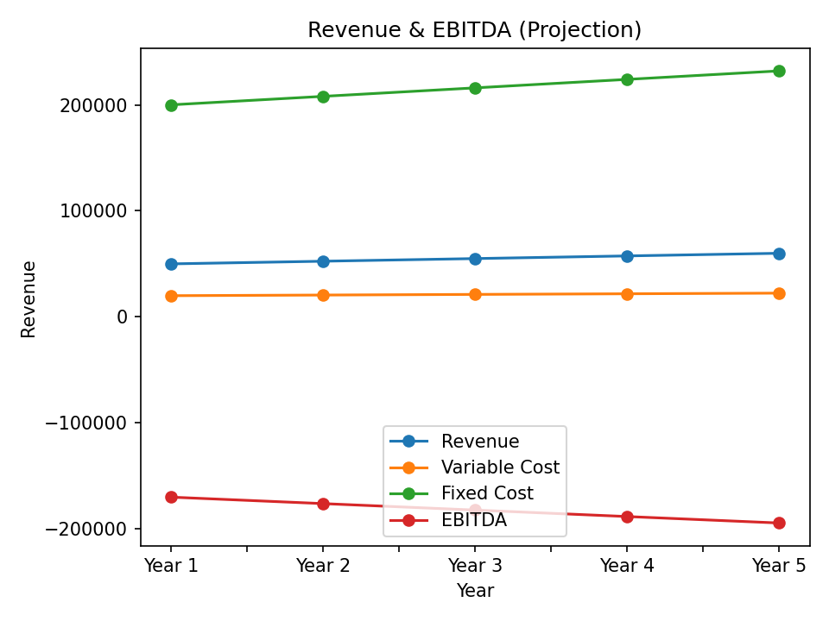

Revenue & EBITDA Projection Chart