**GITHUB**

* Install Git (MINGW) on windows
* Open **GIT Bash**
* Cd C:
* Mkdir GIT
* Cd GIT
* git init
* git config - - global user.name “Your_User_Name”
* git config - - global user.email “xyz@gmail.com”
* git clone <https://github.com/AbhiReddyMiru/Demo>

https://github.com/AbhiReddyMiru/**GIVE_YOUR_REPOS_NAME**

* ls (U can see all files what are there in your GITHUB repos)
* Add some file in /c/git/Demo (ex: test.py)
* git add test.py
* git status

**YOU WILL SEE SOMETHING LIKE THIS**

On branch master

Your branch is up-to-date with 'origin/master'.

Changes to be committed:

(use "git reset HEAD <file>..." to unstage)

new file: test.py

* git commit -m "This a first commit" test.py(filename)
* git push -u origin master

It will ask GITHUB NAME and PASSWORD

* You will find your newly added file in your GITHUB repo

**Commands:**

Remove Directory: rm -rf **Directory name**

Login in to sub branch: git clone -b loginissue(SubBranchName) <http://github/AbhiReddyMiru/Demo.git>

Git remote -v : display origin and link

EXCERSICE ON GITHUB WHEN BOTH CLIENTS USING SAME REPOS

1. Created two folder name AliceRepo and BobRepo
2. Open two Git Bash for both Alice and Bob Repo
3. For Both

* git init
* git config - - global user.name “Your_User_Name”
* git config - - global user.email “xyz@gmail.com”
* git clone <http://www.gitbuh.com/Copy_From_Clipboard>
* cd **Repo_Name**
* Check both folder have all the files which are in u your Repo.

1. Make changes for files whatever you want in both Bob and Alice folder.
2. git status: Shows the status for modified files which are in **RED**
3. git add . (make changes in your local machine)
4. git status: You can see in **GREEN**

For Alice_Repo: (IN_ALICE_GITBASH)

* git commit -m “Commit is made by Alice”
* git push -u origin master
* check your repo Changes will be made which are done by ALICE.

For Bob_Repo: (IN_BOB_GITBASH)

* git commit -m “Commit is made by BOB”
* git push -u origin master
* You will see it will be rejected.

1. Now you want to make changes in master which are done by BOB. So in BOB GIT_BASH

* git pull - - rebase origin master
* git status

you can see what all changes made before you, what are making conflict

* git mergetool this will help you to merge you contect in master.

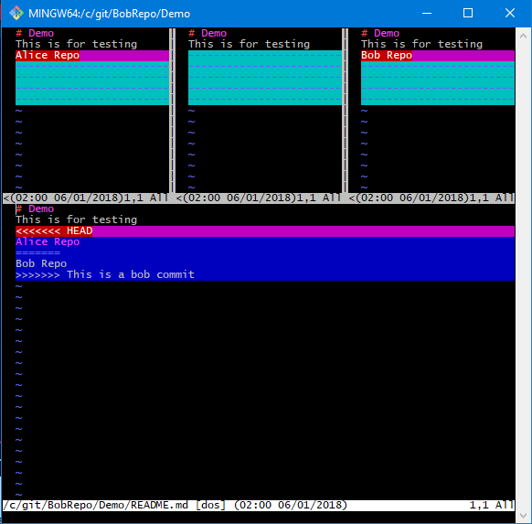

1. bottom part is your changes

see if you want to make any changes. Press i for insertion mode

orelsse exit by :wq option

1. git rebase - - continue
2. git push -u origin master

you can find changes in GITHUB