MSME Financial Health Card
Technical submission for CARS24
Prepared by Abhishek Rai
Open the deployed Streamlit application
Open the complete GitHub repository

Executive summary
I built an end-to-end demonstration that converts alternative financial information into a reviewable MSME health card. The system accepts business profile, GST, UPI, bank, credit, payroll and operating-behaviour inputs. It returns seven health scores, a separate eligibility recommendation, a risk category, an indicative credit limit and an unusual-profile review signal. The intended user is an underwriter who needs to understand both the recommendation and the financial evidence behind it.
The implementation uses 50,000 supplied synthetic business records. I compared simple linear models with CatBoost on a fixed training and validation split, then evaluated the selected models once on 7,500 held-out records. Compact CatBoost predicts the health scores; logistic regression predicts eligibility and risk; a separate CatBoost model estimates positive credit limits. IsolationForest identifies unusual profiles for review.
Overall health has a test mean absolute error of 1.76 points on the 0–100 scale. Eligibility macro-F1 is 0.902 and risk macro-F1 is 0.838. These are measures of agreement with the supplied synthetic labels. They do not demonstrate actual default prediction, improved approval rates or reduced credit losses.

What the evaluator can use
The hosted application supports portfolio filtering, individual health cards, explanations, input snapshots and JSON or printable HTML downloads. The repository includes executed notebooks, trained artifacts, API documentation, test results and local-run instructions. The accompanying ZIP contains the same committed project files, allowing review without relying only on GitHub.

How to read this report
Pages 2–3 explain the data and model choices. Pages 4–5 interpret overall and subgroup results. Pages 6–7 demonstrate the health card and its explanations. Pages 8–9 describe architecture, verification and reproducibility. Page 10 maps the solution to the evaluation criteria and identifies what remains necessary for lending deployment.

Data understanding and feature design
The dataset contains 45 columns: one identifier, 33 permissible input fields and 11 supplied outcomes. All outcomes and the identifier are excluded from predictors. Probability_of_Default is a supplied synthetic outcome; it is not used as an input or presented as a validated real-world probability of default.

Missing values and distribution decisions
EMI_On_Time_Rate_Pct is missing in 65.112% of rows, corresponding exactly to businesses without loans. Treating these values as zero would incorrectly encode no repayment experience as failed repayment. The pipeline retains missingness and adds an explicit no-loan indicator. Zero credit history also remains valid, which is essential for new-to-credit businesses.
Amounts and counts have long right tails. Turnover skew is approximately 5.59 and falls to 0.03 after log1p; UPI inflow skew falls from 7.76 to about −0.08. Linear pipelines therefore log selected nonnegative variables before scaling. CatBoost retains raw numerical values. Large observations are preserved unless they violate the input contract. The 865 records with bank debits above credits retain their negative surplus.
Derived feature | Calculation | Reason
Bank surplus margin | (Credits − debits) / credits | Operating cash headroom
Balance coverage | Balance / debits | Buffer relative to monthly outflow
EMI burden | Monthly EMI / credits | Repayment burden
GST margin | (Sales − purchases) / sales | Trading margin proxy
Payroll burden | Payroll / credits | Recurring staffing cost
GST bank alignment | GST sales / bank credits | Cross-source consistency
UPI net flow | UPI inflow − outflow | Signed payment-channel balance

Zero denominators produce missing ratios, never infinity. Bank surplus, UPI net flow and negative revenue growth remain signed. GST, UPI and bank inflows may describe overlapping activity, so they are never summed as independent revenue. These are snapshot proxies, not audited accounting ratios.

Redundancy and validation
The original high-correlation export contained both directions of every pair. The corrected all-numeric report has 16 unique pairs with absolute Pearson correlation at least 0.90. This includes input–target relationships; it is not 16 input-only pairs. GST sales and bank credits have correlation 0.9963. A compact alternative removes turnover and GST sales as direct predictors while retaining bank credits and derived ratios. Range, finite-value and cross-field checks complement the statistical review.

Model development and selection
The split uses 35,000 training rows, 7,500 validation rows and 7,500 test rows, with seed 42 and stratification by customer segment plus risk category. Imputation, encoding, scaling, feature bounds and anomaly thresholds learn from training data only. Validation chooses the model family, feature set and eligibility threshold. Test records are reserved for the final assessment.
Task | Candidates | Selected
Seven health scores | Dummy, multi-output Ridge, CatBoost | Compact CatBoost
Eligibility | Dummy, logistic regression, CatBoost | Compact logistic regression
Risk category | Dummy, logistic regression, CatBoost | Compact logistic regression
Positive credit limit | Log-target Ridge and CatBoost | Full-feature CatBoost
Unusual profile | IsolationForest | Training 98th percentile cutoff

Why these models
This is a structured tabular problem with 50,000 rows and known labels. Ridge and logistic regression establish transparent, inexpensive baselines. CatBoost captures nonlinear effects and categorical interactions without a custom neural network or embedding pipeline. No LLM is required for scoring or recommendations; a language model would add cost and uncertainty without addressing a missing capability.
The score decision uses mean MAE across all seven outputs and a per-score guard: prefer Ridge only when it is within 1% of CatBoost and no score worsens by more than 0.5 points. Full Ridge achieves validation mean MAE 0.543 versus 0.480 for full CatBoost. Ridge is more accurate on several simple component labels, but its business-stability error is about 1.85 points. CatBoost provides a more balanced seven-output model.
For classifiers, logistic regression is preferred within 0.01 macro-F1 of CatBoost. Full risk CatBoost scores 0.841 versus 0.840 for logistic regression, so the small gain does not justify the extra model complexity. Compact logistic regression remains within the tolerance. Positive-limit CatBoost wins with validation rupee MAE of INR 141,423 versus INR 163,209 for full Ridge; the compact CatBoost limit model is worse at INR 157,208.

Training configuration
Ridge uses alpha 10. Logistic regression uses C 1 and a 100-iteration convergence ceiling. CatBoost uses depth 6, learning rate 0.07, up to 650 boosting iterations and early stopping patience 50. Losses are MultiRMSE for scores, RMSE on log limits, Logloss for eligibility and MultiClass for risk. Iterations are not neural-network epochs. Progress bars show fitting progress; early stopping can validly finish below the configured maximum.

Held out performance and interpretation
The table below reports test performance of the frozen selected models. MAE is average absolute error in score points; RMSE gives larger errors greater weight; R² measures explained variation relative to a constant prediction. High component R² values indicate strong reconstruction of synthetic scoring patterns, not evidence of real lending performance.
Score | MAE | RMSE | R squared
Business Stability | 0.252 | 0.330 | 0.998
Cashflow | 0.274 | 0.367 | 0.998
Revenue Consistency | 0.256 | 0.345 | 0.998
Payment Behaviour | 0.233 | 0.334 | 0.997
Business Growth | 0.326 | 0.434 | 0.999
Compliance | 0.234 | 0.306 | 0.998
Financial Health | 1.757 | 2.199 | 0.879

Eligibility and risk errors
Eligibility macro-F1 is 0.902, ROC-AUC 0.979 and PR-AUC 0.993 at the validation-selected probability threshold of 0.54. Of 1,926 synthetically ineligible test businesses, 264 are predicted eligible. Of 5,574 eligible businesses, 299 are predicted ineligible. These errors matter differently to a lender, so the demonstrated threshold is not a production approval policy.
Risk macro-F1 is 0.838. The confusion matrix shows no direct High-to-Low or Low-to-High errors in this test split; errors are concentrated around Medium. For example, 289 High-risk and 378 Low-risk records are predicted Medium, while 269 Medium records are predicted High and 312 are predicted Low. A reviewer should therefore treat the category as a summary with uncertainty rather than a precise rank.

Credit limits and anomaly review
For eligible businesses, positive-limit MAE is INR 143,697 and log RMSE is 0.180. The complete pipeline, which returns zero for predicted ineligibility, has MAE INR 149,944 across all test businesses. Reporting both separates amount estimation from eligibility errors. Selecting on rupee MAE also ensures that the business-scale error remains visible despite log-target training.
IsolationForest flags 2.12% of test records using a threshold fitted at the training 98th percentile. Without anomaly labels, this rate is not precision, recall or fraud-detection accuracy. It reports how often the demonstration asks for an unusual-profile review.

Segment results and limitations
An aggregate metric can hide a model that performs poorly for the businesses the assignment is intended to serve. I therefore evaluated customer segment, industry, existing-loan status and turnover bands, with the largest-business group defined using the training 99th percentile.
Segment | Rows | Health MAE | Eligibility F1 | Limit MAE INR
Existing-to-Credit | 2094 | 1.755 | 0.901 | 147,554
NTB | 2246 | 1.736 | 0.899 | 148,665
NTC | 3160 | 1.774 | 0.905 | 152,435

NTC health MAE is 1.774 and eligibility macro-F1 is 0.905 across 3,160 records. NTB results are similar, with health MAE 1.736 and eligibility macro-F1 0.899. This supports functional coverage of both segments in the synthetic evaluation. It does not prove that the system increases approvals or avoids disparate outcomes in a real applicant population.

Large businesses remain the main amount risk
The 75 test businesses above the training turnover P99 have complete-limit MAE of INR 1,900,525, compared with INR 24,666 in the lowest turnover quartile. Health-score error stays near 1.73 points in the largest group. The main weakness is therefore monetary exposure estimation rather than a general failure of all outputs. A production review should examine relative error, exposure-weighted loss and tail stress cases before using the recommended amounts.

Anomaly rates require contextual review
Anomaly flag rates are approximately 3.96% for Existing-to-Credit, 1.87% for NTB and 1.08% for NTC. Rates also differ by loan status: 3.82% for borrowers versus 1.21% for non-borrowers. The anomaly model deliberately avoids raw business size and missing credit history as direct signals, but other financial behaviours can still correlate with those groups. Unequal rates are documented, not automatically corrected or interpreted as misconduct.

What this evaluation cannot establish
There are no observed defaults, loan-vintage outcomes, dated transaction histories or labelled fraud cases. A random stratified split tests generalization within the supplied synthetic distribution; it cannot measure future-period drift or lender-to-lender transfer. No confidence intervals or repeated-seed stability study are claimed. Apparent near-deterministic score relationships may reflect the synthetic generation process, but the underlying formulas have not been proven.
The next meaningful validation step is an authorized dataset with defined outcomes and time windows, followed by temporal evaluation, calibration, subgroup audits and a lender-approved decision policy. Adding model complexity before obtaining that evidence would not resolve these limitations.

Financial Health Card and user workflow
The health card is the main decision-review surface. It places overall health, risk, eligibility and indicative limit together, then exposes the six component scores and source evidence. The overall score is its own model output; the application does not invent weights to aggregate the components. A high score is therefore not automatically an approval.
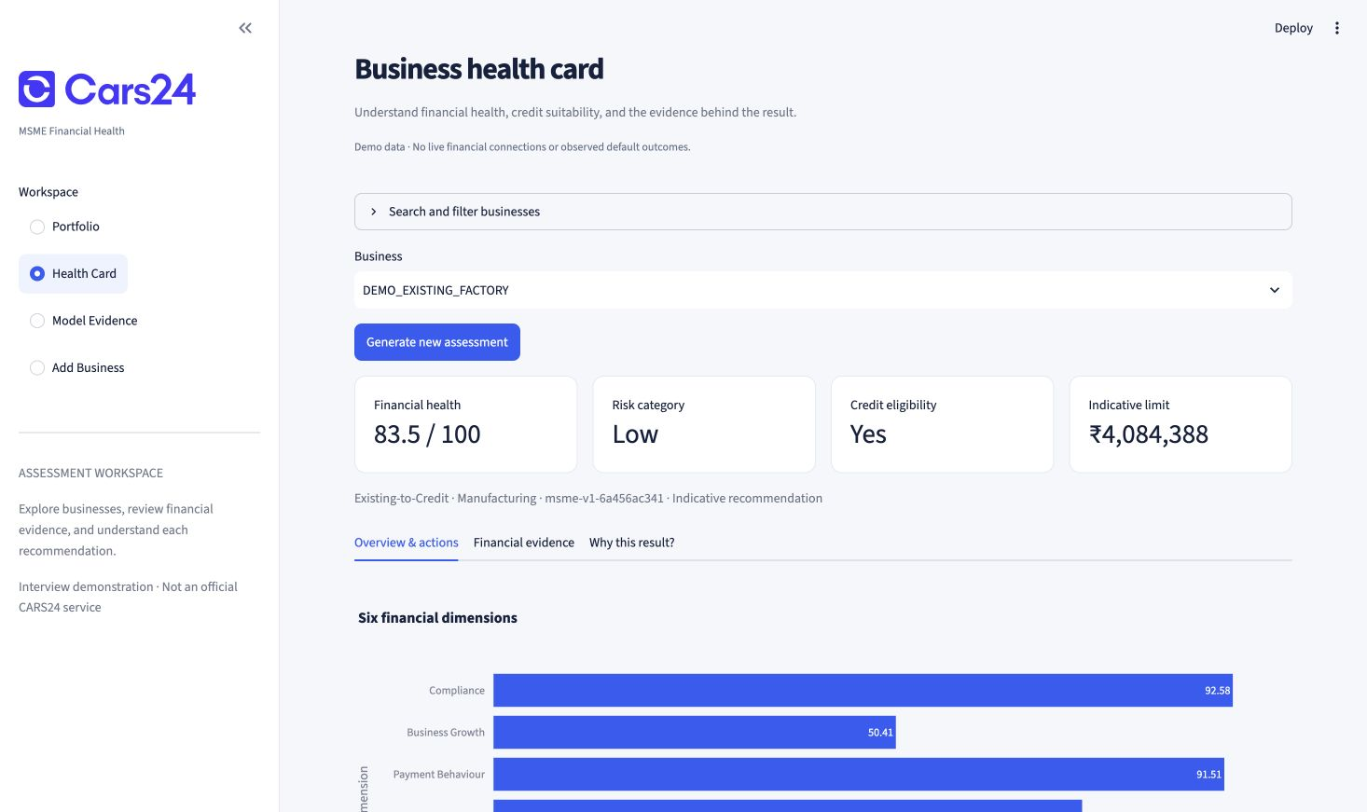
Financial Health Card view showing the decision summary and component dimensions

How the information supports underwriting
Business stability summarizes operating continuity; cashflow and revenue consistency expose liquidity and variability; payment behaviour and compliance show operating discipline; growth provides context for future capacity. The source metrics let an evaluator connect those summaries to bank surplus, EMI burden, GST behaviour and payroll signals. Data-quality notes distinguish unavailable history from negative history.
The portfolio view helps an evaluator filter by segment, industry and predicted risk, then inspect one business in detail. The six included scenarios provide reproducible examples without redistributing the supplied dataset. Identifiers such as DEMO_NTC_RETAIL are demonstration labels, not real company identities. The add-business workflow accepts a new snapshot and supports an immediate assessment.

Downloads and freshness
JSON preserves structured scores, credit information, explanations, input evidence and version identifiers. Printable HTML packages the card for review outside Streamlit. When a newer snapshot exists, the previous assessment remains available but is marked stale until rescoring; portfolio scored aggregates exclude stale assessments. This avoids presenting an old recommendation as a result for new data.
There is no dated history in the source dataset. The dashboard shows monthly aggregates and supplied growth or volatility measures, and explicitly states that historical charts are unavailable. It does not fabricate a transaction timeline for presentation.

Explainability and a worked example
Explanations use native CatBoost SHAP for selected tree models and linear-model contributions for the selected logistic models. The baseline plus contributions must reconstruct the raw model output before clipping the visible score to 0–100. For classifiers, raw contributions explain the model margin rather than being added directly to displayed probabilities.
Features are grouped by financial source so that an underwriter can review banking, GST, payroll and operating behaviour together. Correlated features can share attribution, so a large contribution is not a causal claim. Recommendation text is generated from deterministic evidence templates. It does not promise that changing one feature will produce a particular lending outcome.

Worked case from the saved demonstration card
The saved DEMO_NTC_RETAIL example describes a Tier 2 retail proprietorship operating for four years, with no existing loan and zero credit-history months. Monthly bank credits are INR 620,000, debits INR 470,000 and average balance INR 310,000. Its EMI rate is null because no repayment history applies.
Evidence | Value | Interpretation
Bank surplus | INR 150,000 | Credits less debits
Surplus margin | 24.2% | 150,000 / 620,000
Balance coverage | 0.66 | 310,000 / 470,000
Payroll burden | 14.5% | 90,000 / 620,000
GST margin | 38.3% | (600,000 − 370,000) / 600,000

The saved card reports overall health 81.70, Low risk and an indicative limit of INR 1,168,825. The business is predicted eligible and is not anomaly-flagged. These values are taken from examples/health_card.json, not inferred from the screenshot. Its separate Business Growth score is 45.49, illustrating why the individual dimensions remain visible even when the overall score is high.
The absence of formal credit history is disclosed instead of being replaced by failed repayment. Positive surplus and filing discipline provide alternative evidence for review, but neither proves repayment capacity over a future loan term. The saved recommendation asks the business to maintain filing discipline, payment timeliness and regular cashflow review.

Review indicators and consistency
The system separately flags unusual profiles, problematic financial evidence and conflicting predictions for human review. Predicted ineligibility gates the limit to zero; risk category is not used as a substitute eligibility rule. This matters because the supplied dataset includes Medium-risk businesses that are nevertheless ineligible. Explanations support review of the model output rather than certifying it as a correct credit decision.

Architecture and integration boundaries
The design separates offline training from online assessment. The notebooks produce frozen models and evaluation artifacts. scoring.py centralizes validation, feature preparation, predictions, explanations and card rendering; api.py handles REST and persistence; dashboard.py provides the user interface. This shared scoring path reduces the chance of notebook and application logic diverging.
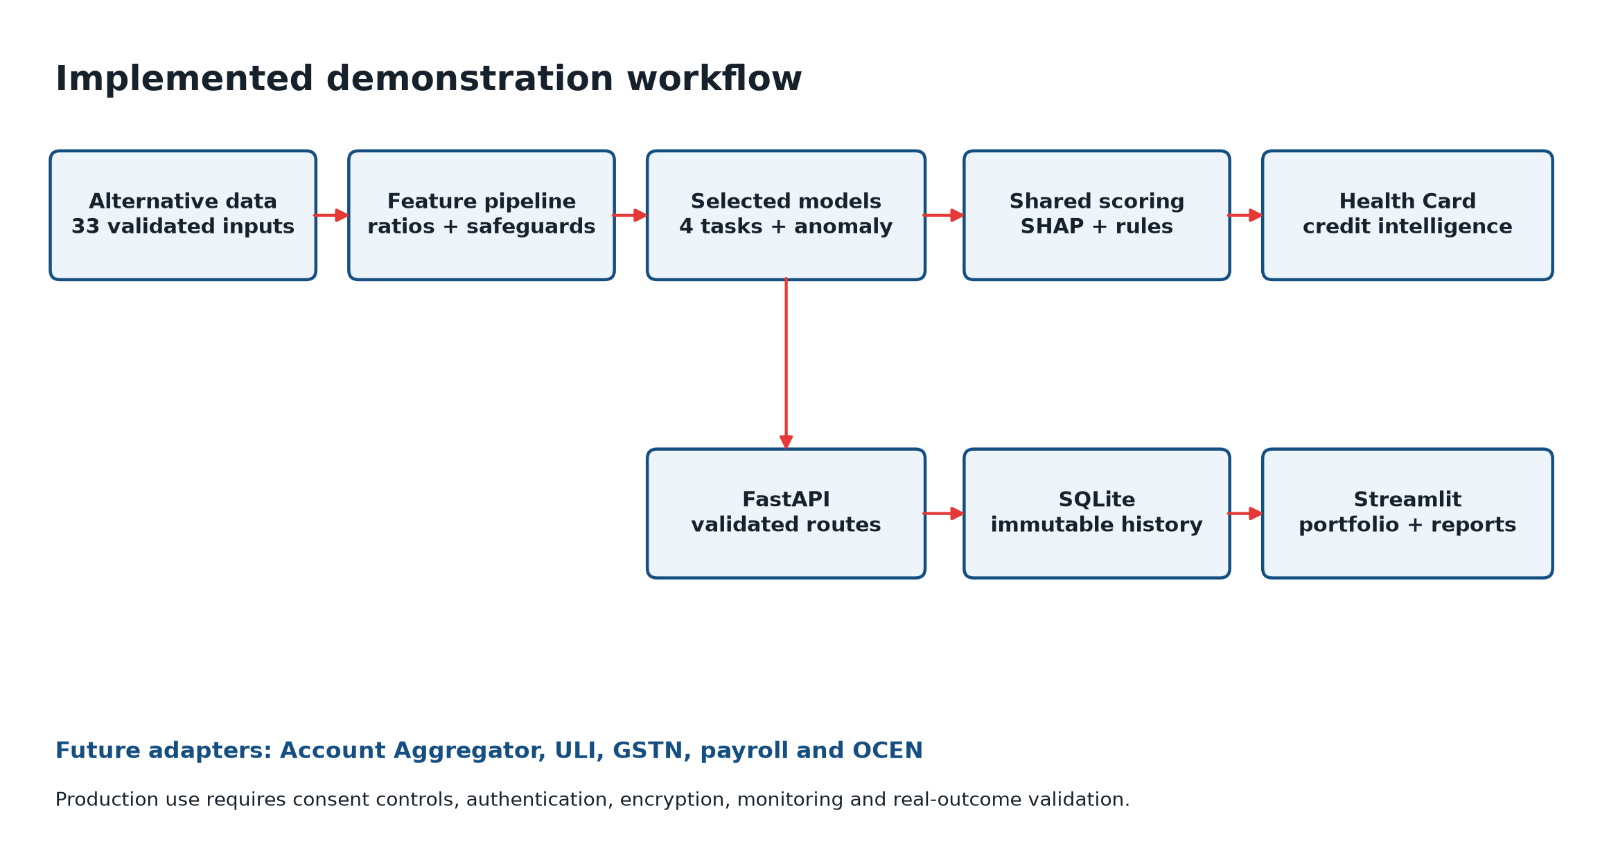
Implementation overview with offline artifacts and online assessment components

Assessment lifecycle
POST /businesses validates the identifier and 33 input fields, then creates a snapshot. POST /businesses/{id}/assessments scores the latest snapshot and appends an assessment. POST /assess combines those steps for instant scoring. GET routes retrieve the card, credit recommendation, assessment history and portfolio. Each saved assessment identifies its input snapshot and model version.
SQLite provides lightweight persistence for the demonstration. Repeated assessments append records rather than overwrite earlier results. The local API uses a persistent database; the hosted application uses a temporary visitor-specific workspace and the same routes in process. This is sufficient for review of the workflow, but temporary hosting is not durable portfolio storage or production tenant isolation.

Path to consent based source integration
A future adapter layer would normalize authorized Account Aggregator, ULI, GSTN, banking and payroll data into the validated snapshot contract. Each retrieval would need consent scope, purpose, expiry, revocation status, reporting period, source provenance and freshness. GST and bank comparisons require aligned periods before the derived features are meaningful. OCEN or lender workflow integration would carry the reviewed recommendation downstream; regulated lending actions remain outside this demo.
Scaling should start with measured demand: authenticated APIs, managed durable storage, an immutable model registry and independent inference workers. Queues, caching or separate explanation workers become useful only when latency and volume justify them. No live financial integration, consent verification or throughput benchmark is claimed.

Verification deployment and reproducibility

What was checked
The recorded verification includes 18 passing automated workflow and hosted-mode tests. Coverage includes excluded target fields, missing EMI values, unseen model categories, zero denominators, negative surplus, malformed payloads and repeated assessments. Ingestion rejects unknown fields, nonfinite values and inconsistent fixed-enum or cross-field combinations. The API preserves assessment history and exposes model versions.
Notebook/API parity is checked for NTC, NTB and existing-credit examples. Explanation reconstruction errors recorded in the latency report are zero or approximately 2.84 × 10⁻¹⁴ for the sampled health scores, consistent with floating-point precision. The dashboard includes structured and printable downloads. Automated test success establishes these behaviours in the demonstrated environment; it does not certify security or regulatory readiness.

Measured responsiveness
The recorded warm-scoring sample has median 21.3 ms and p95 25.9 ms on the development Mac, excluding explanation generation. The three recorded explanation cases take approximately 57–65 ms. These are local samples, not hosted end-to-end latency or load-test results. Cold starts, network delay and multiple concurrent users can change the experience.

Running and reproducing the work
For immediate review, open the hosted app and compare DEMO_NTC_RETAIL with DEMO_NTC_STRESSED. Inspect source evidence, the explanation view and downloads. For local use, activate the ml conda environment, install requirements.txt, start uvicorn api:app on localhost port 8000, and start Streamlit with dashboard.py in a second terminal. The README contains the exact commands and configuration options.
To reproduce training, place the authorized msme_synthetic_50k.csv in the project root and execute data_analysis.ipynb followed by modeling.ipynb with the ml kernel. The original input is excluded from distribution. Trained artifacts and independent demo scenarios are included, so running the assessment demo does not require retraining. The saved manifest records the dataset checksum, split seed, input allowlist, selected models and excluded outcomes.

Updating the deployed results
Training results are consumed through saved model artifacts and report files. A changed notebook parameter only affects the app after the relevant cells run successfully, the updated artifacts are saved and the deployed repository revision is updated. Existing saved assessments retain their original values and version references until a new assessment is requested. This preserves history rather than silently rewriting prior decisions.

Evaluation coverage and delivery conclusion
Criterion | Weight | Implemented evidence
Problem Understanding | 10% | NTC and NTB framing; separate health, risk and eligibility; explicit outcome limits
Data Engineering and Feature Design | 15% | EDA, structural missingness, guarded ratios, source overlap and compact comparison
AI and ML Model Quality | 20% | Baselines, validation selection, held-out metrics, subgroup and tail-error analysis
Explainability and Interpretability | 10% | SHAP reconstruction, source groups, deterministic recommendations and worked case
Financial Health Card Design | 15% | Seven scores, decision summary, evidence, review notes and printable card
Dashboard and User Experience | 10% | Portfolio filters, comparison scenarios, ingestion, freshness and downloads
Scalability and System Architecture | 10% | Shared inference, REST, snapshot history and documented production path
Innovation and Practicality | 10% | Eligibility-gated limit, missing-history handling, anomaly review and reproducible demo

Contribution to the expected outcome
The implementation demonstrates how alternative financial data can support review of businesses with limited formal credit history. One validated assessment request produces consistent scores and evidence, which could reduce repeated manual preparation. Portfolio filters and explanations make the results inspectable. These are demonstrated capabilities; increased approval rates, reduced turnaround time in an underwriting team and improved portfolio quality remain business hypotheses requiring a controlled real-world evaluation.

What remains before operational lending use
The remaining work is substantive: consent-connected data ingestion; reporting-period alignment; authenticated and tenant-isolated services; durable storage; model promotion and audit controls; outcome-based calibration; temporal and subgroup validation; monitoring; and lender-approved policy and human escalation. The synthetic demonstration should therefore be evaluated as a complete technical prototype with documented boundaries.

Submission contents
The GitHub repository and full repository ZIP contain the source, executed notebooks, trained artifacts, evaluation outputs, API and architecture documentation, examples and this report. The live application is the fastest way to inspect the implemented user experience. The README provides direct evidence links for each criterion.
Live application
Repository and evaluator navigation

