Exercise 1: Freestyle Job - Windows File Transfer Automation

1. Objective: Automate file transfer between two directories on a Windows
machine.
2. Steps:
- Create a Freestyle Job in Jenkins.
- Configure the job to execute a Windows batch command:
xcopy C:\source-directory C:\target-directory /E /I /H /Y
- Add a post-build action to check the success of the transfer using a
custom message.
3. Task: Test the job by placing some files in the source directory and verifying they
are transferred to the target directory.

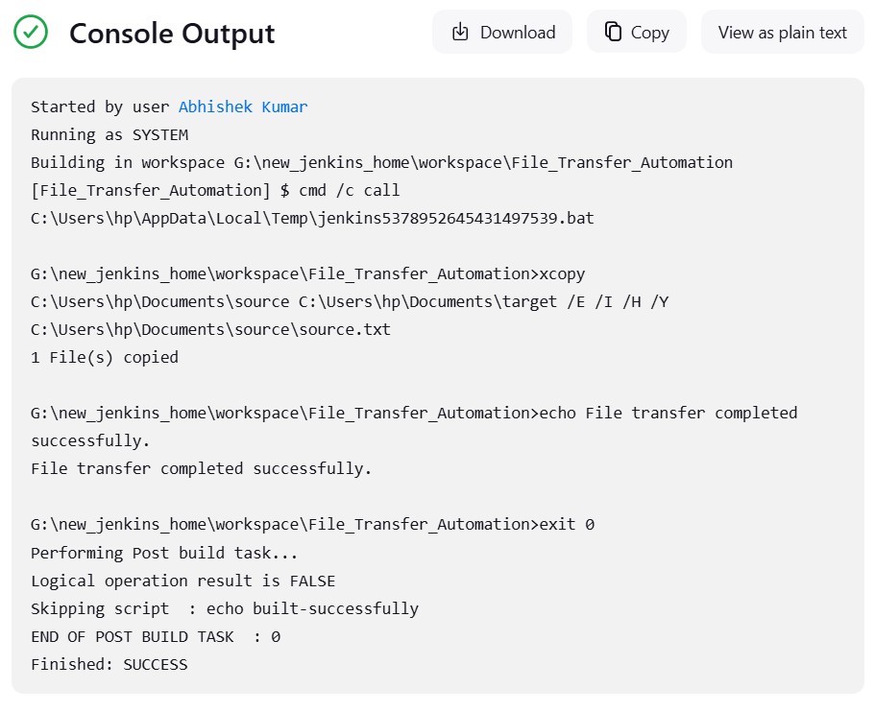

Exercise 2: Freestyle Job - Build and Deploy a JavaScript Project

1. Objective: Build and deploy a JavaScript-based web project.
2. Steps:
- Create a Freestyle Job.
- Configure the job to:
  - Clone a JavaScript repository (e.g., a React project) from GitHub.
  - Run npm install to install dependencies.
  - Build the project using npm run build.
  - Copy the build folder to a deployment directory using a Windows batch command or PowerShell.
- Archive the build artifacts for future reference.

3. Task: Verify the deployment by accessing the web application from the
deployment directory.

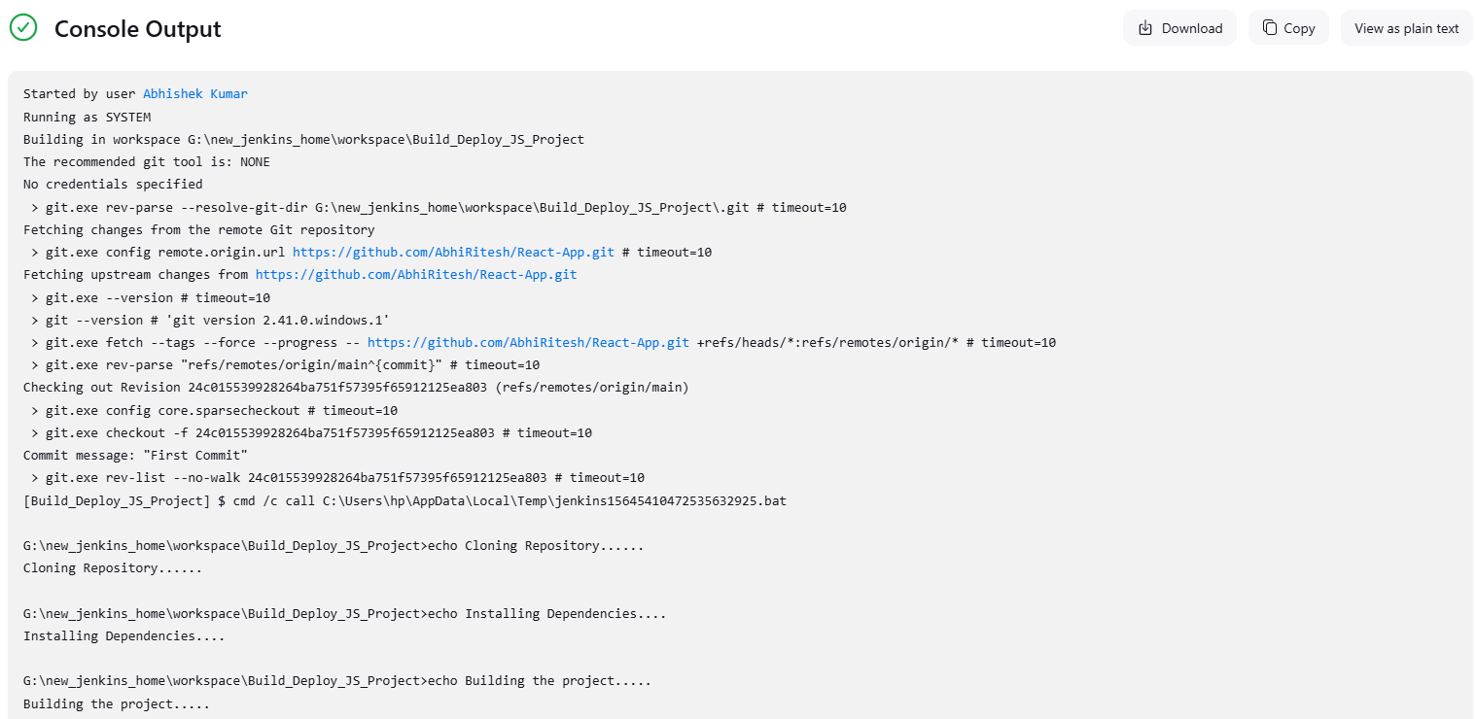
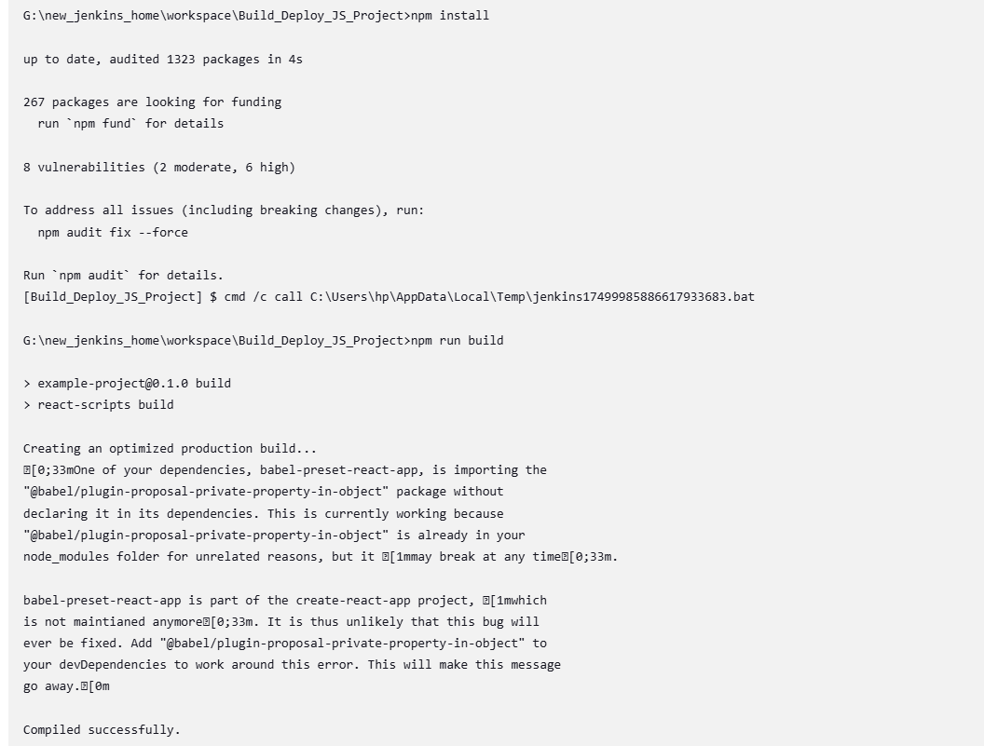
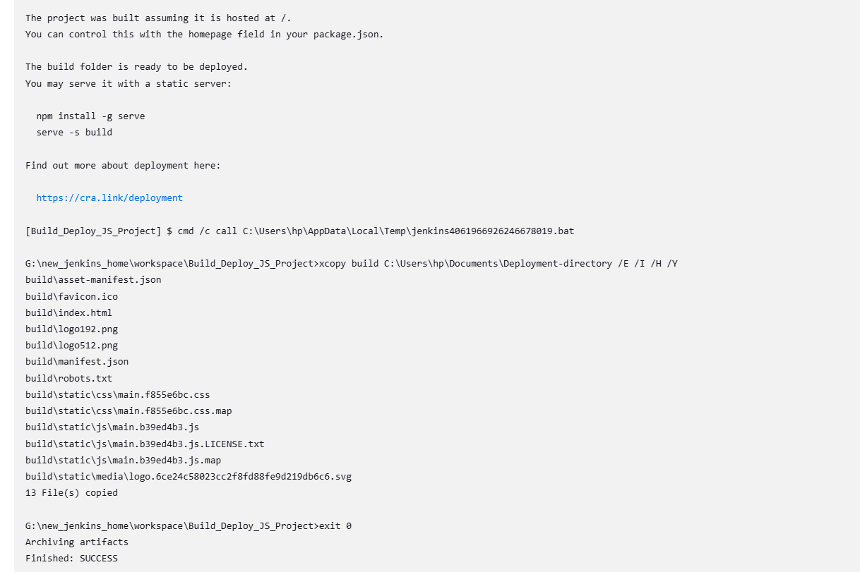
Exercise 3: Freestyle Job - Flask Application Deployment

1. Objective: Automate the deployment of a Flask application.
2. Steps:
- Create a Freestyle Job in Jenkins.
- Configure the job to:
  - Pull the Flask application repository from GitHub.
  - Set up a virtual environment using Python:
python -m venv venv
call venv\Scripts\activate
pip install -r requirements.txt
  - Start the Flask development server.
- Add a post-build action to verify the server is running (e.g., using curl or a similar tool to hit a test endpoint).
3. Task: Test the application deployment by accessing it via localhost.

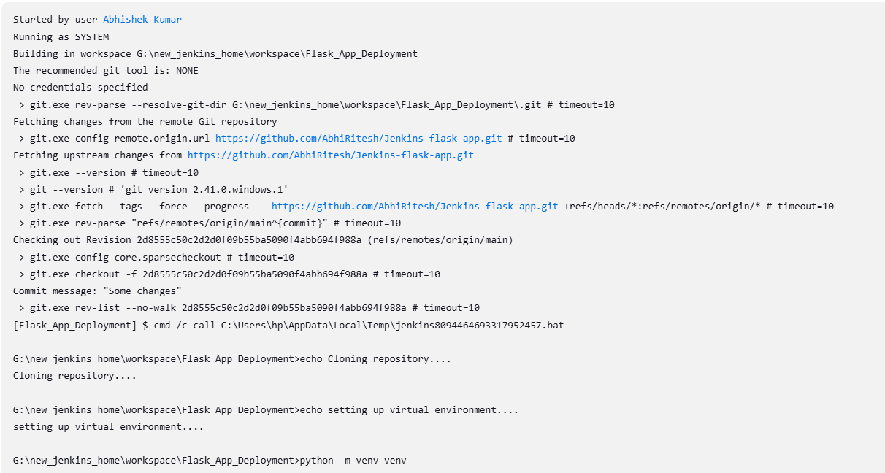
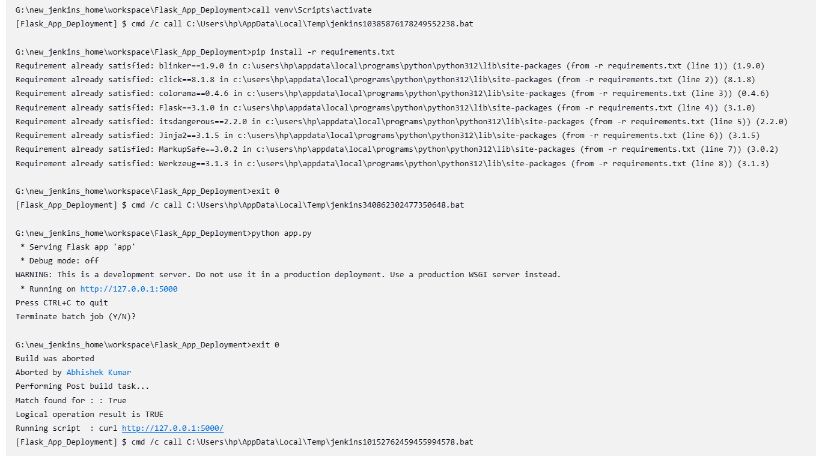
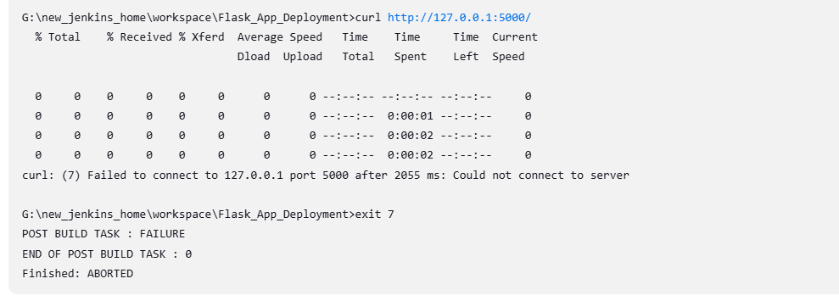

Exercise 4: Pipeline Job - End-to-End CI/CD for a React Application

1. Objective: Implement a CI/CD pipeline for a React web application.
2. Steps:
- Create a Pipeline Job.
- Write a Jenkinsfile to:
  - Clone the React project from GitHub.
  - Install dependencies (npm install).
  - Run tests (npm test).
  - Build the project (npm run build).
  - Deploy the application by copying the build folder to a deployment directory.
- Add stages for:
  - Linting using ESLint.
  - Post-deployment testing using curl to verify the app is running.
3. Task: Run the pipeline and validate each stage's output.

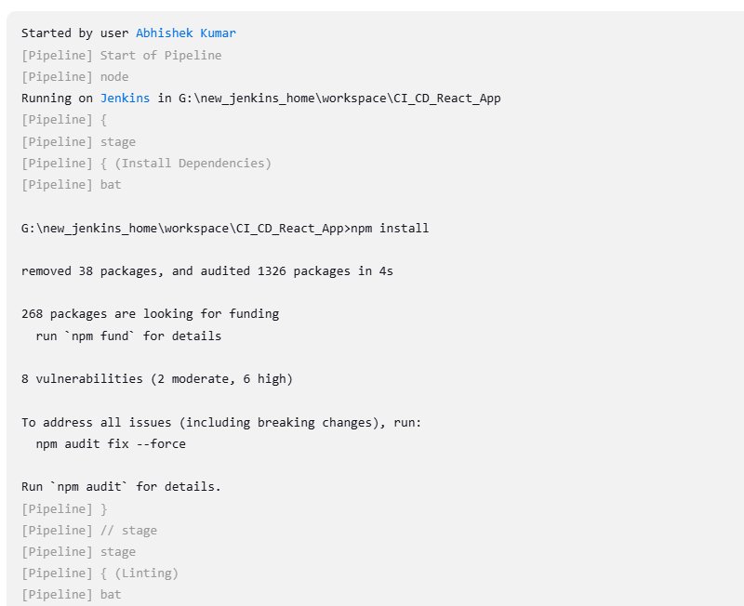
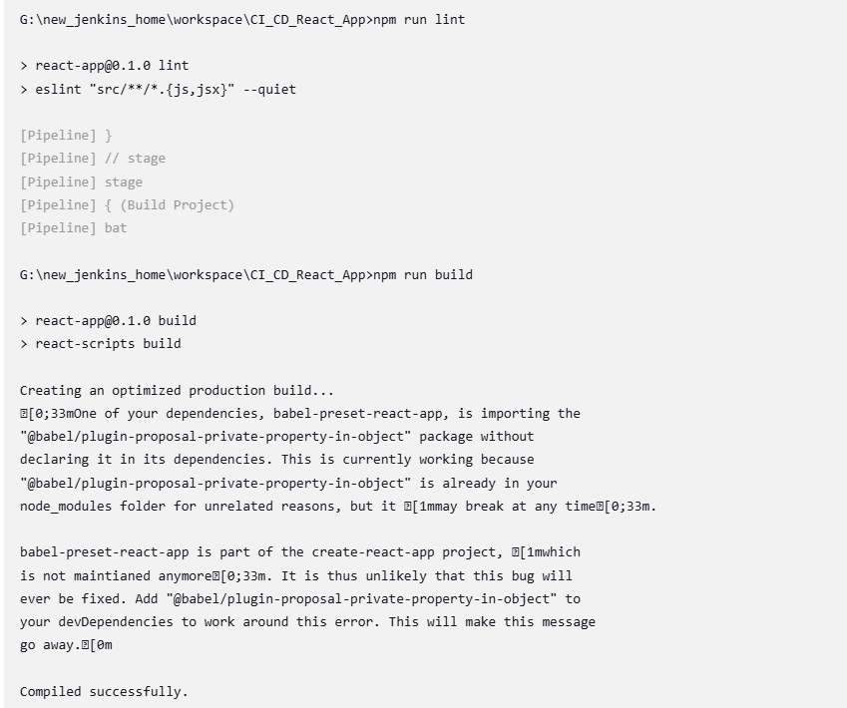
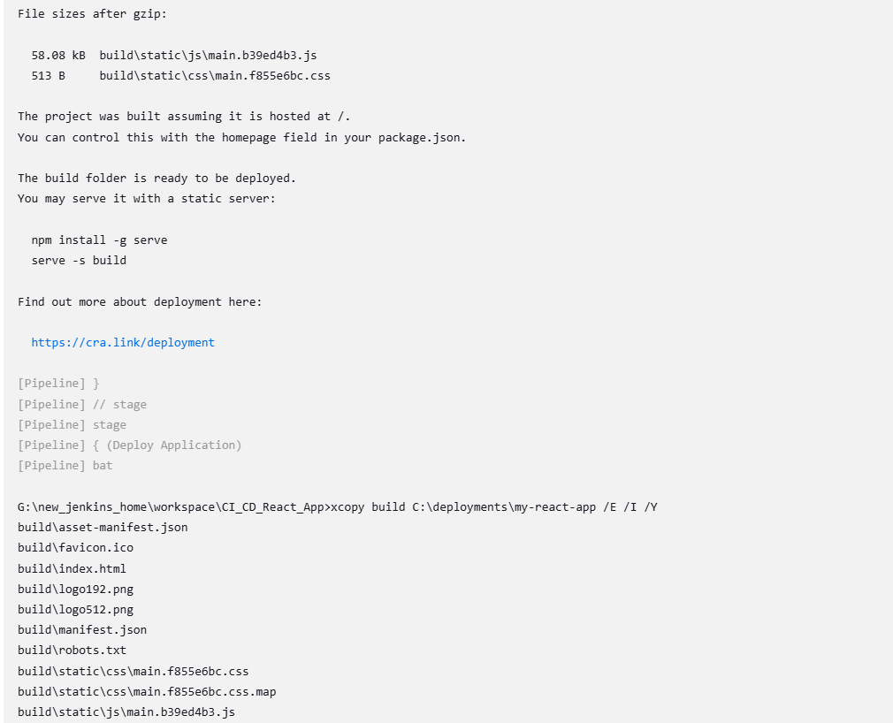
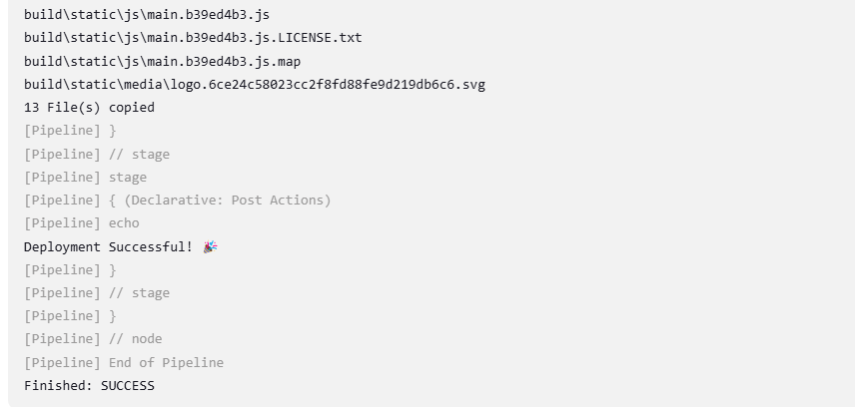

Exercise 5: Pipeline Job - Deploy a Flask Application with Gunicorn

1. Objective: Automate the deployment of a Flask application with Gunicorn on
Windows.
2. Steps:
- Create a Pipeline Job.
- Write a Jenkinsfile to:
  - Clone a Flask application from GitHub.
  - Set up a Python virtual environment.
  - Install required packages using pip install -r requirements.txt.
  - Configure and start the Gunicorn server:
gunicorn -b 127.0.0.1:8000 app:app
  - Verify the deployment using a curl command in the pipeline.
- Add stages for:
  - Unit tests using pytest.
  - Post-deployment endpoint checks.
3. Task: Trigger the pipeline and ensure the Flask app is accessible on localhost.

