Exercise 1: Create and Configure a Virtual Machine
Objective: Create and configure Ubuntu and Windows Virtual Machines on Azure
Portal.
1. Create an Ubuntu VM:
- Log in to the Azure Portal.
- Navigate to Virtual Machines > Create.
- Choose Ubuntu Server 20.04 LTS.
- Configure:
  - Size: Standard_B1s (or similar)
  - Authentication Type: SSH (generate a key pair if not available).
  - Inbound Port: Allow SSH (port 22).
- Deploy and connect using SSH.

2. Create a Windows VM:
- Follow similar steps, selecting Windows Server 2022.
- Configure:
  - Size: Standard_B1s (or similar)
  - Authentication Type: Username and Password.
  - Inbound Port: Allow RDP (port 3389).
- Deploy and connect using RDP.

3. Task:
- Install Apache or IIS on the respective VMs.
- Verify by accessing the default web page from your local browser.

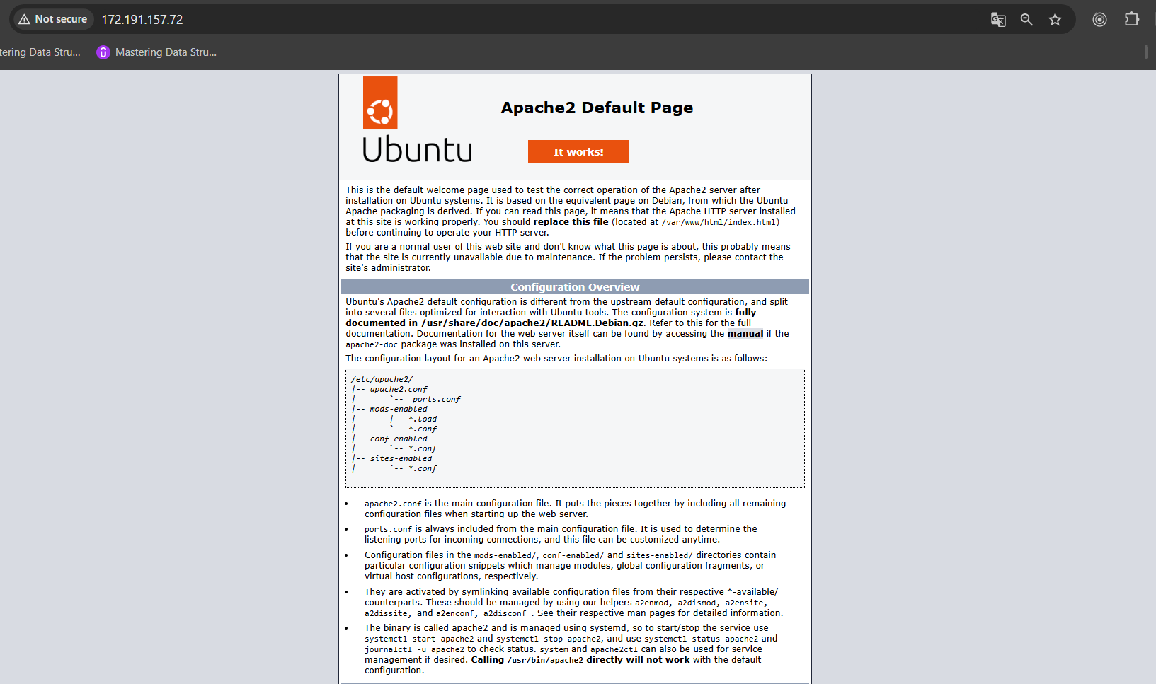
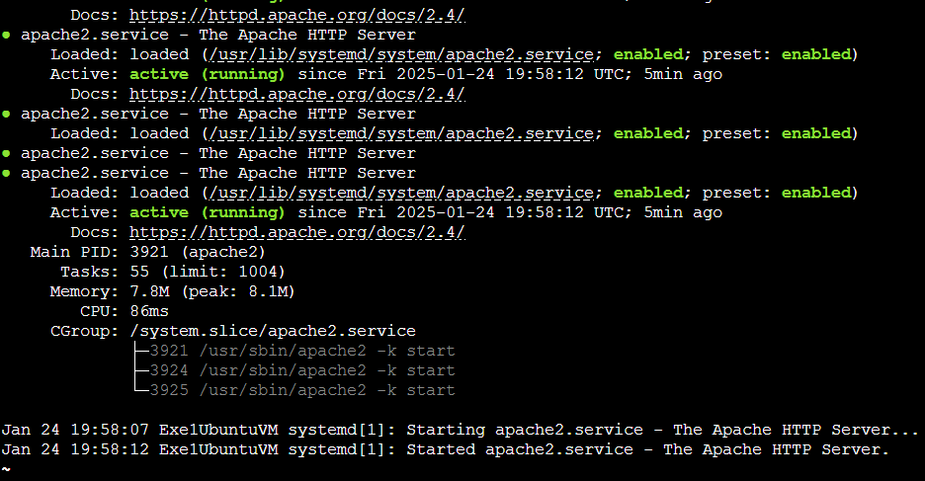
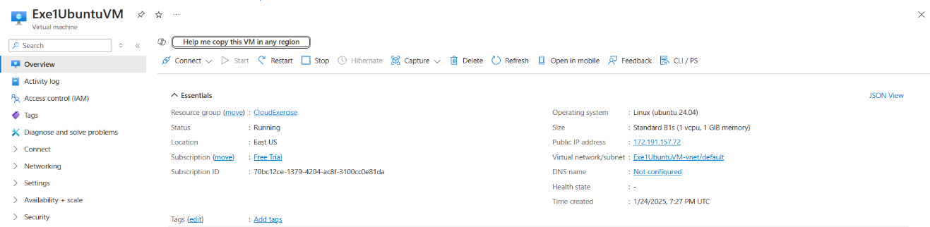

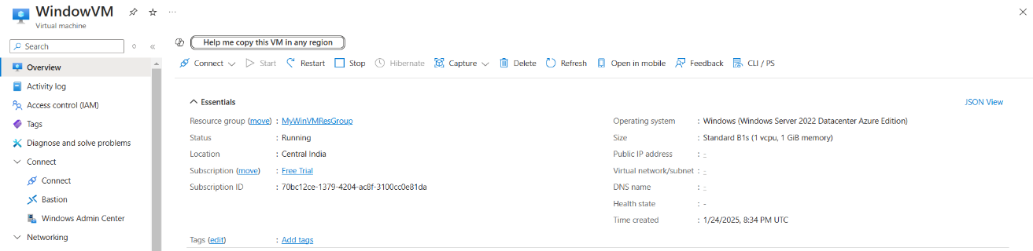

Exercise 2: Deploy a Static Web Application
Objective: Host a static website using Azure App Service.
1. Navigate to App Services > Create.
2. Choose:
- Runtime Stack: Python 3.10 (or latest).
- Operating System: Linux.
- Region: Closest to your location.
3. Deploy the application.
4. Upload a simple static website (e.g., index.html and CSS files) using FTP or the
Kudu console.
5. Task:
- Verify the deployment by accessing the site via its public URL.
- Modify the HTML to include a message like: "Welcome to Azure Static
Web Apps!"

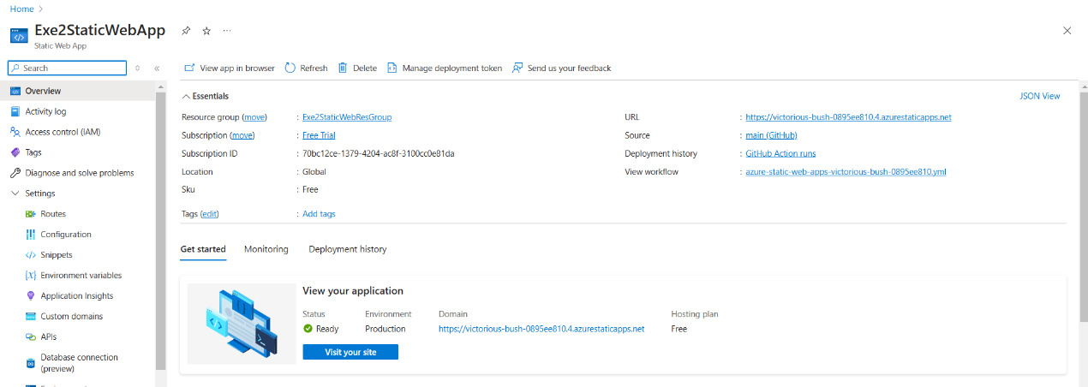

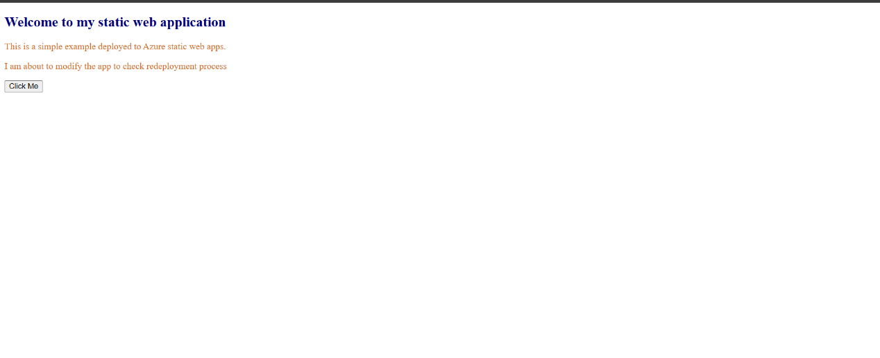

Exercise 3: Deploy a Flask Application (Dynamic Web App)
Objective: Deploy a Python Flask application using Azure App Service.
1. Create a Flask app:
from flask import Flask
app = Flask(__name__)
@app.route('/')
def home():
return "Hello, Azure Flask App!"
if __name__ == '__main__':
app.run(debug=True)
2. Push the code to a GitHub repository.
3. In the Azure Portal, navigate to App Services > Create.
4. Configure:
- Runtime Stack: Python 3.10 (or latest).
- Deployment Source: Connect your GitHub repository.
5. Deploy the Flask app and verify it by accessing the public URL.

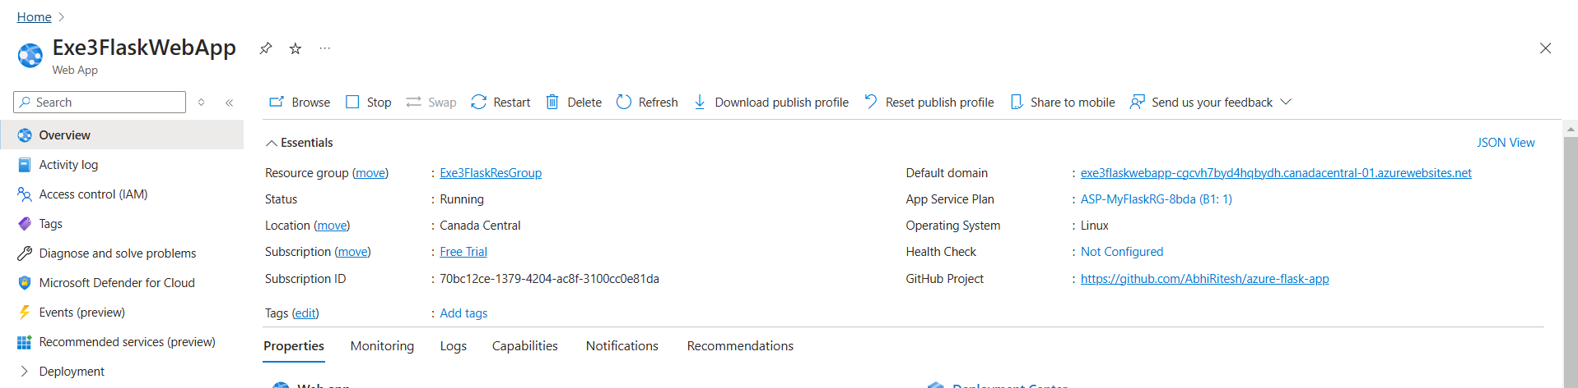


Exercise 4: Set Up and Use an Azure SQL Database
Objective: Create an Azure SQL Database and connect to it from your local machine.
1. Navigate to SQL Databases > Create.
2. Configure:
- Database Name: StudentDB.
- Server: Create a new server with username and password.
- Compute + Storage: Use the free tier.
3. Deploy the database.
4. Connect using Azure Data Studio or SQL Server Management Studio (SSMS).
5. Task:
- Create a table Students with columns ID, Name, and Age.
- Insert sample data and query it

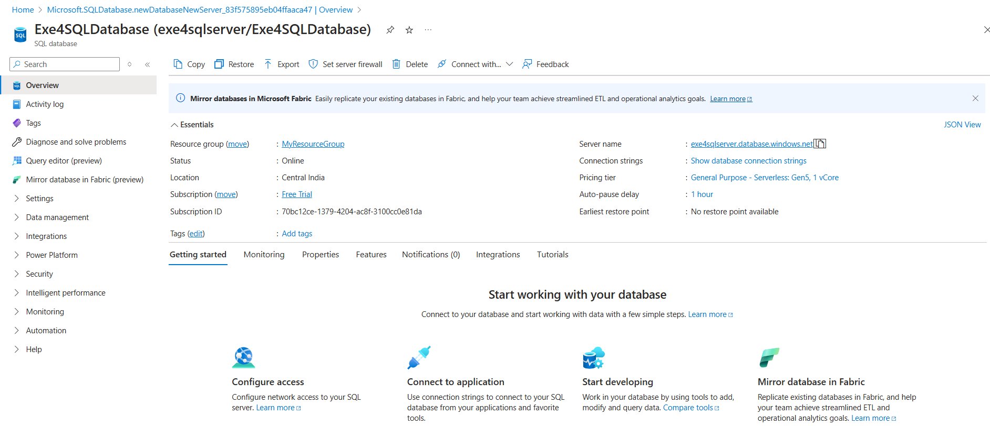
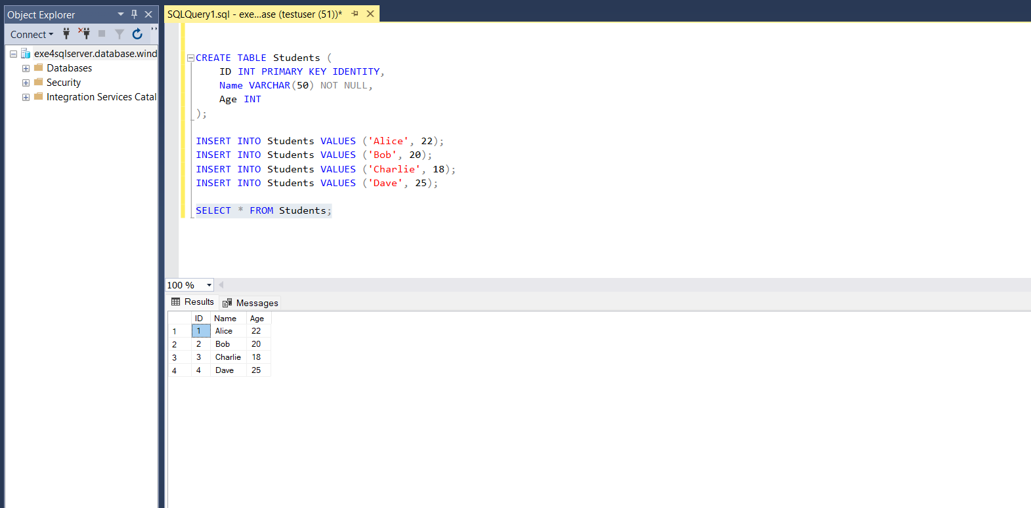
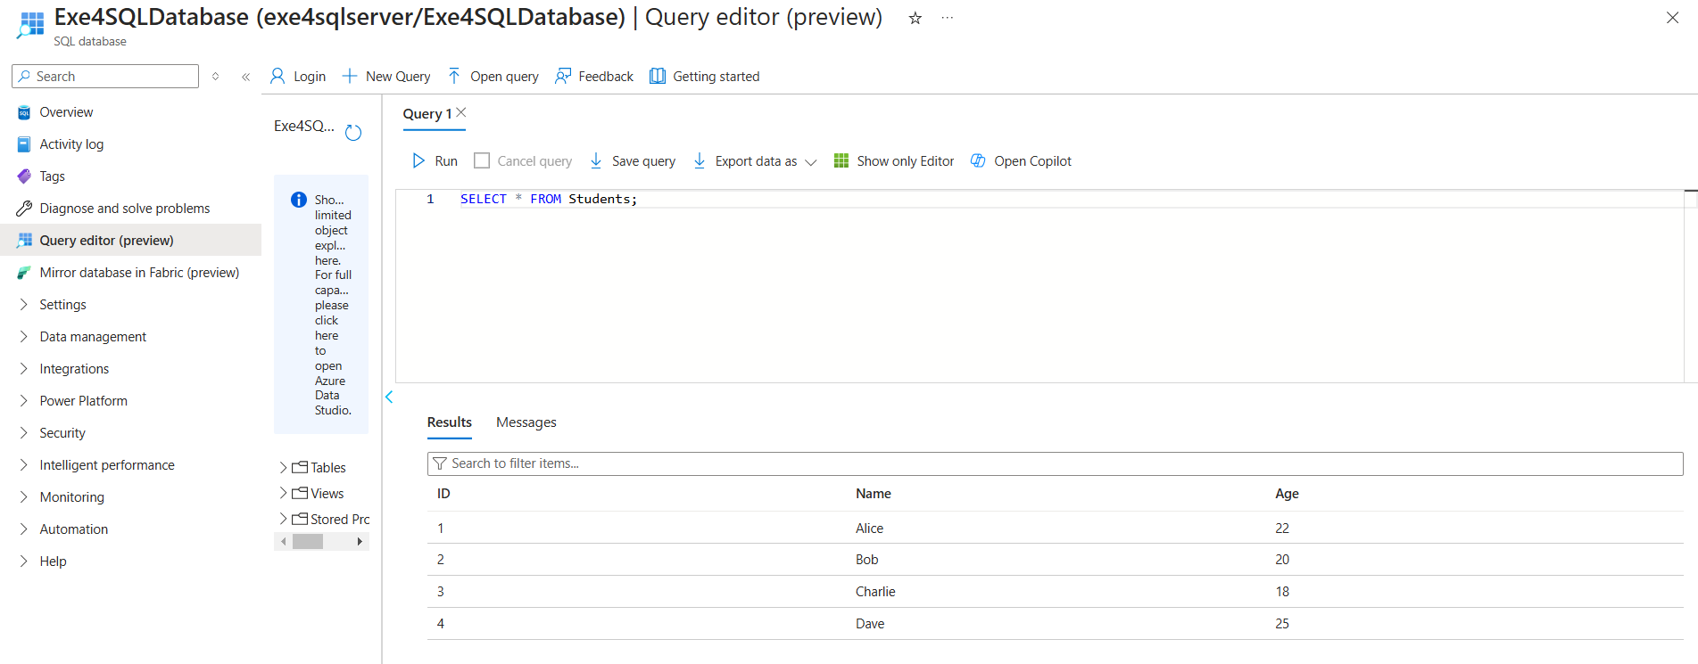

Exercise 5: Integrate Flask App with Azure SQL Database
Objective: Connect a Flask app to Azure SQL Database and perform CRUD
operations.
1. Use the Flask app from Exercise 3.
2. Install required libraries:
pip install flask pyodbc
3. Modify the app to connect to the SQL Database:
import pyodbc
conn = pyodbc.connect(
'DRIVER={ODBC Driver 17 for SQL Server};'
'SERVER=<your_server>.database.windows.net;'
'DATABASE=StudentDB;'
'UID=<your_username>;'
'PWD=<your_password>')
cursor = conn.cursor()
4. Add a route to fetch and display data from the Students table.
5. Deploy the updated app to Azure App Service.
6. Task:
- Verify CRUD functionality by interacting with the app via its public URL.

