Campus Placement

Wireframe Document

List of Figures

**Figure 1: Homepage** 2

**Figure 2: Sub-categories for Specialization in Higher Secondary Education** 3

**Figure 3: Sub-categories in Work Experience** 3

**Figure 4: Sub-categories in Under Graduate Education** 3

**Figure 5: Sub-categories in Specialization in MBA** 3

**Figure 6: Predictions page 1** 4

**Figure 7: Prediction page 2** 4

Homepage:

The User interface has been kept very simple with the user entering their academic details as seen in the figure below:

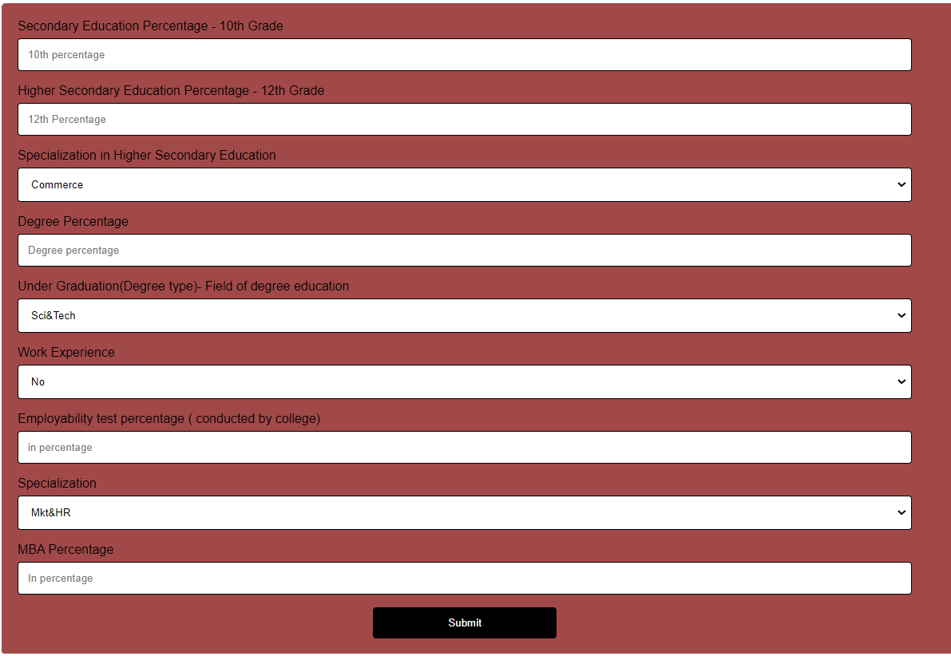

**Figure 1: Homepage**

Subcategories:

Following are the subcategories in the elements of the homepage as per the dataset.

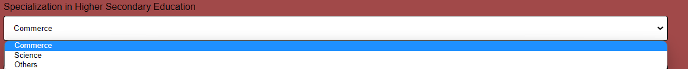

**Figure 2: Sub-categories for Specialization in Higher Secondary Education**



**Figure 3: Sub-categories in Work Experience**

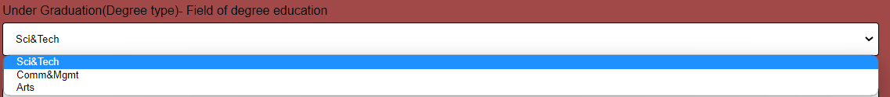

**Figure 4: Sub-categories in Under Graduate Education**



**Figure 5: Sub-categories in Specialization in MBA**

Predictions page:

By entering the academic details and clicking the submit button the user will be taken to the prediction page which will show the following outcome as per the data entered.



**Figure 6: Predictions page 1**



**Figure 7: Prediction page 2**