**A Project Report on**

**“VOICE ASSISTANT”**

**Submitted in partial fulfillment of the requirement for**

**Degree in Bachelor of Engineering (Information Technology)**

**By**

Siddhant Gunjal (5019167)

Tini Tomy (5019169)

Abhishek Yadav (5019173)

**Guided by:**

Prof. Suchita Dange



**Department of Information Technology**

**Fr. Conceicao Rodrigues Institute of Technology**

Sector 9A, Vashi, Navi Mumbai – 400703

**University of Mumbai**

**2020-2021**

**CERTIFICATE**

This is to certify that the project entitled

**“VOICE ASSISTANT”**

**Submitted By**

Siddhant Gunjal

Tini Tomy

Abhishek Yadav

In partial fulfillment of degree of **B.E**. in **Information Technology** for term work of the project is approved.

**External Examiner Internal Examiner**

**_________________ ________________**

**External Guide Internal Guide**

**_________________ _________________**

**Head of the Department Principal**

**__________________ _________________**

**Date: - College Seal**

Declaration

I declare that this written submission represents my ideas in my own words and where others' ideas or words have been included, I have adequately cited and referenced the original sources. I also declare that I have adhered to all principles of academic honesty and integrity and have not misrepresented or fabricated or falsified any idea/data/fact/source in my submission. I understand that any violation of the above will be cause for disciplinary action by the Institute and can also evoke penal action from the sources which have thus not been properly cited or from whom proper permission has not been taken when needed.

-----------------------------------------

(Signature)

-----------------------------------------

Siddhant Gunjal (5019167)

Tini Tomy (5019169)

Abhishek Yadav (5019173)

Date:

**ABSTRACT**

* Voice control is a major growing feature that change the way people can live.
* The voice assistant is commonly being used in smartphones and laptops.
* AI-based Voice assistants are the operating systems that can recognize human voice and respond via integrated voices.
* This voice assistant will gather the audio from the microphone and then convert that into text, later it is sent through GTTS (Google text to speech).
* GTTS engine will convert text into audio file in English language, then that audio is played using play sound package of python programming Language.

**INDEX**

|  |  |  |
| --- | --- | --- |
| **Sr. No.** | **Topic** | **Page No.** |
| 1 | Introduction  1.1 Aim and Objectives  1.2 Problem Definition   * 1. Scope / Assumptions   1.4 Limitations | 8-10 |
| 2 | Literature Survey and Analysis  2.1 Related work   * 1. Existing System   2. Requirements Analysis | 11-12 |
| 3 | System Design   * 1. Use Case diagram   2. Flow chart | 13-14 |
| 4 | Implementation details  4.1 System Requirements (Software/Hardware) | 15 |
| 5 | Experimental Results   * 1. Snapshots | 16-22 |
| 6 | Conclusion and Future Scope   * 1. Conclusion   2. Future Scope | 23 |
|  | References | 24 |
|  | Appendix A: Code Sample | 25 |
|  | Acknowledgement | 26 |

**LIST OF FIGURES**

|  |  |  |
| --- | --- | --- |
| **Sr. No.** | **Name of the Figure** | **Page No.** |
| 1 | Use Case Diagram | 13 |
| 2 | Flowchart | 14 |
| 3 | Snapshots  3.1 Introduction  3.2 Wikipedia Search  3.3 Meaning  3.4 Translation  3.5 Opening Google Chrome  3.6 Searching on Web  3.7 Map  3.8 Playing Songs on YouTube  3.9 Jokes  3.10 Date and Time  3.11 Sending an Email  3.12 News, Headlines  3.13 Speedtest  3.14 Weather Report  3.15 Math Problems  3.16 Bye, Exit | 16-22 |

**LIST OF TABLES**

|  |  |  |
| --- | --- | --- |
| **Sr. No.** | **Name of the Table** | **Page No.** |
| 1 | Literature Survey  (Related Work) | 11 |
|  |  |  |
|  |  |  |
|  |  |  |
|  |  |  |
|  |  |  |
|  |  |  |
|  |  |  |
|  |  |  |
|  |  |  |

1. **INTRODUCTION**

A virtual assistant is a [technology based on artificial intelligence](https://chatbotsmagazine.com/intelligent-assistants-i-a-85c21f9d3b8e). The software uses a device’s microphone to receive voice requests while the voice output takes place at the speaker.

**You can –**

* Open various applications, also it can translate sentences into different languages.
* Can search anything and give you the result, also guide to reach a destination.
* Can play any song, tells a joke, also tells you date and time.
* Can set alarm, reminders.
* You can send emails and messages.
* Also, it can perform speed test and tells you the weather report.
* It can also solve maths problems.

**1.1. AIM AND OBJECTIVE**

**Aim –** The aim of the software is to perform the tasks of the user at certain commands, provided through speech.

**Objectives: -**

* To ease most of the works of user through speech.
* To provide hands free experience to the user.
* To develop cross platform software.
* To develop open-source software.
* To understand different aspects of Python programming.

**1.2. PROBLEM DEFINITION**

* We are all well aware about Cortana, Siri, Google Assistant and many other virtual assistants which are designed to aid the tasks of users in Windows, iOS and Android and their respective platforms. But they are specific to their Operating System only. We can’t use them on different systems.
* Also, they are not editable i.e., Open Source, so user can’t add their additional functionality into it.

**Solution: -**

* As our Voice Assistant is a Python Script and we all know Python is a Portable language, so it can run on any platform, just we need is a python interpreter.
* And as it is open source, users can alter and modify the script according to their need.

**1.3. PROJECT SCOPE**

**Functional –**

The functional scope of this project is to automate all the tasks of user with just voice command.

**Non-functional –**

The non-functional scope of this project is to make the user experience hands free for any task to make Human life comfortable.

**1.4. LIMITATIONS**

* Listening problem –

Voice Assistant sometimes face problem to process wrong pronounced words and miscellaneous words.

* Silent mode support –

Voice Assistant gives response in voice output thus it doesn’t work properly in silent mode.

* Navigation languages –

Voice assistant can interpret and understand only Indian English.

* Internet access –

Voice Assistant needs active internet connection to run and give desired output.

1. **LITERATURE SURVEY AND ANALYSIS**

**2.1. RELATED WORK**

|  |  |  |  |  |
| --- | --- | --- | --- | --- |
| Sr. No | Title of Paper | Authors | Description | Year |
| 1 | Personal Assistant with Voice Recognition Intelligence | Dr. Kshama V. Kulhalli  Dr. M.S.Sheshagiri  Mr. Abhijit J. Patankar | The Most famous application of iPhone is “SIRI” which helps the end user to communicate end user mobile with voice and it also responds to the voice commands of the user. | 2020 |
| 2 | A Review on Voice Assistance using Python | Subhash Mani Kaushal, Megha Mishra | Artificial Intelligent has been in great use when it comes to day-to-day life. Computer science defines AI research as the study of brilliant agents | 2020 |
| 3 | Smart Voice Based Virtual Personal Assistants with Artificial Intelligence | Ankit Pandey,  Vaibhav Vashist,  Prateek Tiwari,  Sunil Sikka,  Priyanka Makkar | Communication and Technology has a long history but still constantly and actively growing and changing. The technology changes so fast that today everybody has an AI Personal assistant. | 2020 |
| 4 | AI Based Voice Assistant Using Python | Deepak Shende,  Ria Umahiya, Monika Raghorte, Aishwarya Bhisikar, Anup Bhange | Artificial intelligence technologies are beginning to be actively used in human life, this is facilitated by the appearance and wide dissemination of the Internet of Things (IOT). | 2019 |

**Table No. 1.1 Referred IEEE Research Papers**

**2.2. EXISTING SYSTEM**

We are still far away from understanding the genuine capability of speech recognition technology. This applies both to the refinement of the innovation itself and to its coordination into our lives.

**Following were the Limitations of Voice Assistant –**

* Usage statistics and user data are sent to the developer
* Installation required
* User cannot edit or change the modules
* Not a free Software

**2.3. PROPOSED SYSTEM**

**Following Features added to Voice Assistant –**

* Does not collect any user data
* Installation required
* User can edit and add new modules
* Free Software
* lightweight
* Simple User interface

1. **SYSTEM DESIGN**

**3.1. USE CASE DIAGRAM**

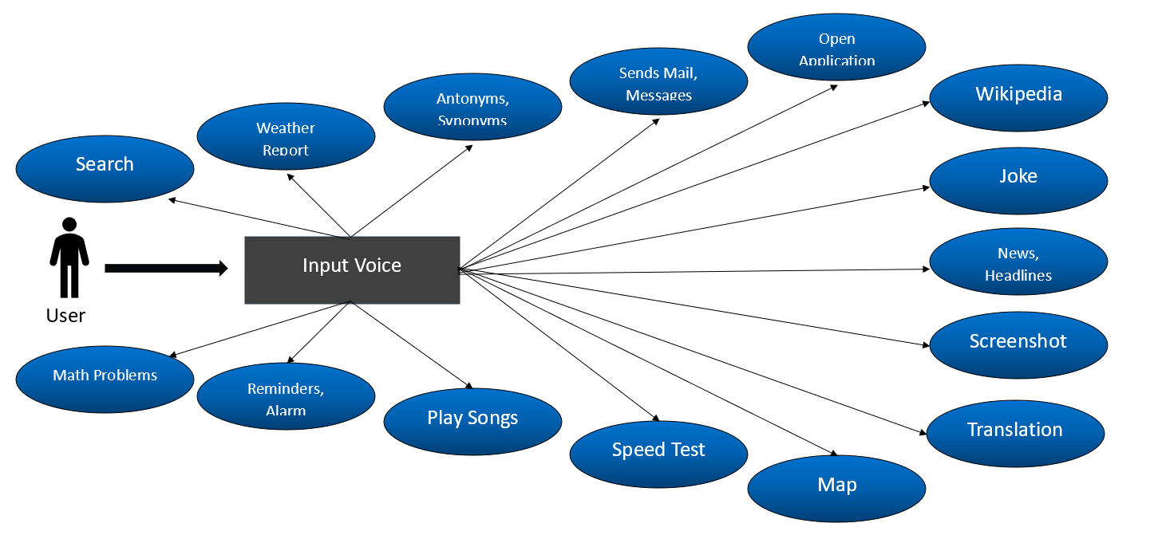

**Fig. 1.1. Use Case Diagram**

**3.2. FLOWCHART**

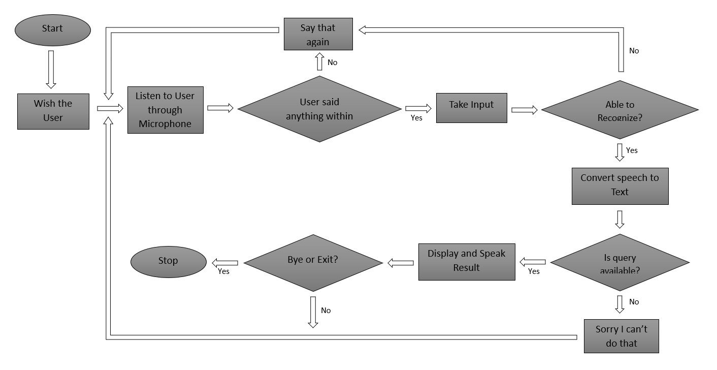

**Fig. 1.2. Flowchart**

1. **IMPLEMENTATION DETAILS**

**4.1. SYSTEM REQUIREMENTS**

**Software Requirement –**

* Operating System: Windows 7/8/8.1/10 64 bits

Linux Ubuntu/Debian/Kali Linux/Fedora

Mac OS X 10.11/10.12/10.13/10.14/10.15/11

* Python 3.7 or higher
* IDE: PyCharm/Visual Studio Code

**Hardware Requirement –**

* Memory (RAM): 1 GB or higher
* Processor: Pentium IV or higher
* Hard Disk: 500 MB required
* Microphone

1. **EXPERIMENTAL RESULTS**

**5.1. VOICE ASSISTANT SNAPSHOTS**

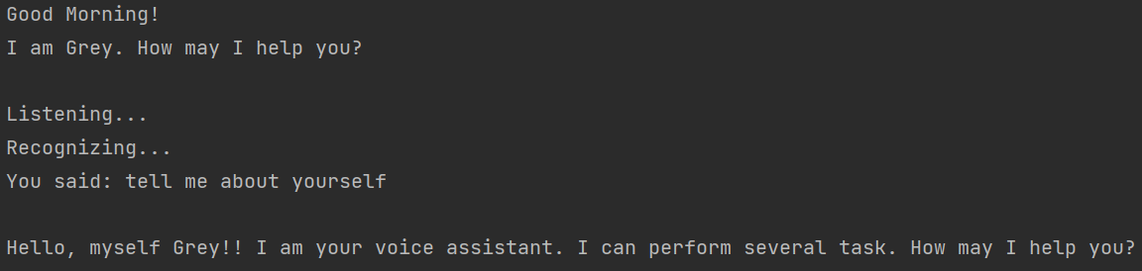

**Fig. 3.1 Introduction**

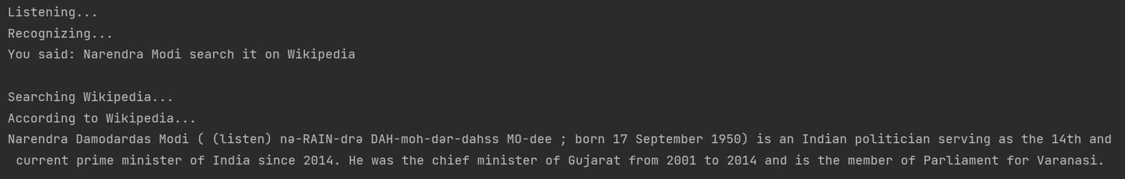

**Fig. 3.2 Wikipedia Search**

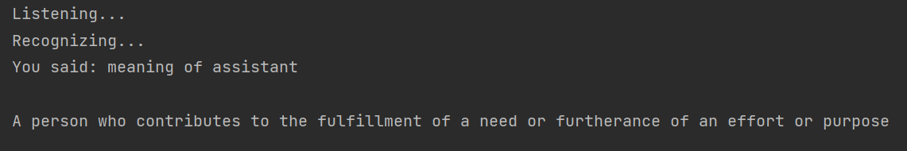

**Fig. 3.3 Meaning**

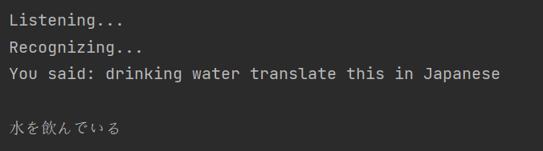

**Fig. 3.4 Translation**

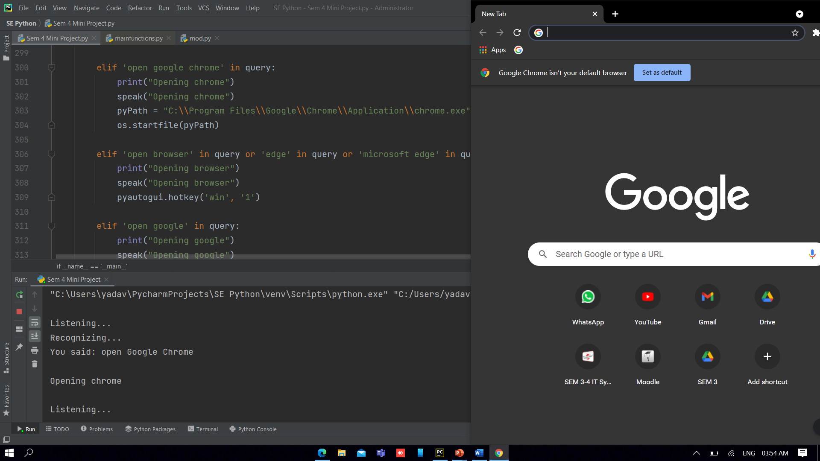

**Fig. 3.5 Opening Google Chrome**

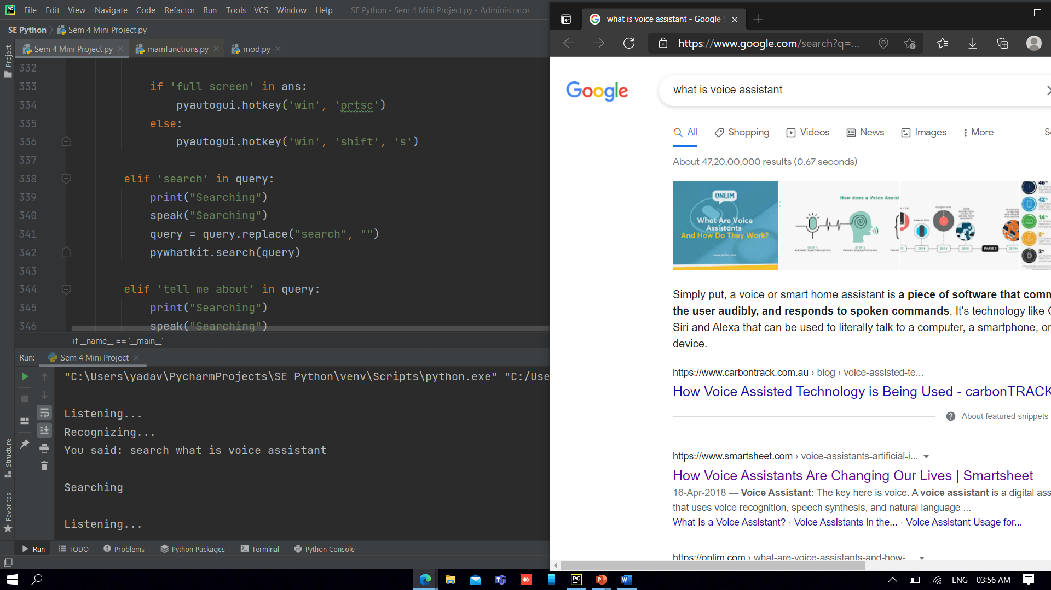

**Fig. 3.6 Searching on Web**

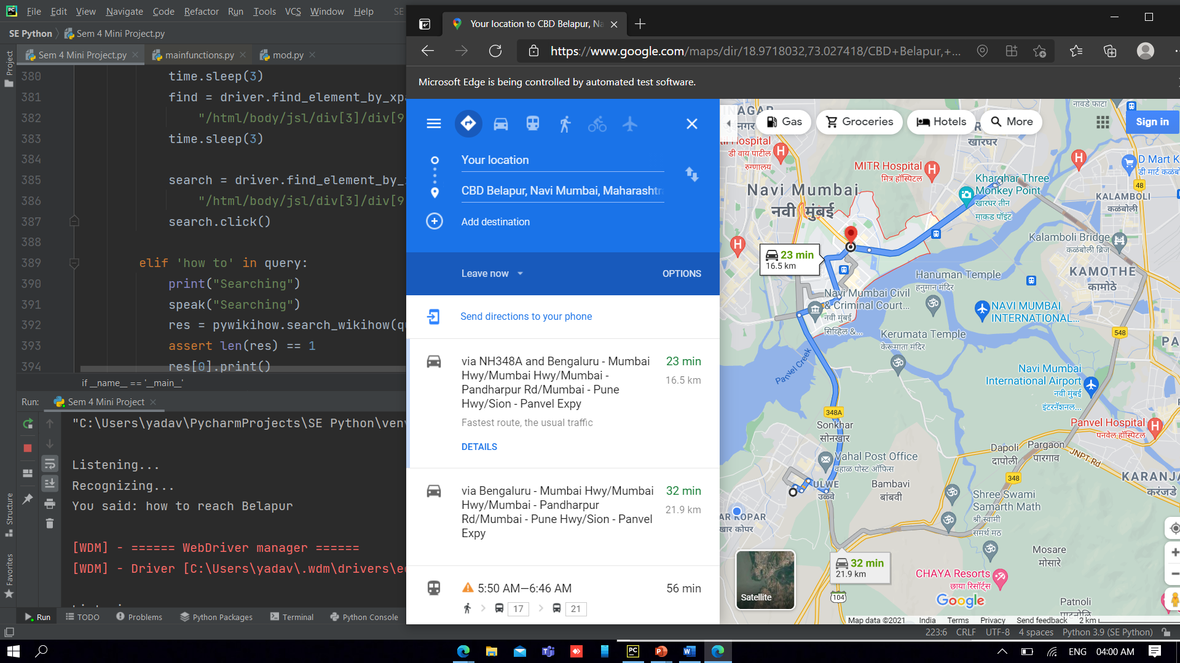

**Fig. 3.7 Map**

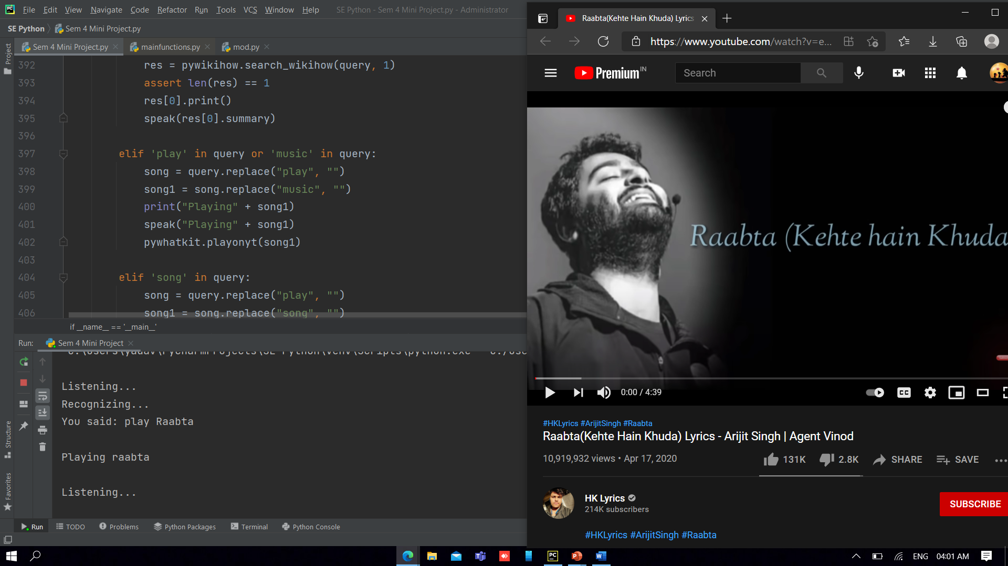

**Fig. 3.8 Playing song on YouTube**

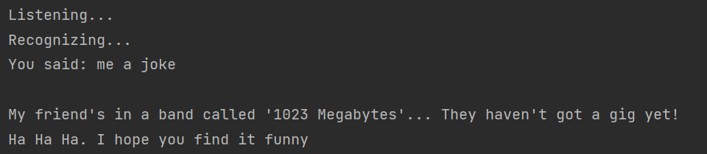

**Fig. 3.9 Jokes**

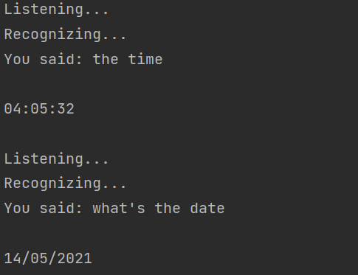

**Fig. 3.10 Date and Time**

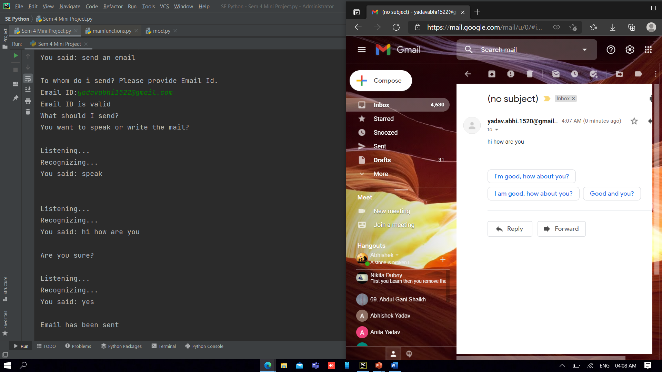

**Fig. 3.11 Sending an Email**

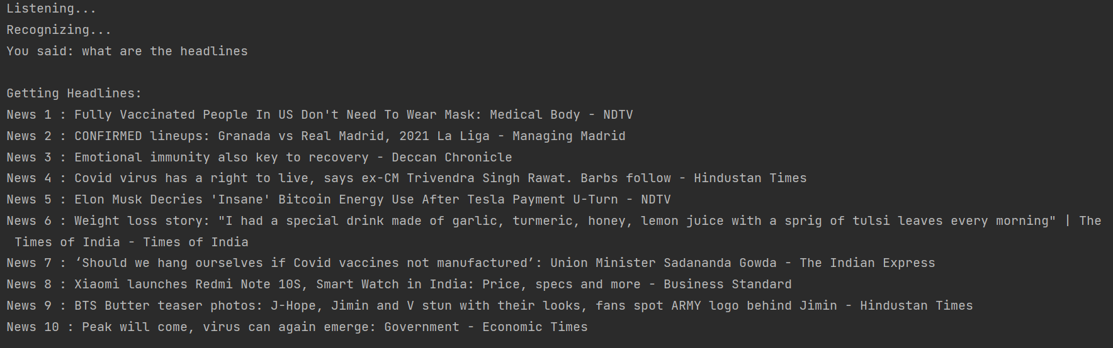

**Fig. 3.12 News, Headlines**

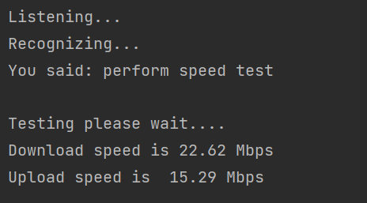

**Fig. 3.13 Speedtest**

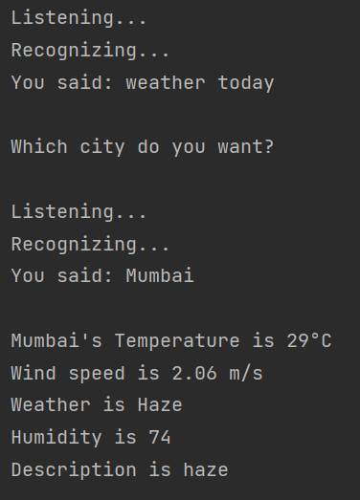

**Fig 3.14 Weather Report**

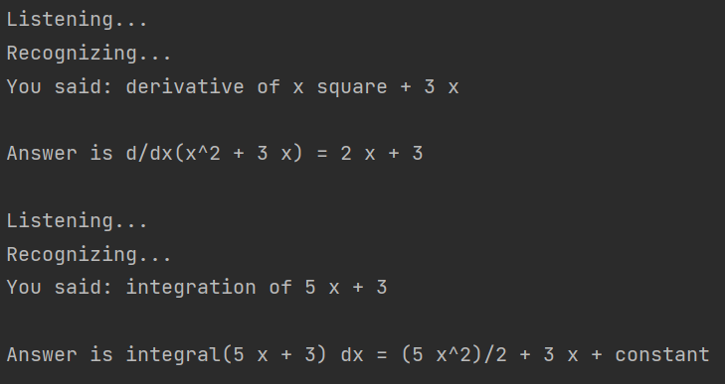

**Fig 3.15 Maths Problems**

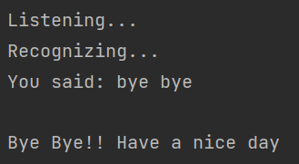

**Fig 3.16 Bye, Exit**

1. **CONCLUSION AND FUTURE SCOPE**

**6.1. CONCLUSION**

Voice Controlled Personal Assistant System will use the Natural language processing and can be integrated with artificial intelligence techniques to achieve a smart assistant that can control the computer and applications and even solve user queries using web searches.

It can be designed to minimize the human efforts to interact with many other subsystems, which would otherwise have to be performed manually.

By achieving this, the system will make human life comfortable.

This project helped us to understand different aspects of Python Programming through different packages, modules and APIs.

**6.2. FUTURE SCOPE**

* Controlling Smart Home appliances.
* Chatbot, talking to user.
* GUI based interface.
* Play Games.
* Controlling Device.
* Read notification or messages for you.
* Calling a person.
* AI based Knowledgebase.
* Storing queries for future references.

**REFERENCES**

**Books Referred:**

E Balagurusamy, “Introduction to computing and problem-solving using python”, McGraw Hill Publication.

Dr. R. Nageswara Rao,” Core Python Programming” , Dreamtech Press, Wiley Publication

Learning Python, 5th Edition, Marks Lutz.

**Websites Referred:**

* [https://ieeexplore.ieee.org/document/9210344/figures#figures](https://ieeexplore.ieee.org/document/9210344/figures)
* <https://ieeexplore.ieee.org/document/8993344>
* <https://pypi.org/>
* <https://docs.python.org/>
* <https://www.geeksforgeeks.org/>

**CODE SAMPLE**

**Modules –**

* **pyttsx3:** pyttsx3 is a text-to-speech conversion library in Python.
* **speech_recognition:** Library for performing speech recognition, with support for several engines and APIs, online and offline.
* **pywhatkit:** PyWhatKit is a Python library for Sending WhatsApp message at certain time, it has several other features too.
* **googletrans:** Google Translate API for Python.

**Packages –**

* **smtplib:** The smtplib module defines an SMTP client session object that can be used to send mail to any Internet machine with an SMTP or ESMTP listener daemon.
* **selenium:** The selenium package is used to automate web browser interaction from Python.

**APIs –**

* **Wolframalpha API:** Python Client built against the Wolfram|Alpha v2.0 API.
* **News API:** News API is a simple JSON-based REST API for searching and retrieving news articles
* **OpenWeatherMap API:** openweathermap is a service that provides weather data.

**ACKNOWLEDGEMENT**

We would like to express a deep sense of thanks and gratitude to our Project guide Prof. Suchita Dange for constantly guiding us throughout this project. Her constructive advice and constant motivation have been responsible for the successful completion of this project.

We have been greatly benefitted from the valuable guidance, encouragement and kind supervision given to us throughout this project which help us to develop the project successfully.

**With sincere regards,**

**Project Group 23**