Coursework Cover Sheet
Students should complete the input fields contained in this form and attach it in front of your formal assessment submission. All fields within this form are required. Please ensure that check boxes and radio buttons are appropriately selected. The last three questions are just for you to personally consider.

Department and assessment information:
School Name: Engineering and Computing
Assessment title: Optimising Campus Service Operations
Course Title: Bachelor of Science with Honours in Software Engineering
Module Title: Computational Thinking
Module Code: CO2412
Year of Study: 2025-2026

Academic Misconduct / Plagiarism Declaration
By attaching this front cover sheet to my assessment I confirm and declare that I am the sole author of this work, except where otherwise acknowledged by appropriate referencing and citation, and that I have taken all reasonable skill and care to ensure that no other person has been able, or allowed, to copy this work in either paper or electronic form, and that prior to submission I have read, understood and followed the University regulations as outlined in the Academic Integrity Policy and Procedure for Academic Misconduct

Have you checked the following? This will help your assessment achievement.
I have applied the learning outcomes for this module ☑
I have checked for Academic Integrity via Turn-it-in ☑
I have followed the guidance in the Assessment Brief and have not used AI to boost my grade unfairly. ☑
I have used references in accordance with instructions in the Assessment Brief ☑
I have proofread my work for spelling, grammar and punctuation. ☑
I have checked that the word count/size of this submissions accords with the guidance provided in the Assessment Brief.☑

Well-being
We wish to support any student who is experiencing mitigating circumstances which prevents students from performing to the best of their ability when completing or submitting assignments. If you are experiencing such circumstances, then you may apply for Mitigating Circumstances. Wherever possible this must be done prior to handing in your assignment.

Do you need to apply for mitigating circumstances for this assignment No

Please refer to the Mitigating Circumstances Policy

Questions you may wish to consider:
- Have I allowed sufficient time to prepare this assessment?

- Have I reflected on previous feedback and made improvements in accordance with advice?

- What grade am I expecting?

Name: W.R.V Abhiman Sri Nayanamina
GNum: 21337845
Module Title: Computational Thinking
Module Code: CO2412
Assignment title: Optimising Campus Service Operations
Assignment Tasks
Task 1 – Problem definition and decomposition
Problem definition
The problem where is The University of Lancashire. The university offers multiple services daily. It runs around three services which are maintenance, IT support, and cleaning across academic buildings, laboratories, hostels and administrative facilities. The current situation is all task handles by manually. When a university system like this (All task allocations are in manual system), it won’t be a good enough and efficient one. The services should be comfortable for that learning stuffs and staff also. This gets delays, inefficient scheduling, and unnecessary stuff movement across the university. There is no automated and efficient way for this problem. There is no automated way to priorities requests, assign staff based on workload, and calculate the best and shortest route for the location.
What does the university want (key problem): The University of Lancashire wants an automated system that manages services requests efficiently, recommend the easiest way with minimum travel time between buildings and ensure the task are completed or not on time.
This solution applies computational thinking to redesign this process using structured algorithms.
This requires selecting algorithms for sorting, searching, and routing, and ensuring data is stored and anytime access if needed. The focus thing of making a system like this is reducing time wastage, optimise scheduling and increase the efficient level of the system instead of old manual based
on system. So, for that, firstly, they want to break the problem in to sub problems and find solutions.

Break into subproblems
- Task sorting:
task should be sorted according to priority, deadline or location.
Ex: if university wants to do urgent tasks first, they should look if urgent tasks are in there or not. For that, they want task sorting
- Searching for staff/requests:
Quick check for staff availability or task details.
Ex: if the task is more important, they should put staff for that task quickly.
- Route recommendation:
To reduce travel distance and time between university buildings.
- Task Allocation
To assign staff fairly based on workload and where the locations they want more.
Input, process and output
- Input:
Locations.csv, requests.csv, staff.csv
(Getting inputs from these files)
- Process:
Sorting tasks, searching staff availability, route calculation, task assignment
- Output:
Optimised task lists, staff schedules, shortest travel routs
Abstraction using Flowchart
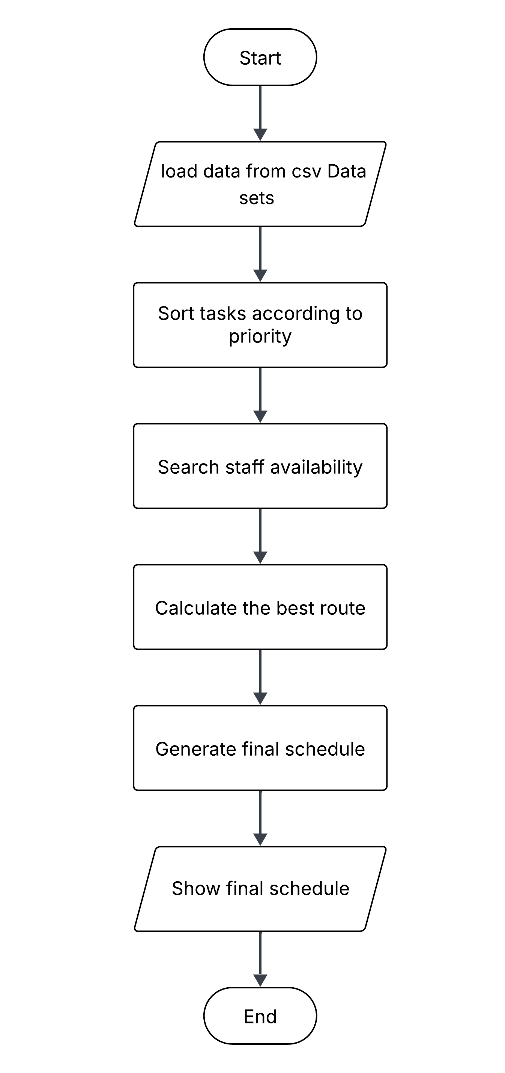
(Alam & Abdulmotaleb El, 2017)
Task 2 – Algorithm Design and Reasoning

In this scenario, we use Selection Sort + Insertion Sort and Linear Search + Binary Search. what the campus requires is fast sorting of tasks and quick retrieval of staff and getting task details. This kind of methods suitable for small or large unsorted data. This will show completely in the following parts such as pseudocode section, logic, complexity and suitability for the campus scenario.
(Cormen, Charles E, Ronald L, & Clifford, 2022)

Selection Sort
- Pseudocode
for i from 0 to n - 1:
minIndex = i
for j from i + 1 to n - 1:
if arr[j] < arr[minIndex]:
minIndex = j
swap arr[i] and arr[minIndex]

- Logic Explanation
In Selection sort, it divides the whole elements into two parts which are sorted portion and unsorted portion. The sorted portion at the beginning and the unsorted portion is the rest. It means that is progressively reduced. During each iteration, the algorithm scans the unsorted rest of the list for finding the minimum value in list. Once found, that minimum element is swapped into its correct value position in the sorted part. The full algorithm goes like this until all elements are placed in right places. Which means ascending order.

- Suitability
Selection sort is a straightforward algorithm method. it useful for small size of datasets. It’s main advantage is simplicity. There are no complex theories in this. It’s easier to implement and debug. However, in some complex scenarios, selection sort is not a good idea for very large datasets. It is suitable when sorting small size of lists. For this situation, we can use this algorithm for staff.cvc.xlsx
Because that file is verry small.

- Complexity

- When the case is Best:
Time complexity = O(n²)
Space complexity = O(1)

- When the case is Average:
Time complexity = O(n²)
Space complexity = O(1)

- When the case is Worst:
Time complexity = O(n²)
Space Complexity = O(1)

Insertion Sort
- Pseudocode
for i from 1 to n - 1:
key = arr[i]
j = i - 1
while j >= 0 and arr[j] > key:
arr[j + 1] = arr[j]
j = j - 1
arr[j + 1] = key

- Logic Explanation
Insertion sort builds sorted one element at a time. It means first it compares element 1 and 2. And then it recognizes what element the smallest one is. And then it’s sorting in the sorted list, and the rest keep as unsorted.
- Suitability
Insertion sort is especially useful for environments like new tasks updates frequently. As an example, when the tasks are sorted by time and only a few entries are added, insertion sort performs efficiently. So, then this insertion sort makes practicality for daily campus services request updates.
- Complexity

- When the case is Best:
Time complexity = O(n)
Space complexity = O(1)

- When the case is Average:
Time complexity = O(n²)
Space complexity = O(1)

- When the case is Worst:
Time complexity = O(n²)
Space Complexity = O(1)

(GeeksforGeeks, 2023)

Linear Search
- Pseudocode
for i from 0 to n - 1:
if arr[i] == target:
return i
return -1

- Logic Explanation
Linear Search checks each element in a lint one by one until the target value in found, or until the list is ending. It does not require any preprocessing.

- Suitability
This uses for small datasets or unpredictable data ordering stuffs. This uses for unsorted lists such as staff availability logs, or location descriptions. Usually, this searching method is not using for large datasets. But it’s more effective and simpler for this scenario.

- Complexity

- When the case is Best:
Time complexity = O(1)

- When the case is Worst:
Time complexity = O(n)
Binary Search
- Pseudocode
low = 0
high = n - 1

while low <= high:
mid = (low + high) // 2
if arr[mid] == target:
return mid
else if arr[mid] < target:
low = mid + 1
else:
high = mid - 1

return -1

- Logic Explanation
Binary search works by repeatedly having a sorted list. First, it gets Low key and High key of the list, and they are putting to this formula for getting mid value ((l + h)/2). They are sorting the list like this after found or reached the nearest value that we want.

- Suitability
This searching algorithm is useful when the dataset is sorted. This can use for task IDs, staff IDs, or room numbers. Also, we can use this algorithm for large data sets. Because this provides highly efficient access
- Complexity

- When the case is Best:
Time complexity = O(1)
Space complexity = O(1)

- When the case is Worst:
Time complexity = O(log n)
Space complexity = O(1)

Final Justification
Overall, Insertion sort and Binary Search are the most efficient algorithms for this campus solution. Insertion sort is more suitable for service request lists. Because it is updating frequently. As well as it runs close to O(n). this makes more efficient that selection sort.
When it comes to searching algorithms, Binary Search offers best performance when working with sorted campus records. Its time complexity is O(log n) which allows to quickly locate staff and that kind of stuff. And it is better to use large datasets.

- So, Insertion Sort and Binary Search are the best ways to use this university services problem.
(GeeksforGeeks, 2023)

Task 3 – Python Simulation and Testing
Algorithm Implementation
In this section, the algorithms we selected (Selection sort, Insertion sort, Linear search, Binary search) are going to implement in python.

Selection Sort
def selection_sort(arr):
a = arr.copy()
comparisons = 0
for i in range(len(a)):
min_index = i
for j in range(i+1, len(a)):
comparisons += 1
if a[j] < a[min_index]:
min_index = j
a[i], a[min_index] = a[min_index], a[i]
return a, comparisons

Insertion Sort
def insertion_sort(arr):
a = arr.copy()
comparisons = 0
for i in range(1, len(a)):
key = a[i]
j = i - 1
while j >= 0 and a[j] > key:
comparisons += 1
a[j+1] = a[j]
j -= 1
a[j+1] = key
return a, comparisons

Linear Search
def linear_search(arr, target):
comparisons = 0
for i in range(len(arr)):
comparisons += 1
if arr[i] == target:
return i, comparisons
return -1, comparisons

Binary Search
def binary_search(arr, target):
low, high = 0, len(arr)-1
while low <= high:
mid = (low + high) // 2
if arr[mid] == target: return mid
elif arr[mid] < target: low = mid + 1
else: high = mid - 1
return -1

Dataset Simulation
In this scenario, we commanded as if a file missing or too small, random values should be generated. It works with using Python random module. To measure the performance testing, datasets are loading from CSV files which we provided.
In this part, I tested deferent dataset elements for calculating the performance. If we tested more elements, we could have a better graph. So, we generated additional random requests.
For sorting algorithm, I tested 50,100, 200, and 400 elements.
For searching algorithm, I tested 1000, 200, 5000, and 10000 elements. (this needs bigger size of datasets to clearly see the performance differences)
Performance Metrics
Execution time
This calculates with milliseconds (ms)
import time

start = time.time()
result = selection_sort(data)
end = time.time()
time_taken = end - start

Memory Usage
This calculates in kilobytes (KB)
In this section, I used a simple way to measure the memory usage. It works with len command. It is counting how many elements were stored in each dataset.
memory_used = len(data)

Number of comparisons or operations
I added counter variables inside the loops (sorting and searching algorithm)
This measures how each algorithm performs when dataset size increases.
comparisons = 0
comparisons += 1

(W3Schools, 2023)

Visualisation
Matplotlib was used to generate charts and comparing algorithm performance. We are discussing four graphs here
- Sorting execution time comparison
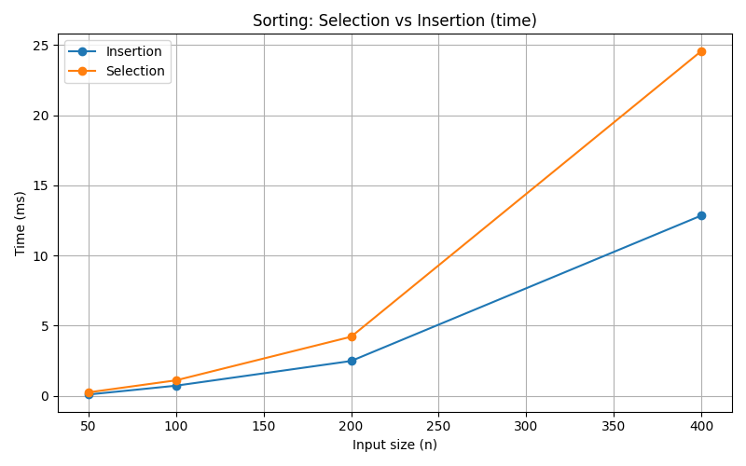

As we can see, insertion sort is completely faster than selection sort. This because of fewer comparisons and early stops.
- Counting sorting comparisons
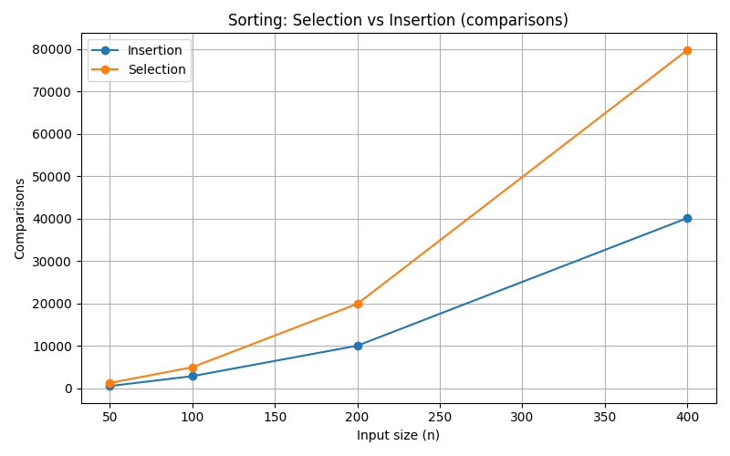

Selection sort is performed the highest number of comparisons, but the insertion sort did fewer comparisons as we can see

- Searching execution time comparison
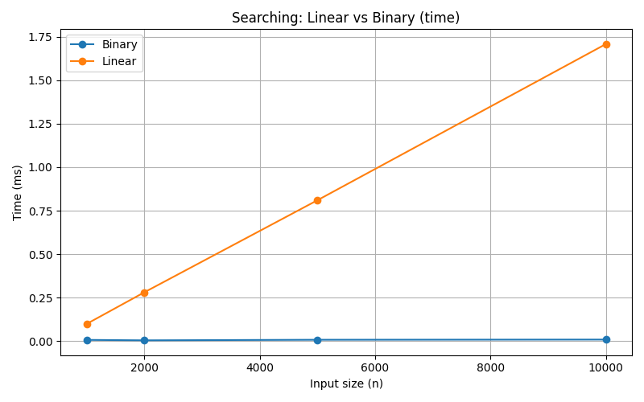
As we can see, the Binary search is performed well in this scenario rather than Linear search. Because of its O(log n) complexity.
- Counting searching comparisons
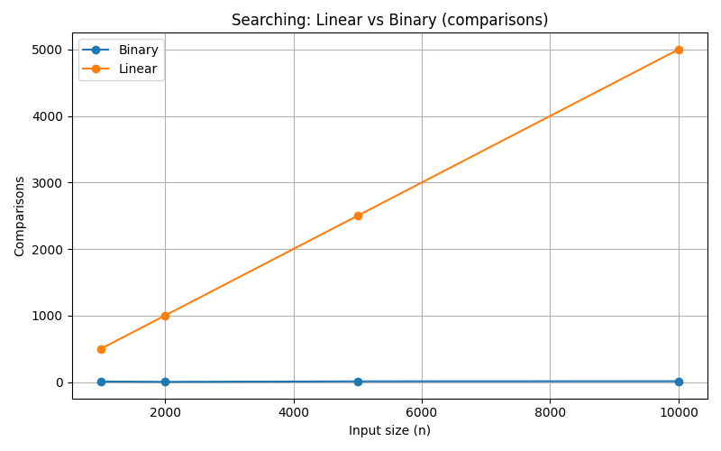

In here, Binary search was required few comparisons, but Linear search comparisons are increased with dataset size.

- Finally, we can have a better idea of what sorting and searching method the best is. Insertion sort is the most efficient method from these two.
- The most suitable and best searching method is Binary search when data Is sorted.
(Hunter, 2007)

Task 4 - Route Optimisation and Evaluation
The campus service system wants a better path suggestion system for decrease travel time and improves the productivity when the staff wants to travel between buildings. In here, we discuss about two algorithms (Greedy Nearest Neighbour and Dijkstra Algorithm) to identify efficient travel path.

Implementation to the map
Nodes – this represents locations such as Library, Cafeteria, IT building, Engineering building, admin office, Car parking.
Edges – edges represent walkways between buildings.
Weights – this shows distance or cost of walkways.
This clarification will help to understand and identify real world movements across the campus.

Greedy Nearest Algorithm
Basically, this algorithm works by selecting the closest unvisited location from the current location. As an example, if someone wants to travel from Library to Engineering Building, so this algorithm shows up the nearest locations one by one after reaching them,

Library Cafeteria | Cafeteria IT Building | IT Building Engineering Building
This algorithm only shows the nearest way at each stop. Sometimes it may be the closest one. But this is a simple and a fast way.

Dijkstra’s Algorithm
Dijkstra’s algorithm finds the shortest way from the starting point to the destination point, it measures shortest way by considering all possible routes. It builds the way to reach destination with minimum distance
In here, the algorithm updates all distance to all nodes and going through the route that has the smallest distance between the nodes. As an example, if someone wants to travel from Library to Engineering Building,

Library Cafeteria IT Building Engineering Building

With this algorithm, this guarantees to show the best shortest and the minimum costed route to us.

Performance Evaluation
Metrics | Greedy Nearest Neighbour | Dijkstra’s
Total travel distance | Medium (sometimes will be lower path) | Lowest
Computation time | Faster | Slower than Greedy
Scalability | Suitable for small graphs | Suitable for large graphs

Trade-off Discussion
Basically, we discuss route efficiency, computation cost, and code simplicity in here. The Greedy Neighbour is the easiest and understandable method, but it suitable for small or time critical situations. Sometimes it shows longer travel distance to the destination. Dijkstra’s algorithm is computationally expensive and it’s harder to implement. But the result is more efficient route (lowest distance). Finally, these two algorithms depend on priority of whether speed or optimality.

Computational thinking reflection
Decomposition – Break the campus problem into nodes, edges, and distances.
Abstraction – ignoring real world unnecessary details and focusing locations and distances.
Modelling – imagine the campus as a graph and applying the algorithms
Finally, these technics solved the real world problem into manageable and structured one.
(Dijkstra, 1959)

References
Cormen, T.H., Leiserson, C.E., Rivest, R.L. and Stein, C. (2022) Introduction to Algorithms. 4th edn. Cambridge, MA: MIT Press.
Wing, J.M. (2006) ‘Computational thinking’, Communications of the ACM, 49(3), pp. 33–35.
Hunter, J.D. (2007) ‘Matplotlib: A 2D graphics environment’, Computing in Science & Engineering, 9(3), pp. 90–95.
GeeksforGeeks (2024) Sorting algorithms. Available at: https://www.geeksforgeeks.org/sorting-algorithms/ (Accessed: 25 December 2025).
GeeksforGeeks (2024) Searching algorithms. Available at: https://www.geeksforgeeks.org/searching-algorithms/(Accessed: 25 December 2025).
Dijkstra, E.W. (1959) ‘A note on two problems in connexion with graphs’, Numerische Mathematik, 1, pp. 269–271.

