Arup Kumar Bhattacharjee 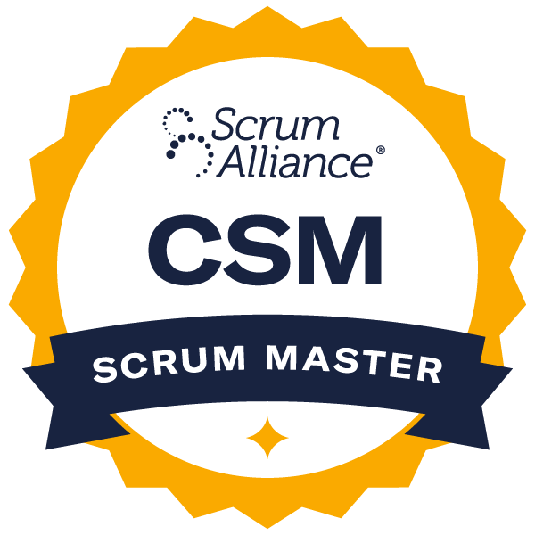
https://www.linkedin.com/in/arupbhattacharjee/
Email: arup.bhattacharjee@gmail.com || Cell: +1 214-940-6841
Current Location: McKinney, TX

Agile certified SAP Project Manager having 18+ years of experience in SAP Products, Implementation and Project Management. Worked in SAP implementation projects starting from data migration from legacy systems to setup the new system for the Business Users, this also includes process and framework setup and trainings. Managed integration system activities including monitoring the technical architecture including scalability, availability, and archiving and undertook performance tuning activities for SAP integration activities. Managed a large number of Cutover activities and executed project plans and progress, reporting cutover status during deployment and mock cutovers, and is responsible for updating the template for future cutovers. Leading an S/4 HANA migration project with end-to-end project management, blueprinting, design, testing, user training, and post-go-live support. Well versed with project management tools like JIRA, ServiceNow, Visual Basic, and MS Project.

Best known for providing value using Agile, Scrum and Waterfall methodology and contributed to:

- Strategic Vision & Direction
- Faster time to market
- Business Acumen
- Process Improvement
- Financial Management
- People Management
- Stakeholder Management

Technology

- SAP ABAP
- ODATA
- FIORI
- Splunk
- Ansible
- S/4 HANA
- SAP Screen Personas
- Visual Basic
- Service Now
- Data Migration
- JIRA
- MIRO
- MS Project

Education:
Masters in Information Technology, University of Madras, 2008
Bachelors in Computing & Information Systems, University of London, 2001

Professional Experience:
Global Logic Mar 2024 – Present
Product Owner – SAP S/4 Hanna Transformation Project & Data Integration Mar 2024 – Mar 2025
(Client – Is a marketing and sales services company)
Project Description:
Retiring Microsoft Dynamics, converting the core Finance System to S/4HANA platform on RISE. Achieve organizational goals to reimagine E2E processes, strengthen finance capabilities, leverage new innovations, save manual time and drive efficiency.
Responsibilities:
As a Product Owner in a large-scale SAP Transformation project, played a key role in managing Data Integration business features for the Enterprise Data Integration Team.
- Strategic Planning & Roadmap Development
  - Define and manage high-level roadmaps for the engineering team’s execution.
  - Collaborate with Product Leadership for Planning goals, ensuring alignment with quarterly and yearly objectives.
  - Suggest growth opportunities based on customer interactions and business needs.
- Requirement Management & Stakeholder Collaboration
  - Engage with Product Owners, Architects, PMO, Infrastructure, and Business stakeholders to gather requirements and define product features.
  - Ensure all requirements—both functional and non-functional—are validated before release.
- Testing & Release Management
  - Develop an end-to-end testing strategy for product features.
  - Conduct User Acceptance Testing (UAT) and validate requirements before release.
  - Own release plans, set delivery expectations, and provide product updates to stakeholders.
- Technical & Data-Driven Decision Making
  - Support data integration needs.
  - Provide business case justifications and analysis to align with the product strategy.
- Cross-Functional Collaboration & Best Practices
  - Partner with Product Management leaders to prioritize the developments based on business needs and ROI.
  - Ensure the team follows best practices and provide necessary training.
  - Collaborate effectively with a distributed team across multiple time zones.
COSOL Americas Feb 2023 – Feb 2024
SAP Delivery Manager - S/4 Hanna Data Migration Project - Mining Client
Responsibilities:
- Lay out clear plans for project execution by developing detailed schedules, defining milestones and deliverables, identifying resource requirements, and coordinating day-to-day activities across resources.
- Ensure achievement of the project's intended business benefits remain paramount by applying an appropriate amount of discipline to evaluate changes to the core aspects of the project (e.g., scope, requirements, timelines, and cost)
- Communicate the right things about the project at the right time in the right way by developing communication plans, tailoring communications to intended audience(s), and delivering information consistently and in a perceptive manner.
- Connect with project stakeholders on an ongoing basis.
- Identify and mitigate issues and conflicts with project teams, manage project dependencies.
- Plan and schedule project timelines and milestones using appropriate tools.
- Track, manage and coordinate invoice project milestones and deliverables.
- Provide insight into project health by applying appropriate metrics to measure project performance, comparing actual performance to planned performance on an ongoing basis, identifying root causes of situations that could negatively impact project performance, and preparing and delivering executive level briefings when needed.
- Coordinate project development through the project lifecycle.
- Part of SAP ILM and data archiving process, involved in Finance, Materials Management and Plan Maintenance archiving the transaction data.
- Work with process owners on the retention policy(SAP ILM) for Financial Documents before migration to SAP HANA.
- Led a team comprising Azure Data Factory(ADF) architect and consultants with SAP functional SME’s to copy data from SAP to ADF for MM and PM. Dashboards are created using Power BI to visualize the data, this involves finalizing the connector, SAP tables, CDC connectors etc.
- Led the complex object migration strategy/blueprinting for FICO&PS modules – GL Balances, Asset, Project Balances, Vendor Master etc.
- Led the complex object migration strategy/blueprinting for MM module – Material Master, Storage Locations, PO’s, Inventory Balances etc.
- Led the complex object migration strategy/blueprinting for PM module – Work Center, Open Work Orders, Attachments, Functional Locations etc.

Accenture Solutions Pvt Ltd Aug 2006 - Jan 2023
SAP Program Manager and Automation Lead Jan 2019 - Jan 2023
Responsibilities:
- Business/vendors/teams/stakeholders coordination and bridge for project execution & delivery.
- Facilitate/Manage end-to-end project management process as per client standards.
- Providing efficient communication between all stakeholders and their alignments as necessary.
- Facilitate triage for defects management for quick resolution and closure.
- Managing Cutover activities and facilitating bridge calls - Execute project plan and progress, report cutover status during deployment and mock cutovers, responsible for updating the template for future cutovers.
- Coordinate with the IT leads for testing, data migration, IT system cutover activities and legacy process transition.
- Assist with Identifying all communication needs during the cut-over/ Pre & post and build a communication matrix.
- Delivery of work within time and budget with full transparency of dependencies, risks, and priorities.
- Participate as part of the product’s management team by meeting regularly with the product manager, head of product development, product owners, client services, and head of technical operations.
- Driving agile/scrum team, process, conduct daily status meetings and delivery.
- Experienced in JIRA and Confluence
- Requirements gathering on archiving objects in FI, MM, PM and determine the retention time(SAP ILM), configuration, testing and support data migration to third party content management systems.
- Lead the Organizational Change Management Process due to Agile implementation:
  - Understand how the project will impact Employees and Stakeholders
  - Develop Communication and Training Plans
  - Sustain the change
  - As a self-starter, capable of hitting the ground running and driving transformative change seamlessly
  - Convey complex and highly technical information to a diverse audience
  - Worked cooperatively with organizational teams and business customers to provide excellent customer service

Product Owner & Solution Architect/Pre-Sales Jan 2016 - Dec 2018
Factory setup, serving multiple clients.
Responsibilities:
- Part of Accenture Innovation center handled 100+ pre-sales opportunities.
- Role involves attending workshops with customer, understanding business problem, capture requirement, prepare User Story.
- Define technology components & related architecture.
- Estimate effort, team skills & execution framework.
- Worked in SAP implementation projects starting from data migration from legacy systems to setup the new system for the Business Users, this also includes process and framework setup and trainings.
- Designed solution for SAP DevOps.
- Understood the client landscape and the Life Cycle of the project and accordingly proposed the tools and assets as a part of SAP DevOps.
- Proposed the roadmap, effort and the skill set involved for the project.
- Managing Cutover activities and facilitating bridge calls.
- Worked for IS Retail client – Master Data, POS Interface, Procurement, and requirement planning.
- Involved in the SAP data archiving of FI, CO, MM and other custom objects as per corporate retention(SAP ILM) requirements.
- Document the results and migrate the archived data to Document Server. Work with business process experts in sign off.
- As a Product Owner managed full stack product developments projects which involved non-SAP technologies like java, node.js etc. Followed the Agile delivery methodologies to deliver the project. Part of Agile delivery maintained the Epic and User Stories into JIRA and followed all Agile ceremonies.

US-Based Multinational Chemical Client Jan 2014 - Dec 2015
Project Manager and SAP Screen Personas Architect
Responsibilities:
- Bring to life a ‘SAP Lite’ solution for the client by creating the simplified User Experience.
- End to end project management, blueprinting, design, testing, user training and post go live support.
- External application integration.
- Master Data conversion and loading.
- Change Management – including both training and performance support, communications, organizational design, and role definition.
- Deployment, cutover coordination, and support.

SAP ABAP Consultant and Project Management Jan 2009 - Dec 2013
Factory setup, serving multiple clients (Reusable Technical Library)
Responsibilities:
- Lead the design and build the global re-use platform that improves quality of technical deliverables while reducing effort, time, and cost.
- Assessment of SAP object inventory to understand the fitment of reusable assets.
- Validate the design and development of objects to ensure reuse.
- Tracking of effort savings from reuse
- New SAP Technologies involved like Fiori, CDS Views, OData

SAP ABAP Consultant Aug 2006 - Dec 2008
Pharmaceuticals - Multinational science and technology company
Responsibilities:
- Technical expert, ensuring quick turnaround in identifying application issues and providing timely solutions.
- Develop detailed plans and accurate estimates for completion of build, system testing and implementation phases of project.
- Transform business function requirements into technical program specs to code, test, and debug programs.
- Develop, code, document and execute unit tests, systems, integration, and acceptance tests.
- Perform performance tuning to improve performance over multiple functions.
- Engage other technical team members in the design, delivery, and deployment of solutions.
- Ensure integration system activities including monitoring the technical architecture (particularly scalability, availability, and archiving) meet all SLA's.
- Manage operational support, performing work during change windows as well as providing on call support as required by the team.
- Undertake performance tuning activities for SAP integration activities.
- Mentor and coach junior developer resources
- Provide consulting services on new and existing initiatives.

