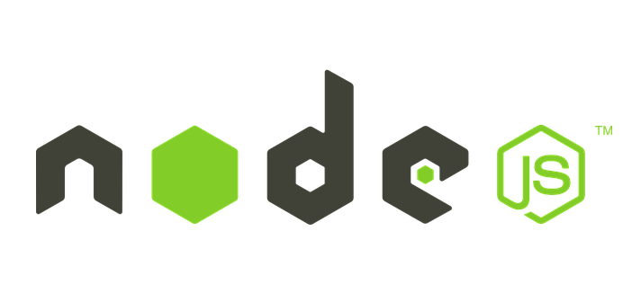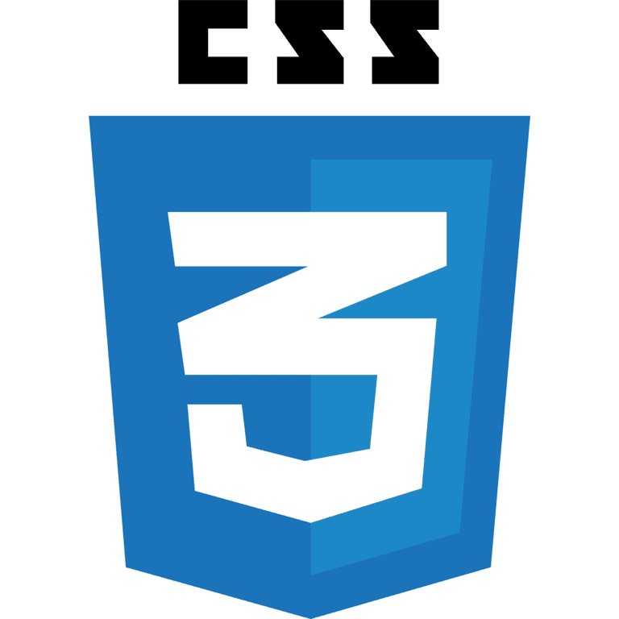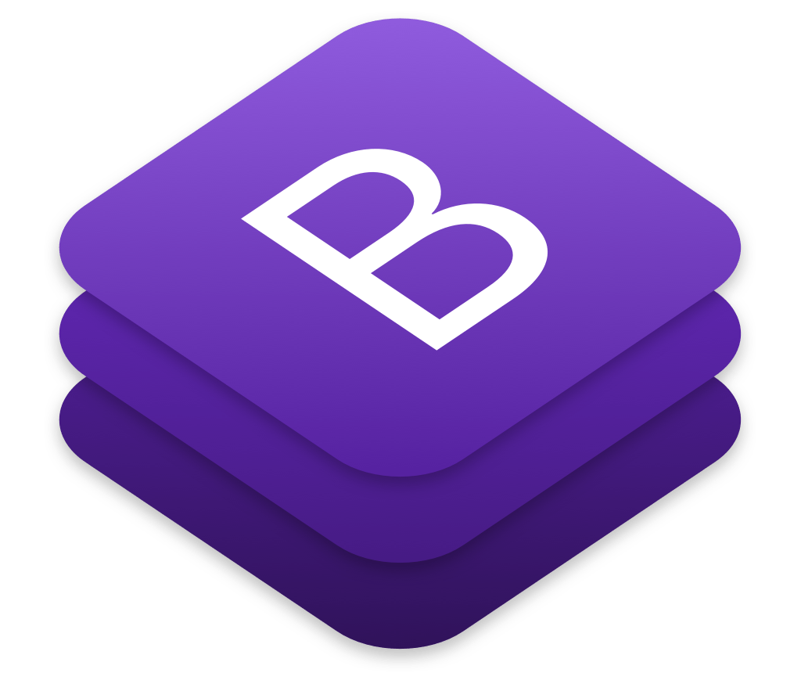

Ganesh Eijjada
Contact Details: +1-5735198777 , ganeshijjada169@gmail.com

Full Stack Developer - MERN

☁ Expert in Java,React.js, Node.js, JavaScript, Redux, MERN

SUMMARY

- 10+ years of professional experience in Web Development, designing User Interface (UI) applications and web applications using HTML5, XHTML, CSS3, JavaScript, ReactJS, developed single page applications using React Redux architecture, ES6, web pack and grunt.
- AJAX, JSON and XML with experience in the software development life cycle.
- Experience in creating web applications using MERN and MEVN stack, implemented with Express.js and MongoDB to create comprehensive web applications.
- Well versed with Software Development Life Cycle process which includes designing, developing, testing and implementation.
- Demonstrated use and strong knowledge of React.js, Node.js and JavaScript.
- Experience applying the latest development approaches including MVC framework in the browser, event-driven applications using Ajax, Object Oriented (OO) JavaScript, JSON and XML.
- Expertise in maintaining websites, software and understanding and modifying existing code.
- Extensive Knowledge in developing single-page applications (SPAs) using various JavaScript frameworks like ReactJS and AngularJS
- Have good knowledge in Responsive web design.
- Extensive Knowledge and experience of advanced concepts like React – Redux usage, React Router, Webpack.
- Strong knowledge on working with graphQL schema, queries and mutations to interact with mongo DB and several other data layers.
- Extensive experience with ReactJS and working with redux architecture for state management.
- Experienced in developing web and mobile applications using latest JavaScript ES6 features and frameworks such as ReactJS, and Redux.
- Working with ECMA Script 6 features. For build of JSX and ES2015 (ES6) used Babel, web pack.
- Experience working with testing tools like Firebug, Firebug Lite, Chrome/Safari web inspectors and IE Developer Toolbar.
- Exposure with React Native for building web apps for mobile devices like iOS and Android.
- Excellent verbal, written and interpersonal communication skills with both technical and non-technical audiences.
- Involved in design and development of graphQL and services to interact with data storage layer
- Well verse with resolving cross browser compatibility issues and making sure web apps run smoothly in all the browsers and environments.
- In-depth knowledge of Object-Oriented Programming Concepts (OOPS), Internet Technologies and related technologies like Restful APIs (GraphQL), Web Services, XML, HTML and JavaScript.

TECHNICAL SKILLS

Frontend Development | HTML5, CSS3, JavaScript (ES6+), TypeScript, React.js (Hooks), Next.js, Redux-Toolkit, React Router DOM, Tailwind- CSS, Material-UI, Responsive Designs, SCSS, Shadcn/ui, SPA, PWA
Backend Development | Node.js, Express.js, REST APIs, GraphQL, Socket.IO, JWT, OAuth, CORS, Bcrypt, MVC Architecture
Databases & Storage | MongoDB (mongoose), Firebase (Cloud Firestore, Storage, Authentication), Cloudinary
Mobile App Development | React Native Expo, React Native Google Mobile Ads, react-navigation, Expo Notifications, react native paper
Tools and Platforms | Postman, Canva, Visual Studio Code, Cursor IDE
Deployment | Firebase Hosting, Netlify, Vercel, Heroku
Containerization | Docker
Version Control | Git, GitHub

PROFESSIONAL EXPERIENCE

State Farm Insurance, Bloomington IL March 2024- Till Date
Role: Full Stack Developer- MERN

Responsibilities:

- Designed and developed web pages using with HTML5, DHTML, CSS3, SASS, Ajax, Bootstrap, ReactJS, Node JS based on the W3C standard.
- Developed and optimized MERN stack applications, improving performance & security
- Designed and integrated RESTful APIs and GraphQL, reducing API latency by 40% and improving responsiveness.
- Implemented JWT and OAuth authentication, strengthening security while ensuring seamless user access.
- Enhanced backend efficiency, optimizing database queries and API interactions to improve scalability and reduce response times.
- Writing front-end code like HTML5, CSS3, jQuery for assigned User requirements using ReactJS, and various other JavaScript frameworks.
- Involved in writing application level code to interact with APIs, Web Services using AJAX, JSON.
- Created the Node.js Server using Express.js and from front-end side ReactJS, backend is MongoDB.
- Created AWS Lambda, EC2 instances provisioning on AWS environment and implemented
- security groups, administered Amazon VPC’s.
- Created Responsive Designs (Mobile/Tablet/Desktop) using HTML5 & CSS3.
- Used ReactJS for creating Routes, Filters, Directives and Services and create maintainable and testable
- single page application.
- Programmed various jQuery plugins such as Buttons, Calendar, Grid, List box, Tab Container, Accordion, Menu, Dialog boxes and Toolbars.
- Used ChartJS to implement Data Visualization by displaying charts in task manager module.
- Improve performance of the application by optimizing REST calls, and minifying the JavaScript code, making more reusable components and writing modular, industry standard and uncluttered code.
Involved in debugging HTML5, CSS3 and JS code using tools such as Chrome Inspector, Firefox Firebug.
- Used Jenkins to build and deploy the application and Bitbucket for code repository and version control.
- Used the Mozilla Firefox extension, Firebug, Developer tools to view and debug HTML,DOM and JavaScript.
- Wrote test plans and performed unit testing and performance testing using Jasmine and Karma.
- Followed Test Driven Development in order to minimize errors that can creep up in later stages.
- Bugzilla was used to report and track bugs, JSLint for ensuring quality code.

Environment: HTML5, CSS3, SASS, JavaScript, jQuery, Reactjs, Bootstrap 3, Node JS, JSON, AJAX, AWS,Express.js, MongoDB (2.2.4), MERN stack, Grunt, Bower, Jasmine, Karma, Maven, TomcatServer, Jenkins, Bugzilla, Bitbucket

Fresenius Medical Care, Lexington, USA Sep 2023- March 2024
Full Stack Developer
Responsibilities
- Developed fully functional responsive modules based on Business Requirements usingHTML5, CSS3, Bootstrap, SASS, JavaScript, jQuery, jQuery plug in, React.js.
- Designed and implemented modules for disbursements, deposits, credit and history of accounts. Along with that designed web pages for internal website for work list, brancha dministration andcustomer service.
- Created the Node.js EXPRESS Server combined with Socket.io to build MVC frame work from front-end side ReactJS to backend MongoDB.
- Involved in creating reusable UI components to render view pages using ReactJS along with Redux.
- Used React as framework to create a Single Page Application (SPA) which can bind data to speciﬁc views and synchronize data with server using CSS3, Bootstrap, React and Redux.
- Duties included helping the team to create standards for UI/UX development and enforcement of those standards.
- Installed the application on AWS EC2 instances and configured the storage on S3 buckets.
- Used Email.js for the automatic loan e-mail reminders.
- Created the schema and wrote middleware to store the data on Mongoose, MongoDB.
- Processed JSON data from RESTful web service by using axios to get resources from the database and populated data to the client side.
- Managed projects with Web pack and combined with Bower package manager to install JavaScript latest version of libraries based on running in the Node.js environment.
- Used ECMA script 6 with react.js and used BABEL to transpile the code to ECMAscript5.
- Developed dynamic data visualizations by using D3.js (Data Document Driven).
- Validate user input before sending the page off to the server by using the JavaScript.
- Performed Unit testing on applications using tools Mocha and Chai by following Test Driven Development, used JIRA for bug tracking and JSLint for ensuring quality code.
- Used Jenkins for continuous integration and continuous deployment pipeline.
- Used GIT as version control tool to update work progress And attended daily Scrum sessions.

Environment: HTML5, CSS3, Bootstrap3, SASS,AWS, JavaScript, AJAX, JSON, XML, JQuery, ReactJs, Redux, Axios, Node.js (4.1.1), Express.js, MongoDB (2.2.4), MERN stack, Jasmine, Karma, Maven, Tomcat Server, Jenkins, JIRA, Git

MIMOS, Malaysia Feb 2018- July 2022
Full Stack Developer

Responsibilities
- Responsible for creating efficient design and developing User Interaction screens / SPA using HTML5, CSS3, JavaScript, React.JS, Material UI and Bootstrap.
- Involved designing in web pages using HTML5, CSS3, JavaScript, Bootstrap, SASS, React.js, Redux, Flex.
- Design React components and higher order components.
- Implemented Both Client side and server-side pagination.
- Using Internal Design system developed react application from scratch
- Used React Router for routing the redux app to connect redux and react to support routes.
- Worked in using React components, Forms, Event, Keys, Navigation and Redux concepts.
- Worked with React hooks 16.8 where we can use states and all the working logic in functional Components with services and integrating them in production application
- Used CSS and Bootstrap to develop Rich UI Components such as Accordions and Modal Windows using pure HTML 5 AndCSS3.
- Worked on state, specs, props and events to create interactive React JS components.
- Implemented MVVM architecture using React and Redux framework.
- Developed the flux pattern by using redux framework as a core dependency.
- Developed high performance customer facing e-commerce application using ReactJs, Redux-saga, React Hooks, React-Router, JavaScript, HTML5, CSS3, SASS, Bootstrap4 .
- Developed UI patterns using NodeJS.
- Managed state within the app using Redux and persisted certain parts of the state to device via Redux Persis.
- Used Redux Framework architecture (like Reducers, Containers, Saga) for integrating the data with React
- Used React concepts like JSX (JavaScript Syntax Extension), components, state and props.
- Extensively used CSS preprocessors like LESS for re-usable style components.
- Implemented CSS Box Model and styled web pages using CSS preprocessor LESS and implemented Mix ins, functions, custom grid systems
- Implemented functionality using, Typescript and ES6.
- Developed single page applications using React Redux architecture, ES6.
- Wrote code to handle cross browser compatibility issues in IE 7, 8, 9, FF, Safari and Chrome.
- Building components library, including Tree, Slide-View, and Table Grid.
- Have worked on AWS to integrate the server side and client-side code.
- Worked with JASMINE unit test framework to write unit tests for JavaScript code.

Environment: React.JS, JavaScript, Typescript, MERN, Node.JS, NPM, Redux, CSS3, HTML5, Flex, JSON, jQuery, AJAX, Bootstrap, Material UI, Jest and Enzyme, Dom, ES6, JSX, GIT, CI/CD, Jenkins.

E2 Solutions, India May 2015- Jan 2018

Full-stack web developer

Responsibilities
- Designed multiple pages with different functions using React.js and React-Router to navigate these pages (Product list page, Product details page, Product creation and edit pages, customer cart page and customer login page) with user-friendly flow when switching.
- Used React latest hook components to develop this application. I used Redux to centralize and manage application data to create Interfaces.
- Worked extensively in API development,specifically for web use
- For ATOS,Managed a team of 3-5 developers to build a Cloud Management UI website.
- Incorporated backend Micro services and build layers on portals and this application was developed with React components which includes Modules and dashboard for reporting purpose dynamic portal and provisioning cloud level operations.
- Deploy this portal using CI/CD ,GitHub workflow
- Creating images in Jfrog Artifactory to deploy kubernetes containers
- Worked in an agile environment with weekly stand-ups,kept track of user-stories/bugs in GitHub projects and conducted 2 hours of sprint planning and retrospectives per week.
- Designing, developing and testing the web application by using the HTML5, CSS3, Bootstrap, React.JS and Redux.
- Extensive experience in developing the Accessible Web Pages for people with disabilities according to the 508-Compliance
- Designing the CSS templates for use in all pages on the website working with CSS Background, positioning, text, border, margin, padding, and table.
- Applied optimization techniques to reduce page size and load times to enhance user experience using sprites.
- Develop the user interface by using the React JS, Redux for SPA development.
- Used Input, Output properties and shared services for data communication between the components.
- Reusable angular components were developed targeting to reduce the large chunk of the code base using component-based architecture.
- Develop user interface by using the React JS, Redux for SPA development.
- Involved in responsive design and developed a single ISOMORPHIC responsive website that could be served to desktop, Tablets and mobile users using React.js.
- Used React-Router to turn application into Single Page Application
- Used ReactJS components, Forms, Events, Keys, Router, Animations and Flux concept.
- Used React-Autocomplete for creating Google maps location search on the webpage.
- Used ReactJS components, Forms, Events, Keys, Router, Animations and Flux concept.
- Building stable React components and stand-alone functions to be added to any future pages.
- Develop the Drag and Drop functionality using React-Draggable
- Used React-Autocomplete for creating google maps location search on the webpage.
- Components for UX-Library consisted of Button, Checkbox, Input, Icons, Toggle Button, Dropdown, Multi-Level Dropdown and many more.
- Experience with distributed version control system such as Git
- Worked on NSS (Mozilla), PKCS11 library to develop the CRYPTO operations for the Node.
- Worked with NPM commands and using Package.JSON for managing dependencies and dev-dependencies of Node.js applications.
- Developed crypto rest services using NodeJS and integrated services with HSM (Hardware Security Module)
- Worked with modules like MongoDB and mongoose for database persistence using Node.js to interact with MongoDB.
- Utilized Node.js, Socket.io, Redis, Supervisor, Grunt, Yeoman, and Angular for scalable website architecture and Realtime technology.
- Utilized tools like Jenkins, Docker, docker-compose, and helm to build, test, and deploy code related to the eCommerce platform.

Environment: HTML 5, CSS3, SASS, LESS, JavaScript, Bootstrap, Ajax, React JS, React Native,Redux, Flex, SQL Server, XML, XSL, XSLT, JSON, Github, Restful API,Oracle apex, JIRA, Jasmine and Webstorm.

