Qadeer Mohammed
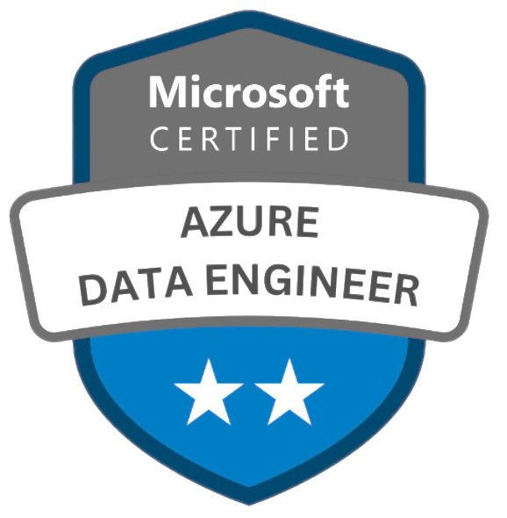
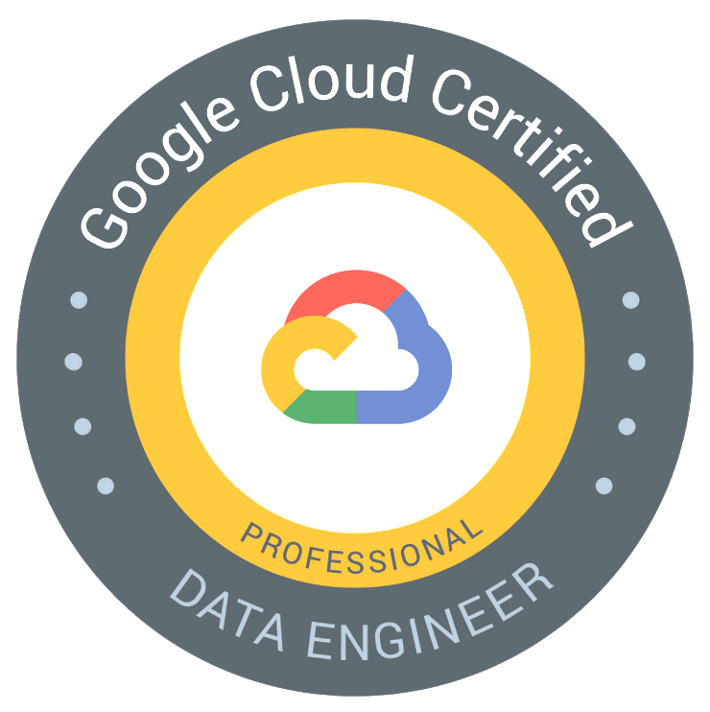
Senior Data Engineer
Email: qadeermohammed776@gmail.com| Phone: +1 972-800-7119

Summary
- Over 10+ years of professional experience in Data Engineering, with expertise in designing, developing, and deploying data pipelines across industries like Hospitality, Entertainment, Healthcare, Retail, and Finance.
- Skilled in utilizing Google Cloud Platform (GCP) services such as BigQuery, Cloud Storage (GCS Buckets), Cloud Functions , RBAC , Dataflow, Pub/Sub, Dataproc, Cloud Shell, and BQ Command Line Utilities to build scalable data pipelines and enable real-time processing.
- Proficient in Amazon Web Services (AWS) technologies, including Elastic MapReduce (EMR), Redshift, S3, EC2, Lambda, and Glue, with experience in implementing auto-scaling and Elastic Load Balancing (ELB) for optimal application performance.
- Expertise in Microsoft Azure services, leveraging tools like Azure Data Lake Storage (ADLS), Azure Data Factory (ADF), Stream Analytics, Azure SQL Data Warehouse, and Databricks to architect and manage scalable, secure data platforms.
- Designed and implemented GCP-based data pipelines, leveraging Cloud Dataflow, BigQuery, and Pub/Sub to process and transform structured and semi-structured data seamlessly.
- Migrated legacy SQL systems to AWS Redshift, employing advanced indexing techniques to improve performance and query efficiency.
- Built ETL workflows on Azure Data Factory (ADF), Databricks, and Azure SQL Data Warehouse, enabling large-scale data transformation and analytics.
- Engineered high-performance Big Data solutions using GCP Dataproc, integrating it with BigQuery and Cloud Storage for advanced analytics and reporting.
- Developed ETL pipelines on AWS Glue, connecting it with other AWS services to ensure smooth and efficient data workflows.
- Delivered scalable data processing architectures with AWS EMR, Redshift, and Lambda, utilizing S3 for cost-effective and scalable data storage.
- Leveraged GCP BigQuery and Cloud Dataflow for analyzing real-time data streams and generating actionable insights.
- Designed and deployed data processing frameworks on Azure, combining Stream Analytics, Data Lake Analytics, and SQL Data Warehouse for sophisticated analytics.
- Automated data workflows using AWS Lambda and GCP Cloud Functions , RBAC , ensuring efficient ingestion and processing of varied data sources.
- Implemented efficient ETL pipelines using tools like Azure Data Factory (ADF), GCP Dataflow, and AWS Glue, streamlining data transformations across hybrid environments.
- Created serverless data solutions utilizing GCP Cloud Functions , RBAC , Pub/Sub, and BigQuery to support real-time analytics and reduce operational overhead.
- Secured data pipelines across AWS, Azure, and GCP by applying encryption, IAM roles, and data masking to meet regulatory compliance requirements.
- Integrated AWS S3, Azure Data Lake, and GCP Cloud Storage into hybrid cloud pipelines, facilitating smooth data transfer and unified analytics across multi-cloud platforms.

Technical Skills

Big Data Ecosystem | Apache Spark, HDFS, Yarn, MapReduce, Kafka, HIVE, Sqoop, Oozie
Google Cloud Platform | Data Plex,Big Query, Cloud Storage, Cloud Functions , RBAC , Cloud Run, Dataflow, Cloud SQL, Dataplex, dataprep, cassandra , Dataform, Cloud Pub/Sub.
Operating Systems | Linux, Windows, Unix, Mac-OS-X
Databases | Oracle 11g/10g, MySQL, MS-SQL Server, DB2, Teradata,S3 Buckets.
Version Control Tools | GIT
Tools Used | Eclipse, Putty, Winscp, NetBeans, QlikView, IntelliJ
Methodologies | Agile/Scrum, Rational Unified Process and Waterfall
Monitoring Tools | Google Cloud logging, Google Cloud trace
Scripting Languages | Python, bash/Shell scripting
Programming Languages | Python, Scala, SQL, PL/SQL, Linux Shell Scripts , Javascript ,Java.
Data Process/ETL | PBM Data,Data Pipelines, PBM Data Ingestion, Qlik Replicate, Terraform, Tekton, Airflow, Tensorflow HIPAA , Data Goverance , Data Acquisition .

Professional Experience

Client: Webster Bank, Stamford, Connecticut August 2023 to Present
Role: Sr. Data Engineer
Responsibilities:
- Acquired extensive experience in leveraging Google Cloud Platform (GCP) services like Data Plex ,BigQuery, Cloud Dataproc, Cloud Functions , RBAC , Composer (Airflow), and GKE to build scalable and efficient ETL pipelines for advanced data analytics and processing.
- Designed and executed data workflows using Azure Data Bricks, Azure Data Lake, and Blob Storage, enabling seamless processing of large datasets for analytics and machine learning.
- Constructed and managed ETL pipelines using Azure Data Factory (ADF) and Azure Data Bricks, optimizing both real-time and batch data transformation processes.
- Orchestrated complex data workflows on GCP Composer (Airflow) with custom operators to streamline integration across storage and compute resources.
- Automated data processing and query optimization for structured and semi-structured datasets using GCP Dataproc and BigQuery.
- Utilized Python and libraries like Pandas, NumPy, and PySpark to process, transform, and analyze large-scale data effectively.
- Designed real-time analytics and predictive modeling pipelines using Azure Data Bricks, supporting advanced machine learning operations.
- Deployed and scaled containerized applications on Google Kubernetes Engine (GKE) to enhance reliability and optimize resource utilization for data applications.
- Created custom GCP Airflow operators to connect cloud storage, compute, and database services, ensuring seamless data integration and orchestration.
- Automated end-to-end data ingestion, transformation, and validation workflows with Python, Airflow, and Spark, ensuring accuracy and efficiency.
- Developed high-performance data pipelines using GCP BigQuery and Cloud Functions , RBAC , managing large-scale data ingestion and analytics.
- Transformed data from diverse sources using Azure Data Factory and Data Bricks, delivering clean and high-quality datasets for downstream applications.
- Enabled actionable business insights by managing real-time streaming data through GCP Pub/Sub and Azure Stream Analytics.
- Scaled data processing workloads using Google Kubernetes Engine (GKE) to ensure high availability and efficient resource allocation.
- Integrated Azure Data Lake, Blob Storage, and Data Bricks to build advanced analytics and machine learning pipelines, enhancing data-driven decision-making.
Environment: Python, SQL, GCP Dataplex,BigQuery, GCP Cloud Dataproc, GCP Cloud Functions , RBAC , GCP Composer (Airflow), GKE (Google Kubernetes Engine), Azure Data Bricks, Azure Data Lake, Blob Storage, Azure Data Factory (ADF), AWS EC2, AWS S3 Buckets, AWS Lambda, AWS Glue, Amazon Redshift, Hadoop, PySpark, Spark Streaming, Apache Kafka, Hive, HDFS, Sqoop, Power BI, SaaS, Pandas, NumPy, Terraform, GIT, Apache Airflow, Talend, MySQL, Teradata, Spark, Scala, PowerShell.

Client: Elevance Health, Indianapolis, IN Feb 2021 to May 2023
Role: Sr. Data Engineer
Responsibilities:
- Partnered with business stakeholders and user groups to gather requirements ,PBM Data, designing data pipelines that improve workflows and enhance efficiency.
- Developed comprehensive project roadmaps for PBM data initiatives, aligning technical execution with business goals to this Organisation.
- Acquired proficiency in AWS databases such as RDS (Aurora), Redshift, DynamoDB, and Elastic Cache (Memcached & Redis) to support scalable data storage and retrieval systems.
- Engineered ETL pipelines using AWS Glue and PySpark, facilitating data integration from S3 into Redshift data marts for advanced analytics.
- Designed fault-tolerant and auto-scaling architectures using Terraform templates, managed AWS security groups, and automated CI/CD processes with AWS Lambda and CodePipeline.
- Configured AWS S3 buckets and Glacier for secure, highly available data storage, backup, and retrieval solutions.
- Utilized GCP tools like Dataplex,Dataproc, BigQuery, Cloud Functions , RBAC , and Cloud Storage (GCS) to create scalable, efficient data engineering workflows.
- Set up and managed GCP Cloud Shell SDK to deploy services such as Dataproc, Storage, and BigQuery, facilitating seamless migration from on-premises systems to Google Cloud.
- Processed and analyzed streaming data using Spark Streaming and Apache Kafka, incorporating Delta Lakes on GCP Dataproc for unified data management with ACID transaction support.
- Automated ETL workflows with Apache Airflow on GCP, seamlessly integrating structured and unstructured data into BigQuery for real-time analysis.
- Built dynamic dashboards and visualizations using Tableau and Power BI, utilizing data from BigQuery, GCS, and AWS S3.
- Migrated and optimized cross-platform data workflows by integrating AWS Glue, S3, Redshift, and GCP BigQuery to streamline operations.
- Designed data migration pipelines from on-premises systems to GCP Dataproc, BigQuery, and Cloud Storage, ensuring seamless integration and high availability.
- Implemented real-time data processing workflows on GCP Dataproc and AWS EMR, leveraging Spark Streaming and Kafka for actionable insights.
- Created and automated ETL pipelines with AWS Glue and GCP Composer (Airflow), facilitating data workflows across multi-cloud environments.
- Configured and monitored data lakes on AWS S3 and GCP Cloud Storage, enabling scalable storage solutions for structured and unstructured data.
- Deployed and managed containerized applications on Google Kubernetes Engine (GKE), integrating with AWS Lambda to enable event-driven workflows.
Environment: AWS RDS (Aurora), AWS Redshift, AWS DynamoDB, AWS Elastic Cache (Memcached & Redis), AWS Glue, AWS S3, AWS Glacier, AWS Lambda, AWS CodePipeline, AWS EMR, GCP BigQuery, GCP Dataproc, GCP Cloud Functions , RBAC , GCP Cloud Storage, GCP Composer (Airflow), GCP Cloud Shell, GKE (Google Kubernetes Engine), Spark, Scala, PySpark, Spark Streaming, Apache Kafka, Delta Lakes, Terraform, Tableau, Power BI.

Client: Direct energy, Huston TX September 2018 to February 2021
Role: Data Engineer
Roles & Responsibilities:
- Designed and implemented ETL pipelines using AWS Glue and Lambda with PySpark, automating data extraction, transformation, and loading processes from diverse sources into Snowflake and AWS S3.
- Built scalable data pipelines on AWS EMR, processing data with Spark Streaming and Scala, and integrated Kafka messages to curate and deliver data to Redshift, Athena, and S3 buckets.
- Architected and maintained data solutions using AWS S3, DynamoDB, and Snowflake, ensuring optimal data storage and retrieval with advanced security frameworks leveraging AWS Lambda and IAM roles.
- Created and deployed AWS CloudFormation templates for provisioning VPCs, subnets, and NAT gateways, ensuring the secure and fault-tolerant deployment of web applications and databases.
- Designed and deployed data integration pipelines on Azure Data Factory (ADF) and Azure Data Bricks, enabling seamless ETL workflows for structured and unstructured data.
- Implemented advanced analytics models on Azure Data Bricks using PySpark and Python libraries like NumPy, Pandas, and Scikit-learn, driving data-driven insights for business decisions.
- Migrated and optimized data pipelines from on-premises systems to Azure, configuring Azure Data Lake and Blob Storage for scalable data solutions.
- Built automated workflows for real-time and batch processing using Azure Data Bricks and ADF, focusing on enhancing data transformation and operational efficiency.
- Collaborated with Data Science, Marketing, and Sales teams to design and implement data pipelines on AWS and Azure, meeting diverse business requirements.
- Monitored and ensured the quality and integrity of data using SQL Databases and automated ETL operationalization in AWS and Azure environments.
- Developed and optimized data pipelines in Azure Synapse Analytics and Azure Data Bricks, integrating large datasets from Azure Data Lake and performing advanced transformations using PySpark and SQL.
- Configured AWS QuickSight for data visualization, enabling dynamic dashboards and insights by integrating data from AWS S3, Redshift, and Snowflake.
- Implemented secure, scalable data workflows by leveraging Azure Blob Storage, Azure Data Factory, and Python, ensuring high availability and performance for ETL processes.
- Automated deployment of ETL jobs using Terraform and managed continuous integration and delivery pipelines with Jenkins and AWS Lambda, improving operational efficiency.
Environment: Python, SQL, Hadoop, Pig Scripts, HDFS, AWS S3, Lambda, SaaS, Azure SQL, Azure Data Lake, Dynamo DB, Snowflake, Redshift, Athena, Kafka, Quick sight, EMR, RDS, Elastic Cache, Jenkins.
Client: Way fair, Boston May 2014 to March 2017
Role:DataAnalyst
Roles & Responsibilities:
- Deployed, configured, and maintained Apache Hadoop clusters to support application development in alignment with project specifications.
- Designed and built ETL data pipelines using tools like Hive, Spark SQL, and PySpark to streamline data extraction, transformation, and loading processes.
- Developed Spark programs with Scala, utilizing functional programming techniques for batch data processing workflows.
- Integrated data into Power BI from diverse sources such as SQL, Excel, and Oracle, enabling dynamic reporting and analytics.
- Leveraged GCP services like BigQuery ML and Data Studio to perform machine learning and advanced analytics on datasets stored in Alation, driving data-informed decision-making.
- Authored Spark Core programs to preprocess and clean data before loading it into Hive or HBase for further analysis.
- Utilized data transformation tools, including Data Stage, SSIS, Informatica, and DTS, to handle complex data workflows.
- Created UML diagrams such as Use Cases, Activity Diagrams, Sequence Diagrams, and PBM Data Diagrams, ensuring clear PBM Data representation.
- Built ETL pipelines with Pig and Hive to extract data from multiple sources and load it into the Hadoop Data Lake for centralized storage.
- Processed diverse data formats, including JSON and XML, and implemented machine learning algorithms in Python for predictive modeling.
- Developed reusable database components such as PL/SQL program units, libraries, functions, procedures, and triggers, ensuring adherence to business logic.
- Gained expertise in GCP tools like Dataproc, GCS, Cloud Functions , RBAC , Data Prep, Data Studio, and BigQuery for advanced data engineering workflows.
- Employed SSIS to extract, transform, and load data from heterogeneous sources into target systems with accuracy.
- Designed and documented data mapping, transformation rules, and data cleansing processes for managing OLTP and OLAP environments.
- Visualized data using Tableau during rapid model development in Python, integrating with SAS and MSSQL databases for updates.
- Created DataFrames and datasets using Spark-SQL context for preprocessing and machine learning models.
- Designed HBase row keys to store Text and JSON values in a sorted order, enabling efficient retrieval using Get/Scan operations.
- Led ETL design, including source identification, source-to-target mapping, data cleansing, quality checks, and comprehensive documentation.
- Built and managed Jenkins CI pipelines to automate code integration and deployment processes.
- Queried and reported data using Airflow, Presto, PySpark, Zeppelin, and Jupyter, enhancing workflow insights.
- Installed and configured Airflow to orchestrate workflows and developed custom Python-based workflow automation solutions.
Environment: Hive, Spark SQL, PySpark, Oracle, HBase, Data Stage, Power BI, SSIS, Informatica, Pig, Jenkins, Airflow, Presto, Zeppelin, Jupyter.

