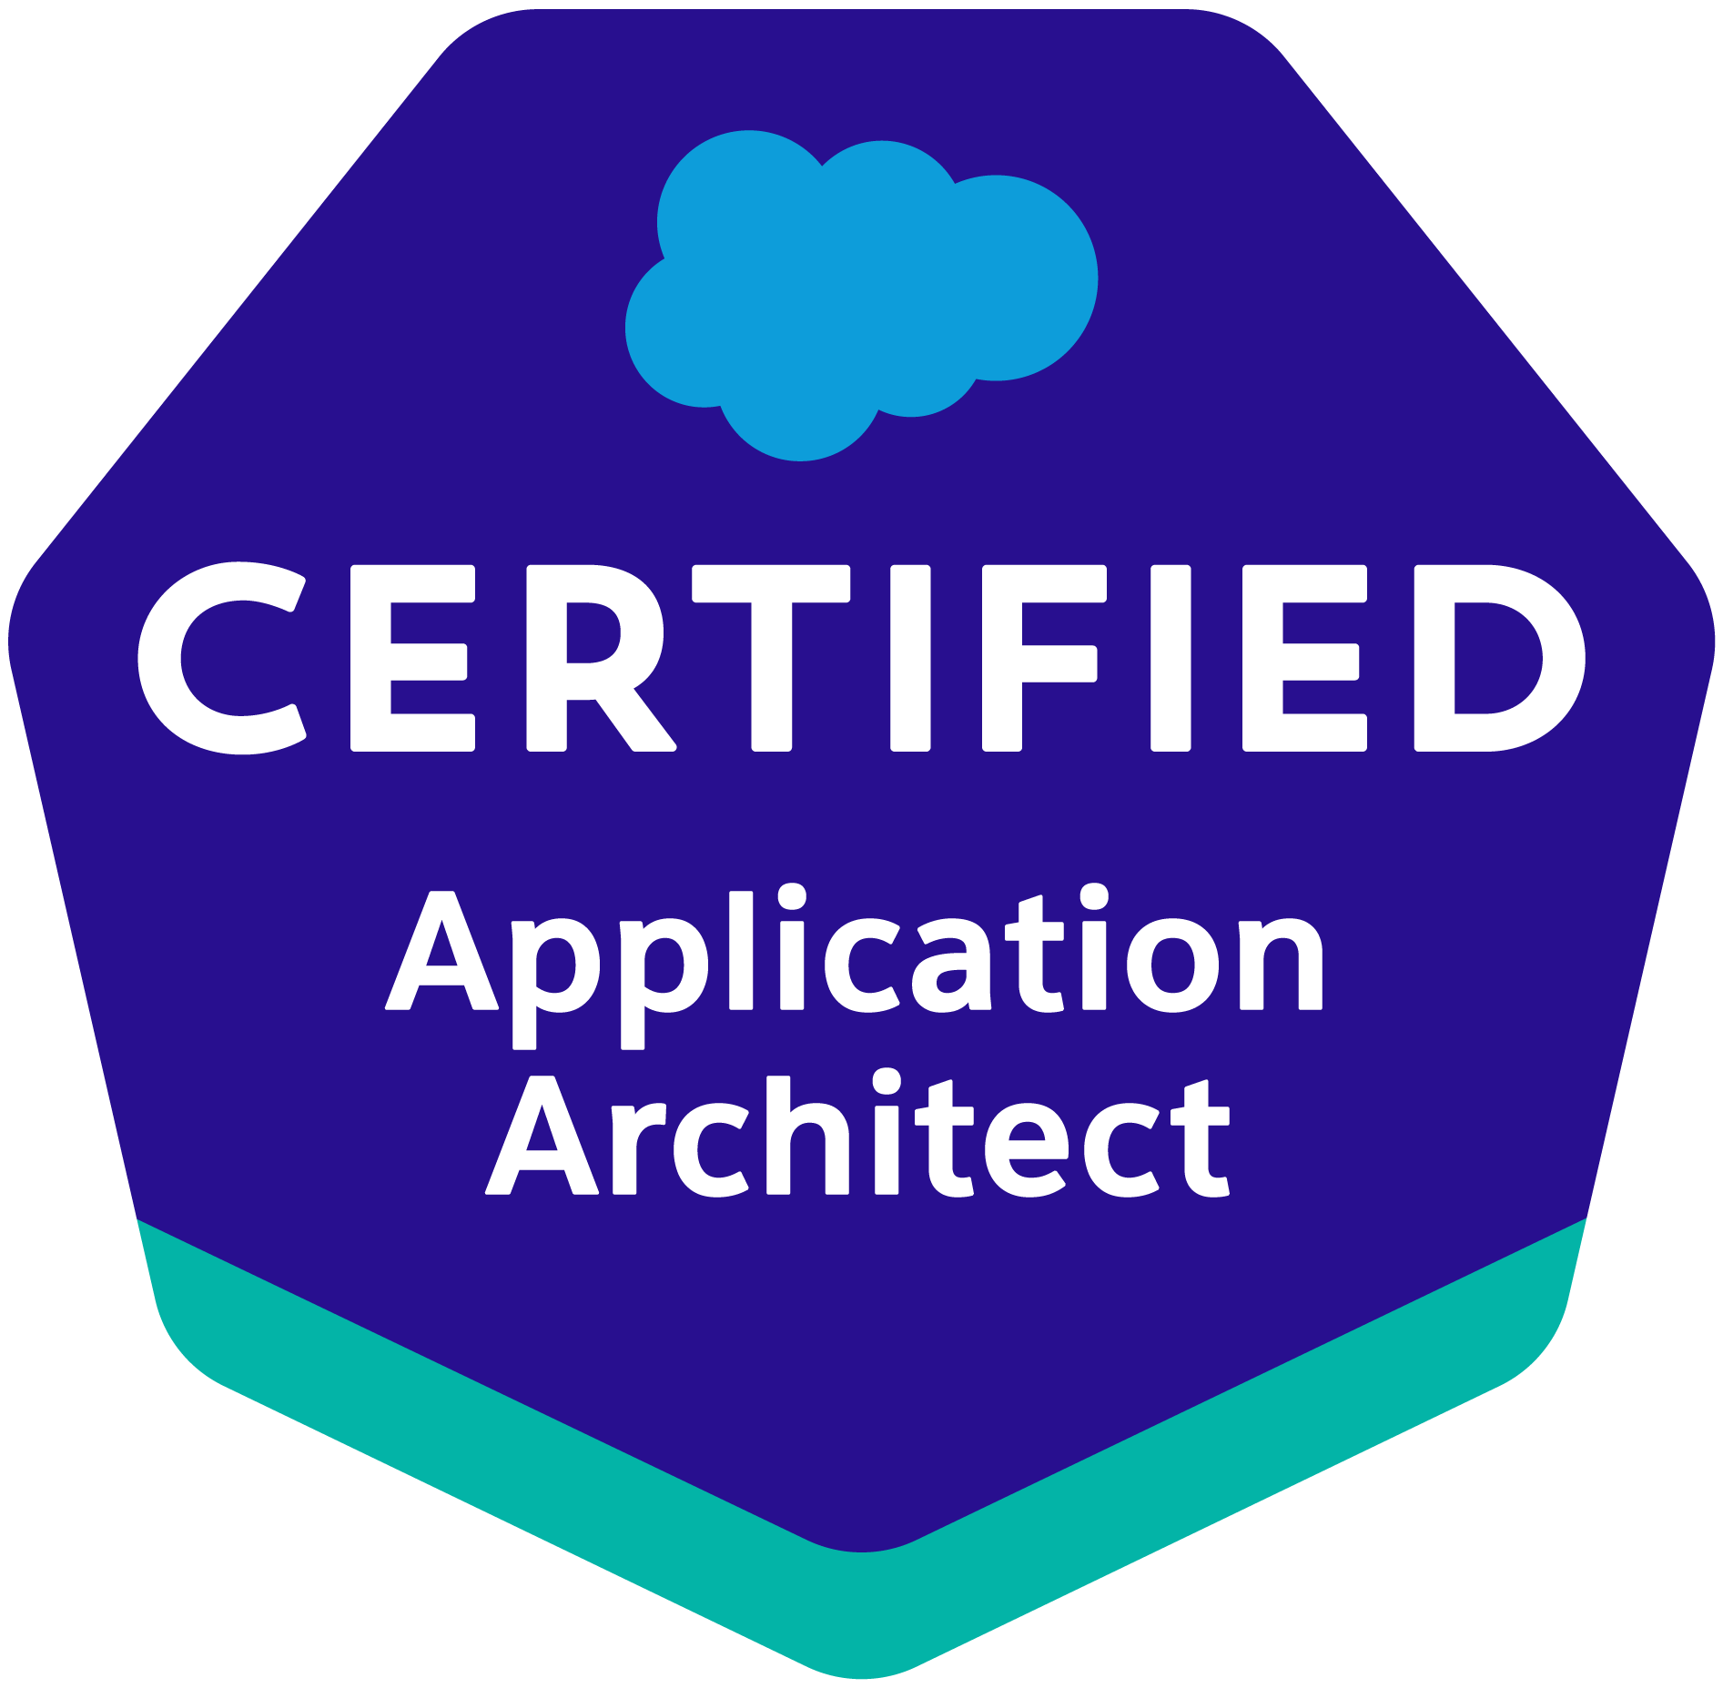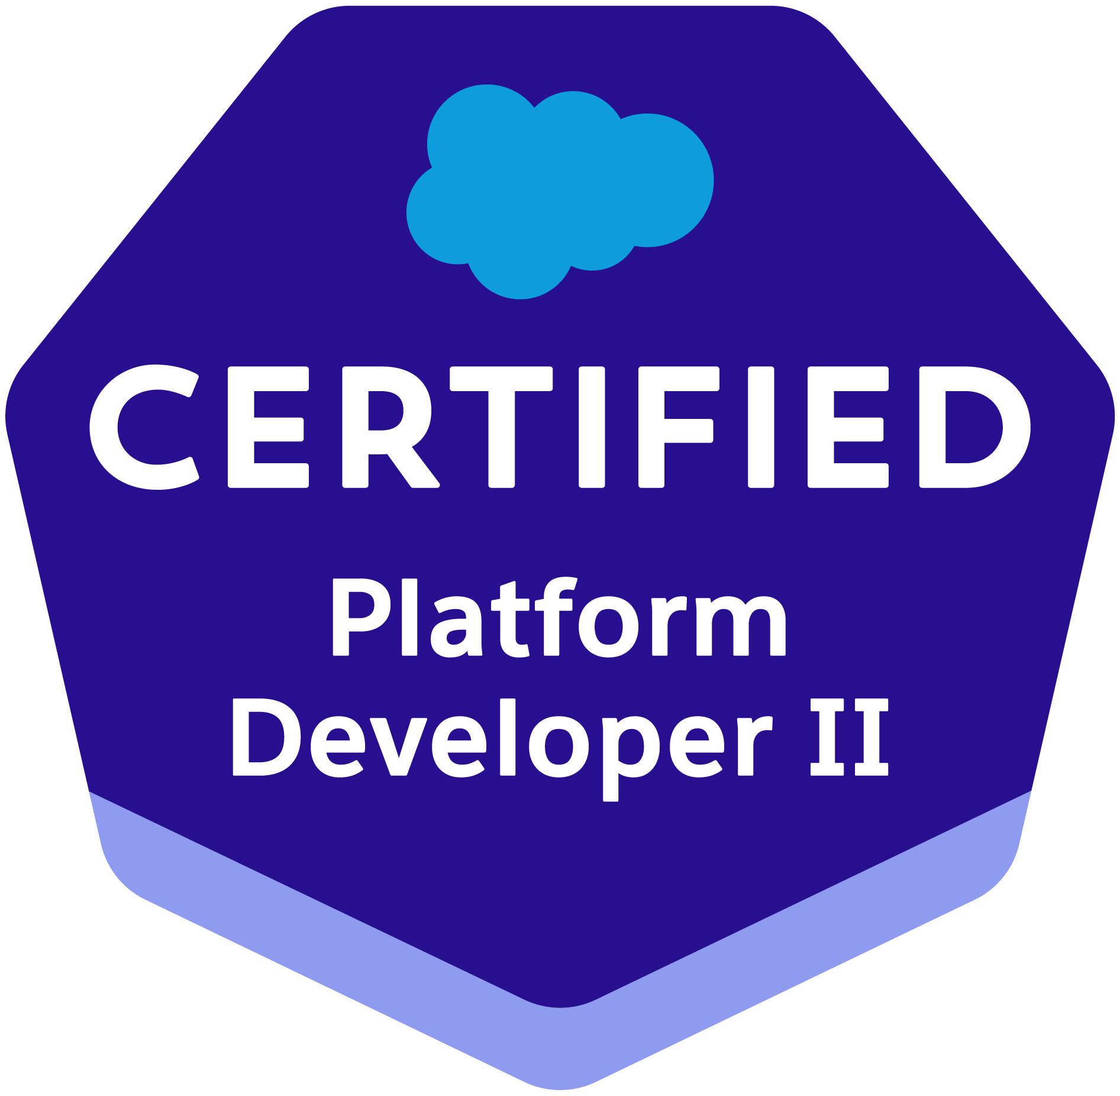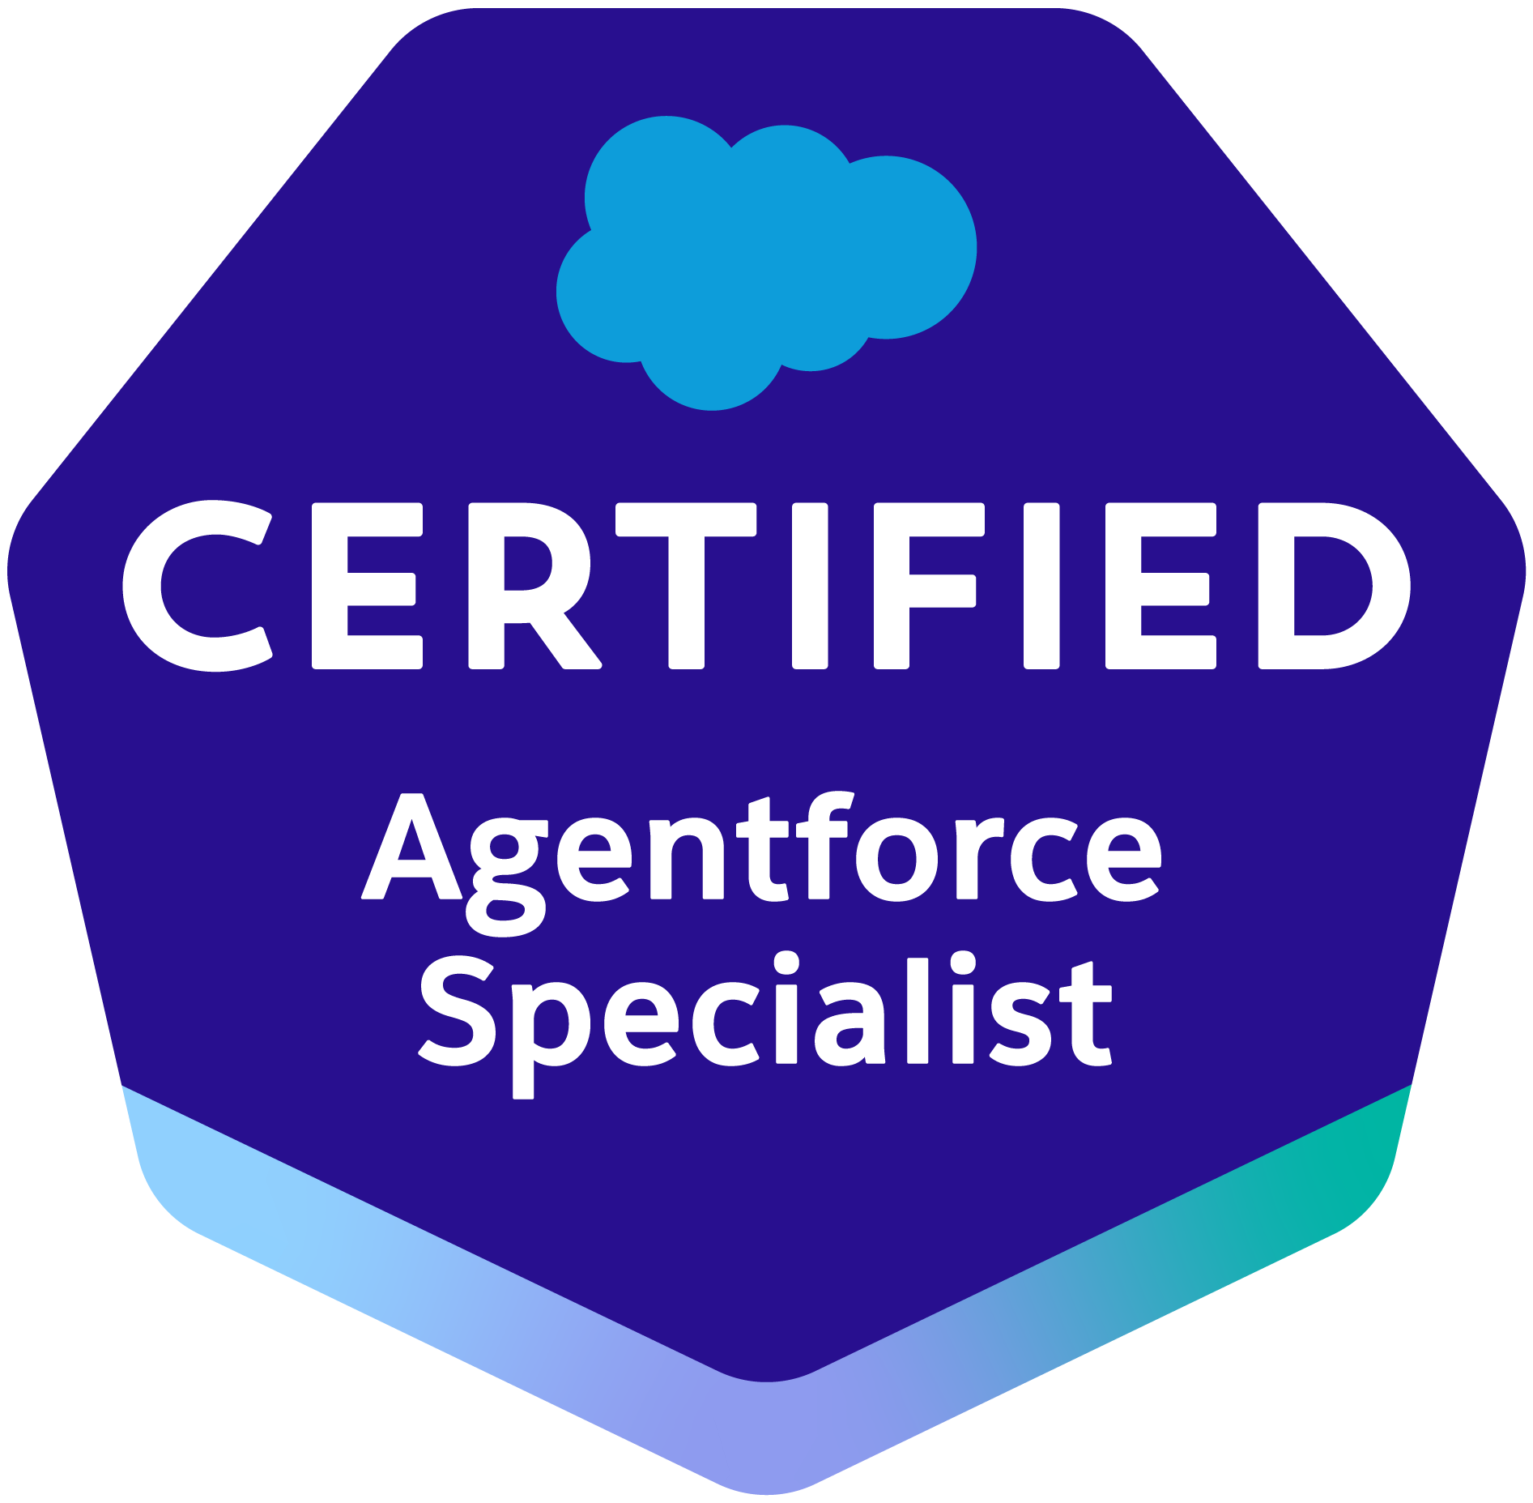

Sai Teja
saiteja.sfdc@outlook.com
____________________________________________________________________________________________________________

- Salesforce Certified Application Architect with 8+ Years of experience in Salesforce CRM platform as both Architect & Developer.
- Accumulated extensive Salesforce knowledge and hands on experience on Sales, Service, Experience and Consumer Goods Cloud.
- Experienced in all phases of Software Development Life Cycle (SDLC), quality management systems and project life cycle processes.
- Proficient in Agile Methodology.
- Experience in converting Salesforce Classic to Lightning for 10+ applications.
- Experience in acting as a liaison between offshore team and the Business performing meeting facilitation, work plan creation, task management.
- Expertise in configuring and administrating Salesforce CRM environment.
- Experience in Object Oriented Analysis and Design (OOAD) and understanding of the Force.com architecture.
- Good experience in developing Rich Interface Applications using Lightning Web Components (LWC).
- Expertise using Apex Data loader for data management in force.com platform.
- Implemented security and sharing rules at object, field, and record level for different users at different levels of organization.
- Implemented chatter to improve internal communication and enhanced customer service.
- Extensive experience in designing of custom objects, custom fields, picklists, role-based page layouts, Triggers, Validation Rules, Approval Processes, custom Tabs, custom reports, report folders, Reporting Snapshots, Dashboards, and Email templates according to application requirements.
- Experience in creating unit test cases and coordinated change requests to drive the business requirements during Integration and testing stages and reviewing the application.
- Possess strong communication and Interpersonal skills. Can quickly master and work on new concepts and applications with minimal supervision. Attention to detail, thoroughness, tenacity and an investigative drive to discover the underlying causes of technical problems.

EDUCATION

• M.S. Computer Science – New York Institute of Technology, Manhattan, New York ,2016
• B.S. Computer Science - Osmania University, India, 2015.

Certifications:
- Salesforce Certified Platform Developer I
- Salesforce Certified Platform Developer II
- Salesforce Certified Administrator
- Salesforce Certified Advanced Administrator
- Salesforce Certified Platform App Builder
- Salesforce Certified Sales Cloud Consultant
- Salesforce Certified Service Cloud Consultant
- Salesforce Certified Sharing and Visibility Architect
- Salesforce Certified Data Architect
- Salesforce Certified Application Architect
- Salesforce Certified AI Associate
- Salesforce Certified Agentforce Specialist
Click here for Trailblazer Profile

Professional Experience

The Hershey Company Aug ‘20 – Till Date
Sr. Analyst Retail Solutions Salesforce Development

Responsibilities:

- Involve in requirements gathering and configuring and customization according to business requirement.
- Participate in daily scrum meetings, analyze assigned user stories, identify/resolve gaps in functional user stories/business requirements.
- Customized mobile capabilities for field reps to streamline in-store operations.
- Implemented visit planning, inventory checks, and surveys using Consumer Goods Cloud.
- Configured Consumer Goods Cloud features for retail execution and in-store productivity.
- Implement new requests, which may involve complex functionality, and evaluate tasks required to deliver the new functionality or features effectively.
- Create Lightning Web Components based on the requirements using HTML5, JavaScript and CSS.
- Adhere to defined coding standards and best practices to develop well-structured, maintainable and easy to understand code.
- Create, customize, test and deploy SF reports based on user requirements and maintain existing report base.
- Work with the offshore team when there are merge conflicts.
- Provide knowledge and suggestions of Salesforce.com to support the implementation of the product.
- Automated business processes using Salesforce automation tools, such as Flows, Formulas and email Alerts.
- Work with Rally Software on day-to-day basis for ticket tracking.
- Work with Blue Canvas, an integrated DevOps solution for change management and deployment process.
- Use Visual Studio Code as IDE for development.
- Support the testers during the testing phase of the stories.

The Hershey Company (Indus Group Inc.) Jan ‘19 – Aug ‘20
Software Developer

Responsibilities:
- Involve in requirements gathering and configuring and customization according to business requirement.
- Participate in daily scrum meetings, analyze assigned user stories, identify/resolve gaps in functional user stories/business requirements.
- Implement new requests, which may involve complex functionality, and evaluate tasks required to deliver the new functionality or features effectively.
- Involve in estimation and analysis for migration from classic to lightning.
- Create custom lightning components for JavaScript buttons which are not supported in lightning.
- Customize Visualforce pages to align with salesforce new Lightning UI experience.
- Develop custom apex classes and apex triggers to meet the business requirement.
- Convert the JavaScript buttons to Lightning Quick actions.
- Adhere to defined coding standards and best practices to develop well-structured, maintainable and easy to understand code.
- Create, customize, test and deploy SF reports based on user requirements and maintain existing report base.
- Work with the offshore team when there are conflicts.
- Provide knowledge and suggestions of Salesforce.com to support the implementation of the product to clients.
- Automated business processes using Salesforce automation tools, such as Process Builder, Workflows, Formulas, Flow and email Alerts.
- Used JIRA Agile for project management and bug tracking.
- Work with The Welkin Suite IDE for development and administrative tasks.
- Use version control tools like Atlassian Bitbucket for maintaining and deploying the custom code.
- Support the testers during the testing phase of the stories.
- Maintain the local and remote repositories using source tree.

Capital Blue Cross (Agile Squad Inc.) Sept ‘17 – Jan ‘19
Application Developer

Responsibilities:
- Actively associated in gathering requirements for building standard and custom objects, page layouts and various record types specific to the business processes.
- Experience in acting as a liaison between offshore team and the Business performing meeting facilitation, work plan creation, task management.
- Built various reports and dashboards as per the business requirements.
- Built complex validation rules and lookup filters to improve the quality of data.
- Developed various time-dependent workflow rules and added email alerts to notify the users based on specific conditions.
- Built custom settings in conjunction with Apex triggers to mute the triggers for specific users performing data migration.
- Setup various permission sets to grant additional privileges set of users.
- Setup user profiles that give the users permissions to objects they need access to.
- Implemented field level security fields to restrict access to users.
- Built role hierarchy representing level of data access that a user or group of users should have to certain records.
- Developed batch apex classes and scheduled daily jobs using apex scheduler.
- Developed Contact smart search using Visualforce page and extension apex classes involving complex JavaScript.
- Developed several Visualforce pages, controller extensions, visualforce email templates and triggers involving apex best practices.
- Developed various web services classes for integrating with middleware software to import the data to Salesforce.

Starwood Hotels & Resorts (I2IT Solutions Inc.) Mar ‘17 – Sep ‘17
Salesforce Developer

Responsibilities:

- Built custom objects, fields, and page layouts based on gathered requirements.
- Designed validation rules, workflows, email alerts, and lookup filters to improve data quality.
- Deployed metadata using Force.com IDE and ANT tool.
- Integrated Salesforce with third-party systems through web services.

