
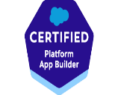
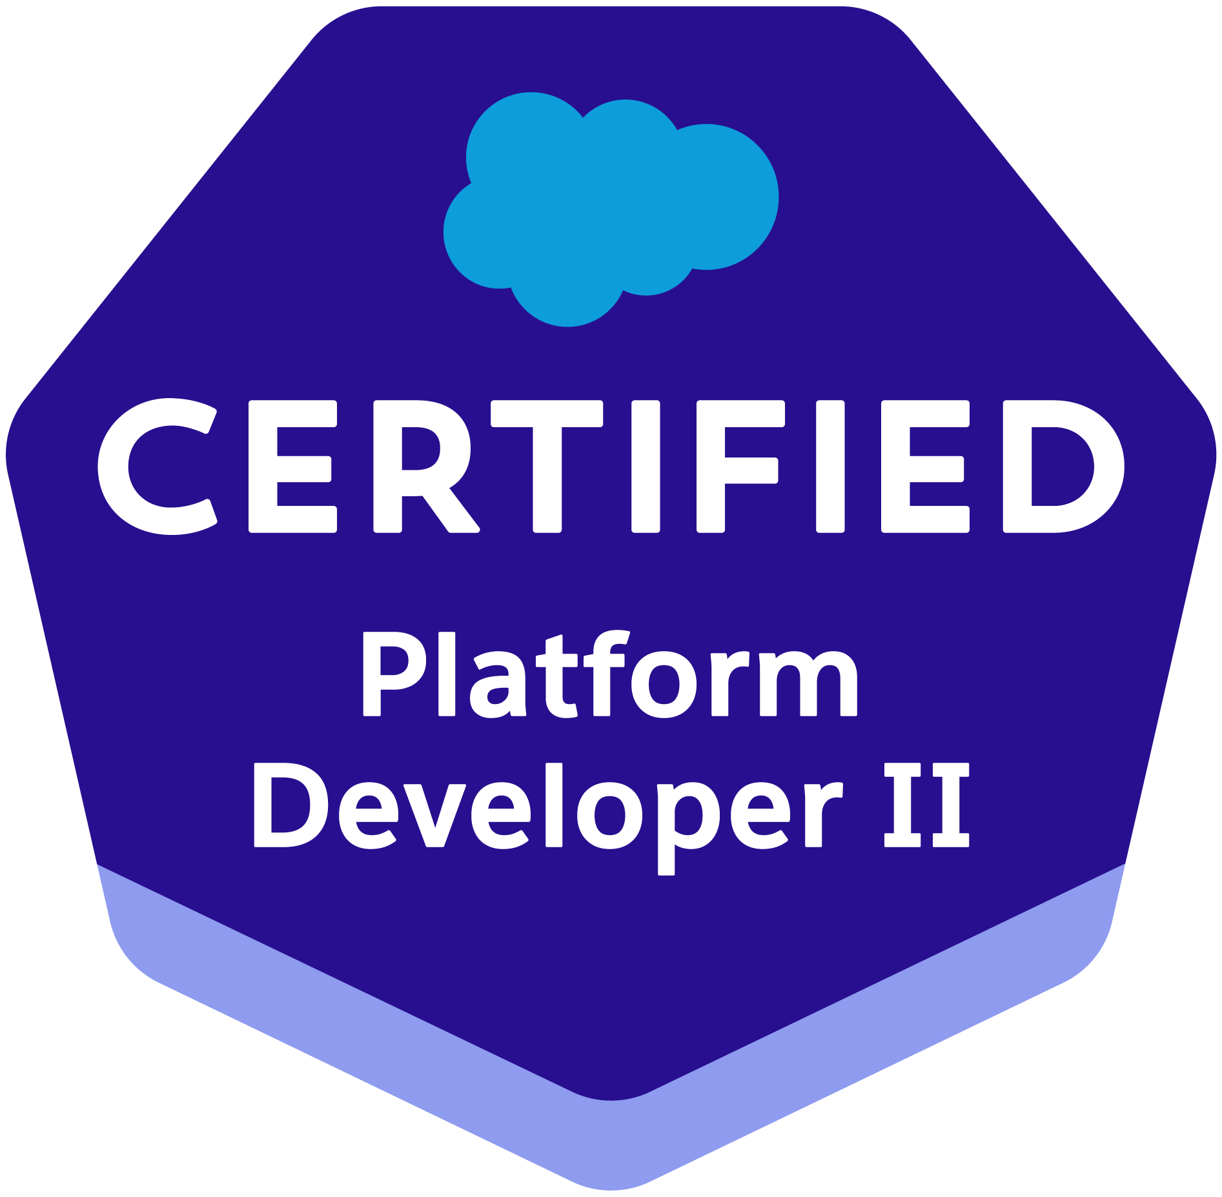


Vijay Mudam
Sr. Salesforce Developer
Phone: 669-271-0603
Email: vijaysfdc87@gmail.com

Salesforce Certified Force.com Developer with around 10+ years of professional IT experience with strong Object-Oriented Analysis, Designing and Programming skills with 7+ years of Development, Administration, and Implementation experience in Salesforce.com CRM and Force.com systems along with 3+ years in Java/Web development.

Summary
- Over 10+ years of IT experience in all phases of Software Development Life Cycle (SDLC) which involves requirement gathering, requirement analysis, design, development, implementation & enhancement of projects in SalesForce.com and Java technologies
- 7+ years of extensive knowledge of Salesforce.com CRM and its Development Life Cycle and 3 years of Java/web development.
- Worked in developing Salesforce Lightning applications using Lighting Components, Controllers and Events and used custom CSS in the components.
- Created quick action buttons using lightning components.
- Created custom objects and custom files in lighting experience.
- Worked on applications in Lightning Web Components (LWC).
- Strong Experience working with Apex classes, Triggers, Controllers, Controller Extensions, Components and Application Design and Development on multitenant Force.com platform.
- Proficient in dealing with the functionalities related to the Sales Cloud, Service cloud & AppExchange applications.
- Implemented and delivered projects under Agile/Scrum development environment with both large & small project teams.
- Experience in developing client-specific solutions on Force.com platform using Triggers, Apex Classes, Controllers, Standard Controller, Controller Extensions and Visualforce, SOQL, SOSL and handling Apex Governor limits to achieve complex business functionality.
- Developed a SOAPUI based framework to enable testing of legacy SOAP/REST API implementations and Salesforce Service cloud integration with CI/CD Automation.
- Integrated SFDC with external systems using REST API.
- Worked on new concepts of Salesforce Lightning components, Spinners, lightning action buttons etc.,
- High level of proficiency in creating Roles, Profiles, Email Services, Tasks, Email Templates, Workflow Rules, Workflow Alerts, Actions and Workflows Approvals. Configured and maintained User profiles, role hierarchy and Password policies.
- Extensive experience in creating Custom Objects, Custom Fields, Picklists, Record Types, Validation Rules, Approval Processes, Custom Tabs, Queues, Public Groups and Communities. Extractions to various formats, workflows, relationships, Lookups.
- Creating and designing of Reports, Custom Reports, Report Folders, Snapshots, Dashboards and Email generation according to application requirements.
- Experienced in analyzing business requirements and Entity relationship diagram and implementing them with Salesforce Junction objects, master-detail relationships and lookup relationships.
- Implemented Security and Sharing Rules at Object, Field and Record level for different Users at different levels of organization.
- Good knowledge on CRM business processes like Campaign Management, Lead Management, Account Management, Opportunity Management, Knowledge Management, Support Processes and Forecasting.
- Master level experience in Lead, Web-to-Lead, Case Assignment, Case escalation rules, Web-to-case and Email-to-case. Also worked on Live Agent App.
- Experience in installing, managing, and evaluating the AppExchange applications.
- Worked on Data Migration tools like Apex Data Loader, Workbench to Import and Export the data to theForce.com platform.
- Expertise in deployment from Sandbox to Production using Force.com Migration Tools like, Force.com IDE, Change Sets, Workbench, git, GitHub, Jenkins, VS Code.
- Possess good analytical, de-bugging and documentation skills, strong knowledge of sales, marketing, service and support automation.
- Ability to meet deadlines and handle pressure in coordinating multiple tasks in a work/project environment.

Education: Sep 2015 – Dec 2016
Master of Science in Computer Science Northwestern Polytechnic University, Fremont, CA.
Bachelor of Technology in Electrical Engineering, JNTU, Hyderabad, India.

Technical Skills:
Salesforce Technologies: | Apex Language, Classes, Triggers, SOQL, SOSL, Visualforce (Pages, Components and Controllers), Apex Data loader, Apex Web Services, Dashboards, Analytic Snapshots, Custom Objects, Case Management Automation, (Service Cloud) Live Agent, Marketo, Lightning Design System.
Salesforce Tools: | Force.com Eclipse ide Plug-in, Force.com Explorer, Force.com Data loader, Excel Connector, Force.com Platform (Sandbox and Production), Force.com Migration Tool, Offline Edition, App Exchange Data loader.
Programming Languages: | Java, Apex, C, C++, SQL
Databases: | SQL server, Oracle, MS Access
Operating Systems: | Windows NT / 2000 / XP Pro / Vista, Windows Server 2000 / 2003 / 2008, Macintosh.
Java/Web Technologies: | Java, JDBC, Servlets, Java Script, Web Services, HTML, XML.
Others: | MS Office Suite, Photoshop, Http Client, JSON Framework

Work Experience:

EDUCATION & CERTIFICATIONS:
- Certified Salesforce Administrator
- Certified Salesforce Platform Developer-I
- Certified Salesforce Platform Developer-II
- Certified Salesforce App Builder
- Certified Salesforce Service Cloud Consultant

WORK EXPERIENCE:
Client: Louisiana State – Baton Rouge, LA [August 2021-Present] Role: Sr. Salesforce Developer

Responsibilities:
- Involved in requirements gathering with multiple project managers, to better customize and utilize the full functionality of the Salesforce.com CRM solution.
- Followed Agile Methodology and as a process attended Daily Scrum Meetings, Retrospective Meetings, Sprint Planning Sessions, and Backlog Grooming Sections.
- Worked on various salesforce.com standard objects like Accounts, Contacts, Opportunity, Leads, Cases, Campaigns, Reports and Dashboards.
- Created Custom Apps, Custom Objects, Custom Tabs, Custom fields, Page Layouts, Search Layouts, Custom Links, Custom Buttons, Related Lists, Relationships (Look up, Master-Detail, One-one and Junction Objects) and other components.
- Created and managed user accounts and security - including new user account creation, profile, and role management, sharing rules, field-level security, security controls, Permission Sets, Public groups and Queues.
- Created and maintained the email templates to be used in the Workflows, Auto Assignment Rules, and Auto Response Rules.
- Created web-to-case (Service Cloud) to support online lead capture and case capture and designed various types of email templates for auto response to customers.
- Designed, and developed Apex Classes, Controller Classes, extensions, and Apex Triggers for various functional needs in the application. Also developed Asynchronous Apex by implementing Batch Classes, Schedulable Apex, Future methods. Used SOQL & SOSL with consideration to Governor Limits.
- Developed and enhanced various web services in REST API & SOAP API to support Inbound Integration. Also consumed external webservices by making call outs to support data exchange between Salesforce and External systems.
- Used HTTP Callout using JSON to fetch records/data from other system and display them on the fly in the Lightning Page each time the page opens by making use of callouts with Continuation framework.
- Developed many Ui applications using Visualforce, AURA Lightning Framework and Lightning Web Components (LWC). Implemented custom, generic salesforce Lightning components i.e., Modularize and Reusable custom components. Worked on building front-end development using HTML5/HTML, CSS3/CSS2, Bootstrap, Java Script, jQuery to bring dynamic versions of components when setting up in Lightning App Builder.
- Worked on Community portal by adding custom UI components to intake cases from public. Placed several validations on the public portal to ensure most of the data is taken for a case.
- Implemented Single Sign-on authentication in salesforce to let user’s login seamlessly against corporate database, other client applications.
- Created Unit tests to provide a testing framework that allows to write unit tests, run tests, and have code coverage results.
- Used Data Loader to bulk load data into salesforce from other databases by exporting them into CSV files. Also used Data Import Wizard and workbench for data processing.
- Worked on renewing Salesforce Certificates.
- Interacted with the Salesforce.com premium tech support team on a regular basis. Also provided Production support.

Environment: Salesforce CRM, Salesforce Service Cloud, Service Console, Case Management, Apex Classes, Apex Triggers, Visualforce Pages, Apex Controllers, Visualforce Components, Batch Classes, Batch Jobs, Lightning Components, Aura framework, Lightning Web Component framework (LWC), Community/Experience cloud.

Cummins, Columbus, In Aug 2020 – Aug 2021
Salesforce Developer

Responsibilities:

- Coordinated with the business to understand the business and structure.
- Interacted with various business user groups for gathering the requirements for Salesforce.com implementation and documented the Business and Software Requirements.
- Implemented the Salesforce.com applications using Agile SCRUM Methodology that involves the iterative development methodology.
- Created Custom Apps, Custom Objects, Custom Tabs, Custom fields, Page Layouts, Search Layouts, Custom Links, Related Lists, and other components.
- Created Workflows, Workflow Actions, Time-Dependent workflows, Process Builder, Flows, Approval Process. Converted Workflow Rules and Process Builders related to few Objects into Apex Triggers to maximize the performance.
- Managed user Accounts and security - including new user Account creation, profile and role management, sharing rules, and security controls
- Developed Email to Case, web-to-lead for Customer Service. Also implemented Case Management by creating record-types specific to the user groups, assignments rules, escalation rules, case templates, etc.
- Designed email templates for survey and various requirements using lighting SLDS and standard CSS. Created sites for the same.
- Developed a SOAPUI based framework to enable testing of legacy SOAP/REST API implementations and Salesforce Service cloud integration with CI/CD Automation.
- Integrated SFDC with external systems using REST API.
- Developed Apex Classes, Controllers, Apex Triggers, Apex Test classes and VF pages. Developed and scheduled Batch Classes (Batch Jobs) and created Java Script Buttons.
- Worked on developing Salesforce Lightning application using Lighting Components, Controllers and Events and used custom CSS in the components.
- Created multiple reusable Lighting Components and used Lightning Design System to convert Classic to AURA Lightning in both Service Cloud and Sales Cloud.
- Developed applications in Lightning Web Components (LWC).
- Created Buttons using Lightning Web Components in Community Portal.
- Used VS code for code migration from Personal Sandbox to Dev. Involved in using Change Sets to deploy Components between sandboxes and production orgs. Followed CI/CD process for deployments using Force.com Migration Tool and Snapshot.
- Expertise in deployment from Sandbox to Production using Force.com Migration Tools like, Force.com IDE, Change Sets, Workbench, git, GitHub, Jenkins, VS Code.
- Worked on Workbench and other integration tools like Apex Data Loader, etc for date migration and analysis.
- Provided Production support and debugging.

Environment: Salesforce.com Unlimited Edition, Apex, Visualforce, Lightning, AURA Framework, Lightning Web Component (LWC), Data Loader, Workflow & Approvals, Email Services, VS Code, HTML, Java Script, GitHub, VSCode.

Honeywell Intelligrated, Mason, OH Feb 2019 – July 2020
Salesforce Developer

Responsibilities:
- Interacted with Business groups for gathering the requirements for implementation and documented the Business and Software requirements.
- Worked on developing Salesforce Lightning application using Lighting Components, Controllers and Events and used custom CSS in the components.
- Implemented and delivered user stories under Agile/Scrum development environment.
- Extensive experience in creating Custom Objects, Custom Fields, Picklists, Record Types, Validation Rules, Approval Process, Custom Tabs, Queues, and Communities, Extractions to various formats, Workflows, relationships, Lookups.
- Experience in developing client-specific solutions on Force.com platform using Triggers, Apex Classes, Controllers, Standard Controllers, Controller Extensions and Visualforce, SOQL, SOSL and handling Apex Governor limits to achieve complex business functionality.
- Experience in providing production support, analyzing the cause and fixing it.
- Analyzing the code and making respective modification.
- Developed and maintained validation rules and custom workflow.

- High level of proficiency in creating Roles, Profiles, Email Services, Tasks, Email Templates, Workflow Rules, Workflow Alerts, Actions and Workflows Approvals. Configured and maintained User profiles, role hierarchy and Password policies.
- Created new Custom Objects, assigned Fields Dependent Pick-Lists, Record lists, Custom Tabs, Components and Custom Apps.
- Implemented Field Level Security for sensitive data holder Fields.

Environment: Saleforce.com platform, Lightning components, Lightning apps, Apex Language, Data Loader, HTML, Java Script, Workflow & Approvals, Reports, Custom Objects, Custom Tabs, Email Services, Sandbox data loading.

Kaiser Permanente, Pleasanton, CA July 2018 – Jan 2019
Salesforce Developer

Responsibilities:

- Coordinated with the business to understand the business and structure and resolve the issues.
- Used eclipse Force.com toolkit for creating Apex classes and Apex Triggers.
- Worked on lightning component and its features.
- Created custom objects and custom files in lighting experience.
- Involved in creating quick action buttons using lightning components.
- Worked in Administration, configuration, implementation and support of service max and salesforce applications.
- Experienced in ServiceMax data migration, optima and Integration.
- As part of maintenance project prepared knowledge shared document for future reference.
- This implementation includes JavaScript, pages, classes and configuration.
- As part of enhancement worked on classes, triggers, visual force pages, knowledge articles, Java Script.
- Used AGILE methodology during all the phases of System Development Life Cycle (SDLC), and analysis artifacts such as use cases.
- Collectively worked with the salesforce architects for designing the application using the salesforce portal.
- Provided security at different levels in salesforce instances.
- Faced the challenging experiences in dealing with multiple tasks and meeting the deadlines.
- Analyzing the code and making respective modification.
- Documented every ticket resolution process for future reference.
- Interacted with the users to provide necessary access required for training purposes.
- Worked on the knowledge article management.
- Loaded the knowledge articles from production to UAT to make sure we have backup and updated knowledge articles for training purposes.
- Create complex workflows and Approval processes.
- Implemented Data segregation through Record Types and Field level security.
- Developed and maintained validation rules and custom workflow.
- Create and Customize Custom Objects, Formula Fields, Cross Object Formulas, Roll up summary fields, validation rules, dependent picklists, and complex page layouts.
- Worked on email to case. Refreshed the sandbox
- Developed and maintained custom Reports and Dashboards.
- Tested thoroughly and deployed to production.
- Deployed code to production using change sets.
- Used ANT tool to migrate from Dev to QA.
- Coordinated with the offshore team to improve the overall process of resolving issues.

Environment: Saleforce.com platform, Lightning components, Lightning apps, Apex Language, Data Loader, HTML, Java Script, S-Controls, Workflow & Approvals, Reports, Custom Objects, Custom Tabs, Email Services, Security Controls, Sandbox data loading, Eclipse IDE Plug-in, Windows 7.

UPMC Presbyterian, Pittsburgh, PA March 2017 to Jun 2018
Salesforce Developer

Responsibilities:
- Interacted with various business user groups for gathering the requirements for Salesforce.com implementation and documented the Business and Software Requirements.
- Implemented the Salesforce.com applications using Agile SCRUM Methodology that involves the iterative development methodology.
- Managed user accounts and security - including new user account creation, profile and role management, sharing rules, field level security, security controls, Permission Sets, Public groups and Queues.
- Created Custom Apps, Custom Objects, Custom Tabs, Custom fields, Page Layouts, Search Layouts, Custom Links, Related Lists, and other components.
- Worked on creating Picklists, Dependent Picklists, Lookup Relationships, Master Detail Relationships, and Formula Fields on the Custom Objects and created Junction objects.
- Worked on Workflows, Workflow Actions, Time-Dependent workflows, Process Builder, Flows, Approval Process.
- Implemented Email to Case for Customer Service. Also implemented Case Management by creating record-types specific to the user groups, assignments rules, escalation rules, case templates, etc. Created web-to-lead, to support online lead capture, and designed various types of Email templates for auto response to customers.
- Created reports and dashboards for different objects based on the user requirements.
- Installed and uninstalled Salesforce AppExchange Apps.
- Developed Apex Classes, Controllers, Apex Triggers, Apex Test classes and VF pages. Developed and scheduled Batch Classes (Batch Jobs) and created Java Script Buttons.
- Worked on Integrating Salesforce with Oracle BigMachines (CPQ) to generate Quotes and get them auto approved. Developed of SOAP and REST based web services.
- Created multiple reusable Lighting Components and used Lightning Design System to convert existing Visualforce pages to lightning components.
- Used GitHub, Jenkins, Mavens mate for code migration from Personal Sandbox to Dev.
- Involved in using Change Sets to deploy Components between.
- Data Migration using Workbench and other integration tools like Apex Data Loader, etc.

Environment: Salesforce.com platform, Apex, Visualforce, Lightning, Oracle BigMachines, Data Loader, Workflow & Approvals, Email Services, Reports, Dashboards, Custom Objects, Custom Tabs, Security Controls, Eclipse IDE Plug-in, Salesforce Sandbox, HTML, Java Script.

Fortuna Technologies, India May 2012 – Aug 2015
JAVA/J2EE Developer

Responsibilities:
- Analyzed the customer provided functional Requirements and prepared High level design document, UML class diagrams using rational tool.
- Having the ownership of the total use cases and implemented the agile methodologies.
- Developed User Interface components of Site Manger, ePublish templates using JSP (Java Server Pages), HTML, DTHML, CSS (cascading Style Sheets), AJAX (Asynchronous JavaScript and XML) and JavaScript used for front end validations of web pages, ePublish form templates.
- Developed and maintained Widgets using Spring MVC, Spring IOC (Inversion of Control) and implemented Hibernate OR mapping to communicate with database.
- Designed and implemented the Hibernate Domain Model and involved in writing (HQL) hibernate queries to manipulate data in database.
- Involved in to writing the PL/SQL Stored Procedures, cursors and functions to access the content from database in ePublish content Management tool.
- Worked with AJAX and JavaScript for asynchronous communication and Worked with WSAD5.1 (Web Sphere Application Developer) as IDE, CVS as version control.
- Involved in configuration of Data sources in Web Sphere Application Server and involved in writing UNIX shell, Perl scripting for deployment process in AIX systems.
- Developed Unit Test case classes and tested persistence methods of the different components using JUnit framework.
- Good experience in debugging the application by running the server in debug mode and having the experience in usage of log4J to persist the data in log files.

Environment: J2SDK, J2EE (Servlets, JSP, JDBC, XML, XSLT2.0), JavaScript, Ant1.7.x, Putty, JQuery, TOAD, Hibernate, AJAX, Junit4.x, Windows XP and other office tools.

