Chandrashekar Mahesh
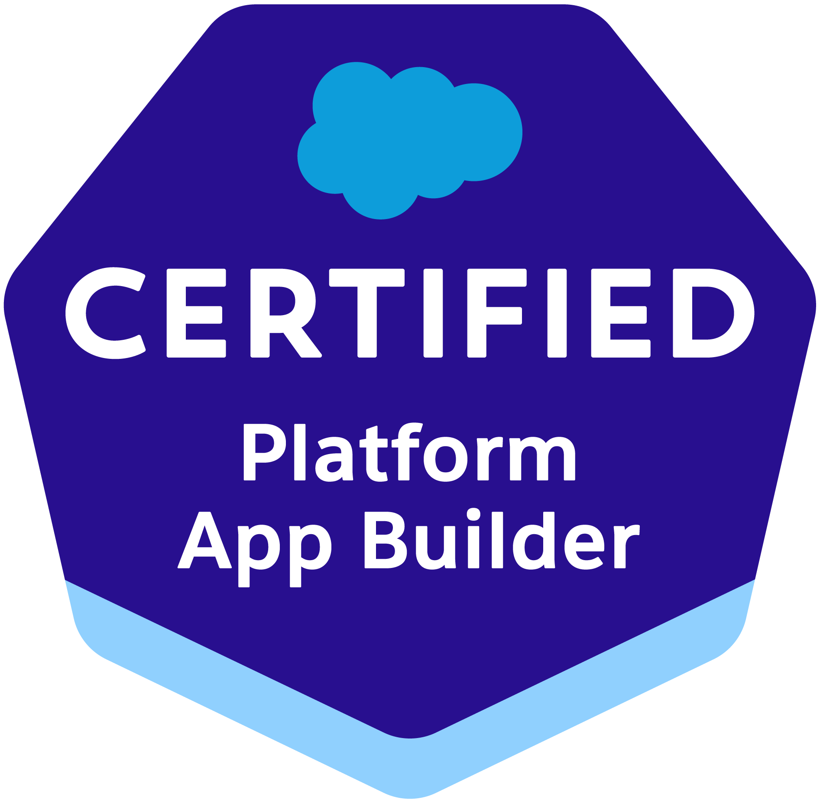

910 782 2870
Mail id: chandrashekarsfmc@gmail.com
LinkedIn: https://www.linkedin.com/in/x-chandrashekar-mahesh/

PROFESSIONAL SUMMARY:

- Master level understating of Salesforce.com CRM and SF Marketing Cloud and its development Life Cycle. Over 10+ years of experience in IT industry and 8+years involvement in the Salesforce as Salesforce Developer, Administrator, Analyst, Classic to Lightning migration and various Marketing automation studios.
- Good knowledge on all phases of software development life cycle including functional analysis, development of technical requirements, prototyping, coding, testing, deployment and support.
- Experience working in Agile/Scrum development methodology, involved in Requirement gathering, Analysis, Design, Development, Configuration, Customization, Administration, and application Support on Salesforce.com and Force.com Platform across various industry verticals.
- A/B split Testing w.r.t Content, Subject lines, and Images to guide the future deployments to be more affluent.
- Creating and sending user-initiated and triggered email interactions, including send definitions.
- Configuring Mobile Push notifications and SMS to ensure relevant messaging using Mobile Studio.
- Proficient in writing SQL quires and using data filters to create the desired condition to create the Data Extension.
- Conducted quality assurance reviews on emails to ensure rendering (using Litmus) looks fine in all devices.
- Created Microsites and Cloud Pages for the events conducted by the client and capturing the customer data in smart capture form and storing it to the Marketing cloud Data Extension
- Creation of new File Locations on SFMC set up using SSH key values to Export or Import Data to external SFTP.
- Experienced in integration of SFMC with external applications by using Web Services API, Metadata API and SOAP.
- Maintained a holistic view of all business processes and users in the system and identify cross-functional impacts regarding configuration, process, workflows, and reporting.
- Highly skilled in the reporting function within Salesforce with the ability to create and troubleshoot complex reports and dashboards.
- Experience as the technical developer on projects focused on Salesforce - Sales Cloud, Service Cloud, Marketing Cloud and the Force.com platform and which Used REST and SOAP web services.
- Experienced in Data Migration from other applications to Salesforce using Apex Data Loader and worked on different Salesforce.com environments such as sandbox and production environments.
- Experience is using ETL tools mostly Jitterbit, Informatica.
- Strong in SFDC Functional areas - Accounts and Contacts, Case Management, Leads, Campaigns, Opportunities, Dashboards and Reports.
- Familiarity with partner relationship management, and customer portal, debug logs, documents tab, forecasting.
- Expertise in implementing security and sharing rules at object, field, and record level for different users at different levels of organization.
- Expertise in troubleshooting AMP Script and JavaScript and configure Salesforce Marketing Cloud connector.
- Expertise in querying salesforce.com database using SOQL& SOSL queries using Force.com Explorer.
- Using Personalization Builder, clicks made on the community portal were being tracked and content recommendation on community cloud, email, cloud pages were made based on the Subscribers Clicks (behavior) on the portal.
- SSO set up, User creation and Assign roles to users.
- Capable enough to work in a fast-paced environment and under time constraints as necessary.
- Possessed a focused urgency and willingness to manage multiple short and moderate-duration projects simultaneously and had professional written and verbal communication skills for interaction with engineering team, technical support personnel and customers. Self-motivated energetic team player.

EDUCATION:

Bachelors in Information science and Engineer (National Institute of Engineering, Mysuru 2014)

TECHNICAL SKILLS:

SFMC | Email studio, Mobile studio, Content Builder, Journey Builder, Automation studio, Cloud pages, Personalization Builder, Contact Builder, Web Studio, and Social Studio, Workflow and Approvals
Web Technologies | JSP, JQuery, JDBC, Java Script, CSS3, XML, XML Schema, DTD, HTML, DHTML, JSON, Angular, AJAX, Bootstrap and Web service, AMP Script. SSJS
Relational DB | SQL, SOQL, SOSL
Programming Languages | C, C++, Java, Shell Scripting (Python, Bash), Sas Programming,
Integration | MC connector, Mule soft, Annex Cloud, Shopify, Mobile Connect

Certifications
Salesforce Certified Marketing Cloud Email Specialist (CREDENTIAL ID: 20983738).
Salesforce Certified Administrator (CREDENTIAL ID: 20998578).
Salesforce Certified Marketing Cloud Consultant (CREDENTIAL ID: 21051643).
Salesforce Certified Marketing Cloud Developer (CREDENTIAL ID: 21303427).
Salesforce Certified Marketing Cloud Admin (CREDENTIAL ID: 22679959).
Salesforce Certified App Builder(CREDENTIAL ID:).
Salesforce Certified Platform Developer I(CREDENTIAL ID: 4235935)

PROFESSIONAL EXPERIENCE:

Client: PenFed Credit Union, Tysons, VA Jan 2025 - Present

Role: Salesforce Marketing Cloud Lead

- Architected integrations between SFMC and external systems (e.g., Salesforce CRM, CMS, eCommerce, and CDP platforms).
- Developed REST/SOAP API solutions to enable real-time data sync between SFMC and other enterprise applications.
- Designed custom preference centers and subscription management solutions using CloudPages and SSJS.
- Designed data strategies for segmentation, profile unification, and audience targeting.
- Created customer journeys based on behavioral and transactional data using Einstein AI, Interaction Studio, and Decision Splits.
- Ensured data hygiene and governance by implementing Data Retention Policies, deduplication rules, and compliance with GDPR & CCPA.
- Built SQL-based queries in Automation Studio for data transformation, segmentation, and reporting.
- Developed AMPscript and SSJS to enable dynamic content, personalization, and complex business logic in emails.
- Designed and implemented scalable SFMC solutions aligned with business objectives.
- Architected multi-channel marketing automation strategies using Journey Builder, Email Studio, Mobile Studio, and Advertising Studio.
- Developed custom data models and optimized Data Extensions (DEs) for efficient segmentation and personalization.
- Integrated SFMC with Salesforce CRM, external databases, and third-party APIs using Marketing Cloud Connect (MCC), REST/SOAP APIs, and ETL tools.
- Optimized query performance to prevent SQL timeouts and inefficient data processing in SFMC.
- Diagnosed and resolved email rendering issues, personalization errors, and tracking discrepancies.
- Implemented best practices for deliverability, IP warming, and sender reputation management. Provided technical leadership and SFMC best practices to marketing and IT teams.
- Conducted SFMC training sessions for business users and developers.
- Advised stakeholders on customer engagement strategies, campaign optimization, and automation improvements.

Client: TIAA Bank, Bloomington, MN May 2024 - Jan 2025

Role: Salesforce Marketing Cloud Developer

- Set up Content Zones to display Web Campaign on Personalization Builder, Listeners to track the interaction and collect actions.
- Creation of custom templates to match with the Website styles to display offers.
- Configured and managed the Salesforce Data Cloud to create a unified customer profile by integrating data from multiple sources, including Salesforce CRM, Marketing Cloud, and external systems.
- Implemented identity resolution to match and merge duplicate records across various data streams.
- Automated workflows and data syncs between Salesforce Data Cloud and external tools using API integrations and Salesforce AppExchange solutions.
- Designed and maintained data models and entity relationships in Salesforce Data Cloud to support segmentation and personalization.
- Creation of Profile Objects and User attributes to store the user behavior to target the audience while publishing web campaigns or trigger campaigns.
- Creation of Product Catalog from Json Data retrieved from Website by installing MCP Beacon.
- Trigger Send and Transactional email set up for order, payment confirmations by decrypting xml data received from MuleSoft Integration.
- Defined and mapped data streams into harmonized formats to enable advanced analytics and reporting.
- Leverage Exit Intent Pop to collect missing user info on secured login page.
- Set up of SFTP user to extract or import the user data from MCP.
- Creation of Personalization Custom reports to analyze the impressions, clicks and views produced on the Web Campaign published in the site.

Client: Life Time Fitness, Chanhassen, MN. Apr 2023 – April 2024

Role: Salesforce Marketing Cloud Lead

Description: The Healthy Way of Life Community Since opening its doors nearly 30 years ago, Life Time has evolved into something completely unique. Today it’s a growing community of people who have defined a new path forward. Where health, knowledge and relationships are valued. Where our energy is channeled for good. And where purpose drives our daily lives.

Responsibilities:
- Set up landing pages/smart captures for the new accounts to sign-up or enter the contest on Landing pages using Amp script.
- Set up dynamic sender profile, sender classification while setting up new Business units for different markets.
- Setting up journeys with entry source as API event and testing it with Postman app using the SFMC components.
- Monitoring campaign post-deployment to validate completion.
- Creating Templates which can re-used by clients with WYSIWYG (What You See Is What You Get) components.
- Creation of SQL activities using automation studio to use the target Data extension in Journey Builder as an entry source to run daily/hourly.
- Develop different Email templates for implementation of dynamic email marketing program using AMP Script, HTML, CSS and SSJS.
- Developed Data Model in Marketing Cloud for the Data Extensions using Synchronized Data Extensions, Shared Data Extensions, Salesforce Data Extensions and used filters and queries.
- Followed Agile Scrum methodology that included iterative application development, weekly Sprints and stand up meetings.
- Used SOQL queries with consideration to Governor Limits for data manipulation needs of the application using platform database objects.
- Involved in resolving issues found during Unit Testing, QA Testing & User Acceptance Testing (UAT)
- Developed various Custom Objects, Tabs, Entity-Relationship data model, validation rules, Components and Visualforce Pages.
- Performed Salesforce.com configuration activities creating Users, Roles, Profiles, Organization Wide Defaults, Permission Sets, Public Groups and Queues.
- Automated sharing rules whenever there is a new change in Sales teams instead of using an Apex trigger.
- Created page layouts, search layouts to organize fields, custom links, related lists and other components on record detail pages and edit pages.
- Created Email templates, approval processes, approval page layouts and defined approval actions on them to automate the processes
- Created Wave datasets from using internal Salesforce data and external data sources.
- Capturing BI requirements and designing dashboards in Wave Analytics.
- Retrieved customer data from third party APIs and migrated the data to be displayed on Salesforce Lightning Components.
- Used SKUID to create custom components as an extension to Lightning.
- Worked on Migrating data from third parties like cloud box, NetSuite, Oracle, SQL Server, local system files (CSV) to Salesforce using Informatica.
- Used Demand Tools for data deduplication, normalization, standardization, comparison, import, export and mass delete for records.
- Developed Quote documents using X-Author for word, also developed customized login screen for community user and functionality to redirect user from Salesforce to Apttus CPQ Quote creation using APTTUS API's, Apex, Visualforce and Trigger.
- Implemented the Web Services through WSDL in the Salesforce.com for outbound messaging.
- Created modern Enterprise Lightning Apps combining Lightning Design System, Lightning App Builder and Lightning Component features.
- Created multiple Lightning Components, added CSS and Design Parameters that makes the Lightning component look and feel better.
- Provided post-implementation support to assist end users in creating reports, dashboards and certain Administration tasks including creating and maintaining user profiles and privileges.

Environment: Salesforce.com Platform, Force.com, Force.com Eclipse IDE, Lightning Experience, Lightning Components, Apex classes and Controllers, HTML, CSS, Data Loader, WSDL, SOQL, SOSL, Scrum, Custom objects, Custom fields, Web Services.

American RedCross Volunteer Dec 2022 - Mar 2023

Role: Salesforce Admin

Description: We are a trusted partner to businesses around the world and give our customers the confidence to reach their full potential.

Responsibilities:
- Worked with the user group for requirement gathering throughout the planning and implementation.
- Designed and developed Visual Force Pages to meet various functional needs.
- Performed day to day User Management on SFDC Org by configuring Sharing Rules, Permission Sets, Roles and Profiles.
- Started using Lightning Experience for new modern user interface.
- Migrated data using Apex Data loader to centralize data and processes across different divisions that were previously using decentralized systems / databases.
- Implemented Data segregation through Record Types and Field level security.
- Developed and maintained validation rules, Auto responsive rules and custom workflow.
- Create and Customize Custom Objects, Formula Fields, Cross Object Formulas, Roll up summary fields, validation rules, and dependent pick lists, and complex page layouts.
- Developed and maintained custom Reports and Dashboards. Tested thoroughly and deployed to production.
- Used Force.com Eclipse IDE for developing Apex Pages, Controller Classes and Triggers for deploying the projects components into different Sandbox Environments.
- Used Email to Case, Web to Case features and created a community where the customers can create, update and manage their cases.
- Created case escalation rules to escalate cases automatically if they are not resolved within a certain period, also worked on app-exchange tools for tracking orders.
- Worked on real time User Stories and creating Test Scenarios, Test Plans, and Test Cases.
- Created journeys and implemented marketing campaigns using marketing cloud tools like Journey Builder, Email Studio and Automation Studio.

Environment: Saleforce.com platform, Force.com API, Workflow & Approvals, Escalation rules Reports, Custom Objects, Marketing Cloud, Custom Tabs, Email Services, Web services, DocuSign, Draw loop, Jitterbit, Visual Force, SalesForce.com Data Loader, Security Controls, HTML, XML, Workbench, Sandbox, Informatica Power Center 8.6.1, Eclipse IDE Plug-in, Dashboards, Analytical Snapshot and Data Migration, ANT.

Client: Deloitte USI, Mumbai, IND Mar 2019 - Oct 2022

Role: Salesforce Consultant

Description: Verizon delivers the promise of the digital world by enhancing the ability of humans, businesses and society to do more new and Verizon is a global leader delivering innovative communications and technology solutions that improve the way our customers live, work and play.

Responsibilities:
- Worked on Setting up the business user’s access so they can login to Salesforce using SSO (Single Sign On), Site minder.
- Performed a complete GAP Analysis to identify problems and inconsistencies with the business requirements and specifications. Agile Development Methodology was followed for the implementation.
- Created various Profiles, Roles, and Page Layouts and configured the permissions based on the organization hierarchy requirements.
- Used Salesforce Automation (SFA) for Sales Lead Management, Opportunity Management, Account and Contact Management, Data Quality Management, and Approvals and Workflow.
- Implemented Apex Classes & Triggers and linked them to manage the workflows implemented in the system.
- Implemented case management automation (on Case Object) to track and solve customer’s issues. Implemented Email- to- Case entry and manual case entry for entering customer’s cases in Cases Tab.
- Developed Case Escalation rule to escalate the case depending on SLA.
- Involved in Functional, Regression, Integration, System and Performance testing of client server and web applications. Implemented JSON classes to convert JSON format content into local apex classes.
- Used Jira to synchronize between Salesforce automatically created Salesforce cases from Jira.
- Setup, maintain and optimize Email marketing campaign utilizing Exact Target/Salesforce Marketing Cloud
- Worked with scheduling Apex Batch jobs for processing large records. Performed IDE, Change Sets and ANT Script deployments as needed and validated the components before deployment to ensure a smooth process.
- Used Salesforce Data Loader and Jitter bit Data Loader to import and export the data.
- Setup Live Agent as part of Case Management implementation inside Service Cloud.
- Implemented search, filtering, and tagging features to make it easier for sales to locate relevant marketing content and documents in SalesForce.com CRM Content.
- Authored Systems Requirement Specification (SRS), Use case, System Requirement Change Request, and Data Dictionary to Delta's SFDC implementations such as Sales Cloud, Marketing Cloud and Salesforce Chatter.
- Created outbound messages and generated WSDL files for multiple end points. Consumed WSDL files into java platform by generating java API using axis tool.
- Developed custom UI using CSS, HTML, Visualforce components and used JQuery, Java Script for front-end validation.

Environment: Force.com Platform, Salesforce.com Custom/Standard Objects, Custom Tabs, Page Layouts, Force.com Web Services API, SOQL/SOSL Queries, Workflow & Approvals, Reports, Eclipse, Force.com Eclipse Plug-in, Service Cloud, Sales Cloud, SalesForce.com Sandbox, Email Services, Security Controls, Sandbox data loading, HTML, Java Script, CSS, SRS, WSDL, SOAP.

Client: Hexaware Technologies Jun 2017 - Feb 2019

Role: Salesforce Administrator

Description: Mastercard Incorporated is an American multinational financial services corporation headquartered in the Mastercard International Global. Transforming the way we live Electronic payments have the ability to create a world with greater opportunities for all. To take us beyond borders, to new markets. Beyond mere moments, to meaningful experiences. That's the power of a World Beyond Cash®. And that's Priceless®.

Responsibilities:
- Interacted with clients for requirements gathering, analysis and development. Interacted and interviewed Business Stake Holders to understand business process.
- Solid understanding of Governor limits and performed configurations in accordance with the limits.
- Assigned tasks among development team monitored and tracked progress of project following agile methodology.
- Implemented Pick lists, Dependent Pick lists, lookups, Master detail relationships, validation and formula fields to the custom objects. Created e-mail templates and inbound e-mails.
- Designed and deployed Custom tabs, validation rules, Approval Processes and Auto-Response Rules for automating business logic.
- Worked on Process Builder and Workflows.
- Developed and executed test cases for systems testing and User Interface Acceptance testing.
- Developed and Documented timelines for Project Delivery, and managed Projects and Resources to successful completion.
- Worked on Activities, Case Management, Solution Management and CTI integration.
- Developed and configured Dashboards, Reports and Report Folders for different user profiles based on the need in the organization.
- Used Apex Data loader to create, upsert, update and delete records on a daily/weekly basis.
- Created various Profiles, Roles, Page Layouts and configured the Permissions based on the Organization hierarchy requirements.
- Implemented Email-to-Case, Web-to-Case entry and manual case entry for entering customer's cases in Cases Tab.
- Created Sharing rules on Standard and Custom Objects.
- Migrated code from Sandbox to QA and QA to Production using cascade tool.
- Created Salesforce role hierarchy using Organizational hierarchy and defined data access/restriction via OWD settings; sharing settings; assigning profiles, assigning roles and assigning groups; monitoring field level security.

Environment: Salesforce.com Platform, Activities, Cases, Workflow & Approvals, AppExchange, Custom Reports & Dashboards, Custom Objects, Custom Tabs, Email Services, Salesforce.com Data Loader, Dream Factory Utilities(Cascade), Sandbox, Service cloud.

Client: eClerx , Mumbai IND. Jul 2015 - March 2017

Role: Salesforce Marketing cloud Specialist

Description: We create, deliver and optimize successful digital marketing campaigns for our clients. We run and manage all forms of digital campaigns for brands, publishers, agencies, and platforms. We take existing business strategies and translate them into actionable digital campaigns. Our scaled teams have deep media, marketing, data, technology, and creative experience – and it’s this combination of expertise that enables us to excel across industry-leading platforms.

Responsibilities:
- Edit Photoshop/Creative files as required.
- Build emails via HTML paste or using Salesforce Marketing Cloud templates
- Leverage SFMC tools and scripting languages to update content and enable subscriber personalization and/or segmentation
- Perform preliminary QA testing for proper content, functional and rendering performance Manage the customer approval and revisions process through the deployment of test sends
- Setting up User-Initiated Sends for e-mails created with their respective target Data extension for the deployment
- Responsible for reviewing key aspects of the email design, build, and deployment process to ensure optimal quality, including:
- Email rendering/content check for the normal English content, or general check-up of the links/images used in the email.
- Subscribers import and segmentation, including dynamic content and personalization
- Perform functional testing (clicking links, confirming tracking data, etc.)
- Verification of send configuration (i.e. Subject lines, audience/segmentation, deployment cadence, etc.)
- Converting client provided PSD file into html file by developing the simplest static and responsive template by using Dreamweaver/Microsoft Expressions Web 4.0 and Photoshop. Segment the data using queries and create send-able data extensions.
- Monitor Salesforce implementation performance and troubleshoot/resolve issues
- Requirement gathering and converting them into technical components.
- Edit Photoshop/Creative files as required.
- Demonstrate client’s POC for Sales Cloud and Marketing cloud.
- Develop technical integration approaches, including data flow, architectural diagram/visuals and other technical requirements.
- Architecture and development of functionality using Apex, Visual force, Js, SOQL.
- Worked towards configuring and customizing Salesforce environments to facilitate customer’s requirements.

