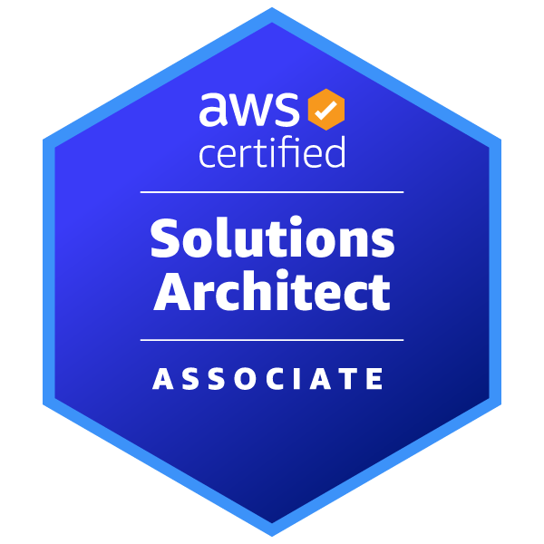
Gopi Naga Sai Thattukolla
ServiceNow Admin Developer/Business Analyst
gopinagasait@gmail.com

Professional Summary:
- With around 4+ years of experience in ServiceNow, I specialize in enhancing IT service management and improving asset management systems. My expertise includes upgrading CMDB management, integrating SCCM for accurate asset tracking, and facilitating platform use for non-technical staff while ensuring compliance.
- Developed and refined various ServiceNow modules such as ITSM, HRSD, and Service Catalogs, utilizing modern web technologies to boost functionality and user experience.
- Involved in implementing third-party integrations like Ansible to ensure data precision and process automation. Additionally, I manage SLAs and oversee access controls, maintaining high security and efficient user interactions within the platform.
- Working experience in various phases of SDLC such as Design, Code Construction, and Test.
- Strong skill set in the ServiceNow suite development including CMS, SOAP/REST integration Service Catalogs, Update sets, Discovery, Business Rules, Workflow, and CMDB.
- Developed necessary development documentation as needed (e.g. technical design, developer notes, etc.)
- Hands-on experience with various IT Services of Service - Now tools like Service Catalog Requests, Asset Management, Configuration Management, Service-Now Administration, Incident and Problem Management, Knowledge Management, Reporting, Integration with Web Services
- Good knowledge of CMDB and Asset Management Services: Business Services and Configuration item relationships.
- Functional knowledge and implementation experience of ITSM frameworks.
- Worked on the waterfall, SDLC, and Scrum environments.
- Worked on ATF (Automated Test Framework).
- Good understanding of object-oriented analysis design and application development.
- Functional knowledge and implementation experience of ITSM frameworks.
- Experience in Application Architecture, Analysis, Technical Design, Development, Implementation, Performance Tuning, Testing, Configuration Management, and Release/Build management in all stages of Full Software Development Life Cycle (SDLC) of software applications using J2EE technologies.
- Strong team player, ability to work independently and in a team as well, ability to adapt to a rapidly changing environment, commitment towards learning, Possess excellent communication, project management, documentation, and interpersonal skills.
- Involved in database designing by creating database objects such as Tables, Views, and Indexes and developed code in the mid-tier server integrating Service Now with other IT systems.
- Built and executed test scripts and validate results to ensure that configuration/customization meeting process owner’s needs.
Technical Skills :
Programming Languages: JavaScript, Python, java, C
Database Management: MongoDB, DynamoDB, MySQL, PostgreSQL
Cloud Services: AWS (S3, Lambda, SES, EC2), Docker, AWS Data Lake
Operating Systems: Windows, MAC, Linux
Version Control: Gitlab, Git, GitHub, Bitbucket
Tools: Tableau, Power BI, Jira, ServiceNow
Methodology: SDLC, Agile, SaFe
Packages: NumPy, Pandas, Matplotlib, SciPy, Scikit-learn, Seaborn, TensorFlow

Certifications:
AWS Certified Solutions Architect – Associate
Certified Developer on Legacy JavaScript Algorithms and Data Structures from Free Code Camp
Professional Experience:

ServiceNow Admin/BA Jan 2024 – Till Present
HCSC (BCBS) - Contract
Domain- Healthcare
Responsibilities:
- Experienced in designing the Content Management System which involve layouts, themes, Various Content Blocks, Content Pages, reusable widgets.
- Configured multiple Catalog Items Front-end web / GUI components using JavaScript, CSS, and HTML5.
- Creating roles that provide selective access to Service Now and then assigning these roles when user needs to access a functionality. This helped a lot in maintaining privacy between users and the system.
- Created Update Sets to migrate customizations from one instance to another instance.
- For HR Department, built an HR service along with an end-user form to automate their paper- based Tuition Assistance Program (TAP), which reduced their turn-around time and simplified the end-user experience.
- Built an application using App Engine Studio with different personas for enabling employee and student graduate assistant
- Identified and researched system problems for root cause. Analyses and provides sound business solutions.
- Work closely with customers, business managers, and application programmers to define future system needs.
- Participated in Knowledge Transfer for ITSM technical/business meetings with customers and other partners.
- Designed email templates by using HTML and jelly scripting and used them in notifications.
- Managed ITIL Processes monitoring overall system performance using the System Performance and System Diagnostic dashboards
- Knowledgeable and familiar in the ServiceNow ITOM offerings and can lead a customer through knowledge and requirements discussions for implementing and deploying ServiceNow ITOM, including the following: Event Management, Discovery, CMDB & Service Mapping.
- Acts as a resource to provide guidance to system users and/or application programmers.
- Trains users in proper utilization of business systems, including providing written procedures.
- Acts as liaison between external customers, system users and Information Technology staff.
- Works directly with application programmers to define the steps required to develop or modify computer programs.
- Work on assigned projects with respect to global enhancements
- Created reports, workflows, and data imports for Incident, Problem, Service Request, and Change modules.
- Configured SLA’s as per the business needs.
- Creation of email notifications and email scripts.
- Modifications to the assignment groups, Deletion of Assignment groups based on requirement.
- Created ACLs based on the security mechanism provided by Customer and best practices.
- Create a Triggered Survey to send new Survey after every incident.
- Create workflow activities and approvals. Also, configured alerts, notifications, and exchange mailboxes.
- Perform upgrades and view / monitor history and status.
- Provided production support and hyper-care support by working 24/7 as a team and resolving user queries and issues within defined SLAs.
University of Alabama at Birmingham Aug 2023 - Dec 2023
AWS Mail Stream Bot
- Developed an advanced email automation bot hosted on AWS Cloud, managing email communications with users from a database.
- Utilized AWS Lambda for serverless computing to dynamically scale the bot’s operations, including tasks related to email sending.
- Created a user-friendly interface hosted on AWS, facilitating easy uploads of documents and selection of customers from an available list.
- Employed AWS Simple Email Service (SES) for robust email dispatch functions, capable of sending emails with user-specific attached documents.
- Integrated AWS CloudWatch to monitor and track document viewing activities of recipients, providing detailed usage analytics.
- Implemented AWS Identity and Access Management (IAM) policies to automatically revoke user access to documents after they are accessed, thereby enhancing data security and control.
Tata Consultancy Services (TCS) Jan 2019 - Jul2022
Hyderabad, India
ServiceNow Developer
Responsibilities:
- Analyzed and improved CMDB management by producing best practice documents and delivering recommendations. Additionally, integrated manually collected CI information into the CMDB, mapping relationships between CIs to accurately represent Business Services.
- Implemented SCCM integration with ServiceNow for efficient asset data imports, automating synchronization processes and ensuring accurate asset management records.
- Acted as the Citizen Development representative from the ServiceNow Admin team, empowering non-developers to create solutions while ensuring governance and compliance with platform standards.
- Created new groups and managed user memberships within ServiceNow to ensure effective collaboration and access control.
- Offered production support for various modules including Service Catalog, Incident, Problem, Change, Release, Deployment, Task, and Knowledge Management within the ServiceNow platform.
- Involved in the design, development, and implementation of Service Portals, customizing portal pages using Jelly Script and UI Macros.
- Worked on the development of Service Catalogs, including catalog items, record producers, requirement fulfillment processes, and designing workflows.
- Managed integration with the third-party tool Ansible for importing data into the CMDB and triggering Ansible jobs from ServiceNow using Flow Designer through a MID server, thereby enhancing data accuracy and system interoperability.
- Developed order guides and workflows that connect ATS/HRMS tools with ServiceNow for streamlined employee onboarding and offboarding processes, utilizing Orchestration for automation.
- Designed and implemented workflows across multiple ServiceNow modules, including ITSM, Service Catalogs, GRC, Security Operations, Performance Analytics, and HRSD, enhancing platform functionality and user experience.
- Developed ServiceNow portal UI pages using AngularJS, HTML5, CSS, and JavaScript
- Gained direct hands-on experience with multiple ServiceNow IT services, including Service Catalog Requests, Asset Management, Configuration Management, Incident and Problem Management, Knowledge Management, Reporting, and Gauges.
- Designed and implemented new functionalities in ServiceNow using Business Rules, Client Scripts, UI Policies, UI Scripts, UI Actions, UI Pages, Script Includes, JavaScript, and AngularJS.
- Developed and maintained Service Level Agreements (SLAs) and Access Control Lists to enhance user interaction and system security.
- Designed and configured inbound email activities in ServiceNow, automating ticket creation and updates while optimizing email notifications for enhanced system efficiency.
- Planning and coordinating the execution of Implementation along with Technical/Business validations post ever.
- Maintenance/Major release in ServiceNow.
- Shared responsibilities with the Scrum-Master in Sprint Planning and facilitating meetings.
- Created update sets for configuring in different instances i.e., temp, test, UAT, dev and production instances
- Strong knowledge of the server-side scripting Business rules and Script Includes.
- Worked with account manager and customer to get clarifications identified during design process. - Manage Functional Requirements Documentation Process
Education:
- Master of Science in Computer Science, University of Alabama Birmingham - 2023

- Bachelors in computer science, VNR Vignana Jyothi Institute of Technology Hyderabad - 2019

