Kiran Kumar Gottula (12 X Certified Salesforce Architect)
Email: kiran.gottula@gmail.com
Mobile: +1 3143581755
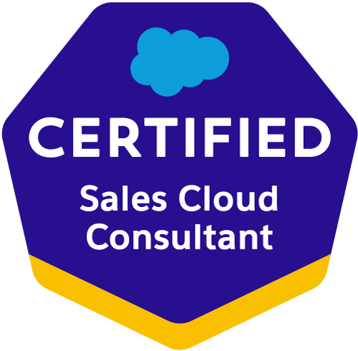
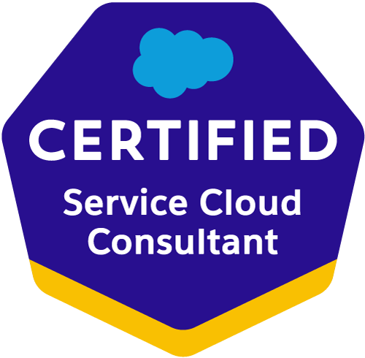
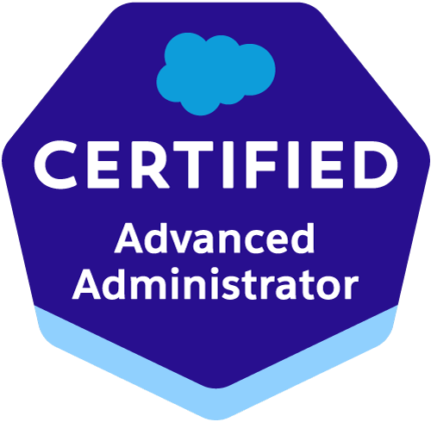

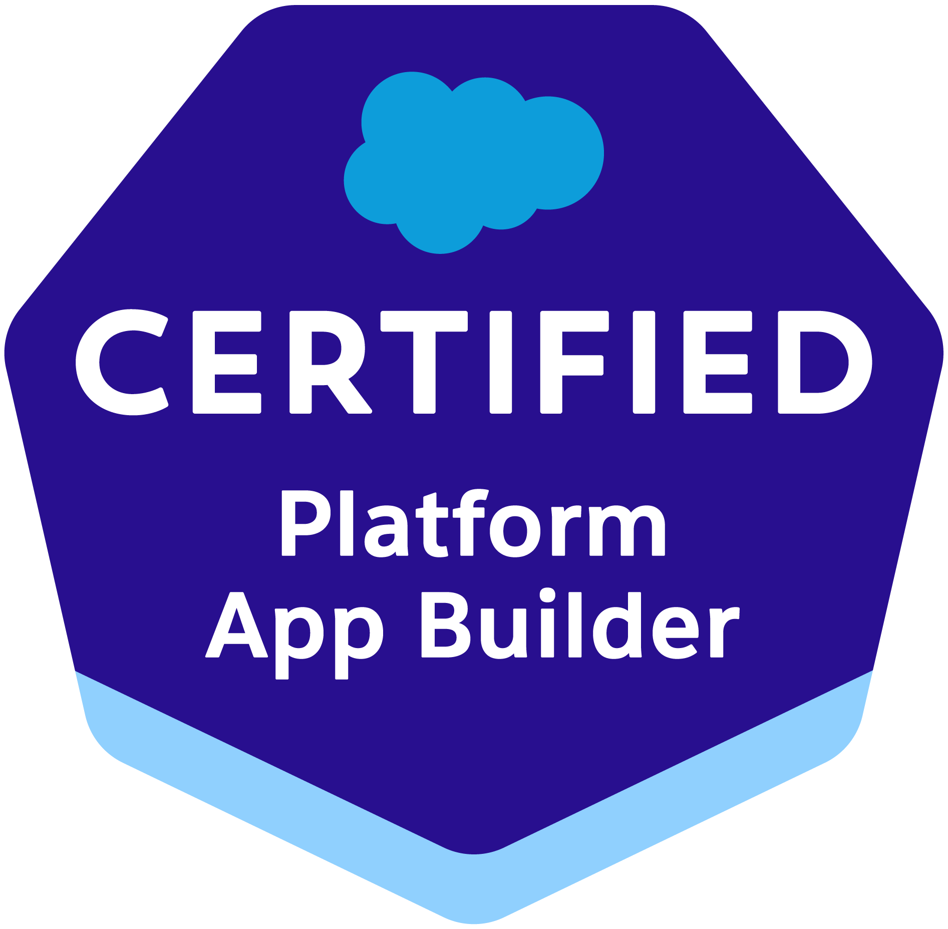

Professional Summary:

- Around 12+ of IT Experience in analysis, design, development, testing, delivery and production support of application software and of Salesforce.com CRM Platform and Apex technologies, Salesforce CPQ, Sales Cloud, Service Cloud, Marketing cloud experience.
- Creating lightning pages using Component, controller, helper, style, documentation, render, design, SVG.
- Implemented Salesforce Lightning Web Components for small set of users within the organization.
- Tested apps by appending multiple Lightning Web components to a Lightning Application thereby deployed Applications from Sandbox to Production.
- Created many B2B Salesforce Lightning Web Components and server-side controllers to meet the business requirements. Experienced in migrating the standard and custom objects in standard experience to lightning experience.
- Created multiple Lightning Web Components, added CSS and Design Parameters that makes the Lightning component look and feel better. Leveraged APEX Controller to make a call for external requests to retrieve data from various API’s and displayed them on to the component.
- Worked on both lightning frameworks Aura and LWC.
- Worked on Einstein Analytics (CRMA) to send data to Talend Cloud and snowflake for generating reports and dashboards.
- Worked on reports and dashboards and data visualizations using snowflake.
- Developed re-usable Salesforce Aura Lightning components.
- Provided B2B system administration and customization support of internal and customer-facing Salesforce environment, especially related to customized applications including Apex, Lightning, LWC, Visualforce and lightning components, user permissions, security settings, process builders, visual flow, custom objects, and validation rules.
- Ability to work with SLDS (Salesforce Lightning Design System) for responsive UI.
- Experience in event-driven architecture using Pub-Sub and Lightning Message Service (LMS).
- Handling client-side caching and optimizing performance.
- Experience in building and customizing Experience Cloud sites.
- Managing community themes, page layouts, and navigation.
- Working with Experience Builder for drag-and-drop customization.
- Implementing custom LWC components inside community pages.
- Managing security settings (sharing rules, guest user access, and permissions).
- Familiarity with Salesforce B2B Commerce Cloud.
- Experience in customizing storefronts for B2B buyers.
- Understanding buyer group segmentation, contract pricing, and self-service portals.
- Managing product catalogs, orders, and checkout workflows.
- Optimizing shopping cart, pricing, and taxation processes.
- Worked on aura framework to define a method as part of a component’s API.
- Worked on aura method simplifies the code needed for a parent component to call a method on a child component that it contains.
- Worked on Migrating from Salesforce Classic to Lightning Experience for some users in the organization.
- Experience in building Lightning Components, Lightning Events, using Lightening Base Components, Lightning UI components and Aura Framework.
- Worked on Salesforce1 Platform to build Mobile App by enabling Lightning Components to make Lightning Application mobile.
- Developed interactive dashboards, datasets, and reports to track key performance indicators (KPIs) across the organization.
- Optimized existing reports and dashboards for better performance and user experience.
- Worked on data accuracy, scalability, and efficiency in CRM analytics reporting.
- Worked with cross functional teams and provided B2B design estimates and solution discussions.
- Good experience in GUI development using Visual Studio code.
- Experience in command-line interface (CLI) environment in salesforce.com.
- Good Experience in version controls GIT, Bit Bucket, Copado.
- Have knowledge on Azure dev Ops, Mulesoft, ORMB, AWS miro services.
- Used data migration tools such as Apex Data Loader, Salesforce Import and Export Wizard, and Force.com Migration tool.
- Experience on implementing Apex classes, Visual Force Pages, Controllers, Triggers, and working with Force.com IDE.
- Closely worked on data integration tools such as MuleSoft, Talend, Snow flake tools.
- Proficient with Sales Cloud, sales, web service, Rest-API, Soap-API, Force.com App-exchange packages and Salesforce Metadata-API, Partner WSDL &Salesforce Enterprise WSDL.
- Experience in Analysis/Design/Development/Testing and Implementation, Client/Server Architecture.
- Involved in defect resolution as part of QA testing, UAT testing and involved in resolving production issues and did post implementation support.
- Have good experience in Trigger, Test Methods, and writing SOQL and SOSL queries.
- Experience using Salesforce Data Migration using Data load tools; Workbench, Jitterbit Data Loader, Informatica, Apex Data Loader and Salesforce API Data Loader.
- Worked on Migration tools Force.com IDE, Eclipse and have knowledge of Changeset migration code and configuration from the Dev sandbox to Production.

Certifications:

- Salesforce Certified Application Architect - April 25, 2022
- Salesforce Certified Platform App Builder - April 25, 2022
- Salesforce Certified Data Architect - March 16, 2022
- Salesforce Certified Sharing and Visibility Architect - February 1, 2022
- Salesforce Certified Platform Developer II - August 1, 2018
- Salesforce Certified Experience Cloud Consultant - June 19, 2018
- Salesforce Certified Sales Cloud Consultant - October 27, 2017
- Salesforce Certified Platform Developer I - November 23, 2016
- Salesforce Certified Service Cloud Consultant - December 8, 2015
- Salesforce Certified Administrator - March 30, 2015
- Copado certified Developer Sep 2020
- Copado certified Administrator Sep 2020
- Trailheads on Einstein Analytics (CRMA)

Salesforce trailhead URL
https://www.salesforce.com/trailblazer/kkumartrailhead

LinkedIn URL:
https://www.linkedin.com/in/kiran-kumar-g-95a27344

Education:

- Bachelor of Engineering from JNTU-K – 2010.

Technical Skills:

Salesforce CRM | Salesforce CRM, CRM Analytics, Eistein Analytics, Einstein Ai, Agentforce AI, Copilot, Chat bot, Lightning Application, Apex Custom Controllers, Apex Classes, Apex Triggers, Visualforce Pages/Components, Apex Web Services, SOQL, SOSL, Workflow and Approvals, Reports and Dashboards.
Tools | Eclipse, Force.com Eclipse IDE Plug-in, Force.com Explorer, Change Sets, Force.com Import Wizard, Force.com Excel Connector, Force.com Platform (Sandbox and Production) Apex Data Loader, Import Wizard, Data Export, Visual Studio (VS) Code, CLI, Apex Data Loader
Languages | Apex, SQL Server 2005.
Web -  Technologies | HTML, XML, CSS, Java Script, SOAP API, REST API
Version controls | GIT, BIT BUCKET, Copado
Databases | MYSQL, Oracle9i, Oracle 10g, Microsoft Access, SQL Server 2005/2008
ETL/Integration Tools | Apex Data Loader, Jitterbit, MuleSoft, Cast Iron, Force.com workbench, Snowflake, Talend, AS400, Informatica Cloud, Tibco, Data Power, ADH, AWS micro services, ORMB, OBIEE, OWC

Work Experience:

Project#1: Digital Enrollment - Weston Union USA
Jul’23 to Till date - Salesforce Architect
Description: Western Union, USA is a leader in global payment services. From small businesses and global corporations, to families near and far away, to NGOs in the most remote communities on Earth, Western Union helps people and businesses move money - to help grow economies and realize a better world. And it moved over $150 billion dollars for their consumer and business clients. It is continuing to innovate, developing new ways to send money through digital, mobile, and retail channels, with an array of convenient pay-out options to meet business and consumer needs.

PROJECT DESCRIPTION:

“WU Digital Enrollment” Application is used by WU to enroll Master/Independent agents for 160+ Non-WUPSIL, WUPSIL and LACA/Mexico countries. Digital Enrollment Process involves high level processes such as Data Collection, Document Generation, digitally signing Agreements/Individual Documents and Approval from Relevant Approvers.

The main objective of WU DE application is to enable Sales Representatives of WU to Digitally Enroll Master/Independent Agents for 160+ countries.DE application is enabled with region specific functionalities and business rules. Following are high level processes that are part of DE application when new independent agents are enrolled.

- Oversee the technical delivery of the Salesforce implementation's custom development, integrations, and data migration components.
- strong knowledge of the Salesforce architecture, encompassing Lightning Web Components, Apex, triggers, flows, and custom objects.
- Determine whether custom solutions are required by mapping Salesforce's capabilities to business requirements.
- Oversee the design and architecture of Salesforce initiatives, making sure they are scalable and reliable.
- Convert business needs into thoughtfully designed solutions that make the most of the Salesforce platform.
- Oversee technical design meetings; create and record technical solutions that complement the business goals of the customer; and pinpoint any discrepancies between the client's intended and actual end states.
- Adhere to and assist in defining code standards. Oversee code reviews throughout projects to guarantee suitable design patterns and quality.
- Performed the role of Salesforce.com Developer and Administrator in the organization.
- Have experience on Experience cloud and worked on building communities for external users.
- Worked with various salesforce.com objects like Accounts, Contacts, Leads, Opportunities, Reports and Custom Objects.
- Experience in building Lightning applications and using B2BLightning Design System, Lightning Implementation(s) Salesforce communities, chatter, and shield experience.
- Build reusable components, and customized Salesforce1 mobile app using Lightning component framework.
- Developing Lightning web components with validation.
- Migrated consistently to Lightning from Classic in order the sales reps find Just-In-Time information about customers and prospects.
- Used Lightning process builder for visualizing and creating automated B2Bbusiness processes.
- Experience in event-driven architecture using Pub-Sub and Lightning Message Service (LMS).
- Handling client-side caching and optimizing performance.
- Experience in building and customizing Experience Cloud sites.
- Managing community themes, page layouts, and navigation.
- Working with Experience Builder for drag-and-drop customization.
- Implementing custom LWC components inside community pages.
- Managing security settings (sharing rules, guest user access, and permissions).
- Familiarity with Salesforce B2B Commerce Cloud.
- Experience in customizing storefronts for B2B buyers.
- Understanding buyer group segmentation, contract pricing, and self-service portals.
- Managing product catalogs, orders, and checkout workflows.
- Optimizing shopping cart, pricing, and taxation processes.
- Worked on aura framework to define a method as part of a component’s API.
- Developed Lightning Components and lightning apps to provide better and more interactive interfaces to end users, which help in sales enhancements.
- Lightning Process Builder and associated actions like Field Update, Email Alert and Creating a Task.
- Experience in modifying Visualforce pages to be supported in Lightning Experience and good understanding of lightning mode and its features.
- Have hands on experience on Case management like email to case, web to case, case assignment rules, case escalation rules.
- Developed Salesforce Lightning applications using Lightning components, controllers, and events and used custom CSS in the components.
- Experience working knowledge & maintaining source control systems, including branching and merging strategies with solutions such as GIT & bitbucket.
- Worked on Einstein Analytics(CRMA) and send data to Talend Cloud and snowflake.
- Integrating data from various sources into Salesforce, ensuring data accuracy, completeness, and timeliness.
- Configuring and maintaining data connectors to external systems.
- Managing and monitoring data pipelines to ensure smooth data flow and processing. Creating and customizing dashboards, reports, and data visualizations to track business KPIs and performance metrics.
- Performing data analysis to identify trends, patterns, and areas for improvement.
- Translating business requirements into actionable analytics insights.
- Utilizing advanced analytics features, such as predictive modelling and AI-powered insights, to forecast trends and behaviours.
- Developing custom analytics solutions based on business needs (e.g., sales forecasting, customer segmentation).
- Applying machine learning algorithms to gain deeper insights from data.
- Collaborating with business teams (sales, marketing, customer service, etc.) to define analytics requirements and ensure reports and dashboards meet their needs.
- Providing training and support to users on how to use CRM analytics tools effectively.
- Customizing Salesforce Analytics apps, including the creation of custom datasets, lenses, and dashboards.
- Writing and optimizing Salesforce queries using SOQL (Salesforce Object Query Language) or Salesforce-specific query tools.
- Ensuring dashboards and reports perform well, even with large datasets.
- Regularly optimizing the performance of analytics applications and processes.
- Managing user permissions and ensuring that sensitive data is protected according to company policies and industry standards.
- Ensuring compliance with data privacy laws and regulations (e.g., GDPR).
- Staying updated on Salesforce CRM Analytics features and best practices, and suggesting improvements or new tools to enhance analytics capabilities.
- Experience with Git source code management systems while integrating with CI/CD tools like Jenkins, GIT, BIT BUCKET, Copado.
- Triggered interface events by user interactions, which includes Lightning Component framework and involved in building Lightning Components using the aura framework.
- Also embedded Lightning Components in Visual force Page by using new Lightning out feature by event-Driven Programming.
- Enabled B2B Aura Framework, by adding Aura Attributes and Aura Handlers for Events to focus on Logic and Interactions in Lightning Applications.
- Coordinated with Business Users and Pricing team to gather requirements for CPQ implementation.
- Working knowledge of product and service configuration, complex pricing rules, defining product bundle structures, constraint rules and options.
- Worked on Salesforce CPQ (Steel brick) pricing using list, cost/markup, percent total, block, price rules, calculator
plugins, filter rules, system and user discounts.
- Strong understanding of Salesforce CPQ capabilities, best practices and limitations and the ability to clearly communicate those to key stakeholders.
- Providing strategic technical insight with respect to the CPQ.
- Supporting the remaining Salesforce CPQ implementation roadmap from design to deployment, user adoption, and ongoing improvements and system administration.
- Worked on various concepts in CPQ like Product Configuration, Quoting, Price Rule, Product Rules, Quote Template, Lookup Query, Custom Script, and Advance Approvals).
- Worked on Discounts, Quoting, Tax Calculations, Complex Pricings, Invoicing, Revenue Schedules, and Orders.
- Involved in maintaining and continuously improving Lead to Order process enabled with Salesforce, Salesforce CPQ, DocuSign, and any other related sales & procurement enterprise applications.
- Proficient in architecting CPQ solutions around business requirements.
- Coordinated with Legal, Business Operations, Orders and Finance teams to execute customer agreements and process purchase orders.
- Performed administrative tasks such as creating users, roles, profiles, sharing rules, email alerts and business processes.
- Elicited the business requirements for the project using One-One Interviews, Document analysis, Surveys, JAD sessions and used the standard template of the organization to develop requirements.
- Collected feedback from management and end users to determine business requirements for future releases.
- Configured Pricing factors like variance pricing, volume-based pricing, attribute-based pricing.
- Created Test Case, Test Plan Document for Project Modules Cases using JIRA.
- Used aura framework to define a method as part of a component’s API. This enables to directly call a method in a component’s client-side controller instead of firing and handling a component event.
- Certified Salesforce Platform Developer-1
- Certified Salesforce Administrator.
- Environments: Saleforce.com platform, Visual Force (Pages, Component & Controllers), Apex Language, Lightning, LWC, Aura, Lightning Components, Data Loader, HTML, Java Script, S-Controls, Dashboards, Reports, Production environment, Workflow & Approvals, Reports, Custom Objects, Custom Tabs, Email Services, Security Controls, Sandbox data loading, Eclipse, IDE Plug-in.

Project#2: Digital Enrollment - Weston Union USA, Cognizant, Canada. Nov’19 to Jul’23 Salesforce Architect
- Oversee the technical delivery of the Salesforce implementation's custom development, integrations, and data migration components.
- strong knowledge of the Salesforce architecture, encompassing Lightning Web Components, Apex, triggers, flows, and custom objects.
- Determine whether custom solutions are required by mapping Salesforce's capabilities to business requirements.
- Oversee the design and architecture of Salesforce initiatives, making sure they are scalable and reliable.
- Convert business needs into thoughtfully designed solutions that make the most of the Salesforce platform.
- Oversee technical design meetings; create and record technical solutions that complement the business goals of the customer; and pinpoint any discrepancies between the client's intended and actual end states.
- Adhere to and assist in defining code standards. Oversee code reviews throughout projects to guarantee suitable design patterns and quality.

Project#3: Digital Enrollment - Weston Union USA, Cognizant, India. May’16 to Nov’19
Senior Salesforce Developer

Description: “Digital Enrollment” Application is used by one of the leading bank to enroll Master/Independent agents for 160+ Non-WUPSIL, WUPSIL and LACA/Mexico countries. Digital Enrollment Process involves high level processes such as Data Collection, Document Generation, digitally signing Agreements/Individual Documents and Approval from Relevant Approvers.

- Designed and deployed the Custom objects, Entity-Relationship data model, validation rules on the objects and tabs, Page layouts, Custom tabs, Components, Visual Force Pages to suit to the needs of the application.
- Responsible for Agile Scrum Methodology
- Created multiple Lightning Web Components, added CSS and Design Parameters from LDS (Lightning Design System) that makes the Lightning web component look and feel better.
- Built customized Lightning web components replacing the existing ones; using JavaScript on the client side and Apex on the server side.
- Enabled Aura Framework, by adding Aura Attributes and Aura Handlers for Events to focus on Logic and Interactions in Lightning Applications.
- Created modern Enterprise Lightning Apps combining Lightning Design System, Lightning App Builder and Lightning Component features.
- Implemented the requirements on Salesforce.com platform and Force.com IDE Plug-in using Eclipse and Apex Classes, Apex Language Apex Triggers, Apex Web services.
- Involved in querying Salesforce tables using SOQL & SOSL queries using Force.com Explorer.
- Involved in development of SOAP/REST based web services using WSDL, SOAP.
- Defined lookup and master-detail relationships on the objects and created junction objects to establish connectivity among objects.
- Experience working across various SFDC implementations covering Sales Cloud, Service Cloud, Call center and App-exchange applications.
- Implemented Salesforce Development Cycle covering Sales Cloud, Service Cloud, Call Center, Chatter & App-exchange applications.
- Involved in CPQ (Configure, Price& Quote) design, mapped to the Salesforce custom objects, and involved in Apttus Advanced Workflow Approvals.
- Created CPQ process using Apptus CPQ and CL AppExchange tool in Quote.
- Created Community, Enabled Community Users, Profiles and Access
- Developed various Visualforce Pages, Apex Triggers to include extra
- Created Custom objects, tabs, Page Layouts, record types in service cloud.
- Designed and deployed workflow rules, validation rules, Approval Processes and Auto-Response Rules for automating business logic in service cloud.
- Imported data into service cloud using Data Loader and Import Wizard.
- Involved in setting up field level access for each custom object created based on the user’s role within the organization.
- Worked with field & page layout customization for the standard objects like Account, contact.
- Created Workflow Rules, Field updates and Email alerts based on the Technical and Implementation design.
- Worked on automating the process for communicating with Users.
- Involved in setting up Salesforce Outbound messages.
- Worked on role hierarchy & sharing rules to configure visibility.
- Implement few Java Script& jQuery customizations for Visual force pages.
- Involved in regression testing with BA team and testing team.
- Environment: Saleforce.com platform, Visual Force (Pages, Component & Controllers), Apex Language, Data Loader, HTML, Java Script, Workflow & Approvals, Reports, Custom Objects, Custom Tabs, Email Services, Security Controls, Sandbox data loading, Eclipse IDE Plug-in, Windows.

Project#3: Patient services – CVS Health Care USA, Accenture, India. Feb’16 to May’16
Senior Salesforce Developer
- Optimized existing reports and dashboards for better performance and user experience.
- Worked on data accuracy, scalability, and efficiency in CRM analytics reporting.
- Worked with cross functional teams and provided design estimates and solution discussions.
- Created many Salesforce Lightning Web Components and server-side controllers to meet the business requirements. Experienced in migrating the standard and custom objects in standard experience to lightning experience.
- Created multiple Lightning Web Components, added CSS and Design Parameters that makes the Lightning component look and feel better. Leveraged APEX Controller to make a call for external requests to retrieve data from various API’s and displayed them on to the component.

Project#4: Farmers Insurance - Delaware USA, Capgemini, India. Dec’14 to Feb’16
Salesforce Developer

Description: Farmers is proud to serve millions of households and businesses across all 50 states and the District of Columbia. Farmers offers insurance and financial products through multiple companies, brands, and distribution channels, including a network of Farmers Insurance® exclusive agencies, tens of thousands of independent agents, and direct sales online and through company call centres. Our products are produced and serviced by tens of thousands of Farmers employees across the United States, including an exceptional national claim service network.

- Worked closely with sales team and business analysts and performed detailed analysis of business and user requirements, designed the solution by customizing various standard objects of Salesforce.com (SFDC).
- Worked with Scrum team using Agile Methodology of 3 weeks sprint cycles to deliver software on time and within budget.
- Used Force.com developer toolkit Apex Classes, Apex Triggers and Visualforce pages to develop custom business logic.
- Worked on installing and integrating ApttusCPQ and Apttus approvals package with Salesforce Sales process.
- Implemented CPQ (Configure Price Quote) solution using ApttusCPQ & Contract Management and also used Apttus CPQ to configure price and quotes for the organization based on regional prices. Managed CPQ process from both SFDC opportunity and excel.
- Used SOQL & SOSL for data manipulation needs of the application using platform database objects and Developed UI containing angular/JQuery in Salesforce
- Constant involvement in exploring apex change apps and using the apps wherever necessary. Used apps like Apttus CPQ, target, Cloud Converter, Chatter un-follow rules, Field Trip, Conga Composer, Docusign etc.
- Performed Apttus CPQ related configuration for product setup, approval matrices, approval rules, process builders and flows.
- Knowledge of Apttus development.
- Strong understanding of Salesforce standard objects and Apttus CPQ application.
- Configure in Salesforce.com CRM to facilitate Apttus implementation.
- Experience in Apttus CPQ, LDAP and Integration with Share point.
- Familiar with Apttus admin settings, Apttus custom settings and DocuSign settings.
- Experience in CPQ Merge Service, Configuration and Pricing APIs (Apttus customization).
- Experience in configure price quote (CPQ) app such as Apttus.

Project#5: Jaco Aerospace – Valencia, CA,USA, Appshark Software Pvt Ltd, India. April’13 to Dec’14
Salesforce Developer

Description: CRM tool assist on SFDC platform which will allow Humana to have a single point of entry for Issues/Requests to enable Corporate Procurement (CP) and Accounts Payable (AP) to better track, report and route questions and request to the appropriate owner and provide metrics surrounding these open or closed issues which will better allow us to address root cause and re-establish and maintain SLAs.
Responsibilities:

- Worked closely with sales team and business analysts and performed detailed analysis of business and user requirements, designed the solution by customizing various standard objects of Salesforce.com (SFDC).
- Involved in end to end testing and configuration enhancements for the CPQ and CLM functionalities.
- Created integration with Apptus CPQ and CLM applications and automating processes on Salesforce platform.
- Involved in data cleanup and mapping in data migration project.
- Worked on Sales and Service Cloud communities sharing business process extend them across offices and departments, and outward to customers and partners.
- Testing the CPQ integration with ERPWorked with Exact Target marketing automation suite for email, landing pages, camping web analytics, lead scoring, assert management, and trigger workflow.
- Worked with Multi-Currency, Product and Price book set-ups.
- Migrated data from Traditional Applications to Salesforce using APEX Data Loader and Informatica on Demand.
- Used the sandbox for testing and migrated the code to the deployment instance after testing.
- Worked as enhancement developer and team member, performed the roles of Salesforce.com Developer and Administrator in the organization.
- Responsible for setting up web service integrations.
Environment: SalesForce.com platform, Apex Script, Web services API, Visual Force Pages, Controllers, CSS, Encryption Fields, Workflow & Approvals, Custom Objects, Custom Tabs, Security Controls, Page Layouts, HTML, Java Script, Reports, Dashboards, Eclipse IDE Plug-in, Windows XP.

