Murali Kanaparthy
Contact: +1 614-615-0430
E-mail: tokanaparthy@gmail.com
Project Management – Telecom ~ Banking ~ Finance and Insurance
16+ years of experience in delivering optimal results and business value in high growth environments.
Project Management ~ Operations Management ~ Program Management ~ Service Delivery
Relationship Management ~ Client Servicing ~ Team Management

Seasoned & consummate professional with rich expertise in initiation, management and execution of projects within set quality and time parameters impacting overall revenue growth. Possess in-depth knowledge of managing operations. Expertise in addressing operational issues & resolving performance bottlenecks. Capable of delivering cost-effective, high-performance technology solutions to meet challenging business demands. Effectively coordinate onsite & offshore operations. Strong ability to independently direct and manage operational processes. Implement improvements for achieving desired performance levels.

Efficiently manage systems with proficiency in maintaining & debugging developed software. Exemplary abilities in building long lasting relationships with key decision makers. Maintain high standards of client service keeping in mind quality & service norms to achieve total customer satisfaction and business retention. Trusted leader empowering teams towards achieving KPI's & SLA’s while chalking out improvement plans.

CORE COMPETENCIES

- Documentation | - Program Management | - Project Management
- Strategic Planning | - Training and Development | - Business Management
- Delivery Management | - Communication skills | - Business Analysis
PROFESSIONAL WORK EXPERIENCE

Project Lead, Rogers Communications, Brampton, ON November 2021-Present

- Work with Strategy Team to Implement Enterprise Architecture Services entire Rogers Organization
- Review, Analyze and implement the new changes like Registration, Account Recovery, Profile Updates and Login information.
- Work with all Teams like Rogers.com, Fido.ca, Rogers for Business, Rogers Yahoo and Chatr
- Responsible for ensuring understanding of the requirements, necessary changes based on the Brand.
- Work with UX Team to create Mock and Copy for various Screens.
- Coordinate between Strategy, Development Team and other teams from various groups
- Work with current Sprint Items and Backlogs for upcoming Sprints
- Work on writing User stories and review with all the teams
- Coordination of various Knowledge Transfer /Technical sessions among Architects and other teams
- Work on the User stories for the current and upcoming Sprints
- Muti Factor Authentication is developed for Enterprise Level
- Coordination of work based on the sprint cycles with various groups.
- Participated in QA and BRT Testing
- Participation in various Knowledge sessions and discussions on implementation strategy
- Working with Implementation Team to make sure code deployment is done as per scheduled timelines
- Participate in all Sprint Ceremonies to know the velocity of Team and give any feedback to improve the Team Performance

Sr Business Analyst/Product Owner, Wells Fargo Des Moines IA July 2019- October 2021

- Work with IT Team to define the business impacts and find the best solutions
- Review, Analyze and implement the new changes
- Work with the current bugs and find the remediation to solve those bugs
- Responsible for Risk & Regulatory business requirements for Master & Reference data
- Create regulatory compliance and traceability documentation
- Coordinate between different Data and Technical teams to ensure corporate-wide solution and data consistency
- Work with current Sprint Items and Backlogs for upcoming Sprints
- Work on documentation such as BRD, FSD and User Guides
- Work on the User stories for the current and upcoming Sprints
- Work with SIT and UAT Teams to verify all the existing scenarios will cover the new functionality and existing Functionality (Regression Testing)
- Working with Implementation Team to make sure code deployment is done as per scheduled timelines
- Participate in all Sprint Ceremonies to know the velocity of Team and give any feedback to improve the Team Performance

Consultant/Business Analyst Transamerica, Plano TX October 2018- May 2019

- Worked with SME’s and created Business Requirements Document
- Build, Implement, and support the data infrastructure ingest and transform data.
- Worked with other BSA’s on various Mainframe, Database Managed Admin systems that involve Party, Policy, Rider and soon information collected and given to development Team for their Development into Data Lake Environment which consists of Hadoop Tables
- Participate in Daily Standoff and update the Team about the progress and any impediments
- Worked with Scrum Master for day-to-day Tasks Prioritization
- Involved in Sprint Planning and Sprint Retrospectives
- Attended various sessions for Knowledge and understanding of various Insurance products
- Worked on Various Admin Systems and still on progress
- Had knowledge in running Hive Queries and validate the Data
- Worked on providing Natural keys to the Developers
- Assisted Testing Team wherever they had questions related to the Admin System

Business Management Consultant, 5/3rd Bank Cincinnati, OH November 2017- September 2018

- Worked with Line of Business and created Business Requirements Document.
- Worked on Writing Functional Requirements for the Business Requirements
- Involved in the application development for better understanding of the business and IT processes.
- Worked closely with SMEs to elicit the required Technology terms and work on Two different Customers where Customers provide payee Data and Customers who doesn’t provide Payee info
- Worked with Mainframe Teams to get the information from the Mainframe System
- Worked with Development Team to work on Extraction of Payee data using Kofax System using OCR Technology
- Worked with Payments IT Team to consolidate the Payee Information along with Account #, MICR Data and Amount along with Payee Name
- Validated the random Checks and made sure the results are correct
- Written System Test Cases, System Test Plan and System Test Report
- Written UAT Test Cases, UAT Test Plan and UAT Test Report
- Worked on Black Box testing to validate the functionalities
- Worked on Microsoft Word, Excel.
- Documentation is stored on the SharePoint
- Upgrade was tested on various Operating Systems and Multiple scanners

Consultant/Business Analyst, Wells Fargo Bank Charlotte, NC April 2016-October 2017

- Interacted as a liaison between Users and the different teams.
- Involved in the application development for better understanding of the business and IT processes.
- Worked closely with SMEs to understand the existing process and upstream departments
- Created Data mapping for various SOR’s in both Data Layers and also worked with DBA’s to create new fields in the process of Mapping
- Worked on the Extraction of Data using ETL to validate the data is updating the tables properly
- Worked on the Glimmer tool to update the changes and track the traceability.
- Worked on SQL developer to validate the database tables
- Written various BRD’s for three phases and successfully completed the migration of 17 SOR’s to the new System
- Worked with Developers and tested the applications and tracked the bugs in ALM and JIRA
- Worked on Microsoft Word, Access and Excel
- All the changes were updated in JIRa for the tracking Purposes,

UAT Test Manager, Qatar Telecom, Doha Qatar May 2012 – December 2015

- Responsible for working as Test Manager for all Telecom Applications of Qatar Telecom.
- Spearheaded a team comprising of 10+ Testers involved in testing various applications.
- Assume the role as Defect Manager and assisted the team in escalations of various defects encountered in Testing Process as this position yet to be filled.
- Successfully developed End to End Process for Testing as the process definition was not clearly set.
- Worked extensively in SPOC environment to make sure environment is ready for each release/application.
- Seamlessly updated resource planning and testing efforts prioritized based on Business requirements.
- Provided insightful assistance to higher management and managed several activities such as resource utilization, complexity of the applications and defects detected in Testing and Savings incurred due to the effective Testing
- Actively participated in several management meetings to enhance the process for UAT and streamlined the process accordingly.
- Worked on Systems like Net cracker RBM, Ericson IN, Comptel Provisioning, TIBCO, Siebel CRM, and Oracle ERP

Delivery Manager, CGI, Sep 2008 – Apr 2012

- Worked extensively as Delivery Manager and actively involved in upgrading, application development, support and maintenance, customer development and integration across customer order management, reseller order management, online order management and win back (Bringing non-Client customers to the Client) for “Bell” Canada and other telecom vendors from Canada.
- Successfully automated the Transition of various Bell Applications from Canada to India.
- Collaboratively worked with the team in Risk Management, Resource Planning and Knowledge Management.
- Handled several business lines including Wire line (PSTN), Internet, DTH and IPTV.
- Took complete ownership for managing Ordering, Billing, Service Assurance and Service Fulfillment activities across different lines of business.
- Cohesively worked with onshore and offshore team on financial planning and estimation of several projects.
- Utilized CPMF Framework, that delayed on cutting edge technologies and process, so the On-Site and Offshore partnership worked very well.
- Managed a team comprising of 50 members depending on the changes on the release and impacted applications.
- Assumed the role as Business Analyst and worked with testing team in understanding the Traceability Matrix and helped team come up with test cases and test conditions as per the requirements to complete the integration testing.
- Worked and mentored with cross functional project teams across different geographies and with multi vendors to deliver new products and services.
- Actively participated in weekly project meetings and effectively communicated with the team in the tasks and updated WBS/Project Journal accordingly.
- Successfully arranged special sessions and managed an entire delivery process from Offshore, On Shore and communicated to Clients about the timelines and financial impacts /trainings for various team members for their growth and to retain employees and have low iteration.
- Developed and monitored tools and dashboard for maintaining the applications and supported many errors that come up after implementation.
- Actively involved in various improvement discussions with Client and onshore team and gave various RFA’s and Change Management requests for various applications in which some of them approved and some are in the process for approval.
- Recently Managed Web logic Upgrade project which was a Major challenge because of multi-vendor team involvement across geographies.
- Involved in formation of BA COE and SA/BA forum in CGI for Knowledge sharing and to follow Best Practices and worked with L& D team regarding Certifications and arranging Seminars on various new Tools and Technologies
- Spearheaded SA/BA forum and successfully prepared application handbook which will have the information of Systems/Applications, Its Upstream and Down Stream Systems and Architecture.
- Instrumental in rapid growth and development of our ADS and AMS services with Bell, that aided in garnering business from Bell Alliant, Bell West, TELUS and Rogers coming from Bell Canada.

Previous Assignments

- Business Analyst, Bell Canada, 2002 – 2008
- Programmer Analyst, Visual Soft Inc, New Jersey, USA, 2000 – 2002
- Software Developer, Sequel Tek Inc, New Jersey, USA, 1998 – 2000
- Software Developer, Patni Computers, Mumbai, India, 1996 – 1998
- Software Developer, V.L Software, Hyderabad, India, 1994 – 1996

ACADEMIC CREDENTIALS
- MBA, IIM, Bangalore
- PGDCA (Post Graduate Diploma in Computer Applications), India
- Bachelor’s degree in engineering, Nagarjuna University, India

PROFESSIONAL SKILLS

Development Languages : ASP, VBScript, JavaScript, HTML, PL/SQL, C and UML
Database : Oracle 7.1, MS Access, Sybase, DB2, MS SQL Server,
Operating Systems : Windows NT/9x, MS-DOS, UNIX
Application Tools : Visual Interdev, VisualBasic4.0/5.0/6.0, Developer 2000, Power Builder
4.0, Cognos.
Others : DHTML, COM/DCOM, MTS, IIS 4.0, Macromedia Generator, Ad Server, Netscape, Internet Explorer, CDO NTS, Microsoft SMTP, Site Server Commerce Edition, Intelliden 4.7, Web Focus, Info Vista and Requisite Pro, Visio, I-grafix, HP Quality Center, Share Point, SOA, eTOM, TOM, NGOSS, RBM,IN, COMPTEL, TIBCO, CRM and ERP

Hardware : IBM PC Compatibles and SUN Workstations and Handheld Devices
Functional Skills : Order to Activate, Service Fulfillment, Revenue Assurance and Service Management Business Analysis/Project/Program Management Office 2007 including Visio, Microsoft Projects and UML

CERTIFICATIONS
- Project Management Professional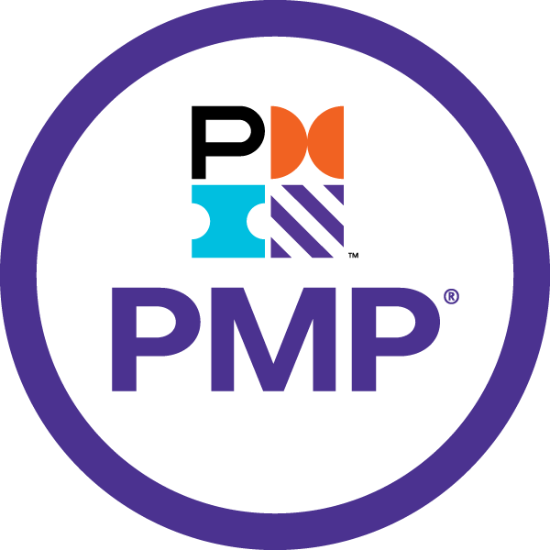
- Certified Scrum Master 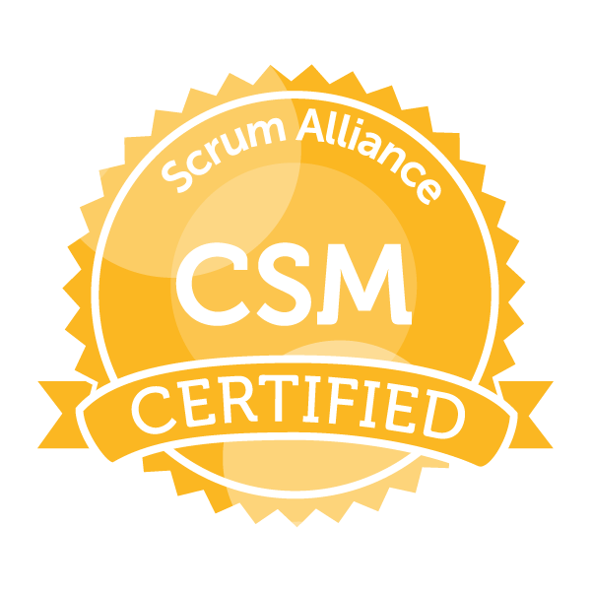
- Business Analyst Master Certificate, Schulich York University, Canada
- Knowledge Management certification from XIME
- Gebbs Certification for Mainframe Training
- Oracle Certification from SQL STAR Hyderabad
-

