Mythilee Velu

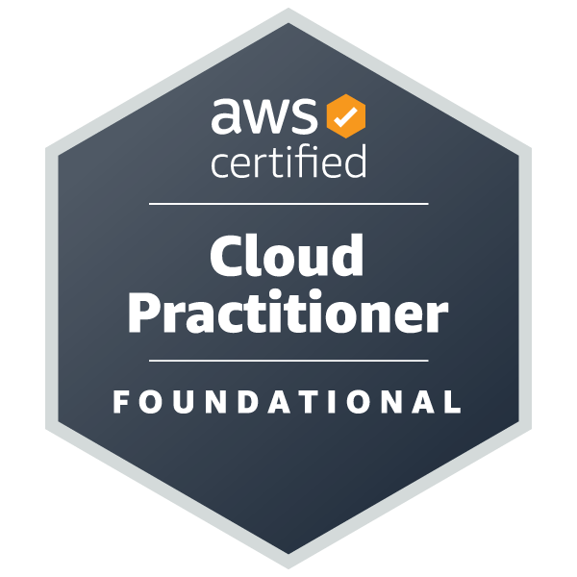
Data Analyst
PH: 940 344 0285
Email: velumythilee1993@gmail.com
Visa : H4 EAD
Summary:

AWS Certified professional with experience in designing, implementing, and optimizing data solutions using SQL, T-SQL, Python, PySpark. Well Knowledge in building scalable ETL pipelines by leveraging Amazon S3, Glue and in data transformation using Apache PySpark, Spark SQL in big bata environment like HDFS and Databricks. Experienced in creating reports and dashboards with SSRS and Power BI.

Certifications:
- AWS Certified Solution Architect - Associate
Validation No: b6fab06ec41a4b64a5c1d5f0ba439015
Validate at: https://aws.amazon.com/verification
Credly Badge: https://www.credly.com/badges/7677b8fc-5eee-49ff-86ad-9bd0da21a790/public_url

- AWS Certified Cloud Practitioner
Validation No: GD8QHZBLPNQ11N9N
Validate at: https://aws.amazon.com/verification
Credly Badge: https://www.credly.com/badges/674c11dd-445e-40a3-93ba-3a1e0d5e3b19/public_url

Tech Profiles:
- Leet Code : https://leetcode.com/u/mythileev/
- Geeks For Geeks : https://www.geeksforgeeks.org/user/mythilee1708/
- StrataScratch : https://platform.stratascratch.com/user/Mythilee1708
- CodeSignal : https://app.codesignal.com/profile/mythilee1708

Skills:
AWS Services | S3,EBS,EFS,EC2, ELB, ASG, Glacier, S3 Lifecycle rules, EMR, RDS, Lambda, Dynamo DB, IAM, SNS, SQS, Cloud Watch, AWS Snow Family.
Programming Languages | Python, T – SQL
IDE: | PyCharm, MS MQL Server 2016/2012 R2/2008
Big Data | PySpark, Databricks
Databases | Microsoft SQL Server, Oracle, MySQL, DB2, Postgres SQL
Data Warehousing | Redshift
Business Intelligence | AWS QuickSight, SSRS, Power BI
ETL Tools | AWS Glue, SSIS
Data Modelling | Entity Relationship Model
Streaming Data | Amazon Kinesis
Infrastructure as Code | AWS CloudFormation
Security | AWS Secret Manager, AWS Certificate Manager(SSL/TLS)

Projects
Worked on from October 2021 - Present
Static Website Hosting with S3:
- Description: Hosted a simple static website using AWS S3 (Simple Storage Service). Uploaded a s Image file(.jpg) in S3 bucket and enabled the public access in order to have the image hosted in the static website.
- Services: AWS S3

Automated Image Processing Pipeline with S3, Lambda, and SQS
- Description: Created an automated image processing pipeline that allows users to upload images to S3. SQS triggers a Lambda function that processes the images (e.g., resizing, generating thumbnails) and stores them back in S3.
- Services: AWS S3, Lambda, SQS, IAM, CloudWatch.
- Impact: Reduced manual intervention in the image processing workflow, improving efficiency by 40%.

Log Analytics with AWS S3, Lambda, and CloudWatch
- Description: Performed a Set up for log collection pipeline using AWS Lambda to process application logs (stored in S3), parse and aggregate the logs, and then store the processed data for analysis. Use SQL queries in Athena to perform analytics on the logs (e.g., finding error trends, request counts).
- Tools/Services: S3, Lambda, CloudWatch, SQL, Python.
- Additional Ideas: Use AWS Athena to perform quick SQL queries directly on the raw log data stored in S3.

Data Transformation with AWS Glue and SQL Queries
- Description: Used AWS Glue to read raw data from an S3 bucket, apply transformations using PySpark (within Glue), and store the cleaned data back into an optimized format (Parquet) in another S3 bucket. After that, query the transformed data using AWS Athena with SQL.
- Skills Learned: Glue, S3, SQL, Data Transformation, PySpark.
- Tools/Services: Glue, S3, Athena, SQL.
- Additional Ideas: Implement a versioning system in S3 for tracking changes in raw data.

Professional Experience

Data Analyst
Cognizant Technology Solutions- Chennai, Tamil Nadu January 2016 to December 2019
Domain: Retail
Client : DFS, Singapore
- AWS IAM service enabled to grant permissions and resources to users. Managed roles and permissions of users with the help of IAM.
- Involved in designing and developing EC2 instances with storage configured in S3,EBS and EFS. Setup Load Balancing with ELB and Scaling with ASG.
- Worked in developing complex T-SQL Stored Procedures and functions to achieve functionality required by the UI Team using Joins and leveraging aggregation and window functions.
- Was involved in requirement gathering for the LoyalT - A CRM Application programmed in SQL for backend and reporting in SSRS.
- Integrated data sources such as Salesforce, AS400 into the LoyalT application and developed logics successfully to credit Store points to the customer.
- Helped the clients to derive solutions to improve the sales with LoyalT Promotion programs which were location/store specific.
- Developed a Python application which connects with LDAP in read only mode to gain customer PII and generate bulk emails about the user’s password expiry in order to reset their passwords.
- Designed and implemented comprehensive Entity-Relationship models to map out database structures, relationships, and data flows, ensuring efficient and scalable database design.
- Have good knowledge in Microsoft Excel and integrate them with SSRS for report generation.
- Developed multiple processes for Daily Data Ingestion from Client Associated data vendors and Production by using SSIS and SSRS.
- Worked on a Workforce Management tool Kronos with scheduling shifts for the employees and running payroll for the Associates. Assigning roles and permissions for the associates based on the least privilege permission requested by the store manager and leads.
- Configured the data integration between the sales from POS and traffic from Countwise by developing an application – Mapping Tool and export it to BI Team for analysis.
- Involved in the application development – Sales associate Commission. This application will add commission to the Sales associate based on the sales performed by the associate for a particular SKU, department or brand.

Education:
Bachelor of Engineering – Electronics & Communication Engineering.
Anna University - RMK College of Engineering & Technology
August 2011 – March 2015
GPA : 8.7 (Anna University Rank Holder – 39th Rank)

