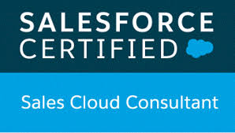
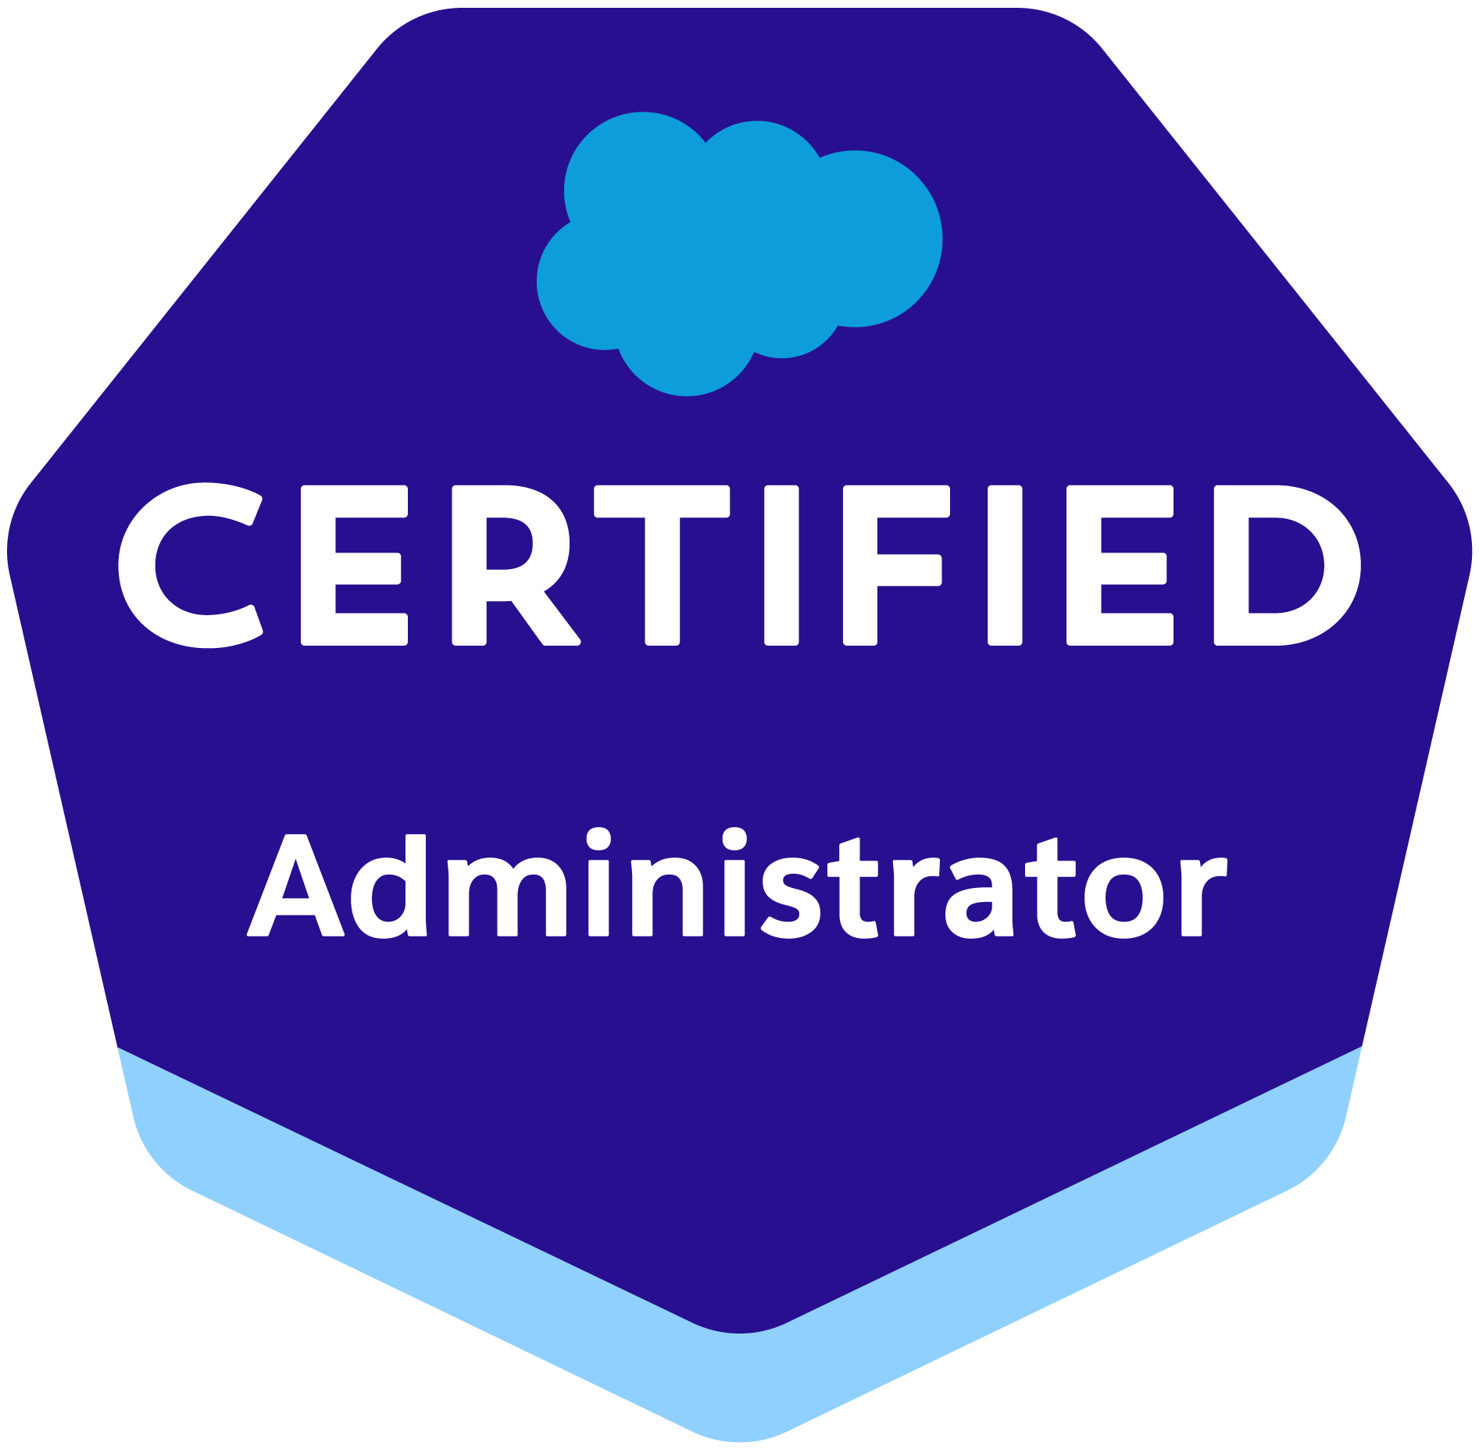
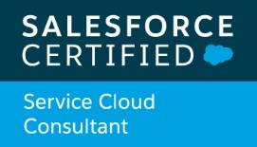
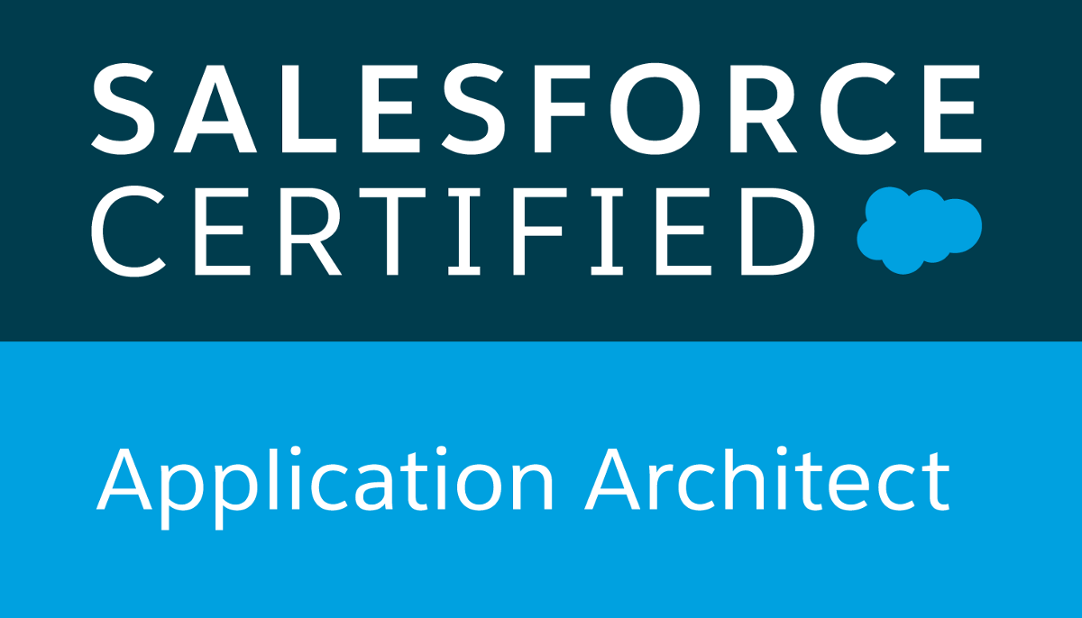
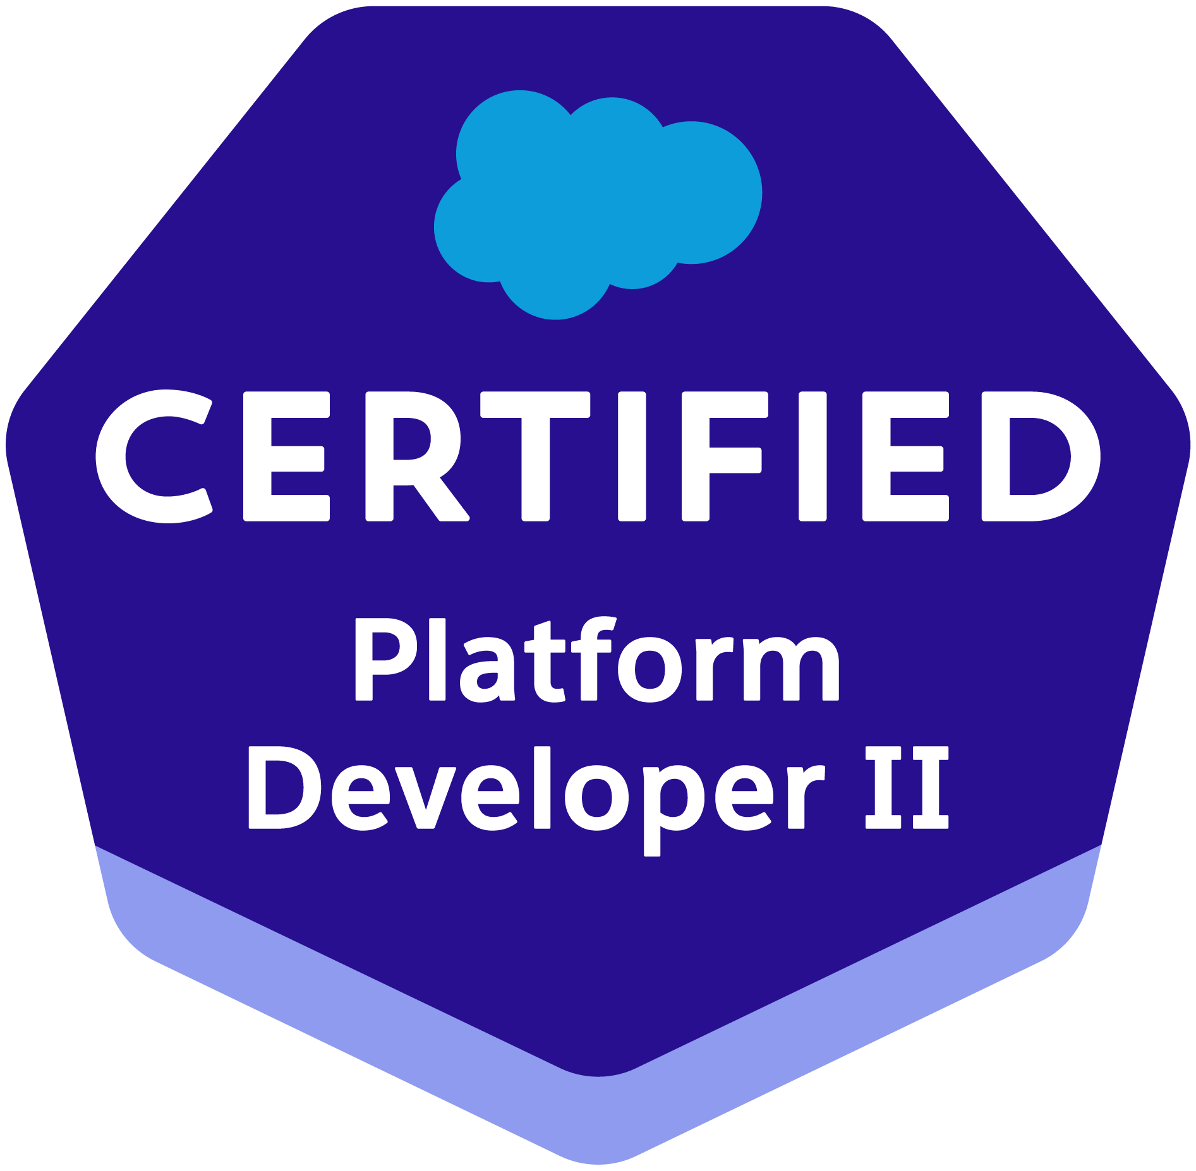
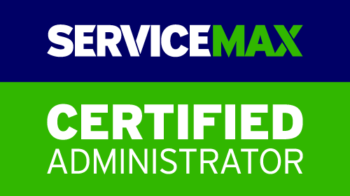

Ravi Kiran Kumar
Mobile: +1 832-280-8808
Email:- gsk.bsr1@gmail.com

Summary:

- I have 11+ years of experience in the Information Technology Industry on which SFDC (Salesforce.Com) and Salesforce.com Certified Force.com Developer (PD1), (PD2), Admin, Service Max Admin 101, Service Cloud consultant, Field Service Lightning, Salesforce AI associate, AI specialist and Application Architect.
- 5 years of experience on Lightning Components Framework and Events
- I have good knowledge in Visual Force, Apex programing language, Aura Components, LWC components from Salesforce platform.
- Well acquaintance with Data migration tool like Apex Data Loader.
- I have good knowledge in Object Oriented Programming (OOP), have good understanding of the Salesforce.Com Object Model.
- Worked extensively on Flows, Validation Rules, Approval process, Profiles, Roles, Page Layouts, Email services and Sharing Rules to drive Key Business decisions.
- Knowledge in Java and Object Oriented Programming concepts.
- Strong experience in interacting effectively with business stakeholders and technical teams at all levels of the organization.
- Minimized code in JavaScript Controllers by adding reusable functions in Helper Component.
- Excellent problem solving skills with strong technical background having the ability to meet deadlines, work under pressure and quickly master new technologies and skills
- Experience in Unit Testing and Integration Testing across various modules
- Involved in every aspect of project life cycle, including collaborative requirements gathering, creating work plans, functional requirements and unit testing plans.
- Experienced in web technologies like HTML, XML, CSS, JSP, JavaScript, WDFL and REST API.
- Hands on Salesforce Integration.
- Hands - on configuration in SFDC Sales & Community Cloud, complex APEC code and configuration, Flow Builder, Process Builder, Customer/Partner communities set up, and create/maintenance of lightning components.
- Proficient in dealing with functionalities related to sales cloud & service cloud, Community Cloud and Custom Cloud
- Hands on Live Agent, Omni Channel.
- Hands on Salesforce Docusign Integration and signature process.
- Knowledge on Financial Service cloud.
- Hands on Omni Studio concepts like Omni Scripts, Flexi Cards, Data mappers and Integration Procedures.
- Hands on Salesforce Lightning Design System and Lightning Components, Aura Framework, JavaScript Controllers, Server-side Controllers.
- Knowledge on Field Service Lightning.
- Hands on Lightning Web Components, Aura components, Visualforce pages.
- Hands on lightning flows.
- Hands on Salesforce CPQ templates.
- Hands on Docusign configuration/Support in Salesforce
- Experience in sales cloud, service cloud and Experience cloud.

Technical Skills:

CRM : Salesforce.com
Languages : Visual force, Apex Programming
Web Technologies : Html, Java Script
Scripting & programming : JavaScript, Salesforce Apex, HTML, SQL, CSS, SOQL, Java
Technologies : Java,J2EE
Database : SQL
Operating Systems : Windows 7 and Windows 8, Windows10

Professional Summary:

Duration : Nov 2022 to Dec 2024
Location : Houston, Texas, USA
Role : Senior Salesforce Developer

Project: :BOP – Business Operations Platform
Client : oneSensormatic Retail (JCI)
- Coordinated with Business Users and Pricing team to gather requirements for CPQ implementations.
- Performed administrative tasks like assign profile, permission sets, Roles, User creation, tabs, triggers etc. for Salesofrce CPQ package related objects.
- Designed, developed, and deployed the Custom objects, Page layouts, Lightning Web Components, , Apex classes & Triggers to suit to the needs of the application for our vertical.
- Worked with functional leads to transform and develop new requirements into design, implementation.
- Identify field mappings from Salesforce Servicemax application to Data fusion for Data Lake module.
- Provided large volume of data set to identify oracle data with Salesforce Servicemax and CPQ related data.
- Developed Web Service Callouts from Salesforce to External Applications using OAuth from Salesforce.
- Experience in building reusable UI components and pages with Lightning component framework.
- Worked on Salesforce Lightning Components for building customized components replacing the existing ones.
- Designed and implemented the User Interface using HTML, CSS, JavaScript,
- Responsible for setting up web service integrations.
- Triggered interface events by user interactions, which includes Lightning Component framework and also involved in building Lightning Components using the aura framework.
- Expertise in aura framework, Lightning Components and Salesforce Lightning Design System (SLDS).
- Created Impressive designs with custom styling to bring dynamic versions of the components when setting up in lightning App builder.
- Developed various Apex Classes, Triggers, Controller classes and methods for functional needs in the application compatible with lightning.
- Created multiple Salesforce CPQ related templates based on region & country specific information.
- Worked on Configurators, Product rules, pricing rules, advanced approvals, option constraints.
- Build CPQ Quoting & Product configuration, pricing for oneSensormatic. Customer has a large family of product with many dependent components and were adding product at individual SKU level.

Duration : Feb 2021 to Nov 2022
Location : Houston, Texas, USA
Role : Tech Lead

Project:
Client : Baker Hughes (Major Oil & Gas Company)
Project Tittle : Baker Hughes FieldApex

- Designed, developed, and deployed the Custom objects, Page layouts, Custom tabs, Components, Aura components, LWC components, Apex classes & Triggers to suit to the needs of the application for our vertical.
- Worked with functional leads to transform and develop new requirements into design, implementation.
- Working Knowledge on Service Cloud and Apex Programming on Force.com Platform.
- Used Data Loader, online third-party tools to insert, update and bulk import & export of data from Salesforce.com SObjects.
- Developed Web Service Callouts from Salesforce to External Applications using SOAP and REST API.
- Experience in building reusable UI components and pages with Lightning component framework.
- Worked on Salesforce Lightning Components for building customized components replacing the existing ones.
- Worked in all the modules of the application, which involved front-end presentation logic developed using JavaScript.
- Also embed Lightning Components in Visual force page by using new Lightning Out feature by event-driven programming.
- Responsible for setting up web service integrations.
- Triggered interface events by user interactions, which includes Lightning Component framework and also involved in building Lightning Components using the aura framework.
- Expertise in aura framework, Lightning Components and Salesforce Lightning Design System (SLDS).
- Created Aura based Components, Attributes and Controllers which can be compatible to access through Lightning App builder.
- Created Impressive designs with custom styling to bring dynamic versions of the components when setting up in lightning App builder.
- Enhanced in Communities by adding new fields, field sets using Salesforce lightning.
- Developed various Apex Classes, Triggers, Controller classes and methods for functional needs in the application compatible with lightning.

Duration : Jun 2019 to Jan 2021
Role : Senior Software Developer
Project:
Client : US (World’s leading Retail/Financial/manufacture Company)
Project Title : GE Energy Management

Project Description:

GE P&W is a, Europe and APAC based Energy, Power and water, Power and Oil business, these can be supporting pre sales, Sales and Field services to the internal users.

Responsibilities:
- Involved in requirement analysis and development.
- Provide technical approach to the internal team and once get approval co-ordinate with team to build the user stories.
- Worked on Salesforce Lightning process builder, Lightning UI/UX app builder and creating Visual Workflows, Salesforce support communities and Chatter groups.
- Used Email to case, Web to Case features and created a community where the customers can create, update and manage their cases.
- Implemented communities and built external pages.
- Enhanced in Communities by adding new fields, field sets using Salesforce lightning.
- Developed custom UI suing CSS, HTML, Visualforce components and used JavaScript for front-end validation.
- Worked on Salesforce Community cloud like how to engage with employees, customers, partners.
- Involved complex business logic using lighting components, Apex classes and Triggers.
- Involved in Service Max related configuration and customization.
- Involved in migration activities using GIT, ANT and Change sets
- Involved in customization and configuration of application.
- Involved in data mapping and data migration.

Duration : Feb 2018 to Jun 2019
Role : Senior Software Developer

Project:
Client : Tip (Major Logistics Company)
Project Tittle : TIP EHS
Project Description: Environment Health and Safety (EHS) application has been developed to help TIP manage aspects of health and safety governance across all regions that TIP have operations and currently for Sites across Europe. This application is used to ensure compliance and continually improve operational excellence.
The application is used to manage, monitor and report on the condition of corporate facilities, equipment, record and minimize injuries to employees and manage health and safety training in compliance with company, regulatory and industry requirements.

Responsibilities:

- Fixed existing Issues and Implemented Training Tracker Module.
- Involved in customization and configuration of application.
- Implemented lightning components and events used SLDS.
- Worked on Aura Framework.
- Involved in developing complex business logic based on apex class, triggers and visual force pages.
- Involved in Unit Testing.

Duration : June 2017 to Feb 2018
Role : Software Developer

Project:
Client : Australia (Major Logistics Company)
Project Title : Toll Group

Project Description: Toll group is a major logistics company operating within Australia. The project included configuration enhancement like profile creation, email templates, profile level permissions, object creation and customization using Visual force, Lightning components and Apex coding and Apex triggers.
Responsibilities:

- Involved in requirement analysis and development.
- Involved in customization and configuration of application.
- Implemented lightning components and events.
- Worked on Aura Framework.
- Programming in JavaScript with proven knowledge and experience extending JavaScript libraries such as Bootstrap, jQuery.
- Involved in developing complex business logic based on apex class, triggers and visual force pages.
- Involved in Unit Testing.
- Involved in creating lightning components and used SLDS.

Duration : Jul 2016 to Jun 2017
Role : Software Developer
Project:
Client : US (World’s leading Retail/Financial Company)
Project Tittle : GE Energy Management

Project Description:

GE EM is US, Europe and APAC based Energy, Power and Oil business, these can be differentiating GE IS (Industry Services), GE IS Services, GE PC (Power Conversion) and GE PC Services. GE EM contains Sales and services process and involves many app exchange products.

Responsibilities:
- Taking care of offshore activities, follow up with Team Lead at Onsite/Client.
- Involved in requirement analysis and development.
- Providing support to the business users using ticket tool Service Now.
- Involved in customization and configuration of application.
- Involved in data mapping and data migration.
- Involved in developing complex business logic based on apex class, triggers and visual force pages.

Role : Software Developer

Project:
Client : Waaree Energies Ltd
Project Tittle : Waaree CRM
Duration : October 2015 to January 16

Project Description:

Waaree Energies Ltd. is one of the leading solar panel manufacturers in India it consists whole sales process and also customized Approval process.

Responsibilities:

- Involved in requirement analysis and development.
- Involved in customization and configuration of application.
- Involved in developing complex business logic based on apex class, triggers and visual force pages.
- Involved in Unit Testing.
- Customized approval process.

Duration : June 2015 to October 2015
Role : Software Developer

Project:
Client : Locon solutions pvt. ltd (Operates an online real estate platform)
Project Tittle : Housing Sales Cloud

Project Description:
Locon Solutions Pvt. Ltd. operates an online real estate platform. It offers Housing.com that provides home- seekers and home-owners with listings of properties for sale or rent. Housing.com includes total sales process from Leads to quote with invoice and payments. It is also include Customized case management

Responsibilities:
- Preparing the design documents and Development Analysis.
- Involved in data mapping and data migration.
- Involved in developing complex business logic based on apex class, triggers and visual force pages.
- Providing production support for Housing Sales Cloud.

Role : Software Developer
Project:
Client : US (World’s leading Retail/Financial Company)
Project Tittle : CRB – Sales force Implementation
Duration : Apr 2013 to May 2015

Project Description:
The project included configuration enhancement like profile creation, email templates, profile level permissions, object creation and customization using Visual force and Apex coding
The project also included loading of Goals for the sales Reps on a Daily as well as Monthly basis, Data Migration for newly implemented applications.

Responsibilities:
- Taking care of offshore activities, follow up with Team Lead at Onsite/Client.
- Involved in requirement analysis and development.
- Preparing the design documents and mapping sheet for Migration.
- Involved in customization and configuration of application.
- Involved in data mapping and data migration.
- Involved in developing complex business logic based on apex class, triggers and visual force pages.

Achievements
- Awarded Manager Special mention award by customer solution practice horizontal.
- Appreciation mail by the client for flawless and timely delivery.

Education Details
- Master of computer applications from Anurag group of institutions, affiliated to JNTU Hyderabad in 2013 with 77.7%
- Bachelor of Computer Science (M.P.Cs) from Loyola Degree College, affiliated by SV University in 2010 with 65%.
- Intermediate (M.P.C) from Y.S.R.R college, Simhadripuram with 83.20% in 2007.
- S.S.C from Sri Sarada School, Wanaparthy with 83.00% in 2005.

