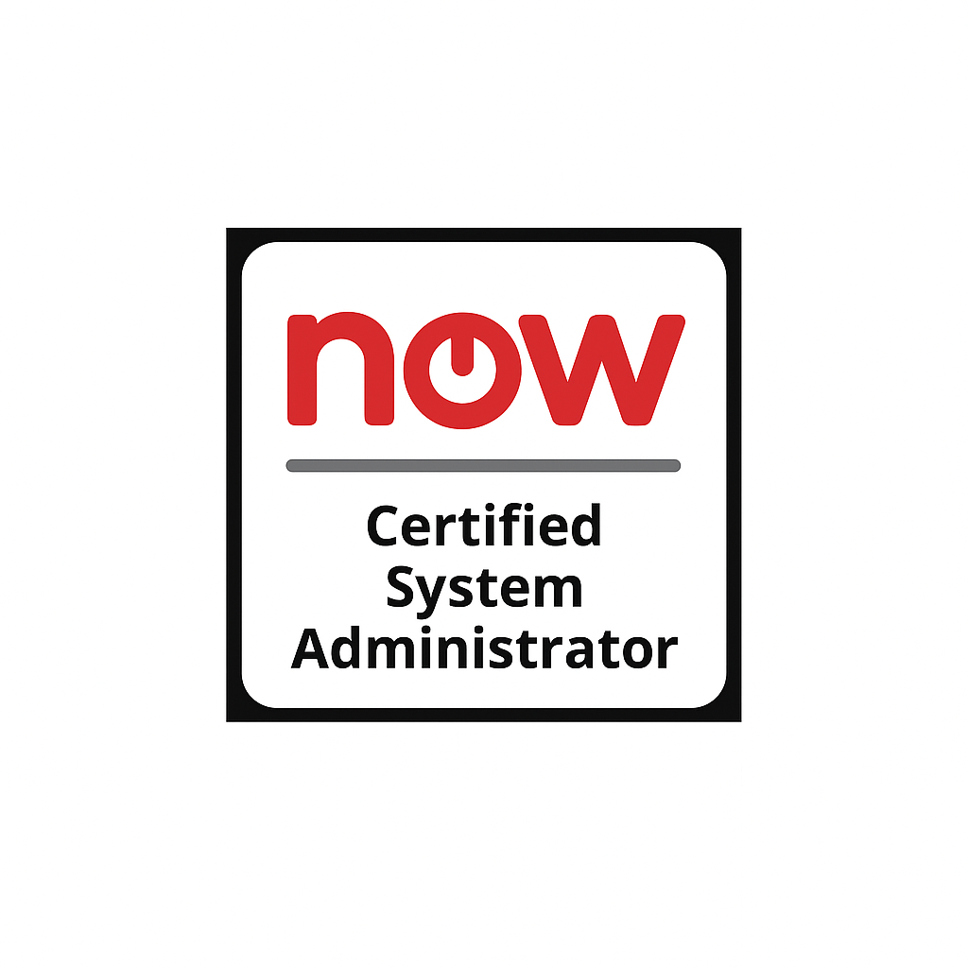
Sundar Kumar
Sr. ServiceNow Developer Phone: +1 (334) 339-3393
Email: ksundar2023@gmail.com
Linkedin Profile: www.linkedin.com/in/sundar-kumar-katikala-20702b352

Professional Summary:

- Completed the ServiceNow Certified System Administrator (CSA) certification, demonstrating proficiency in core ServiceNow platform capabilities.

- Over 9+ years as an IT Professional and 7 years of experience as a Service-Now
Developer/Administrator.
- Extensive development in our ServiceNow platform customization of our Incident, Request, Service Change, Service Level, Knowledge and Configuration (CMDB) applications and processes.
- Created various integration solutions for various stake holders in the firm.
- Developed various database views for the integration purposes for the stakeholders as there are restrictions on the base tables.
- Responsible for the Incident Management, Problem Management and Request Management teams.
- Implemented bi-directional integration between Jira and ServiceNow for creating incidents and issues.
- Created various script includes and MID server script includes and called them in various scheduled jobs.
- Implemented Orchestration on various catalog items to automate complex tasks and modified existing automations to enhance the performance of the instance.
- Participated in cleaning the unwanted records within ServiceNow to reduce the performance outages.
- Worked in production support for all the Service now related issues.
- Involved in planning and coordinating Implementation plan for every release in Service now.
- Excellent hands-on experience in Client and Server-side Scripting.
- Extensive experience in working with User Management including Users, Groups, Roles and Access Control Lists (ACL).
- Deep knowledge of User Interface UI policies, data policies, UI actions and client scripts, activate plug-ins, manage data with tables, import sets and update set.
- Sets up Service Level Agreements (SLAs) and monitors SLA workflows, creates and tracks Service Catalog requests, and items with variables.

- Hands on experience with loading data from various data sources like File, JDBC and Web Services using Import Sets and Transform Maps.
- Extensive experience in integrating Service-Now with third party applications like BMC Remedy, HP Service Manager (SM9), Bomgar.
- Excellent knowledge in Configuring Email Notifications and Scripting Inbound Email actions. Strong understanding of cloud technologies, web applications, networks, protocols and email.
- Working experience on Different versions of Service-Now: Fuji, Geneva, Istanbul, Jakarta, Madrid, Orlando, Quebec, Rome, San Diego, Tokyo, Vancouver, Washington, etc..
- Attention to detail and complex problem solving abilities from operational and technical perspective.
- Ability to work independently and as part of a group.
- Had extensive experience in Reporting and Performance Analytics Module
- Excellent hands-on experience in Client and Server-side Scripting.
- Strong knowledge of relational databases and SQL.
- Customer Service Management (CSM) Portal experience
- Service Portal custom development, specifically the portals for Customer Service Management (CSM)
- Experienced in integrating with 3rd party tools like Perspectium. REST API’s.
- Experience in web development (UI) using HTML 5, CSS 3, Angular JS and JQuery.
- Working experience with Web Services/ SOAP/REST integrations.
- Aptitude for learning and rapidly mastering new applications and technology.

ITSM Tools | Service-Now, ITSM Suite, ITOM Suite, ITBM, HP Service Manager
Databases | MS SQL Server 2016/2018, Oracle9i/10g/11g, MySQL, MS Access, Snowflake
Web Technologies | HTML 5, CSS, ASP.NET, Web Services, MVC, REST Web API
Programming Languages | C, C#, Java, Python,HTML,XML,JavaScript,SQL,Php,Jelly
Scripting Languages | SQL, PL/SQL, T-SQL, VB Script
Work spaces | SOW, CMDB, Asset Executive, Hardware Asset workspace etc

ServiceNow Tools used | Studio, App engine, UI builder, Page designer, editor, Branding editor
Other Tools | Oracle SQL developer, MS Office, JIRA, GitHub, JSON, MS Excel,Docker, AWS
Technical Skills:

Professional Experience:
Co-op Financial Services, St. Petersburg, FL
Dec 2022 – Current
Sr. ServiceNow Developer / Admin

Roles & Responsibilities:

  - Gathered requirements from stakeholders for attributes needed to develop ServiceCatalogitems. Identify and Recommend the ITIL v3 methodologies to deliver technical methodologies around the ServiceNow platform.
  - Worked closely with the Business Analysts and process team to gather requirements to design the applications and formulate the test cases.
  - ServiceNow Developer, External Service Integration and Administrator.
  - Worked migrating data for all the ITSM tables into a new ServiceNow instance using Remote instance spoke, Data sources.
  - Implemented ITSM module from scratch which includes Incident, Change Models, Knowledge, Problem Management.
  - Implemented Service Graph Connectors to integrate with Lansweeper, BigFix, Intone, Azure, Tanium.
  - Involved in analysis of CSDM model, provided documentation on how Service, Service Offering, Application Service parent-child relationship hierarchy is defined and how CMDB classes are used to build the process and added the Service, Service offering, Impacted services to incident and change modules.

  - Implemented Customer Service Management (CSM) as our business is Insurance and Financial services and we have several customers across the America.
  - Work with customer to define requirements and create an entire custom application within the ServiceNow Service Portal application. Included new Tables, Pages and Widgets using AngularJS and Bootstrap for Portal.
  - Working with the UX/UI team, implemented a fully customized Service Portal theme for every page and widget.

  - Customized workspaces like SOW, CMDB, ASSET using UI builder as per the organization needs.
  - Good knowledge of CMDB and Asset Management Services: Business Services, Service Offerings and Configuration item relationships.
  - Communicate with Stake holders and document technical challenges that come across CMDB workshops
  - Develops and manages transforms for bulk updates to the CMDB.
  - Understanding of IT service management (ITSM) and the ITIL business process.
  - Worked on Configuring the IP Addresses to identify the undiscovered CI's and insert them into CMDB.
  - Implemented Predictive Intelligence framework to test if it suits the organizational needs, Developed Classification, Similarity, Clustering, Regression solution definitions, Tested and provided use cases for each solution to make use on Workspaces and default view of incident to predict major incidents, related kb articles, installed a Clustering recommendations utility to provide solutions for each cluster which will help to cut the cost.

  - Worked on CMDB and Asset management, Performed Data migration to import data from other applications and external databases.
  - Worked on Agent Workspace Module
  - Designed the end-to-end onboarding/off-boarding processes in sync with Dayforce-Ceridian
  - Created order guide for new hires
  - Integrated ServiceNow with Microsoft SCCM and loaded workstations and servers into cmdb_ci classes
  - Implemented SSO setup for the ServiceNow instances.
  - Built ServiceNow forms from scratch along with advance customizations at the level of UI Macros/UI pages as per the complex requirements.
  - Created countless Business Rules using the Glide Record Operations.
  - Created Catalog Client Scripts and UI policies to make client side changes.
  - Designed UI pages to use them in catalog items, designed buttons and context menus both on form and lists applying UI scripts. Worked on UI Macros to create pages as templates on requirement from the stakeholders.
  - Worked with Microsoft Azure logic apps to sync data between AD and ServiceNow.
  - Experience in integrating ServiceNow with Web services (SOAP and REST)

  - I have integrated ServiceNow with tools like Salesforce, Remedy, People Soft, We recently implemented GRC module in Service Now.
  - Integrated ServiceNow with Microsoft SCCM and loaded workstations and servers into cmdb_ci classes
  - Built ServiceNow forms from scratch along with advance customizations at the level of UI Macros/UI pages as per the complex requirements.
  - reated Knowledge articles to document the steps in creating the catalog items.
  - Involved in upgrades and worked on bug fixes from upgrades.
  - Worked on various enhancements to Incident, Change, Problem records

Application Environment: ServiceNow (ITSM), Incident Management, Change Management, Problem Management, ServiceNow Orchestration and Automation, Performance Analytics, Team Development (Source Control), ITIL, JavaScript, Web Services, XML, DHTML, JQuery, JSON.

DTE Energy, Detroit, MI Mar 2021 – Nov 2022
Sr. ServiceNow Developer / Admin

Roles & Responsibilities:

  - ServiceNow Developer, External Service Integration and Administrator.
  - Worked on creating Data Sources, Field Maps and Transform Maps.
  - Configured Access Control (ACLs) to accommodate the roles of both users and contacts
  - Create new service catalog requests and items with variables and variable sets and developed UI Appearance for Service Catalog Requests
  - Integrated with HP Service Manager using SOAP Messages and Scripted Web Services
  - Installed and Configured MID Server in clustered environment
  - Integrated ServiceNow with Bomgar Chat application to have remote desktop access to resolve incidents
  - Integrated with CISCO UCS director to trigger VM workflows through catalog item by using
REST API.
  - Worked on Script includes, Related lists, catalog items, catalog client scripts, business rules, CMDB notifications, transform script.
  - Designed a company-wide service catalog that offers a collection of services Involved in customization of UI for a knowledge base

  - Involved in analysis of end user requirements and Business rules based on the given documentation and worked closely with the tech leads and Business analysts in understanding the current ServiceNow system.
  - Configured UI Policies, UI Actions, Client scripts and Business Rules in global and scoped applications (CSM)
  - Designed integrations to transform and load data, and connected serviceNow with external web services.
  - Worked with LDAP directories, as part of Active Directory in fetching user data.
  - LDAP, Initial Data Loads, Import Sets, automated integrations and address exceptions.
  - Implemented Hardware Asset Management from the scratch
  - Developed solutions in the service-now platform that are ITIL V3 compliant and defined business solutions for ITIL users.
  - Worked with business analyst to create and modify Service Catalogs and Request Workflow Designs.
  - Responsible for creating various workflows for Incident Management, Change Management, Service Requests and SLA's.
  - Created Single sign-on using SAML response.
  - Actively involved in daily Scrum meetings
  - Worked on creating users, roles, groups and load the data to service-now objects using import sets on daily, weekly, monthly and on request basis.
  - Responsible for creating homepages including basic reporting, gauge configuration and dash board presentation.
  - Involved in running the daily and weekly jobs to push the data into the application using Import Sets and Transform Maps.
  - Generating weekly reports and metrics for IT management.
  - Configured metrics for indicating KPI of the Industry in different measure.
  - Created many standard workflows which are being re-used and propagated.
  - Documented business processes, functional requirements Conduct information flow analysis, process modeling within and across the multiple business streams.
  - Provided training on service-now process, operations and capability to all required teams.

Environment: Power BI Desktop, Power BI Service, Power BI Data Gateway, DAX, T-SQL, SQL Profiler, MS Excel, Windows 10, MS SQL Server 2018, Snowflake, SQL Server Integration Services (SSIS), SQL Server Reporting Services (SSRS), Azure, Windows 2012/2018 R2 Server.

HCA HealthCare, Tallahassee FL Sep 2019 – Feb 2021 ServiceNow Developer

Roles & Responsibilities:

- Participate in Requirements gathering workshops, design, code, and test reviews cycles.
- Configuring and customization of all modules in service now, such as Incident Management, Problem Management, Change Management, Configuration Management, Asset Management, Service Portal, Service Request Management, Knowledge Management, GRC, Portfolio Management and Release Management.
- Overall responsibility for the system and its processes. Service Now expert for project. Provides training to users. Responsible for access control, security, minor enhancements such as form or workflow editing, and UAT/Regression testing of development.
- Worked on ServiceNow instance Upgrade project. Recent one is from Fuji to Jakarta.
- Having experience in ServiceNow implementation and development using client scripting, BR scripting general script like Java scripting and glide API.
- Experience in Integrations like Moogsoft, SCCM, CAWA, xMatters, Right Answers, TIBCO, Optibot, vRa/vRo, OEM, Live Station and App station.
- Successfully migrate from Remedy and HPSM to ServiceNow.
- Very good experience on Discovery. MID server Configurations, discovery pre-requisites fulfillment, discovery scheduling.
- Post discovery implementation extensively worked on discovery trouble shooting by customizing the Probes, sensors, and Identifiers.
- Worked on SACM project which fine tunes the CMDB and Discovery Modules.
- Very good experience on Service Portal development.
- Worked on 100 of catalog items, order guides and record producers.
- Experience as a programming developer languages/tools are: ServiceNow, HTML, JavaScript, SQL, SQL Scripting, XML and data modeling.
- Thoroughly worked in Domain separation like Data Separation, Process Separation, UI Separation and move existing data to 1 domain of a new instance, which will be configured to be domain separated.
- Environment: ServiceNow (Helsinki, Kingston), CMDB, JavaScript, CSS, HTML, Windows 10, SQL Server, XML, Angular JS, Json, Java

Environment: ServiceNow (Helsinki, Kingston), CMDB, JavaScript, CSS, HTML, Windows 10, SQL Server,
XML, Angular JS, Json

Wells Fargo, San Francisco CA Oct 2017 – Aug 2019 ServiceNow Administrator

Roles & Responsibilities:
- Attended review meetings and project meetings, Analyzed Business Requirements and Functional Specifications and performed Service Catalog, Incident, Problem and Service Level Management Implementation.
- Worked with client for functional requirements within Service Now.
- Created Data Sources from various external applications, scripts to parse incoming data and transform into Service Now.
- Implement Service-Now customization including Client Scripts, UI policies, UI Actions, Script Includes, Business Rules, workflow administration, report setup, and data imports and exports.
- Ability to Work independently or with a team, Experienced in LDAP Directory,Active Directory, eDirectory.
- Assist in the definition of business requirements and provide definitions and updates of system design documentation.
- Experience with Database Manipulation using programming language, Web Technologies
XML,HTML,JAVA SCRIPT, AJAX,CSS,HTTP, etc.
- ServiceNow application development, including creation and configuration of ServiceCatalogs, Email Notifications, Data imports and exports and Reports.
- Experienced in the analysis, development and automation of various ITSM processes including Incident Management, Change Management, Asset Management, and Service Request. The service we also provide to clients is a semi managed service for administering their Service desks that has been implemented.
- This includes various administration tasks within Service desk software.
- Created Buttons and context menus both on form and lists using UI actions, designed many email templates by using HTML and used them in notifications.
- Worked with windows team, network team and Asset team in order to check for the data collected through the discovery is accurate.
- Created new Business Rules, Script Includes, Client catalog script and Client Script.
- Configured chat functionality for Service Desk ticketing queue and created transform maps
for importing CMDB data.
- Written Script Includes and invoked them in business rules and client scripts Imported Active Directory to Service now using data sources.

- Created data sources and loaded the Service-Now tables with different data formats, Created transform maps both automatic field mapping and Scripting, also worked on Asset Management and loaded the data into it.

Application Environment: ServiceNow, ITIL, JavaScript, Web Services, XML, DHTML, JQuery, JSON

Infosys – Hyderabad, India Aug 2015 – Sep 2017
Web Developer

Roles & Responsibilities:

  - Involved in the review and analysis of the Functional Specifications, and Requirements Clarification Defects etc.
  - Involved in developing the UI pages using HTML, DHTML, CSS, and JavaScript.
  - Created user-friendly GUI interface and Web pages using HTML and CSS and JSP.
  - Used Java Messaging Services (JMS) for reliable and asynchronous exchange of valuable information such as payment status report.
  - Developed web pages with functionalities like login, register, forgot password, Email, Filters using JavaScript, JQuery and HTML.
  - Developed the UI using JSP, HTML, CSS, and AJAX and learned how to implement JQUERY, JSP and client & server validations using JavaScript.
  - Developed JUnit test cases for all the developed modules.
  - Involved in Unit Testing of the components using JUnit.
  - Involved in writing SQL Queries, Stored Procedures.

Application Environment: HTML, CSS, JavaScript, DHTML, SQL, PL/SQL.

Education:
Bachelor's Degree in Electrical and Electronic Engineering
Jawaharlal Nehru Technological University, Kakinada (JNTUK),Andhra Pradesh, India.

