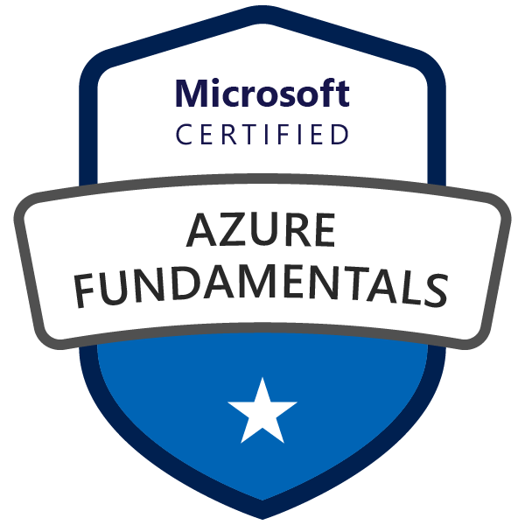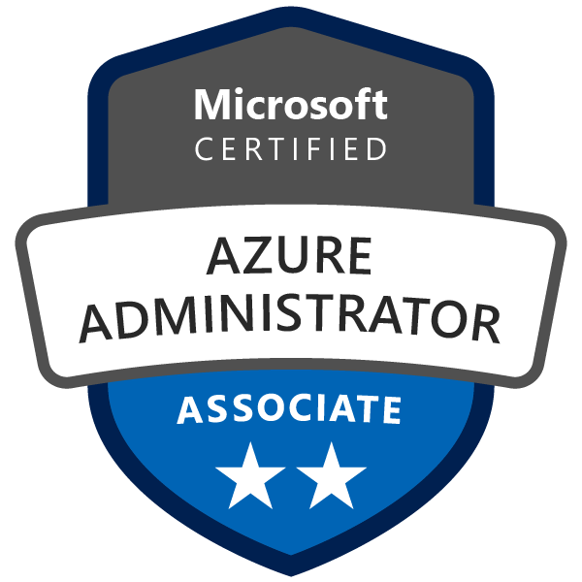
Wilson Thirumoorthi
Mobile Phone: +16146808657
Email: wilsoninfotech@gmail.com
16+ Years of Experience

OBJECTIVE:
Seeking a position to utilize my skills and abilities in the field of IT Infra that offers professional growth while being resourceful, innovative, and flexible responsibilities to implement the skills being acquired there by contributing to the progress of the firm and thus grow personally.
Good Team Player and having a team leading capabilities with excellent communications and Interpersonal Skills.
EXPERIENCE:
Total 16+ Years of experience in the field of Information Technology which includes about 13 Years experience in SAN Storage Administration, Manage and Monitoring, Trouble shooting, and provide Technical solutions.
SUMMARY:
- Experience in Dell EMC- VMAX 250F,PMAX 8000, Unity, XtremIO, Powerscale Isilon H500/F800 NAS High performance Computing (HPC)Cluster , PowerStore 9200T
- Experience in PURE Storage Flash Arrays-M series,X series and Flash Blades S for the NAS shares
- Experience in InfiniBox Storages -F4300 | F6300 series
- Knowledge on IP based block storages- Powerflex/ScaleIO, NetApp Solidfire
- Experience in IBM storage arrays – IBM SVC, IBM V7000 and Flash Storage-FS900.
- Experience in IBM storage arrays – IBM DS8000, IBM DS4000 and ESS 800.
- Experience in IBM Cloud object storage(COS Manager,Accessor,Slicestor)
- Experience in copy services –snap shots,Flash copy, Replications -Metro and Global mirrors, Synchronous, Asynchronous replication
- Experience in NetApp, HP EVA, HP 3par, and HP XP24000.
- Experience in Hitachi Storages-Hitachi Vantara VSP Gseries,VSP 5100, E590
- Experience in Brocade SAN Switches –DCX/5300, Gen6, 7 switches, Cisco MDS 9710/9148T/9396.
- Experience in Performance issue Analysis using-IBM Spectrum control, Virtual Wisdom/Virtual Instruments, NetApp OCUM, OCI tools, Hitachi device manager storage navigator((HDvM - SN).
- Experience in Operating systems Windows 2003 /2008 R2 / XP and Windows 7.
- Experience in VMware (vSphere, vCenter, ESXi) –versions 8.0.2/7.0.2

TECHNICAL SKILLS:
- Storage Administration in, Dell EMC VMAX,PMAX,Powersclae/Isilon, EMC Unity ,InfiniBox F4300 | F6300 series. NetApp Cluster Mode (SAN-FC,ISCSI) NAS-CIFS/SMB/NFS HP 3PAR, HP EVA, Hitachi-Vantara VSP Gseries,VSP 5100, E590.
- Pure Flash Array and Flash blades administration and day to day operations like provisioning/ decommissioning thru GUI/CLI and monitoring and managing the clusters through Pure1 cloud based management tool.
- Configuration of new Infinidat, Pure, EMC storages and migration of file, Block storages from Legacy systems to new ones. Validate the Data integrity and consistency post migrations.
- Document the migration and configuration processes and review with management.
- Storage Administration in IBM Storage products-SVC, V7000, FS900, DS8K and V3700.
- Fabric Administration in Brocade DCX and Cisco MDS switches.
- Storage and San switch OS upgrades(IBM SVC,V7000,NetApp,Brocade DCX,HP 3par, Hitachi, InfiniBox,Pure Storage)
- Volume Creation, Hostmapping, Consistency group creations to set the replications.
- Host group creations and adding the new hosts WWPNs for provisioning, create LDEV from storage pool to host groups.
- Implementing and administration of Storage virtualization and flash copy management.
- Implementing and administration of Remote copy services in IBM SVC (Metro Mirror)
- SVC vdisks Migrations, Thick to Thin Migrations, Real Time Compression Migrations
- Performance analysis for the performance issues using the IBM Spectrum control and Virtual Wisdom Tools.
- Disaster Recovery Management (DRM).
- Excellent communication and self-motivated team leading capabilities.
- Handling escalations and providing trainings to new joiners.
- Basic skills on implementing AD, DNS and Other Windows services
- Experience with VMware administration with vSphere client.
- Experience in data protection, backup, and disaster recovery solutions using Rubrik, Cohesity ,Avamar, Komprise,Symantec,NT backup.
Storages:
- Dell EMC VMAX3,250F,PowerMAX8000,Unity,XtremIO, PowerStore9200T ,Power scale Ision NAS clusters H500/700/F800 .HP EVA, HP 3PAR, HP XP ,Pure Flash IBM SVC, DS8K, Arrays M and X series, Pure Flash blades S series for NAS Shares. Hitachi Vantara VSP Gseries,VSP 5100, E590, InfiniBox F4300 | F6300 and NetApp SAN and NAS(SMB/NFS)
SAN Switches:
- DCX X6, DCX 8510-8, 5300 and 48000, Cisco MDS SAN .
Tools:
- IBM Spectrum Control, Virtual Instruments/Virtual Wisdom, Brocade Network Advisor (BNA),Pure1, SANnav, DCNM,Cisco Fabric Manager, Isilon SyncIQ,InsighIQ,Superna Eyeglass,StorageX migration tool, Unisphere,Remedy (RFC/SR),ServiceNow-Incident, Change management,Problem Management. Python , Ansible and Terraform Skills to Automation. Komprise and Startfish Data management tools,Avamar,Rubrik,Cohesity.
TECHNICAL CERTFICATIONS:
- ITIL® Foundation V3 Certified in IT Service Management
- Azure Fundamentals(AZ-900),Azure Administrator(AZ-104) Certified
- Microsoft Azure Architect Design(AZ-304),Azure Security Technologies(AZ-500)

PROFESSIONAL EXPERIENCE:
ILOGIC INC, USA Oct 2023 – Till
Project: STATE FARM INSURANCE
Role: Storage Engineer
- Managing 200 PetaByte of storage raw space in heterogeneous storage environment.
- Worked on commission/decommission on Dell EMC VMAX, PowerMAX, Powerstore ,Infinidat ,Pure Flash arrays along with Zoning requirements.
- Pure Flash Array and Flash blades administration and day to day operations like provisioning/ decommissioning thru GUI/CLI and monitoring and managing the clusters through Pure1 cloud based management tool.
- Experience Pure Flash Arrays M and X series, Pure Flash blades S series for NAS Shares(CiFS/NFS protocols)
- Pure Hardware refresh activities coordinating with vendor from pure flash arrays Mseries to X series thru change control management.
- PurePOD creation for the replication setup ,Pure Vol, Pure host creation for newly built hosts/host groups along with SAN Zoning
- Legacy system migrations to new Infinidat and Pure,EMC storages
- Monitoring the arrays thru CloudIQ portals.
- Performed the OS/Firmware upgrades for the Dell EMC arrays.
- Worked on Powerscale Isilon (High performance Computing)Clusters for NAS Share builds( NFS,SMB,FTP protocols) and permission issues handling.
- Managing Gen6 Powerscale Isilon (HPC)production clusters F800,H500/H700.
- Planning and implementing the OneFS code upgrade for the Isilon clusters.
- Handling issues for the Multi-Protocol shares for the Isilon clusters
- Upgraded InsightIQ from version 4.1.4 to 4.2.0 and added all the Isilon clusters to them.
- Have designed multiple access zones on Isilon for multiple applications and having the user mapping b/n the AD and linux users.
- Worked on DR Test activities for Storage Arrays on both failover/failback activities.
- Worked on Storage Request ITEMS, Change records like allocation, Zoning and decommission.
- Coordinating with Pure vendor for Hardware related issues to get it resolved.
- Analyze and provide health check report for Isilon clusters
- Have successfully done Real DR activity by doing failover from PROD DC to DR DC and then completed successfully failback for the applications.
- Work on P1/P2 related incidents and update them on proper interval with respect to SLA.
- Attending Weekly/Bi weekly Team meeting to meet the expectations and Vendor calls.
- Performing the planned changes like Code upgrades, Hardware refresh, and coordinate with vendors for any vendor related activities.
- Supporting Disaster Recovery test for critical services from Storage perspective.
- Experience with Unstructured data management for file and object storages using Starfish and Komprise tools
- Data duplication and orphaned file detection and remediation using Starfish and Komprise
- Data protection, replication and migration of file/objects storages using Cohesity and Komprise.
- Backup and disaster recovery planning for on-prem, hybrid, and cloud environments
- Data lifecycle management, retention, and archival strategies

TATA Consultancy Services Limited Jan 2020 – Sep 2022
Designation: Associate Consultant
Project: Walgreens Boots Alliance
Role: Storage Engineer –Engineering Team
- Managing 20 PetaByte of storage raw space in heterogeneous storage environment
- Performing the LCM (Life cycle management) Migration for the legacy Storage arrays-(NetApp,IBM,EMC Storages,Pure Flash Arrays) and hardware refreshes.
- Worked on NDM migration as part LCM project from VMAX 250F to PowerMAX8000 by scheduling changes, planning, implementing and cutover.
- As part of engineering team performing the Design/Plan and Implement the complete LCM Migration projects end to end without any impact to the business.
- Firmware Upgrading IBM SVC, V7000, Flash9000, NetApp Cluster, brocade switches, HPE 3PAR and Dell EMC Storages,Hitchi Vantara VSP and InfiniBox .
- Worked on NAS storages for file storage using SMB/NFS protocols
- Day to Day operations for provisioning nfs mounts,SMB shares and Multiprotocol shares in Active Directory environment for the Isilon/NetApp clusters.
- Proficient in CLI & Isilon webui. configured Isilon NFS,SMB and providing permissions for the image archival data.
- Troubleshooting issues for the client side unable to access CIFS shares for some files/folders on Isilon/NetApp clusters.
- Alert channel configuration on all the Isilon clusters for the Monitoring (SNMP,SMTP,ConnectEMC).
- Performing DR drill every quarter for the smb/nfs shares/exports for the connected source/target cluster using syncIQ replication.
- Managing replications thru Superna appliance for the DR Failover /Failback tests.
- Configured multiprotocol for various applications-creating local users/groups and creating user mapping for the users
- Configuring RBAC for the Isilon clusters and creating the sudoer's file for the root access.
- Pure Flash Array and Flash blades administration and day to day operations like provisioning/ decommissioning thru GUI/CLI and monitoring and managing the clusters through Pure1 cloud based management tool.
- Experience Pure Flash Arrays M and X series,Pure Flash blades S series for NAS Shares(CiFS/NFS protocols)
- Pure Vol,Pure host creation for newly built hosts/host groups along with SAN Zoning
- Coordinating with Pure vendor for Hardware related issues to get it resolved.
- Worked on DR Test activities for pure flash Arrays on both failover/failback activities.
- Have performed real failover and failback process for the production issues and made this successfully.
- Handling performance related issue for host, fabric and storage.
- Python,Ansible and Terraform knowledges to automate the Storage respective tasks like Provisioning,Decommisioning, reclaim,Migrations, Health checks etc on Storage arrays.
- Fabric merging and Configuring Replications.
- Handling escalations and providing trainings to new joiners.
- Part of Hardware refresh plan for all legacy devices
- Prepare documentation about new implementation and Handover to BAU Team.
- Handling P1, P2 incidents with respect to storage issues.
- Customer focusing in terms of Service improvement and lifecycle management of Storage products.
- Handling Storage uplifts and decommissions of cluster, frames and LPARS
- Supporting Disaster Recovery test for critical services from Storage perspective.
- Implemented and managed Rubrik, Avamar backup solutions.
- Provided incident resolution for backup failures, data restoration, and SLA violations.
- Troubleshooting backup failures, performance bottlenecks, and storage utilization issues
- Compliance, security, and immutable backups for ransomware protection

HCL Technologies Feb 2015 –Dec 2019
Designation: Technical Specialist
Project: Unilever
Role: Sr. Storage Administrator

- Managing almost 32 PB of storage raw space in heterogeneous storage environment
- Upgrading IBM SVC, V7000, NetApp Cluster,Pure Flash brocade switches, BNA.
- Handling performance related issue for host, fabric and storage..
- Fabric merging.
- Pure Hardware refresh activities coordinating with vendor from pure flash arrays Mseries to X series thru change control management.
- PurePOD creation for the replication setup ,Pure Vol,Pure host creation for newly built hosts/hostgroups along with SAN Zoning
- Coordinating with Pure vendor for Harware related issues to get it resolved.
- Configuring Metro mirror and flash copy.
- Handling Storage uplifts and decommissions of cluster, frames and LPARS
- Supporting Disaster Recovery test for critical services from SAN end.
- Handling hardware failures like Disk,controller,Storage and SAN components
- HBA replacement (zone changes in Cisco and Brocade)
- Managing the spectrum control and Virtual wisdom and Brocade network adviser and brocade SAN health, SanNav.
- NetApp cluster mode administration,
- Implemented health check automation for IBM SVC, V7000, and Flash system.
- Handled spectrum control and BNA related issues.
- Preparing performance report analysis from spectrum control and VI.
- Handling escalations and providing trainings to new joiners.
- Part of Hardware refresh plan for all legacy devices
- Prepare documentation about new implementation and Handover to BAU Team.
- Handling outages and path failure issues
- Adding new Mdisks and creating Mdisk groups on SVC and V7K
- Zoning and de-zoning activities on brocade and Cisco switches

NITEO Technologies PVT LTD, NEC Company. April 2013 – Feb 2015
Senior Technical Associate -Storage Administration
- SAN Administration of a complex multi peta byte storage environment consists of Various Enterprise/Mid-range Storage Arrays.
- Daily health checkup and monitoring Storage arrays and brocade switches.
- Working with incident and change tickets on priority basis and delivering the solutions in time within SLA.
- Storage allocation to new build and existing host Server on Ds 8000 series.
- Tasks include creation of Volgroups, Host entries in storages, creation and allocation of volumes to the host as per the requirement.
- Configuration and management of Brocade Fabric environment. Tasks include creation of alias, zones, adding zones to zone set and activating zone set.
- Implemented thin provisioning from SVC series to Host servers.
- Working with flash copy and Metro-mirror in SVC.
- Expanding and creating VDisks/Volumes from SVC.
- Configuring SNMP settings in storages and switches.
- Configuring fill word settings in switches.
- Configuring local accounts on switches and distributing to edge switches.
- Performing server based migration and storage based migration.
- Performed firmware upgrade on fabric switches.
- Handling hanging zone set removal and unused ports.
- Maintaining technical documents and tracker list, weekly and monthly reports.
POINTSOLUTIONS LLC,Dubai,UAE.
IT Support Engineer October 2010 - August 2012
- SAN administration of DS 8000 ,ESS 800,SVC Storage arrays and Brocade switches
- Responsible for monitoring, troubleshooting and resolving routine issues like one path down, hosts not seeing storage, HBA failures, and zoning/masking/storage allocation and performance issues.
- Worked on Incidents and change tickets and resolving them on time within SLA.
- Depending upon the host's request created Meta LUNs or allocated additional LUNs for additional storage and also decommissioned the unused storage to improve resources availability, based on Thin Provisioning.
- Played an active role in carrying out various copy services –Flash copy, Metro Mirror and global mirror
- Configured and administered Fibre Channel Switches and performed zoning
- Working on performance analysis and day to day Health checkup activities.
- Maintaining and updating technical and process documents and reports.

CMS INFO SYSTEMS PVT Ltd.
IT Support Engineer at Client Site Dec2006 - Aug2010
Clients: Royal Bank of Scotland (RBS) and CITI Financial

- SAN administration of DS 8000 ,ESS 800,SVC Storage arrays and Brocade switches
- Responsible for monitoring, troubleshooting and resolving routine issues like one path down, hosts not seeing storage, HBA failures, and zoning/masking/storage allocation and performance issues.
- Windows Server/Client Administration, Symantec Backup, Tape library Management.
Education
- Bachelor of Technology in Information Technology (B.Tech IT) 2005

Personal Details:
Mobile No : +16146808657
Email ID : wilsoninfotech@gmail.com

Declaration: I do hereby confirm that the information given is true to the best of my knowledge and belief.
Place: Columbus, Ohio, USA.
Date: Signature Wilson Thirumoorthi

