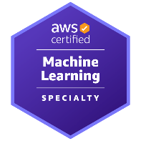
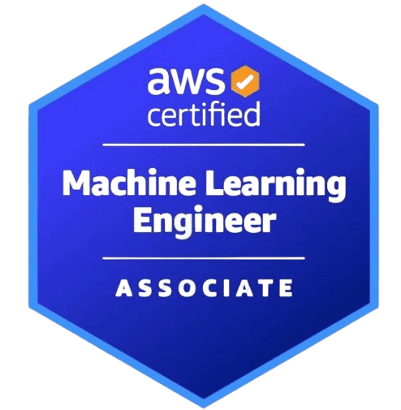
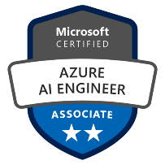
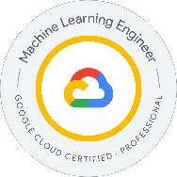
Venkata Hemanth N | AI&ML Engineer
venkatahemanthnelakurthy@gmail.com
(901) 515-1323
www.linkedin.com/in/venkata-hemanth-nelakurthy-092ab1276

Professional Summary
Innovative and results-driven AI & ML Engineer with 5+ years of extensive experience in designing, developing, and deploying enterprise-scale machine learning and deep learning solutions across finance and telecommunications industries. Currently at Goldman Sachs, leading AI initiatives focused on risk prediction, fraud detection, and automation using TensorFlow, PyTorch, Databricks, and Azure ML. Skilled in building robust MLOps pipelines with MLflow, Docker, and Kubernetes for continuous model delivery and monitoring. At Verizon, I contributed to developing predictive analytics and network optimization systems using PySpark, Kafka, and real-time data streaming architectures. Proficient in NLP, LLM fine-tuning, and feature store design for scalable AI applications. Passionate about transforming data into strategic insights, accelerating digital transformation, and driving measurable business impact through intelligent, data-driven decision systems.

Technical Skills:
AI & MACHINE LEARNING ENGINEERING | Predictive Modeling, Classification, Clustering, Ensemble Methods (XGBoost, LightGBM, CatBoost),  Deep Learning (CNN, LSTM, GRU, Transformers),  Feature Engineering, Time-Series Forecasting, Explainable AI (SHAP, LIME), Reinforcement Learning
NLP & GENERATIVE AI | LLMs (GPT-4, LLaMA, Mistral, Gemini, Claude),  Transformers (BERT, RoBERTa, T5, Sentence-BERT),  RAG Pipelines (LangChain, FAISS, Pinecone, ChromaDB),  Prompt Engineering, Fine-Tuning, Document Intelligence, Conversational AI
CLOUD, DATA ENGINEERING & MLOPS | AWS (SageMaker, S3, Lambda), Azure (ML, AKS, Data Factory), GCP Databricks, Airflow, Kafka, Delta Lake,  Docker, Kubernetes, MLflow, Kubeflow, DVC, Terraform, CI/CD
STATISTICAL & ANALYTICAL EXPERTISE | A/B Testing, Statistical Inference, Hypothesis Testing, Anomaly Detection,  Power BI, Tableau, Plotly, Dash, Streamlit
VISUALIZATION, DATABASES & COLLABORATION | Git, GitHub, Jira, Agile/Scrum, Technical Mentorship, Cross-Functional Collaboration
PROGRAMMING & SCRIPTING | Python (NumPy, Pandas, PySpark, Scikit-learn, TensorFlow, PyTorch, Keras),  SQL (PostgreSQL, MySQL, Snowflake, BigQuery),  Bash/Shell scripting for ETL and MLOps automation

Professional Experience:
Client: Goldman Sachs, NY July 2024 to Current
Role: AI&ML Engineer
Responsibilities:
- Built end-to-end AI/ML pipelines for financial modeling using PyTorch, TensorFlow, XGBoost, and Hugging Face Transformers on Databricks & Kubernetes.
- Developed GenAI & RAG frameworks with GPT, LangChain, LlamaIndex, FAISS for chatbots and document summary
- Automated MLOps workflows using MLflow, Kubeflow, Azure ML, and AWS SageMaker for model retraining, deployment, and monitoring.
- Orchestrated large-scale ETL and distributed model training using Airflow, Spark MLlib, Dask, and Ray on multi-terabyte datasets.
- Implemented model governance, drift detection, and validation using Evidently AI, Great Expectations, TensorBoard, ensuring Basel III & GDPR compliance.
- Fine-tuned domain-specific LLMs (FinBERT, Falcon, Mistral) for ESG, credit risk, and sentiment analysis with SHAP & LIME explainability.
- Built real-time fraud , risk detection systems leveraging Kafka, Flink, and autoencoder-based anomaly detection.
- Developed feature stores and semantic search pipelines using Feast, ChromaDB, and Sentence-BERT
- Applied time-series forecasting (LSTM, GRU, ARIMA, Prophet) for financial trends, asset risk, trading optimization.
- Deployed containerized ML workloads using Docker, Helm, Terraform, CI/CD pipelines; optimized GPU performance with RAPIDS & DeepSpeed.
- Applied advanced NLP for document intelligence, sentiment analysis, and financial report summarization.
- Conducted A/B testing, causal inference, and experiment design to validate models, optimize business decisions.
- Leveraged explainable AI (SHAP, LIME, Captum) to enhance transparency in trading and risk models.

Client: Verizon, NJ July 2023 to June 2024
Role: AI&ML Engineer Responsibilities:
- Built AI/ML solutions for network optimization, predictive maintenance, and churn reduction.
- Developed ETL/ELT pipelines using PySpark, Databricks, Kafka, Airflow for large-scale data.
- Created NLP and Generative AI systems with BERT, T5, GPT-4, Hugging Face for automation.
- Fine-tuned LLMs (LLaMA, Mistral, Gemini) with RAG pipelines (FAISS, Pinecone, ChromaDB).
- Applied computer vision models (CNN, ResNet, YOLO) for fault and anomaly detection.
- Implemented time-series forecasting (LSTM, GRU, Prophet, ARIMA) for network capacity planning.
- Built MLOps pipelines using MLflow, Kubeflow, DVC, Docker, Kubernetes, CI/CD.
- Deployed models on AWS SageMaker, Azure ML, GCP Vertex AI ensuring scalability and cost-efficiency.
- Designed feature stores and semantic layers for reusable ML components.
- Applied A/B testing, causal inference, SHAP, LIME for validation and model transparency.

Client: Honeywell, India Jan 2019 to June 2022
Role: Data Scientist.
Responsibilities:
- Built scalable data pipelines using Databricks, PySpark, Azure Synapse for IoT analytics.
- Developed predictive maintenance models with XGBoost, TensorFlow, PyTorch.
- Applied LSTM/TFT forecasting to optimize production and energy efficiency.
- Automated ETL and feature engineering via Airflow and MLflow.
- Designed anomaly detection using Autoencoders and Isolation Forests.
- Used NLP (Hugging Face, spaCy) for log analysis and root-cause detection.
- Built real-time analytics with Kafka and Spark Streaming.
- Deployed models using Docker, Kubernetes, and CI/CD pipelines.
- Ensured model governance and explainability with SHAP and LIME.
- Delivered AI solutions for industrial automation and energy platforms.

Certifications:
- Google Cloud Professional Machine Learning Engineer
- Microsoft Certified: Azure AI Engineer Associate (AI-102)
- MLA-C01 - AWS Certified Machine Learning Engineer - Associate
- AWS Certified Machine Learning – Specialty

Education:
MASTER OF SCIENCE IN INFORMATION SYSTEMS – University of Memphis

