PROFESSIONAL SUMMARY

- IT experience of 7+ years in software design, development, and implementation of various commercial applications in Workday and PeopleSoft.
- Have 6+ years of experience in HCM modules like Payroll, Benefits, Compensation, Time tracking, Recruiting and Absence Management.
- Experienced in Inbound/Outbound integrations Using Core Connector, EIB, Workday Studio, and Managing Business Processes and Experienced in implementing Custom, Packaged and Studio Integrations.
- Expertise in Report Writer, Creating Complex Workday Calculated Fields and Custom Reports.
- Expertise in PICOF (Payroll Integration Common Output File) and PECI (Payroll Effective Change Interface) Integrations along with Document Transformation.
- Configured and developed the Outbound payroll integrations for US, PR, Canada, EMEA, LATAM and APAC countries.
- Designed and involved in the Workday HR Systems Integration Testing process and development of UAT and End-to-End Test plans prior to deploying the integrations in production.
- Involved in Workday Payroll Implementation and Have Go-live/Hypercare experience.
- Experienced in ISU creation and Security Group Creation.
- Involved in Version Testing for the current and earlier Workday releases.
- Experience with C#, Python, Java, SQL, Eclipse, XML, XSLT and Web Services and Expert in designing/development of Interfaces with legacy and third-party systems.
- Defines Test Strategy and Test Approach. Manages the overall test project plan, defect management, issue resolution, and risk management.

KEY AREAS OF EXPERTISE

WorkdayHCM | Workday Integrations | Studio Integrations | Business Process Custom Reports | BIRT | Workday Security | XML | XSLT | Oxygen

OTHER TECHNICAL SKILLS

Workday skills : Workday HCM, PeopleSoft, Workday conversions, Workday Report Writer, iLoads, Core Connectors and Workday Studio.
Technologies/Tools : XML, XSD, XSLT, XPATH.
Web Services : XML, WSDL, XSD.

Document Processing : MS PowerPoint, MS Project, MS Visio, MS Web, MS Excel.
Databases : Oracle SQL, MYSQL, PL/SQL.
EDUCATION
Bachelor of Technology in Computer Science Engineering – JNTU, Hyderabad, India.
2012 to 2016.

TECHNICAL ENVIRONMENT

Workday HCM | Workday Integrations | Studio Integrations | Business Process Custom Reports | BIRT | Workday Security | XML | XSLT | Oxygen

PROFESSIONAL EXPERIENCE

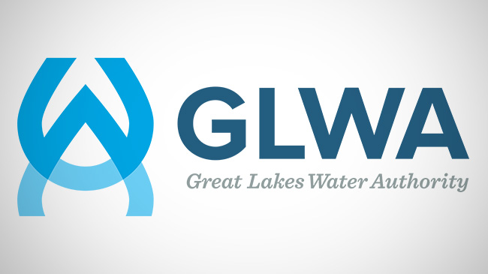
Workday Techno-Functional Developer | Great Lakes Water Authority, Detroit, MI
Sep 2022 – Till Now

- Achieved a seamless transition from Ceridian to Workday within the established timeline and budget.
- Enhanced HR operational efficiency and accuracy through the implementation of automated Workday workflows.
- Successfully mitigated risks and minimized downtime during the go-live phase, resulting in a smooth and efficient deployment.
- Oversaw end-to-end development efforts encompassing integration, reporting, data migration, testing, and deployment phases.
- Collaborated closely with business stakeholders to assess integration requirements, explore various options, and propose tailored solutions. Proficient in translating business rules and requirements into configurable setups within the Workday platform.
- Led a technical team dedicated to supporting integration processes, reporting functionalities, and addressing production issues within the Workday environment.
- Led End-to-End Workday Implementation: Spearheaded the comprehensive implementation of Workday, focusing on designing and testing benefit processes to ensure a seamless deployment.
- Cross-Functional Collaboration: Collaborated seamlessly across various teams to integrate and optimize the functionality of the Workday system, fostering smooth operations across departments.


Senior Workday Consultant | The Mosaic Company, Riverview, FL
Jun 2020 – Aug 2022

- Worked closely with the business to analyze the integration needs, research potential various options and recommend solutions. Have experience in converting the Business rules and requirements into Workday Configurations according to the client.
- Responsible for all development work including integration, reporting, data migration, testing and rollout.
- Lead the Technical team supporting Integrations, Reporting, and Production Issues in Workday.
- Designed and built inbound and outbound Integrations including Studio Integration and have experience in PICOF and PECI Integrations along with Document Transformation using XSLT.
- Expertise in analysis of client's Payroll business needs through client working sessions and day-to-day support of Workday Core HCM, Benefits, Security, Recruiting, Compensation and Reporting issues.
- End-to-end (E2E) Workday Payroll Implementation along with one Background checks integration implementation.
- Developed several custom reports using Workday Report Writer and Workday Studio BIRT.
- Involved in Version Testing for the current and earlier Workday releases.
- Worked on Domain security policy change control and security policy change control.
- Created workday user group to assign to integrations instead Particular User.
- Coordinate with design, development, and testing teams. Responsible for creating UAT conditions.


PeopleSoft Consultant | HTC Global Services, Hyderabad, India
Aug 2016 – Jan 2019

- Involved in development, enhancement, upgrade and maintenance of HR, benefits.
- Part of Early Engagement/Strategic team streamlining projects and determining appropriate approach.
- Administration, employee and manager self-service, E benefits, NA payroll, and time & labor.
- Involved in Install PeopleSoft 9.0 HRMS, People Tools 8.50 demo database.
- Trained HR Operations Team members in effective and consistent PeopleSoft application of operational practices.
- Interacted with key staff to understand current and future business needs for PeopleSoft; provided functional consulting.
- Implemented conversion of data from legacy System to PeopleSoft Application database by using SQL Loader, Import Manager and by writing SQR programs.
- Created and maintained documentation of all changes in the upgrade process.
- Worked on development of technical and functional spec for Payroll and Time & Labor processes.
- Provided data conversion/migration requirement documents and templates for HR/Financial systems.

Technical Environment: PeopleSoft HRMS, People Tools, Application Engine, Component Interface, SQR, SQL

