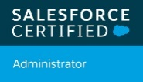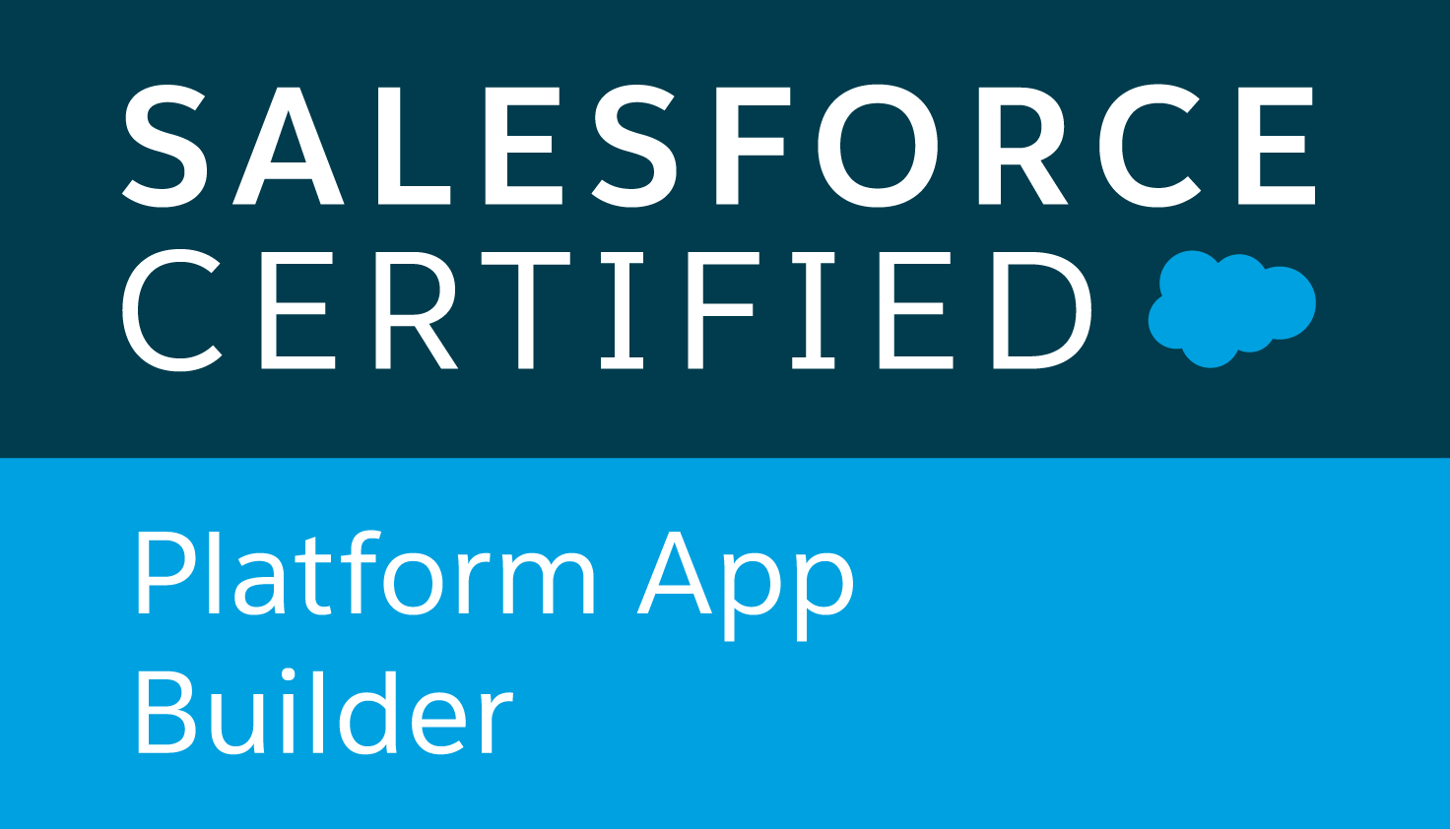
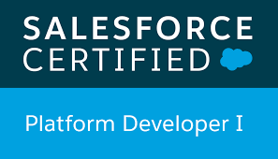
Sai Pavan K
Salesforce Developer

5018301833
 spavank226@gmail.com
OBJECTIVE:
Experienced Salesforce Developer with 6+ years in Salesforce development and administration, skilled in Apex, Visualforce, and Lightning Component Framework, aiming to drive seamless CRM solutions and enhance customer engagement.
PROFILE SUMMARY
- Proficient in Apex and Visualforce development for creating custom functionalities and enhancing user experience.
- Skilled in Lightning Component Framework and Lightning Web Components (LWC) for modern UI development and enhanced performance.
- Extensive experience in Salesforce API integrations, including REST and SOAP APIs, for seamless connectivity with third-party systems.
- Hands-on knowledge of Salesforce Object Query Language (SOQL) and Salesforce Object Search Language (SOSL) for efficient data querying and retrieval.
- Strong expertise in Salesforce Security models, including profiles, roles, permissions, and sharing rules for ensuring data confidentiality.
- Experienced in Salesforce Flows and Process Builder for creating declarative automation and optimizing business processes.
- Knowledgeable in Salesforce DX (Developer Experience) for version control, modular development, and continuous integration.
- Experienced with Apex Triggers to automate complex business logic and enforce data integrity.
- Proficient in Change Sets, ANT Migration Tool, and Salesforce for seamless deployment and environment management.
- Skilled in data migration techniques, including Data Loader and Salesforce Data Import Wizard, for transferring data across environments.
- Familiar with JavaScript and HTML/CSS for developing and customizing Salesforce pages and Lightning components.
- Experienced with Custom Objects, Fields, Page Layouts, and Record Types for effective data modeling and organization.
- Strong understanding of Salesforce Communities for building customer-facing and partner-focused portals.
- Proficient in Governor Limits management, ensuring optimized performance within Salesforce’s multitenant environment.
- Skilled in App Exchange package installation and configuration to extend Salesforce capabilities and support client requirements.
- Proficient in Salesforce Shield for enhanced security, including Event Monitoring and Field Audit Trail, to safeguard sensitive data and meet compliance standards.
- Skilled in developing Custom Metadata Types and Custom Settings for storing application-level configurations, promoting flexibility and reusability across Salesforce environments.
- Experienced in Salesforce Optimizer and Health Check tools for identifying and addressing performance bottlenecks, improving overall system efficiency and security.
- Knowledgeable in Apex Batch Processing and Scheduled Jobs for handling large volumes of data and automating recurring tasks within Salesforce.
EDUCATION
- Masters in Computer Science from University of Arkansas at Littlerock, USA
TECHNICAL SKILLS
- API Integration: REST APIs, SOAP APIs, Bulk API, Streaming API, OAuth, SAML, Web Services
- Data Migration Tools: Salesforce Data Loader, Talend, Jitterbit, Informatica, MuleSoft
- Middleware: MuleSoft, Dell Boomi, Heroku Connect
- SDLC: Agile, Scrum, Collaborative and waterfall.
- Version Control & Deployment: Salesforce DX, Git, Bitbucket, Jenkins, ANT Migration Tool
- CI/CD & Automation: Jenkins, GitLab CI/CD, CircleCI, Automated Unit Testing, Test Classes
- Database & Query Languages: SOQL, SOSL, SQL
- Authentication & Security: SSO, OAuth 2.0, SAML, Salesforce Shield, Encryption
- ETL Tools: Informatica, Jitterbit, Talend, MuleSoft, Apache Camel
- Data Management: Data Loader, Import Wizard, Shield Platform Encryption, Field History Tracking
- Integration Platforms: MuleSoft, Dell Boomi, Informatica Cloud, AWS Lambda (for custom integration)
- Salesforce Admin Tools: Custom Objects, Profiles, Permission Sets, Sharing Rules, Role Hierarchies
- Cloud Platforms: Salesforce Platform, Heroku, AWS (for integration)
- DevOps Tools: Jenkins, Git, Bitbucket, ANT, CircleCI for continuous deployment
- Reports & Dashboards: Custom Reports, Dashboards, Report Types, Reporting Snapshots
- Salesforce CRM: Salesforce Classic, Salesforce Lightning, Salesforce Service Cloud, Sales Cloud
- Programming Languages: Apex, Visualforce, SOQL, JavaScript, HTML5, CSS, Excel
- Front-End Development: Lightning Web Components (LWC), Aura Components
- Salesforce Automation: Process Builder, Flows, Workflows, Approval Processes, Validation Rules.
WORK EXPERIENCE
Occidental Petroleum Corporation, Houston, Texas, USA| Salesforce Developer| May 2023 – Present
OBJECTIVE: Occidental Petroleum Corporation (Oxy) is a major international energy company specializing in the exploration and production of oil and natural gas. I am focusing on customizing and developing Salesforce solutions to streamline energy and resource management processes, leveraging Apex, Visualforce, and Lightning Web Components (LWC) to enhance operational efficiency and support company-wide CRM initiatives.
Key Responsibilities and Achievements:
- Create tailored Salesforce solutions using Apex, Visualforce, and Lightning Web Components (LWC) to support energy operations and optimize workflows.
- Design and implement data integrations with Salesforce APIs (REST, SOAP) to connect with external energy data sources and internal systems.
- Leverage Salesforce Process Builder, Flows, and Apex Triggers to automate business processes and streamline operational tasks.
- Use Lightning App Builder to design and deploy custom applications that enhance user experience and align with Occidental’s unique requirements.
- Utilized Java and Visual Studio to develop and debug applications, integrated with Azure cloud services, managed tasks and workflows in Jira, and implemented e-signature solutions using DocuSign.
- Create real-time, customized reports and dashboards to provide insights on resource management and operations for decision-makers.
- Implement validation rules, duplicate rules, and data enrichment practices to maintain high data accuracy and integrity.
- Use CI/CD tools such as Jenkins and Git to manage code deployments and version control, ensuring smooth release cycles.
- Monitor and optimize Salesforce performance by identifying bottlenecks and implementing best practices to ensure system efficiency.
- Leveraged problem-solving and analytical skills to collaborate effectively with cross-functional teams, fostering strong interpersonal relationships to achieve project objectives.
- Work with IT and data teams to integrate Salesforce with on-premises and cloud platforms such as AWS for comprehensive data access.
- Excel analysis aids backend development, unit test creation, user requirement validation, troubleshooting, and comprehensive test development.
- Follow best practices for Salesforce development, including governor limits, coding standards, and efficient SOQL queries.
- Ensure all Salesforce configurations meet compliance requirements, such as SOX, relevant to the oil and gas industry.
ENVIRONMENT: Apex, Visualforce, Lightning Web Components, APIs, REST, SOAP, JSON, XML, Apex Triggers, Lightning App, Lightning App, CI/CD, Jenkins, Git, Salesforce, AWS, SOQL.
Comerica Bank, Dallas, Texas, USA| Salesforce Developer| May 2022– Apr 2023
OBJECTIVE: Comerica Bank is a prominent financial institution offering a wide range of financial services include retail banking, business banking, wealth management, and mortgage services. I designed and implemented custom solutions on the Salesforce platform to enhance CRM functionalities, including creating Apex triggers, Visualforce pages, & Lightning components.
Key Responsibilities and Achievements:
- Developed custom Salesforce applications using Apex, Visualforce, and Lightning Components to meet business requirements.
- Implemented data integrations between Salesforce and external systems using REST API and SOAP API.
- Customized Salesforce standard objects, including Accounts, Contacts, and Opportunities, to meet business workflows.
- Built and optimized Apex classes and triggers for automation and business logic execution.
- Developed custom Lightning Web Components (LWC) to enhance the user interface and improve end-user experience.
- Configured and customized Salesforce Service Cloud and Sales Cloud to streamline customer service and sales processes.
- Integrated Salesforce with third-party applications using middleware tools like MuleSoft and Dell Boomi.
- Designed and deployed Salesforce Reports and Dashboards to provide actionable insights and data-driven decisions.
- Utilized SOQL and SOSL queries to retrieve and manipulate data from Salesforce objects efficiently.
- Conducted data migration using Data Loader and Workbench to transfer legacy system data to Salesforce.
- Built and maintained complex workflow rules, process builder, and Flow automation to ensure business processes are streamlined.
- Configured permission sets, profiles, and sharing rules to enforce data security and ensure proper access controls.
- Performed unit testing and regression testing to ensure the stability and functionality of the Salesforce applications.
- Used Git and Jenkins for version control and continuous integration to manage code deployments in Salesforce.
- Monitored and optimized Salesforce Lightning performance to ensure a smooth and efficient user experience.
ENVIRONMENT: Salesforce, Apex, Visualforce, Lightning Components, REST API, SOAP API, Apex classes, triggers
MuleSoft, Dell Boomi, SOQL, SOSL, Data Loader, Git, Jenkins
Max Life Insurance, Bangalore, India| Salesforce Admin/ Developer | Nov 2019 – Dec 2021
OBJECTIVE: Max Life Insurance is one of India's leading life insurance companies, offering a wide range of individual and group life insurance solutions. My role is to managing system integrations, configuring workflows, and optimizing CRM processes to enhance sales, customer service, and operational efficiency, ensuring alignment with business objectives.
Key Responsibilities and Achievements:
- Design and implement custom Salesforce applications using Apex, Visualforce, and Lightning components to meet business requirements.
- Configure Salesforce objects, fields, record types, page layouts, and validation rules to tailor the CRM to business needs.
- Manage data imports/exports, data quality, and ensure efficient data migration using tools like Data Loader and Dataloader.io.
- Integrate Salesforce with external systems using REST/SOAP API, middleware tools like MuleSoft and third-party integrations.
- Utilize Change Sets, Salesforce DX, and Git for version control to manage code deployments across environments.
- Integrate Salesforce with marketing tools like Pardot to streamline lead generation, nurturing, and campaigns.
- Manage Salesforce licenses, subscriptions, and renewals for users and integrations, ensuring cost efficiency and compliance.
- Experience in Pardot application designing, enhancements, building, validations and deployments.
- Conduct Salesforce Health Checks, monitor system performance, and implement best practices to ensure optimal platform performance.
- Set up and manage Service Level Agreement (SLA) monitoring within Salesforce to track and ensure timely responses to client requests and claims.
- Acted as Pardot systems Administrator by maintaining data with Pardot, including but not limited to assigning user permissions, User management, role creation, and group configuration for Pardot business users.
- Develop and implement custom workflows specific to the insurance industry, such as underwriting approvals, policy issuance, and claims management.
- Regularly audit Salesforce data and user activity to ensure compliance with industry regulations, such as GDPR and insurance regulatory standards.
- Leverage Salesforce Einstein for advanced analytics and AI-driven insights into customer behavior and business performance
- Configure Salesforce for multi-currency and multi-language support to accommodate Max Life’s international operations and diverse customer base.
- Write Apex test classes to ensure code quality, and manage deployments using Salesforce DX, Git, and other tools to promote code from sandbox to production environments.
- Develop custom Lightning pages and apps for a seamless user interface tailored to the insurance business needs.
- Implement and manage Salesforce Platform Events to enable event-driven architecture and integrate real-time data into the CRM system.
ENVIRONMENT: Apex, Visualforce, Lightning, CRM, REST/SOAP API, MuleSoft, Salesforce DX, Git, Pardot, SLA, GDPR
, AI-driven insights, Apex test classes, DX, sandbox, Lightning pages.
Asian Paints Ltd, Bangalore, India| Salesforce Admin/ Developer | May 2018 – Oct 2019
OBJECTIVE: Asian Paints Ltd. is an Indian multinational company that specializes in manufacturing decorative paints, coatings, and related products. I involved in managing Salesforce environments, optimizing business processes implementing automation, ensuring data integrity, and providing end-user support.
Key Responsibilities and Achievements:
- Administer user profiles, roles, permissions, and licenses in Salesforce to ensure appropriate access control.
- Set up organization-wide default (OWD) sharing rules, roles, profiles, and permission sets to enforce data security and privacy.
- Customize Salesforce objects, page layouts, fields, and record types to tailor the CRM to business requirements.
- Develop and maintain custom reports and dashboards to provide actionable insights into business performance.
- Developed the Lightning pages with the needed UI designs. Performing the UI related activities including Page layout configuration. Ability to perform some Sales force administrative tasks and maintenance like user creation, etc
- Worked on the Web Services for enabling the data to be used outside the domain. Integration with SAP, Oracle and Tibco.
- Made the configurations in the applications time to time as per the requirement gathering.
- Experience on Salesforce migration from Classic to Lightning, Apex classes, Workflows, triggers, Aura platform, batch process, extension, controllers. Experience on Salesforce Lightning Utility Bar and Working Version Control tool Bitbucket.
- End to end flow of Sales Order Management for clients, including refunds, returns and reshipping.
- Working on Continuous Integration tool Bamboo.
- Experience working across various SFDC implementations covering Sales Cloud, Service Cloud, and Call center.
- Involved in Working with Standard Salesforce features like Objects, Workflows, Record Types, Page layouts, Workflow Rules, Case Assignment Rules, and Escalation rules, Validation rules, Profiles, Roles, Reports, and Dashboards etc.
- Experience on Salesforce Lightning UI using Aura Components and LWC. Experience on Salesforce Lightning Communities and Audience settings. Experience on Salesforce Lightning experience on creating reports.
- Used SOQL&SOSL with consideration to Governor Limits for data manipulation needs of the application using platform database objects. Preparing the documentation of the project and excellent communication skills.
Environment: OWD, CRM, UI, SAP, Oracle, Tibco, Aura, Bitbucket, Bamboo, Salesforce Lightning, SOQL&SOSL, SFDC.

