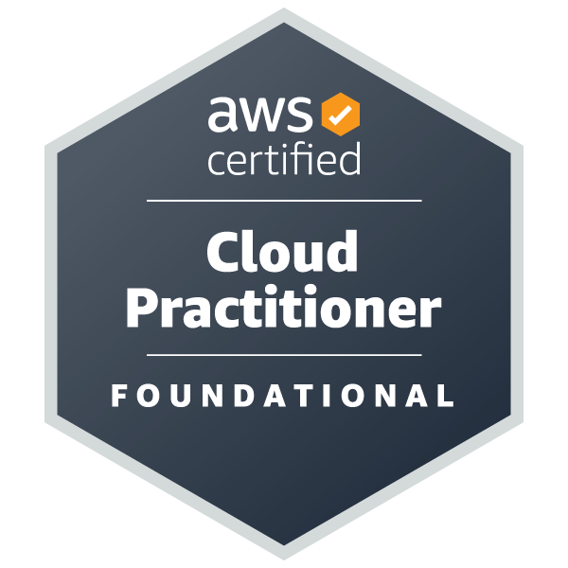
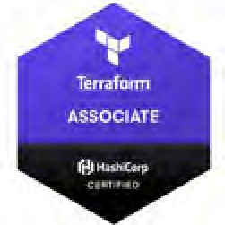
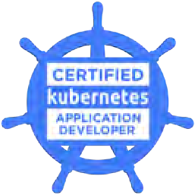
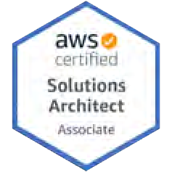
Ajith Jeevarathinam
4800 Printers way, Frisco, Texas-75033
Email-id: Ajithjeeva96@gmail.com Phone No: +1 (205) 370-8728

SUMMARY:
DevOps Engineer with 5+ years of experience delivering secure, scalable, and automated cloud infrastructure. Specialized in AWS, Terraform, Kubernetes, and CI/CD pipelines, with a strong focus on reliability, cost optimization, and deployment speed. Proven impact includes a 20% drop in downtime, 25% cloud cost savings, and 30% faster issue resolution.

SKILLS:
- Infrastructure as Code: Terraform, CloudFormation
- Container & Orchestration: Docker, Kubernetes
- Continuous Integration Tools: Jenkins
- Cloud services: Amazon Web Services (AWS)
- Scripting Languages: Bash, Python
- Monitoring & Logging: Prometheus, ELK Stack

PROFESSIONAL CERTIFICATIONS:
- AWS Certified Solution Architect - Associate
- AWS Certified Cloud Practitioner
- Certified Kubernetes Application Developer (CKAD) – Linux Foundation
- HashiCorp Certified: Terraform Associate

WORK EXPERIENCE:

August 2024 Till Date DEVOPS ENGINEER Home Depot, Dallas, TX
- Automated end-to-end CI/CD pipelines using Jenkins and Maven, accelerating release cycles.
- Provisioned scalable EKS clusters and VPC via Terraform, cutting infrastructure setup time by 60%.
- Orchestrated and scaled containers using Docker and Kubernetes, enhancing deployment reliability.
- Created environments for Analytics/ML team to use tools like Airflow, RStudio Workbench.
- Maintained Red Hat OpenShift clusters, minimizing outages and supporting platform stability.
- Designed and deployed scalable cloud applications using AWS services and Infrastructure as Code (IaC) tools, including EC2, S3, Route53, and Lambda—resulting in improved performance and reduced operational costs.

October 2022 to July 2024 DEVOPS ENGINEER StateFarm, Bloomington, IL
- Led production releases for StateFarm mobile apps, ensuring 99%+ deployment success rate across iOS/Android platforms.
- Collaborated with Product, Dev, and QA teams to streamline delivery in a Continuous Delivery setup.
- Managed SCM, CI/CD, artifact, and change tools, improving release reliability by 20%.
- Enforced Kubernetes network policies to secure container traffic.
- Automated artifact and release flows using Jenkins, improving cross-team delivery speed.

October 2021 to September 2022 AWS SUPPORT ENGINEER Xbiome, Boston, MA
- Built pipelines using CodePipeline, ECS and CloudFormation, cutting deployment effort by 30%.
- Configured S3 versioning and lifecycle rules, reducing storage costs by 20%.
- Created serverless workflows with Lambda and Step Functions, streamlining backend automation.
- Automated infra tasks using AWS CLI and Python, improving operational efficiency.
- Integrated Prometheus for metrics collection and alerting, improving system observability and proactive issue detection.

June 2021 to October 2021 DEVOPS ENGINEER Humana, Louisville, KY
- Led cloud infrastructure automation for healthcare applications hosted on AWS/GCP/Azure, ensuring HIPAA compliance and high availability across multiple environments.
- Built and managed CI/CD pipelines using tools like Jenkins, GitLab CI/CD, or Azure DevOps, accelerating deployment cycles by 40% while ensuring zero-downtime releases.
- Implemented Infrastructure as Code (IaC) using Terraform and Ansible, enabling consistent environment provisioning and reducing manual configuration drift across dev/test/prod.
- Developed automated monitoring and alerting systems using Prometheus, Grafana, ELK Stack, and CloudWatch, improving incident response time by 50%.

EDUCATION
- Aug 2019- May 2021 Master of Science in Data Science University of Alabama Birmingham, USA
- Aug 2013-May 2017 Bachelor of Technology in Information Technology Anna University, India

