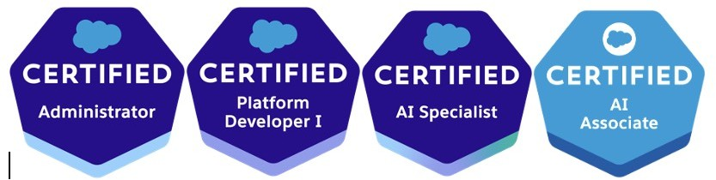
Kiran B
Email: kiranb2707@gmail.com
Mobile: +12252304491

Professional Summary:
- Salesforce Certified Platform Developer with 3.6 years of experience in Salesforce development, and Administration including configuration, customization, and Lightning development.

Skilled in Apex, SOQL, SOSL, Triggers, Lightning Aura Components, and Lightning Web Components (LWC).
- Experience in customizing standard objects (Accounts, Contacts, Opportunities, Cases, Leads) and building custom objects, fields, relationships, workflows, validation rules, and approval processes.
- Strong understanding of security and access controls at the object, field, and record level.

Proficient in SOQL/SOSL queries, sandbox testing, deployments, and Agile methodologies.
- Experienced in Reports and Dashboards to provide business insights and data visualization.
- Comfortable working with business users to gather requirements and implement Salesforce solutions that align with business needs.
- Quick learner, strong team player, and effective communicator with a problem-solving mindset.

Education:
MS in Computer Science, Southern University, Baton Rouge, LA.
Bachelor of Technology from JNTU Hyderabad, India.

Technical Skills:
Salesforce Technologies | Apex Language, Apex Classes, Sales force CRM, Classes/Controllers, Apex Triggers, SOQL, SOSL, Experience cloud, Lightning aura components and Lightning web components.
Sales force Tools | Force.com, vs studio.
Web Technologies | HTML, CSS, Java Script, XML, HTML5, XML, JSON, MS Office
Database | MS SQL, SOQL, SOSL

CERTIFICATIONS
- SALESFORCE ADMINISTRATOR
- SALESFORCE PLATFORM DEVELOPER
- AI SPECIALIST
- AI ASSOCIATE
Professional Experience: 2022 August – 2023 April
Client: TDI
Project: TDI Compliance Role: Salesforce Developer Description:
TDI provides the hidden and overlooked information companies need to make sound decisions. TDI global investigators and analysts use a proven intelligence gathering methodology combined with decades of private sector experience to deliver actionable insight into your enterprise risk. Whether advising on programmatic third-party compliance programs or executing a commercial engagement program designed to mitigate investment risk.

Roles & Responsibilities:
- Created various Custom Objects and defined lookup, Picklist, master-detail relationships, and rollup Summary between those objects. Also created junction objects to establish connectivity among objects.
- Worked on community builder and app builders.
- Used Automation tools like Workflow rules and flow to automate business processes.
- Create the Lightning Web Component as per business requirement.
- Writing test classes to improve the code coverage for existing classes.
- Written triggers for different case scenarios to handle the different DMLs.
- Written test classes for triggers, apex controllers and for different APIs.
- Worked on Deployment using GearSet.

Client: Schneider Electric 2021 March – 2022 August
Project: Bridge Front Office - Sales Role: Salesforce Developer Description:
Schneider Electric SE is a European multinational company that specializes in digital automation and energy management. It addresses homes, buildings, data centers, infrastructure, and industries, by combining energy technologies, real-time automation, software, and services.

Roles & Responsibilities:
- Worked on Flow Builder, Validation Rules, and Sharing Rules.
- Implemented customization through Apex Classes, Triggers, Lightning Web Components.
- Good knowledge and hands-on experience in Force.com platform, Apex Coding, Triggers.
- Implemented Batch apex, schedule apex based on business requirement.
- Worked on Rest Api and Test Classes.
- Custom metadata type creations and usage.
- Defined Lookup and master-detail relationships on the objects.
- Writing test classes to improve the code coverage for existing classes.

Client: Ken42 EdTech Private Limited 2019 November – 2021 February
Project: Turbo start(ken42) Ed-tech Role: Salesforce Administrator Description:
It’s an Ed-Tech company which provides an end-to-end platform to educational institutions to manage their entire Student-faculty life cycle.

Roles & Responsibilities:
- Written validation rules, formula fields, and implemented security settings to maintain data accuracy and system integrity.
- Created reports, dashboards, and custom buttons, links, and actions for enhanced user experience and insights.
- Utilized automation tools such as Workflow Rules, Process Builder, and Flow to streamline and automate business processes.
- Designed and implemented Custom Objects, Record Types, and Page Layouts tailored to business requirements.
- Defined Lookup and Master-Detail relationships to establish data hierarchy and relationships between objects.
- Managed user profiles, roles, and permission sets to ensure appropriate access controls.
- Conducted data imports, deduplication, and validation to ensure data quality and consistency.
- Configured and maintained AppExchange applications to extend Salesforce functionality.
- Provided training and support to end-users to improve adoption and system usage.
- Collaborated with stakeholders to gather requirements and deliver scalable Salesforce solutions.

