Rupali Telang
Mobile: 952-846-9133 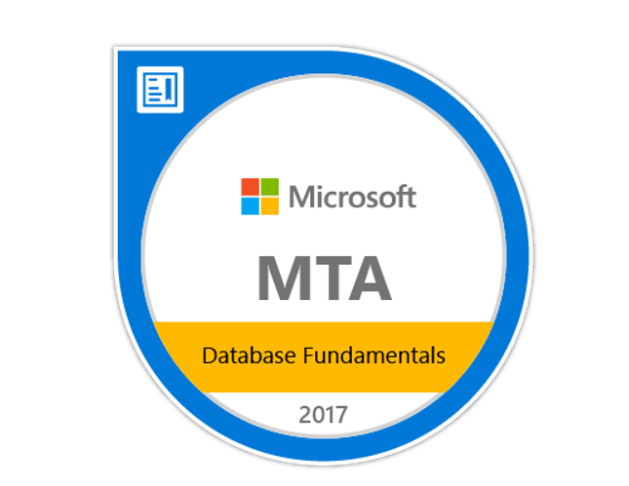

Experienced in Strong analytics, critical thinking and problem-solving skills Involved in the entire development lifecycle helping to define requirements, development and implementation of software projects with hands on experience in SQL Server and Visual Basic .net.

TOOLS/METHODS:
- Visual Studio VB 6.0 & VB.NET 2017/19/22, MVC, ASP.NET, Vue JS
- SQL Server 2017/2012/2008 R2
- Integration Services (SSIS)
- Reporting Services (SSRS)
- VueJS
- Dell Boomi
- Master Data Services(MDS)
- MS Office Suite Professional
- Waterfall/Agile Methodology
- XML, HTML, CSS, TypeScript, JavaScript

EDUCATION:
Master’s in Computer Application (MCA)
Bachelor’s in Computer Science (BS)

PROFESSIONAL EXPERIENCE:
Senior Software Developer Mar 2017 - Present
R&D Systems Inc. (Bio-Techne)

R&D Systems, a Minnesota-based biological products company. Bio-Techne. The use of Bio-Techne will bring the company’s R&D Systems, BiosPacific, Tocris Biosciences, Boston Biochem and Bionostics products under one common brand name.

- Working as a Software developer in .net and created windows and Web application as per business requirement.
- Created APIs using .net web API and Azure Logic Apps.
- Used VueJS for designing UI.
- Created project related Stored procedures and views.
- Created project related SSRS reports and SSIS packages.
- Worked in Master data services to create Models and different entity.
- Integrate 2 system using Dell Boomi.
- Maintain Legacy systems.

Environment: SQL Server 2017, Reporting Services (SSRS), VB.Net, T-SQL, XML, MS Visual Studio 2017/2019, MDS, Dell Boomi, Logic Apps, Vue.JS, Data Factory

Application Development Engineer May 2010 - Aug 2015
Bhatia International Ltd., India

Bhatia international Ltd. is a trading company, which purchase coal from foreign countries and distribute it world-wide.

- Worked as Application Developer for data analysis for in-house purchasing and trading and HR application for the Bhatia International consisting of window based and web based applications
- Lead in creating functional requirements, high level software design and transform it into real application
- Lead the team of two in completing the functionalities as per the project requirements.
- End to end Production support and maintenance of the existing application
- Resolution of the production defects and incidents for the business applications
- Development of new functionalities utilizing Visual Studio 2012 VB.NET application and SQL 2012 backend
- Developed and Optimized Stored Procedures, Views, and User-Defined Functions for the Application
- Generated periodic reports based on the statistical analysis of the data from various time frame and division using SQL Server Reporting Services (SSRS)
- Developed various operational Drill-down reports using SSRS
- Developed different kind of reports such a Sub Reports, Charts, Matrix reports, Linked reports.
- Comfortable in writing Unit/System testing Test Cases and preparing Test Data

Environment: SQL Server 2008/2012, Reporting Services (SSRS), VB.Net, T-SQL, XML, MS Excel/Access, MS Visual Studio 2008/

