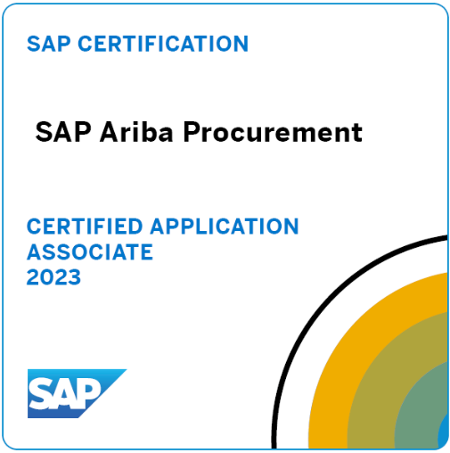
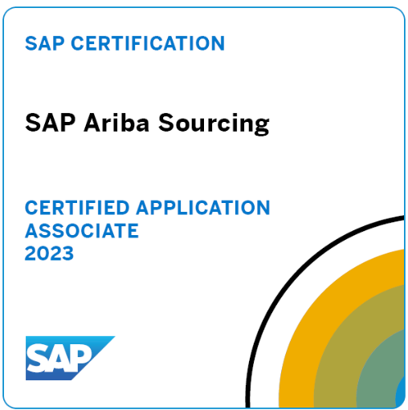
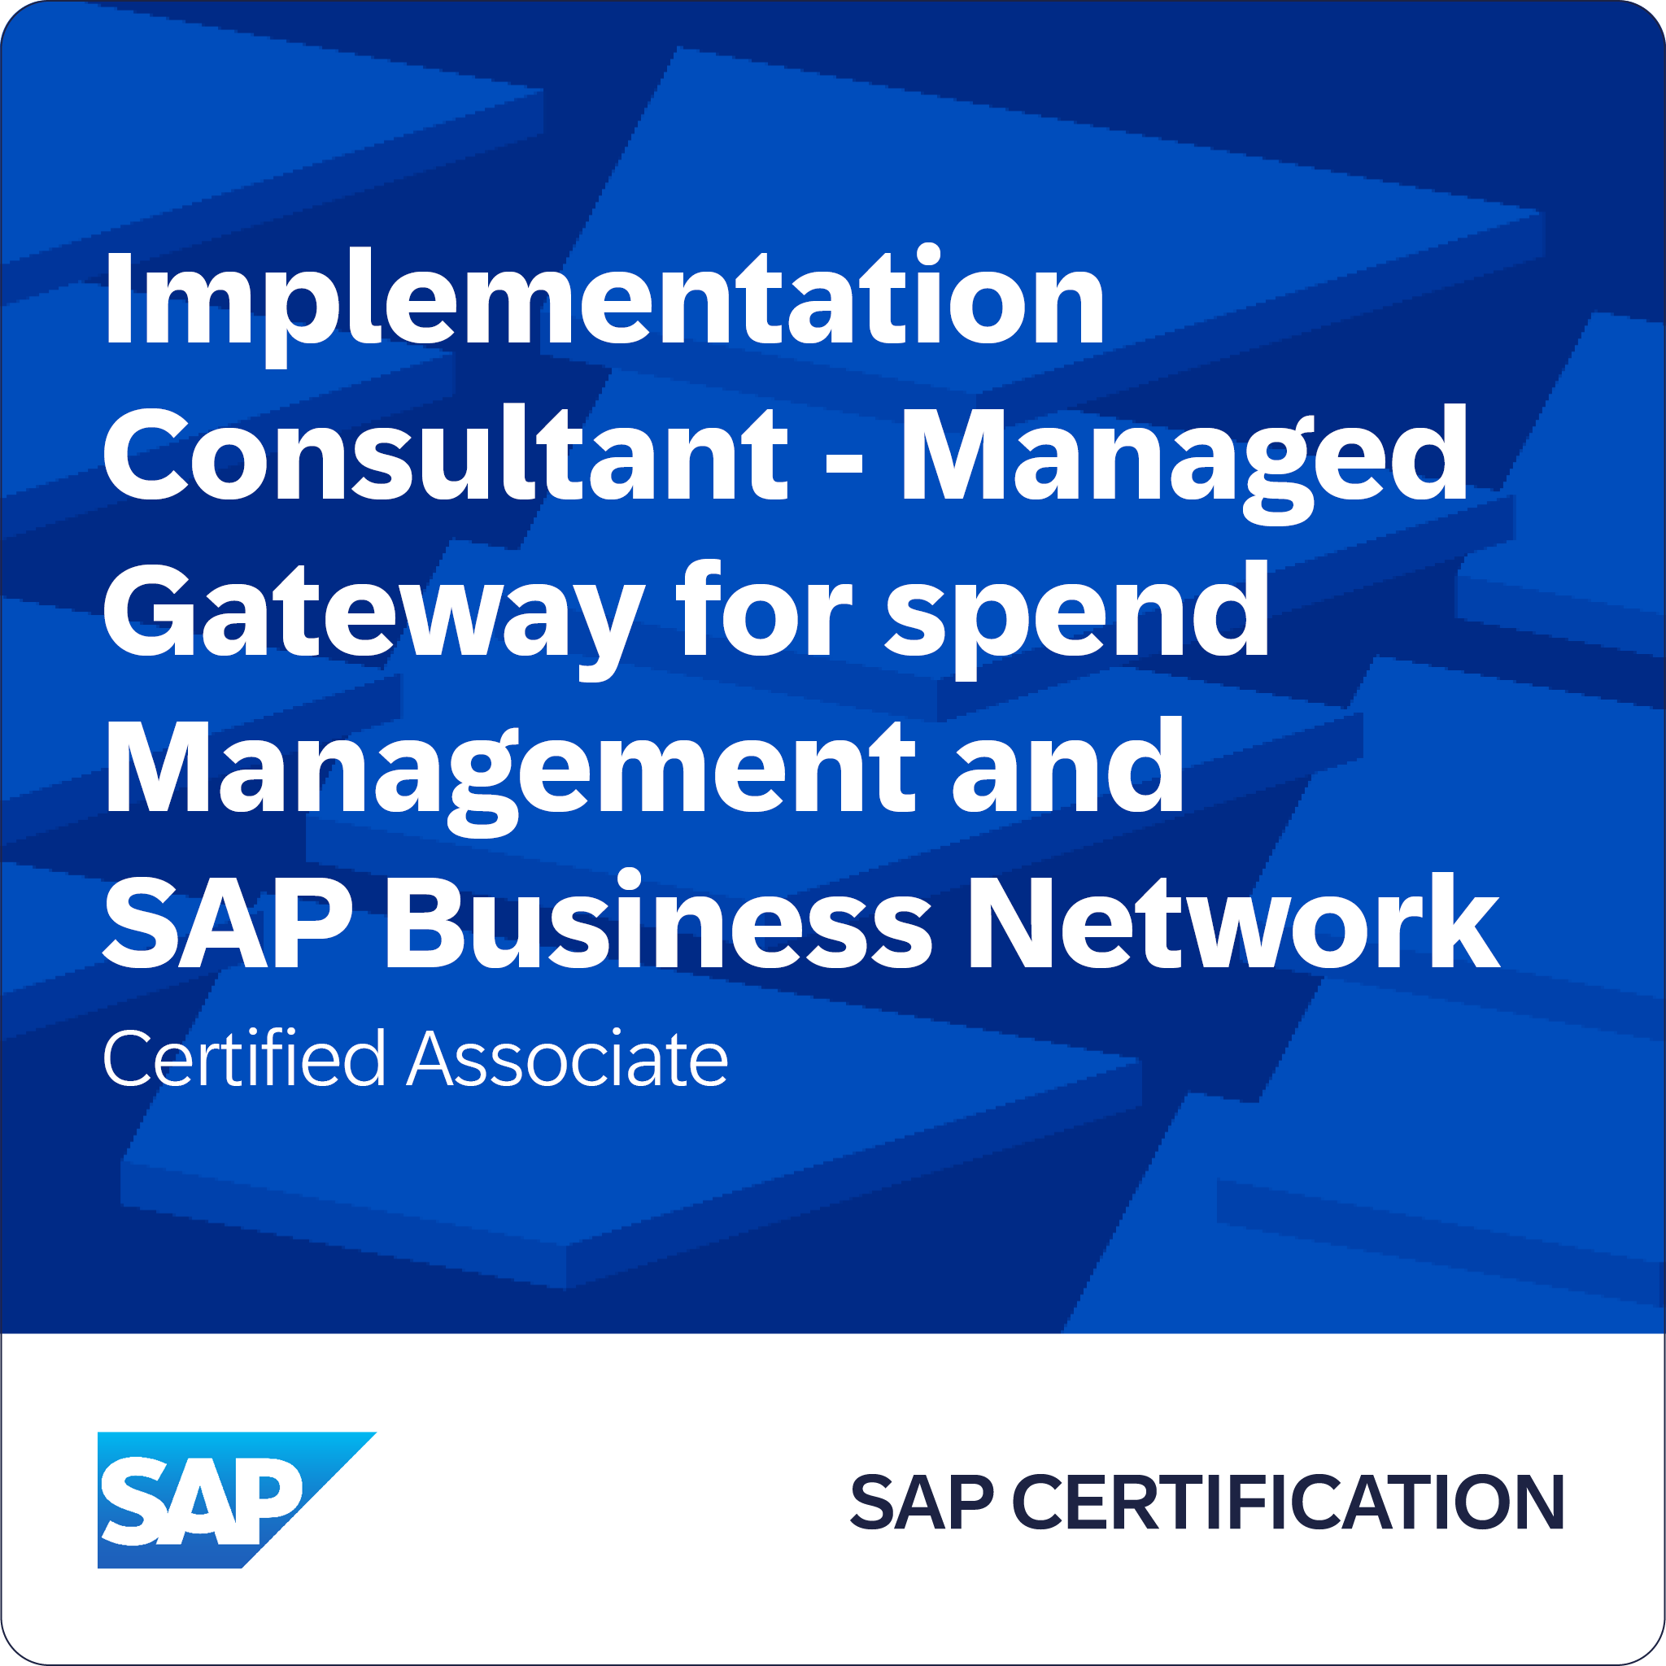
Sairam Brigumalla
SAP ARIBA Pricipal Consultant

Summary:
Certified ARIBA Professional with 16+ years of expertise in System Analysis, Design, Development, Implementation, Customization, Upgradation, and Production Support for business applications, including Ariba Upstream & Downstream solutions (SLP, S2C, P2P & Ariba CIG), SRM, and S/4HANA across diverse industries such as Oil & Gas, Automotive, and Pharma.

Proficient in S/4HANA migrations from ECC using Central Finance (Key Mapping & Value Mapping) and Supplier Master Data Integration between MDG, S/4HANA, and Ariba Buying. Successfully delivered one End-to-End Implementation and multiple support projects.

Ariba & S/4HANA Expertise:
- Extensive experience in Ariba S2C, P2P module integration, including build, testing, implementation, and support.
- Hands-on expertise in Ariba implementation, customization, and system integrations with third-party applications.
- Strong requirement gathering & analysis for rollouts, enhancements, and new business demands.
- Implemented a complete P2O solution for indirect commodities using Ariba & ERP systems.
- Led supplier two-way integration between SLP and MDG for a unified vendor data model via Business Partner Suite Replicate Request Web Service.
- Developed automated supplier partitioned data uploads from S/4HANA (CPI) → CIG → Buying & Invoicing child realm.
- Expertise in automated master data uploads (Cost Center, WBS, Asset Master, and GL Master) from S/4HANA/ECC to Buying realms.
- Guided middleware teams (IPaaS/CIG) in WSDL field mapping updates between Ariba and S/4HANA/ECC.
- Integrated third party Tax Engine (OneSource) with Ariba and S/4HANA/ECC.
- Experience in Invoice reconciliation between AN supplier invoices and Buying
- Deep understanding of SAP-Ariba integration using Integration Toolkit (ITK) & SOAP Web Services.
- Expertise in Contract Management: Authoring, Compliance, and Operational Contracts.
- Skilled in Ariba Sourcing Strategies: Auction type selection, lot structuring, bidding rules, and RFx execution.
- Hands-on experience in e-auctions, supplier onboarding, and decision matrix-based supplier selection.
SAP SRM Expertise:
- Led SRM implementations for Self-Service Procurement (Classic, Extended Classic, and Decoupled), Supplier Self-Services (SUS), and Registration of Suppliers (ROS).
- Expertise in Two-Envelop Bidding, Procurement for Public Sector (PPS), and cFolder configuration.
- Hands-on experience with SRM 5.0, 7.0, and 7.02 implementations and upgrades.
- Conducted business workshops, gathered requirements, and delivered Blueprints, Gap Analyses, Solution Designs, System Configurations, Testing, and Training.
- Managed SRM upgrades from 5.0 to 7.0 and provided post-production support.

SKILLS
Procurement Tools: SAP Ariba Procurement (Buying & Invoicing | Guided Buying), SAP Ariba Strategic Sourcing, Contract Management & SLP, SAP SRM
ERP: SAP ECC, S/4 HANA, SAP MDM, MDG-BP, SAP MM
Others: SAP Solution Manager, HP ALM, Agile & Scrum Technology, Ariba API.

Certifications & Education
- SAP Ariba Procurement Certification.
- SAP Ariba Sourcing Certification.
- SAP Integration Suite, managed gateway for spend management and SAP Business Network.
- Bachelor’s in computer science & engineering from Jawaharlal Nehru Technological University (2006)
Technical:
- SAP ARIBA Integration - CIG, Ariba Network & Buyer Account Setups.
- SAP CVI, ABAP, BADIs, Troubleshooting.
PROFESSIONAL EXPERIENCE:

Client: Saudi Aramco Sept’24 to Till Date
Role: Lead Consultant
Scope: Implementation of Ariba Upstream (SLP, S2C & Sourcing) and Downstream (Buying & Invoicing, Guided Buying) modules, Ariba CIG.
Environment: SAP Ariba, S/4 HANA, SAP MDG-BP
Responsibilities:
- Managing regional responsibility for SAP design, including procurement and interfacing with new generation cloud-based systems such as Ariba Sourcing, CIG and Commerce Automation.
- Maximizing the business value and vision of the SAP Ariba S2C solution, providing functional expertise in configuring the identified business processes according to best practices and acting as lead for S2C implementation.
- Defining functional requirements for required integrations or specific solution developments. Capturing business needs and managing requirements, investigation and coordination in Support, Rollouts, Enhancements and Discovery phases.
- Evaluating and recommending solutions/way forward /options, performing tests for releases, enhancements and new features and facilitating global workshops cross-site.
- Handling & In charge of SAP Ariba Sourcing & commerce Automation solution implementation in testing & authoring of test cases creation in HP ALM.
- Organizing scoping and fit-gap workshops for projects and proposing solutions for key gaps that enhance project growth within agreed time, cost, and quality constraints.
- Initiating solution testing and ensuring the developed solutions are peer reviewed, formally documented, signed off by business, and meet quality standards.
- Implemented the custom mappings in Ariba Sourcing integration for Purchase order and Contract creation in backend S4 system.

Client: Becton, Dickinson May’23 to Sept’24
Role: Lead Consultant
Scope: Implementation of Ariba Upstream (SLP, S2C & Sourcing) and Downstream (Buying & Invoicing, Guided Buying)) modules, Ariba CIG Integration
Environment: SAP Ariba, S/4 HANA, HP ALM, MDG-BP
Responsibilities:
- Lead design discussions/workshops with the client in the area of Source to pay (indirect procurement).
- Support in delivering the latest innovative solutions like SAP Ariba (Buying & Invoicing with Guided Buying, Sourcing) and / or SAP S/4HANA Sourcing & Procurement.
- Translate business requirements into functional specifications.
- Perform required system configurations.
- Configured Ariba Supplementary realm and migrated the custom changes to Ariba production.
- Have technical and functional discussions with developers in order to provide the best solution for the client.
- Support clients with testing and deployment activities and manage challenging (fit to standard) client discussions.
- SAP Ariba Hyper care and post go live support experience.

Client: SIPCHEM Feb’23 to Jun’24
Role: Lead Consultant
Scope: Support of Ariba Upstream (SLP, S2C & Sourcing) and Implement Ariba CIG Integration with S4 HANA system
Environment: SAP Ariba
Responsibilities:
- Conducted workshops with the client, gathered requirements, and prepared the HLD documents.
- Configure the Ariba modules as per the Client requirements and deliver the Build to further phase for SIT and UAT.
- Integrating the SAP systems into the Ariba Upstream (SLP) and Downstream (P2P) through CIG.
- Created integration projects, configured the SAP system with the help of respective teams to establish the connection between Ariba - CIG - SAP system, and tested the transaction flows e.g.: PR, PO, and Receipt.
- Implemented and delivered the Ariba Buying and Commerce automation.
- Implemented the customizations for the Ariba Contract management and integrated with SAP backend system by implementing the custom mappings.
- Configured Ariba CIG routing such that Customer able to create transactions and send to backend systems S4 Hana and ECC at the same time.
- Configured Ariba APIs to integrate with 3rd party systems Eg Sail Point for data extractions from Ariba.
- In addition, Ariba Requisition Configured Budget Check Functionality through CPI integration to backend S4.

Client: Nomad Foods May’22 to Jan’23
Role: Lead Consultant
Scope: Implementation of Ariba Upstream (SLP, S2C & Sourcing) and Downstream (Buying & Invoicing, Guided Buying) modules
Environment: SAP Ariba
Responsibilities:
- Conducted workshops with the client, gathered requirements, and prepared the HLD documents.
- Configure the Ariba modules as per the Client requirements and deliver the Build to further phase for SIT and UAT.
- Integrating the SAP systems into the Ariba Upstream (SLP) and Downstream (P2P) through CIG.
- Implemented and delivered the Phase 2 Ariba Buying & Invoicing and Commerce automation.
- Implemented the customizations for the Ariba Contract management and integrated with SAP backend system by implementing the custom mappings.
- Configured the custom mappings in RFQ integration, Sourcing integration.

Client: Nokia US Jan’ 2019 to May’22
Role: Technical Specialist
Scope: Production support in both SRM and Ariba modules and implemented the business requirements. Worked on the cutover activities for the rollouts & country specific requirements.
Environment: SRM 7.0, Ariba S2C, P2P, SLP, Supplier qualification, risk management, MDG 2.0.
Responsibilities:
- Spearheaded the Design and development of various aspects of Ariba like approval rules, Scheduled tasks, Invoice exceptions, IR engine, Integration events, workflow changes, triggers in realms etc.
- Led seamless integrations between Ariba and external systems like SAP systems and client upstream tools APTTUS, 4Budget.
- Extensively worked on invoice processes like invoice pushes to Accounts Payable, invoice exceptions, IR engine
- Developed the logic to have different VAT rates for different purchases
- Assisted in Unit testing, System testing, System integration testing, User Acceptance testing (UAT) during implementation and rollouts.
- Guided middleware team in maintaining custom mappings for the interface Child1 – Azure IpaaS – ECC.
- Ariba Buyer: Purchase Requisition - Catalog/Non-Catalog, Purchase Order, Receipts
- Ariba Contract Compliance: Contract types, Release and without Release contracts, Receivable, Invoiceable contracts, Amount & Quantity contracts
- Ariba Invoicing: Standard invoice and Credit memo, ASN invoice, Invoice Entry, Invoice Exceptions.
- Supplier AN experienced in supporting handling orders& contracts/BPO’s and supplier invoices.
- Good knowledge or Approval Rules (Simple Rules, Chain Rules, Filter Rules, Constraint Rules), Scheduled tasks, Integration events

Client: Leo Pharma Denmark Jun 16 to Jan’19
Role: SAP SRM/Ariba Consultant
Scope: This project dealt with Rollouts of SRM, new developments and production support and service requests.
Environment: SAP SRM 7.01, ECC 6.0, SRM-MDM 7.1 and POC on Ariba P2P.
Responsibilities:
- Implemented Shopping cart approval process flow from SC cost centre person responsible.
- Configured SRM Org structure integration from HR Org structure.
- Configured the SRM Purchasing org and worked on the user integration issues.
- Configured SRM-MDM catalog integration and uploading the vendor catalogues to data manager.
- Requirements gathered from the LEO business for the rollouts.
- Implemented Country specific requirements.
- Involved in template designing for Supplier registration.
- Good Experience with Requisition Import via Ariba provided WSDL integrating with Legacy applications.
- I have good experience in the Catalog Load process within Ariba.
- Good Experience with Site/Plant, PGroup, and Commodity codes Setup in ECC and replication using ITK from ECC to Ariba.
- Master Data setup in general namely (WBS, Cost Center, Asset, Purchasing Groups, and Users, POrgs, and Company Codes etc.) for Downstream.
- Good Experience leading onsite and offshore teams in completing FUT/FIT/SIT Cycles both SAP and Legacy Systems related.
- Good Experience with resolving Ariba Integration issues eg: Supplier, Invoices over ASN and PO issues.
- Ariba Light (Quick) Enablement process and work closely with Ariba SS with setup etc.
- Supplier Enablement process and flight plan planning and design.
- Contract Management like drafting contracts and uploading documents.
- Conducted Trainings on RFxs (RFI, RFP, e-Auctions i.e. Forward Auction & Reverse Auction), Review Bids.
- Prepared Solution Design Document and Scenarios.
- Resolving and handling issues arrival during the deployment/implementation process.
- Providing input to the technical team involved in the integration whenever required.
- Testing and Designing end-to-end Procurement Cycle using different scenarios including SAP Ariba Supplier Lifecycle and Ariba Sourcing, Contract management.

Client: BMW Germany May’15 to Jun ’16
Role: SAP SRM Consultant
Scope: Production support for the BMW plants Berlin, Dingolfing, Eisenach, Goodwood, Hams Hall, Landshut, Leipzig, Munich, Oxford and Regensburg.
Environment: SAP SRM 7.01, ECC 6.0
Responsibilities:
- Processes BMW Shopping cart, Special process, Portal M and MDM
- BMW special process covers STARD, Everest and SBM, which are having more focus for the business.
- BMW plants have separate SAP ERP backend systems for each plant.
- Supporting day-to-day business and providing resolutions for the issues.
- Daily monitoring activities and informing the users for necessary actions
- Worked on new developments like changing shopping cart with versions and PR versions.
- Involved in making test plans for testing all custom processes and day-to-day user operations.
- Coordinated and supervised all user testing.
- Involved in making setups for SLA.

Client: Atos France Apr ’13 to May ’15
Role: SAP SRM Consultant
Scope: The project dealt with Ariba support for P2O scenario.
Environment: SAP SRM 7.0, ECC 6.0, and Ariba – P2O, Guided Buying, Internal and Punch-out Catalogs.
Responsibilities:
- Support provided on the daily issues on various business objects E.g., Purchase requisitions, Purchase orders and Receipts.
- Performing the ticket monitoring daily, response and resolution.
- Good Experience with working closely with Ariba Shared Services and the Ariba SR process.
- Organizing daily huddles for discussing the day-to-day issues with the team.
- Importing the Supplier organization, Suppliers, Supplier location contacts& supplements.
- Supported Ariba Catalogue issues
- Provided support on integration issues for the Ariba and ERP interface.
- Performed the Site manager activities including monitoring jobs.
- Worked on change requests raised by the users by providing estimations to the Global IT department and delivering the fix within scheduled time by receiving the acceptance of the test scenarios from GIT.

Client: British Petroleum UK Jun’11 to Mar’13
Role: SAP SRM Consultant
Scope: The Project dealt with production support, Version Upgrade, Rollouts and Enhancements.
Environment: SRM 7.01, ECC 6.0, SUS 2.0.
Responsibilities:
- The core responsibility is to analyze assigned tickets and provide satisfactory solutions for the tickets to the clients within the period.
- Support provided for mastering data maintenance, procurement and invoice verification.
- Supported daily issues with PO and POR.
- Coordinating with different teams for contract syndication issues from MDM to SRM.
- Daily monitoring activities were carried out and reporting the business within time with resolutions.
- Involved in data replication of Material and Vendor master and troubleshooting middleware issues.
- Supported various issues related to workflow for shopping cart and purchase orders.
- Resolved shopping cart transfer issues with integrated MM system.
- Strategic Sourcing and Alert Management were involved.
- Remote consulting for customers for resolving the issues for external requirement transfer to SRM in strategic procurement.
- Worked on the interface issues.
- Worked on PDP scenario and the grouping of requirements in SRM Sourcing cockpit.

Client: Nissan USA Nov’10 to May’11
Role: SAP SRM Consultant
Scope: Project deals with Production support and enhancements.
Environment: SRM 4.0, ECC 5.0.
Responsibilities:
- Analyzed the existing procurement process and gathered client requirements for the enhancements through client meetings.
- Created document types and maintained Approvers for shopping cart creation as per the business requirement.
- Standard background jobs BBP_GET_STATUS_2, CLEAN_REQREQ_UP has scheduled.
- Implemented program for updating the user positions in Organization Structure.
- Supporting the production issues and resolving them by interacting with the clients.
- Minor enhancements as per business requirements.

Client: SAP LABS Bangalore May’10 to Nov’10
Role: SAP ABAP Consultant
Scope: This project is mainly for the countries Brazil, France and India. For Brazil localization, we have extended the Shopping cart, Purchase Order and Contract Objects with the Tax related fields by modifying the WEB-Dynpro components
Environment: SRM 7.0, ECC 6.0.
Responsibilities:
- Configured organization structure for Brazil, India and France.
- Maintain business partner data, User assignments for Org Structure, defining Attributes.
- Standard background jobs BBP_GET_STATUS_2, CLEAN_REQREQ_UP has scheduled.
- Enhanced and customized BADIs is as per the client requirement.
- Configured Supplier Enablement for country India.
- Field Enhancements done for the objects Shopping Cart, PO, Contract and Business Partner.
- Added Table Extensions tab for the objects Shopping cart, Purchase order and Contract.

Client: Zagma Solutions Sept’06 to May’09
Role: SAP ABAP Consultant
Scope: Developed programs, scripts, BADIs and Enhancements related to MM and SRM modules.
Environment: SRM 5.0, ECC 6.0
Responsibilities:
- Maintain business partner data, User assignments for Org Structure, defining Attributes.
- Standard background jobs BBP_GET_STATUS_2, CLEAN_REQREQ_UP has scheduled.
- Enhanced and customized BADIs is as per the client requirement.
- Configured Supplier Enablement for country India.
- Field Enhancements done for the objects Shopping Cart, PO, Contract and Business Partner.
- Added Table Extensions tab for the objects Shopping cart, Purchase order and Contract.

