Jihad N. Muhammad
(773) 474-2890 | jihadmuhammad822@gmail.com | Alexandria, VA 22306 | US Citizen | TS clearance
LinkedIn: https://www.linkedin.com/in/jihad-muhammad-111339111/
SUMMARY
- Certified AWS Solutions Architect with 3+ years’ experience in designing IT cloud infrastructures. Proficient in designing cost effective, highly scalable, and fault tolerant systems on AWS.
- Cognitive about designing, deploying, and operating highly available, cost effective, scalable and fault tolerant systems using Amazon Web Services (AWS).
- Adept to developing solutions, procedures & service standards for project transformation and business excellence.
- ServiceNow Certified System administrator with experience managing and maintaining the SN platform ensuring optimal performance, security and compliance.
CLEARNCE, EDUCATION AND CERTIFICATION:
- ServiceNow Certified Systems Administrator
- AWS Certified Solutions Architect – Associate
- AWS Security Specialty
- Comptia Security+
- Hashicorp Certified Terraform Associate
- University of Illinois at Urbana-Champaign December 2019
Bachelor of Science in Technical Systems Management

TECHNICAL SKILLS PROFILE:
- AWS Services: EC2, S3, ELB, Auto scaling Groups, Glacier, EBS, CloudFront, RDS, Redshift, VPC,
Direct Connect, Route 53, Cloud Watch, Cloud Trail, IAM, Dynamo DB, SNS, SQS, ElastiCache, RedShift, Lambda, Kinesis, DataSync
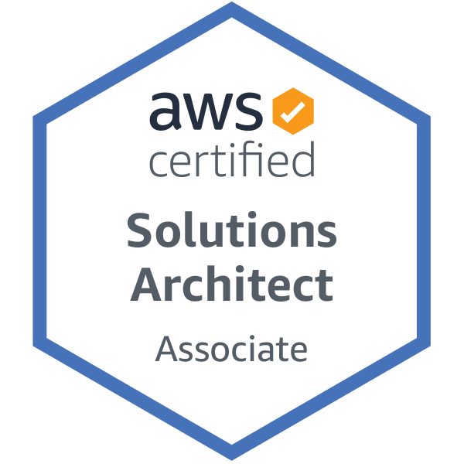
- Programming: JSON, Python,PySpark
- Database Software: RDS (Oracle, MySQL, SQLServer) DynamoDB
- Operating Systems: UNIX/LINUX
- Analysis tool: Excel, Databricks
- Containers: Docker, Kubernetes
- Infrastructure Management: CloudFormation, Terraform
- Configuration Management: Chef, Ansible, Puppet, ArgoCD
- Life-Cycle Tools: Gitlab, Jenkins
- SAAS: ServiceNow
PROFESSIONAL EXPERIENCE
Booz Allen Hamilton Arlington, VA

Cloud Engineer Jan 2023-Present
- In-depth experience in implementing and managing a broad range of AWS services within a DevOps paradigm, including IAM, EC2, S3, VPC, Route53, Redshift, Lambda, ECS, CloudFormation, CloudWatch, and Cognito.
- Designed and implemented CI/CD pipelines in AWS using GitLab, leveraging merge requests to streamline code integration, automate deployments, and enhance development workflows.
- Designed a robust CI/CD pipeline using GitHub Actions, enabling the project to deploy containerized applications and AWS Infrastructure using CloudFormation as the Infrastructure as Code (IaC) tool.
- Developed and conducted 15 training sessions on data maturity, data science, data visualization, Databricks and Tableau suite for AF clients, boosting user proficiency by 50%.
- Managed and monitored the security of serverless applications on AWS, showing expertise in AWS Lambda, API Gateway, and DynamoDB.
- Conducted security hardening for cloud environments using IAM best practices, role-based access control (RBAC), and automated compliance checks.
- Automated infrastructure provisioning with Terraform, Ansible, or CloudFormation, ensuring consistency and reducing manual effort.
- Designed and implemented DevOps solutions to modernize manual processes, transitioning systems and applications into AWS services, including S3, RDS, IAM, EC2, and VPC.
- Configured ServiceNow modules, including ITSM (Incident, Problem, Change, Asset Management), CMDB, and Service Catalog.
Tech Excellence Cloud Engineer | Arlington, VA October 2022 – Dec 2022
- Completed the Booz Allen Hamilton Tech Excellence program, a six-week course covering AWS, Jenkins, Docker, Kubernetes, and Infrastructure as Code, applied knowledge to design and implement scalable solutions, reducing deployment time by 50% and improving efficiency by 20%
- Developed and implemented a CI/CD pipeline using Jenkins, gaining a comprehensive understanding of CI/CD processes and reducing deployment time by 30%.
- Built and managed lab environments utilizing Git, Kubernetes, and Docker, achieving a solid foundation in containerization and improving application deployment practices by 25%.
Ashlaur Construction Chicago, IL
Project Engineer February 2021 – August 2022
- Serves as project engineer for the Northpoint Apartments Project, a 12 building, multi-family development, including 304 apartments in Rogers Park.
- Assisting the project team for the Southbridge project featuring two buildings totaling 206 mixed-income apartment units on Chicago's Near South Side neighborhood. Each building contains retail spaces and includes luxury amenities such as fitness centers, lounges, terraces, and balconies. Daily tasks include monitoring all subcontracted scopes of work, reporting on work completion, and coordinating site deliveries and inventory.

- Work on production cloud support tickets as needed such as: decommissioning servers, creating DB, creating servers, data replication, and troubleshooting infrastructure issues.
- Create and configure elastic load balancers and auto scaling groups to distribute the traffic and have a cost efficient, fault tolerant, and highly available environment.
Arrow & Atlas Chicago, IL
Marketing Account Manager January 2020-May 2020
- Tasked with the generation of profits for multiple clients like Sprint, the Special Olympics and Xfinity.
- Developed successful marketing campaigns for the Sprint drive generating over $10,000 weekly while maintaining a reliable client base by building a personal relationship with each customer.
Illinois Technology Services Champaign, IL
Information Technology and Services Consultant April 2018-December 2019
- Analyzed technical issues of university students and staff to provide effective and timely solutions
- Utilized clear communication to simplify troubleshooting techniques and resolve in-class issues for instructors
- Ensured All IAM users have MFA activated for their individual accounts and limited the number of IAM users with administrative privilege.
- Created and managed user accounts, log management, shared folders, reporting, and group policy restrictions.
- Performed routine system maintenance to ensure quality use and access to technical resources for instructors and students, while preventing unnecessary allocation of ITS resources

