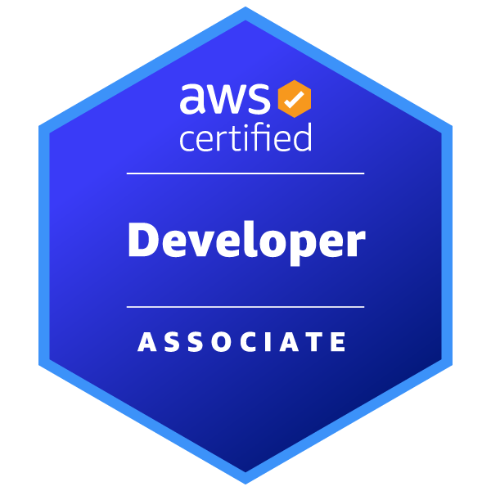

SABITHA BEKKAM
Email: Sabitha.bekkam01@gmail.com
Phone: +1 510-458-6952

SUMMARY:
- Over 10 years of experience as a Senior AWS Developer, specializing in web and application development, analytical programming, and delivering scalable, high-quality software solutions. Proficient in Python, data structures, algorithms, and utilizing libraries like NumPy, Pandas, Matplotlib, and SciPy for data analysis.
- Extensive expertise in building web applications, RESTful services, and APIs using frameworks such as Flask and Django. Experienced in integrating Python ORM libraries (Django ORM, SQLAlchemy) for efficient database management and optimized performance.
- Extensive experience with AWS services, including deploying and managing serverless functions with Lambda, and utilizing storage solutions such as S3, proficient in setting up message queuing with SQS, managing relational databases with RDS, and provisioning scalable compute resources with EC2. Skilled in load balancing with ELB, orchestrating container services with ECS, and leveraging NoSQL databases with DynamoDB.
- Proven experience in automated testing using PyTest for unit and integration testing, ensuring high-quality, reliable applications, while also implementing continuous integration and deployment (CI/CD) pipelines with Azure DevOps and GitHub Actions.
- Hands-on experience with cloud environments, including configuring and managing Azure Virtual Machines, deploying applications using Azure Resource Manager (ARM) templates, and leveraging Azure Functions for serverless solutions to optimize event-driven tasks.
- Experience with container systems like Docker and Kubernetes, including creating and managing Dockerfiles, docker-compose.yml files, and Kubernetes configuration files such as deployment.yml and service.yml.
- Proficient in version control using (GitHub, Gitlab, Jira) starting from creating projects, cloning repositories, and performing tasks such as adding changes, committing them, and pushing updates to remote repositories.

EDUCATION AND CERTIFICATIONS:
- Master’s in engineering management :2017 from Christian brothers University -TN
- Bachelors in Computers Science and Engineering :2015 from JNTUH - India
- AWS Certified developer - Associate

TECHNICAL SKILLS:
Databases | SQL, MS SQL Server, , VMware. Informatica.
Programming Languages | Python, PySpark, pandas, UNIX Shell Scripting
Job scheduling | Shell Scripting, Autosys, Tidal, Control-M, lambda auto schedule
AWS (amazon web services) | Certified associate Developer, AWS (EC2, VPC, ELB, S3, EBS, RDS, Route53, CloudFormation, AWS Auto Scaling, Lambda), AWS CLI,

PROFESSIONAL EXPERIENCE

Sr. AAWS Glue Developer Sep 2022 –present
Fannie Mae – Reston, VA

Responsibilities:
- Designed and deployed scalable, production-grade data pipelines in Python to support cross-functional analytics and ML workloads.
- Led integration of Splunk and OpenTelemetry telemetry data into a unified pipeline for real-time observability.
- Architected Kafka-based messaging systems for ingestion and processing of high-throughput event streams.
- Developed robust REST API connectors for dynamic data exchange with external enterprise platforms.
- Spearheaded Apache Hudi integration for a unified data lakehouse, enabling incremental processing and snapshot querying.
- Collaborated with ML teams to streamline model training workflows, including LLM fine-tuning and deployment on real-time pipelines.

AWS Glue Developer Feb 2021- Sep 2022
Next pathway – New York, NY

Responsibilities:
- Built Python-centric ETL pipelines to aggregate and cleanse data from Splunk, REST APIs, and custom event sources.
- Integrated Kafka consumers and producers into existing pipelines for real-time data synchronization across microservices.
- Implemented modular REST API wrappers for 3rd party services to facilitate automation and real-time alerting.
- Supported Data Lake transformation initiatives by integrating Apache Hudi into existing Hadoop-based architecture.
- Partnered with data science teams to align engineering with ML model needs, including preliminary support for transformer-based models.
- Enabled observability enhancements using OpenTelemetry metrics fused into the data stack.

Sr. AWS Developer Jul 2018 – Jan 2021
Cigna Health Spring – Nashville, TN

Responsibilities:
- Conducted exploratory data analysis (EDA) using Pandas, identifying trends and outliers to inform further
- Developed Python frameworks for ingesting large-scale operational data from REST endpoints and message brokers.
- Designed Kafka streaming pipelines to handle over 1M events/minute, ensuring high throughput and fault tolerance.
- Constructed Splunk dashboards and indexing pipelines tailored for anomaly detection in infrastructure monitoring.
- Initiated early-stage implementation of a unified metadata-driven data lake, laying groundwork for future Apache Hudi migration.
- Contributed to ML initiative prototypes, exploring the potential of LLMs and GPT-style model integrations with structured data workflows.
- Automated system health checks and data quality controls using Python and REST interfaces.

AWS Developer Sep 2017 – Jun 2018
USAA – San Antonio, Texas

Responsibilities:
- Conducted cost analysis and implemented cost-saving strategies using Azure Cost Management and Azure Advisor, optimizing cloud resource usage.
- Automated data validation checks using Pandas, ensuring data integrity before analysis or ingestion for reliable decision-making.
- Leveraged Pandas, NumPy, and Matplotlib for comprehensive data analysis and visualization workflows, enabling actionable insights from complex data.
- Designed and implemented data ingestion and transformation pipelines using AWS Glue, processing terabytes of data daily for efficient data handling.
- Designed and deployed automated backup, restore, and disaster recovery solutions for SQL databases on AWS, ensuring data integrity and minimizing downtime.
- Developed robust RESTful APIs and microservices with Python, ensuring high performance, scalability, and security for web applications.
- Developed backend systems using Python and Flask/Django frameworks, integrating with Microsoft SQL Server as the primary relational database for robust data management.
- Developed serverless applications with AWS SDKs (Boto3 ), leveraging Lambda and various AWS services for scalable cloud solutions.
- Implemented AWS SDKs to integrate AWS services like EC2, S3, Lambda, and DynamoDB, ensuring seamless cloud application operations.
- Developed a web application using Django, integrated with AWS IAM for secure authentication and fine-grained access control.

AWS developer Jan 2016 – July 2017
FedEx – Memphis, TN.

Responsibilities:
- Worked with cross-functional teams to optimize last-mile delivery, analyzing data to reduce errors and improve delivery logistics.
- Worked with cross-functional teams to optimize last-mile delivery, analyzing data to reduce errors and improve delivery logistics.
- Designed and built API integrations with major shipping carriers (FedEx, UPS, DHL) to enable package tracking, label generation, and delivery confirmations.
- Created RESTful APIs with Swagger/OpenAPI specifications, ensuring detailed documentation for clear and effective API management.
- Extensive experience in Python programming to develop scalable applications and software solutions across various domains.
- Skilled in Django, Flask, and FastAPI to design and develop RESTful APIs and web applications, ensuring seamless integration and high performance.
- Built microservices and serverless applications using Python and AWS Lambda, optimizing cloud infrastructure and reducing operational overhead.

AWS Enginee May 2014- July 2015
GE Healthcare – Hyderabad,INDIA.

Responsibilities:
- Involved in the software development lifecycle (SDLC) of tracking the requirements, gathering, analysis, detailed design, development, system testing and Deployment.
- Participated in all phases of the System Development Life Cycle (SDLC), including requirements gathering, system analysis, design, development, testing, and deployment.
- Designed and developed backend systems using Python and Flask/Django frameworks, integrating with Cassandra as the primary database.
- Designed and implemented a robust data management system utilizing MySQL for efficient data storage and retrieval.
- Designed, developed, tested, deployed, and maintained dynamic web applications, ensuring high performance and user satisfaction.
- Developed and modified GUI components utilizing HTML, CSS, and JavaScript (jQuery) to ensure a responsive and intuitive user interface.
- Developed and handled business logic through backend Python code.
- Implemented RESTful APIs using Django for seamless integration with frontend interfaces and third-party services.

