THOTAKURA ABHIROOP
Sr. Salesforce Developer
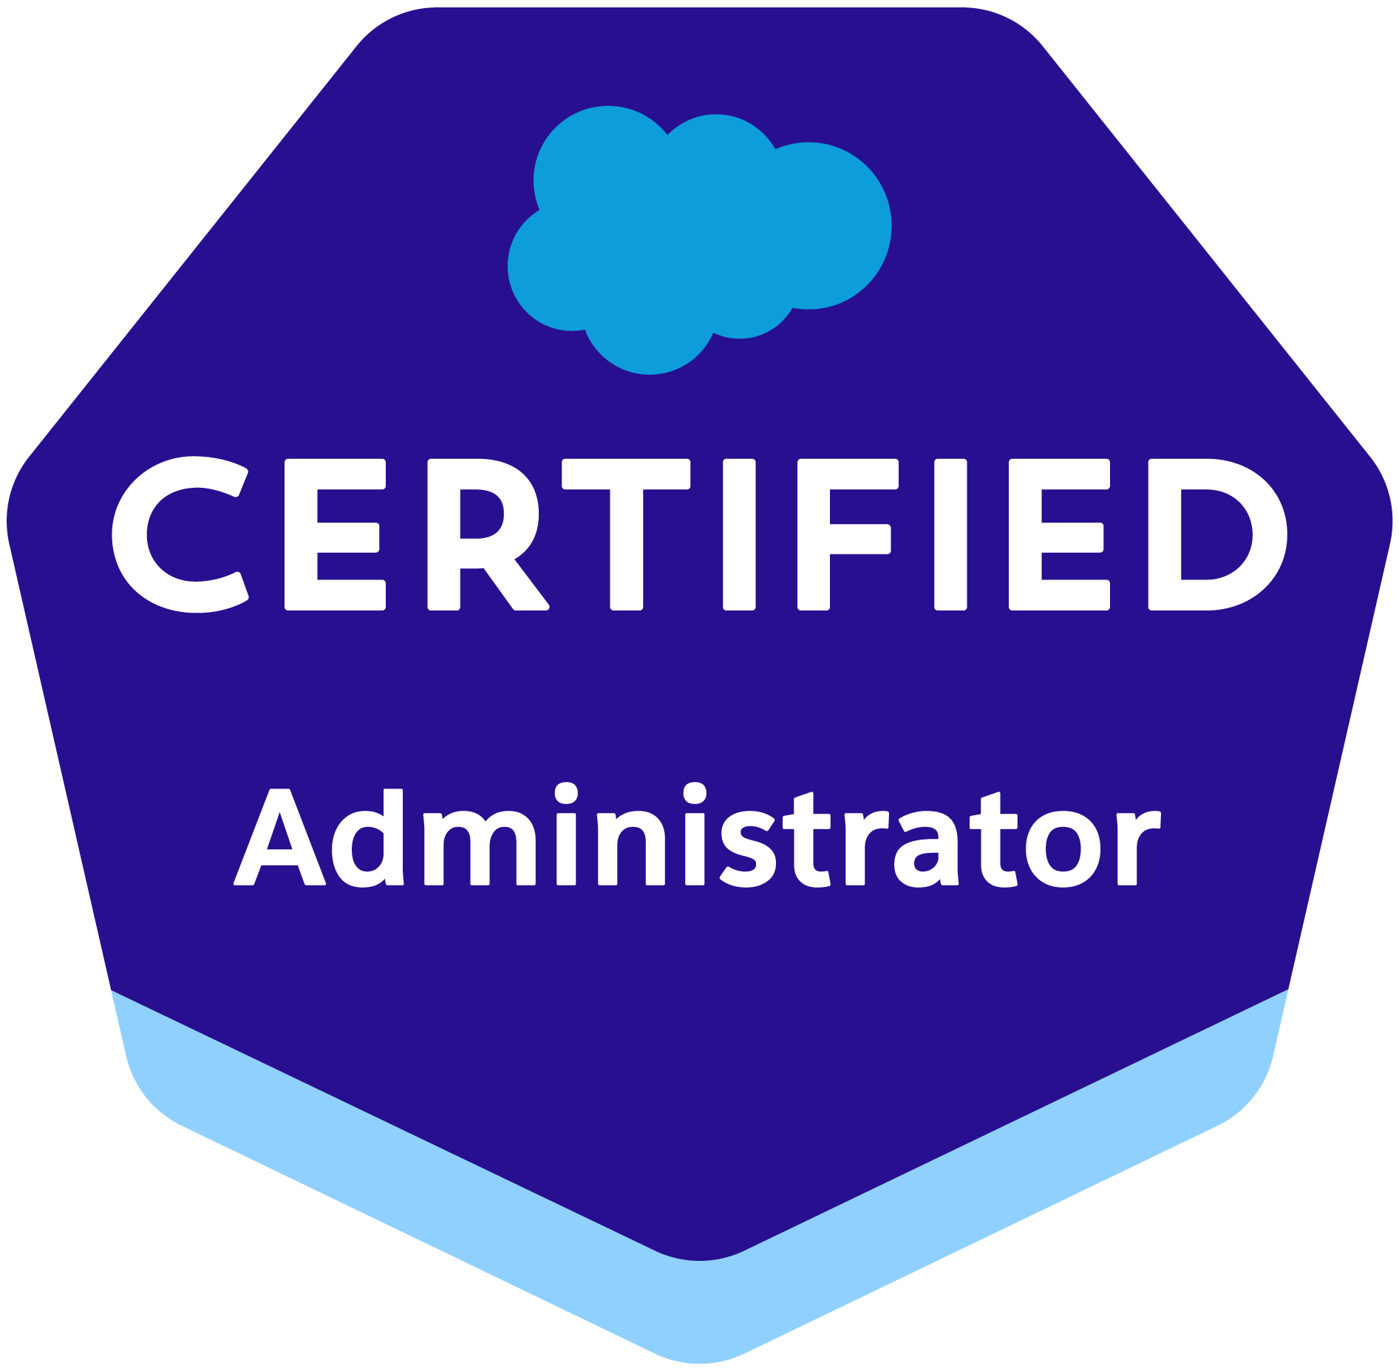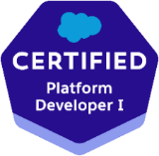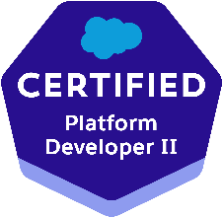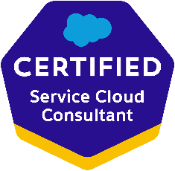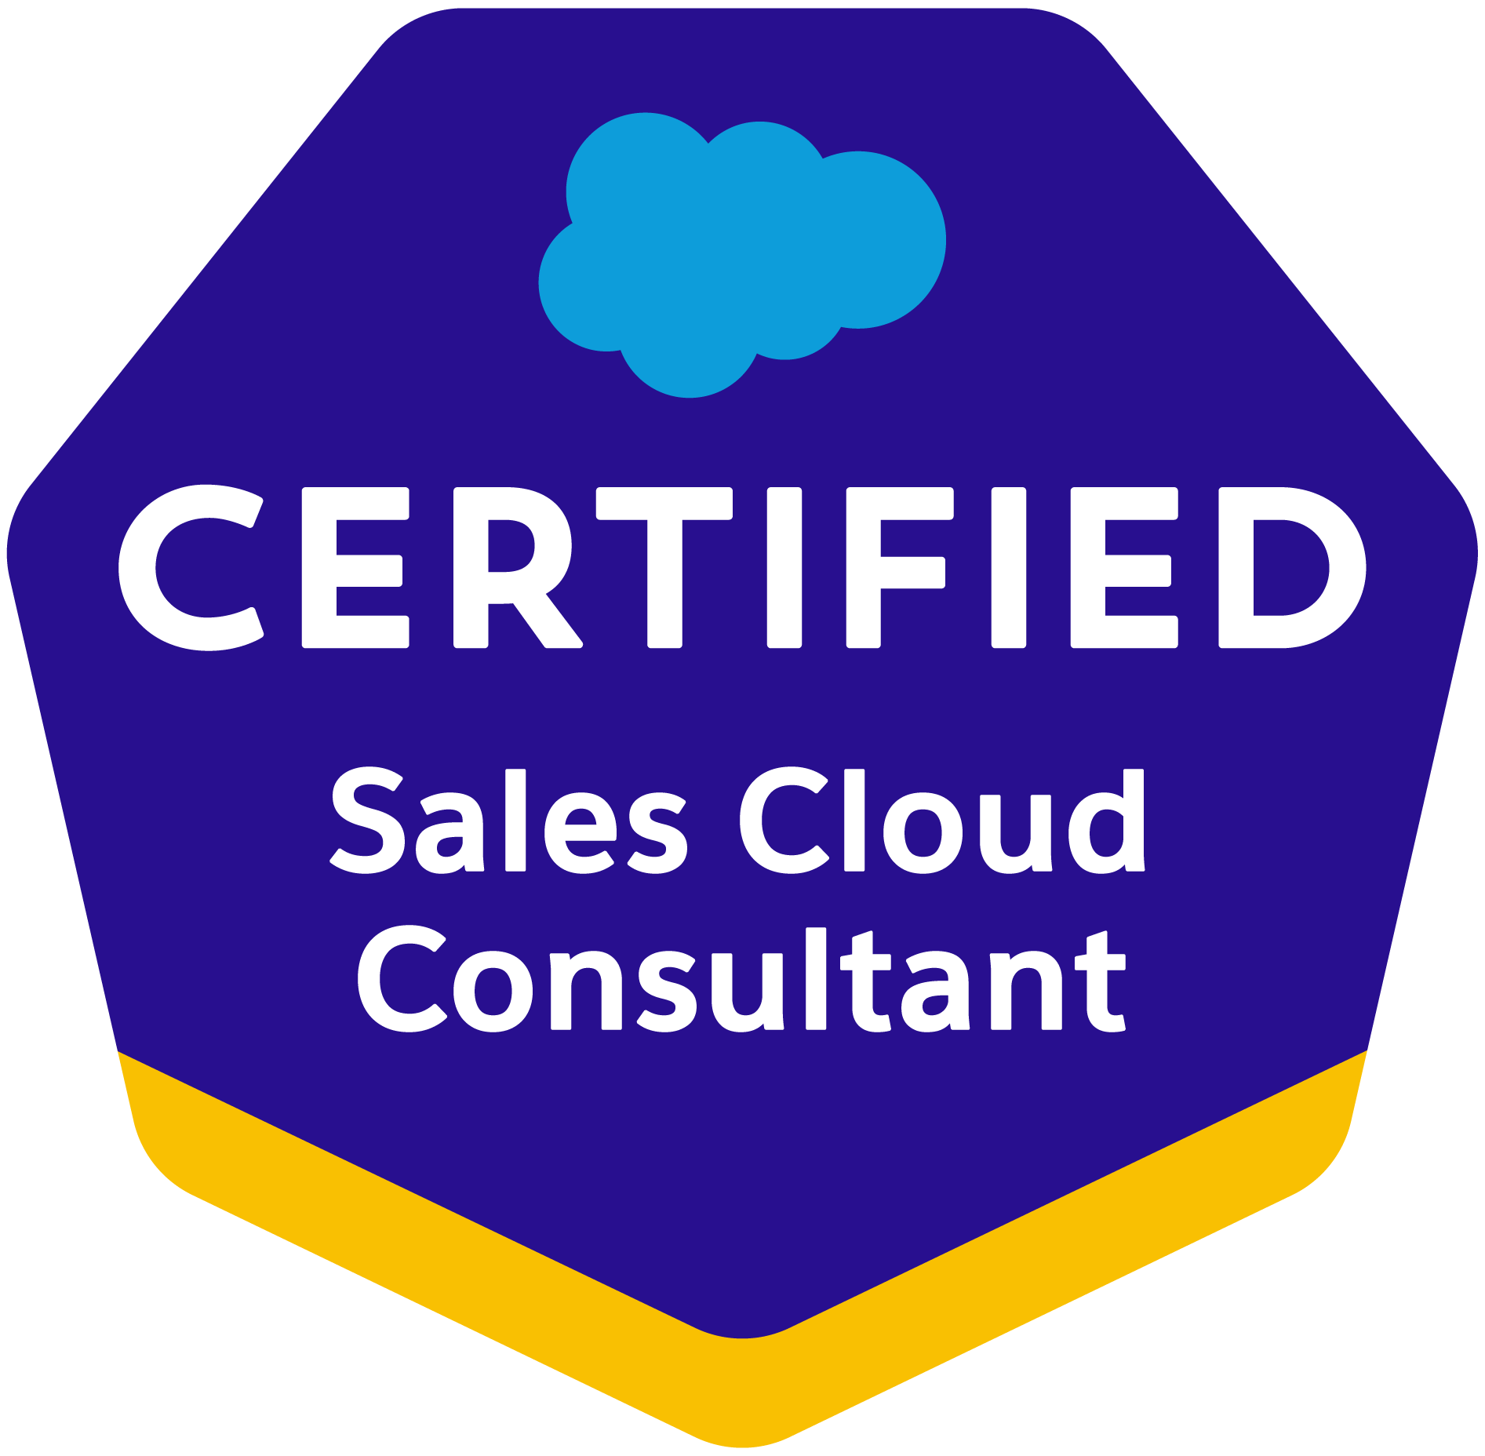
Phone: 929-454-6630
Email: thotakuraabhi1515@gmail.com
www.linkedin.com/in/abhiroop-salesforce-dev
PROFESSIONAL SUMMARY:
- Over 10 years of IT experience across various stages of the Software Development Life Cycle (SDLC), including 5+ years as a Salesforce CRM Developer with expertise in Administration, Development, Integration, and Lightning migration (Classic to Lightning) along with Lightning Component Development. Additionally, 4+ years of experience in front-end technologies like JavaScript, HTML, and CSS.
- Extensive experience in Software Development, covering all phases from Requirement Analysis, Design, Development, User Acceptance Testing (UAT), and Maintenance of cloud-based business applications.
- Developed multiple Lightning Components with custom CSS and design parameters to enhance user experience and UI aesthetics.
- Strong expertise in Salesforce Administration, including creating Profiles, Roles, Users, Page Layouts, Email Services, Approval Processes, Workflows, Reports, Dashboards, Tasks, and Events.
- Collaborated closely with business users to streamline and automate business processes using Salesforce.
- Hands-on experience working across various Salesforce implementations, including Sales Cloud, Service Cloud, Call Center, Chatter, and AppExchange applications.
- Proficient in Salesforce development using Apex Classes, Triggers, Visualforce, and Force.com IDE.
- Experienced in Salesforce project development and administration, ensuring seamless integration and optimization.
- Skilled in integrating Salesforce with REST and SOAP Web Services for seamless data exchange between systems.
- Expertise in the Force.com technology stack, including APEX, Visualforce, SOQL, and SOSL.
- Developed customized Salesforce Mobile Apps using the Lightning Component Framework to enhance mobile accessibility and functionality.
- Implemented Copado's automated testing capabilities to ensure the quality of Salesforce applications.
- Utilized Copado's data deployment features to facilitate the migration of data between Salesforce environments.
- Implemented DocuSign's security features, such as authentication and access controls, to protect sensitive documents.
- Integrated DocuSign with Salesforce reports and dashboards to provide visibility into the document signing process.
- Developed MuleSoft integration tests and performed unit and integration testing using tools such as MUnit and JUnit.
- Implemented MuleSoft deployment strategies using tools such as Jenkins and Maven, and managed deployment environments using Anypoint Runtime Manager.
- Extensive experience in analyzing business requirements, entity relationships and converting to Salesforce custom objects, lookup relationships, junction objects and master-detail relationships.
- Good experience in designing Front-end using Dynamic Visual force pages, Components, HTML, CSS, JavaScript, JQuery, Bootstrap.
- In-depth experience in CRM business processes like Forecasting, Campaign Management, Lead Management, Pipeline Management, Account Management and Case Management.
- Maintain and create workflow rules, validation rules, formula fields, escalation rules, auto-assignment rules, with regards to CPQ and pricing rules.
- Involved in end-to-end QA and UAT testing and validation and CPQ including products, pricing, quoting etc.
- Extensive experience in designing Custom Formula Fields, Field Dependencies, Validation Rules, Workflows, and Approval Processes for automated alerts, field updates, and Email generation according to application requirements.
- Experience in Migrating data from legacy systems to Salesforce using Apex Data Loader.
- Hands on experience with Apex Language, Apex Trigger, Apex Class, Apex Test Methods, Apex Web Service, Visualforce Pages, Visualforce Components & Controllers.
- Collaborated with cross-functional teams, including developers, testers, and business analysts, to ensure alignment and effective delivery of Salesforce solutions in an Agile environment.
- Proficient in version control system Git for managing source code and collaborating with development teams.
- Extensive experience using Git commands, such as clone, branch, commit, push, and pull, to track changes and manage code repositories.
- Used the sandbox for Testing and Migrated the code to the Deployment instance after Testing.
- Unit and Integration Testing for new requirement and get the UAT from the Business owner.
- Configured and maintained user security permissions in compliance with organizational needs.
- Excellent communication and inter-personal skills, accustomed to working in both large and small team environments.
- Strong knowledge & experience working in teams implementing Agile Methodologies.
- Worked on Large Data Integration and Migration Project.

EDUCATION:
- Bachelors of Computer Science from Jawaharlal Nehru Technology University, Hyderabad
- Masters of Science from Stevens Institute of Technology, New Jersey

CERTIFICATIONS:
- Salesforce certified Administrator
- Salesforce certified Platform Developer 1
- Salesforce certified Platform Developer 2
- Salesforce certified Service Cloud
- Salesforce certified Sales Cloud

TECHNICAL SKILLS:
Salesforce Technologies | SalesForce.com, Force.com, Sales Cloud, Service Cloud, LWC, Lighting components, CPQ, Apttus CPQ, Apex Language, Apex Classes/Controllers, Apex Triggers, SOQL, SOSL, Visual Force Pages/ Component, s-Control, Apex Web Services, Partner WSDL & Enterprise WSDL, Work Flow and Approvals, Dashboard, Analytic Snapshots.
Salesforce Tools | Force.com IDE (Eclipse), AJAX Tool Kit, Force.com API tools (Data Loader), Force.com Explorer, Force.com Platform
ETL Tools | Data Loader, Salesforce-to-Salesforce, Apex- Explorer, Informatica.
Languages | Apex, C/C++, Java, J2EE, HTML, XML, CSS.
Database | SQL Server 2008, Oracle, MySQL.
CI CD Tools | AutoRabit, GIT, SVN.
Web | HTML, XML, CSS, JSP, JavaScript, WSDL, SOAP.
Tools | MS Office, Adobe Photoshop, MS Excel, Silverlight, Eclipse IDE.
Web Servers | IBM WebSphere 4.x/5.x, Apache Web Server, Tomcat 6.x
Platforms | UNIX and Windows (NT/2000/XP/Vista/7)

WORK EXPERIENCE:

Client: Amazon, New York, NY Oct 2023 -- Current
Role: Sr. Salesforce Developer
Responsibilities:
- Designed and developed Apex Classes, Controller Classes, Controller Extensions, and Apex Triggers to meet various functional requirements.
- Developed Visualforce pages with Apex Controllers, Batch Apex, Triggers, and Scheduled Apex for automation and enhanced functionality.
- Proficient in using Salesforce CLI to simplify development, continuous integration, and deployment using Salesforce DX.
- Migrated SOAP-based web services to RESTful web services using Spring Boot and Spring REST API for improved performance and scalability.
- Created draft flows, mockup screens in Pega for business demonstrations and contributed to Low-Level Design (LLD) documentation.
- Implemented business automation and workflows using Lightning Process Builder.
- Designed and deployed Custom Objects, Custom Tabs, Validation Rules, Workflow Rules, and Page Layouts tailored to business needs.
- Configured Salesforce components, including Custom Objects, Custom Settings, Custom Labels, Validation Rules, Record Types, Custom Tabs, Workflow Rules, and Approval Processes with automated field updates and email alerts.
- Experienced in data migration using Data Loader and managing code deployment via Eclipse in Salesforce environments.
- Used Data Loader for insert, update, and bulk import or export of data from Salesforce.com objects.
- Created many app pages, home pages integrating the custom components for salesforce lightning and salesforce1 mobile app.
- Developed Lightning apps using Lightning Components (LWC) and made them compatible with salesforce1 mobile app.
- Professional on base Lightning components are available as Aura components and as Lightning web components (LWC).
- Worked on multiple Number of lightning Web Components and allowed the LWC to manipulate the DOM instead of JavaScript.
- Created multiple Lightning Components, added CSS and Design Parameters that makes the Lightning component (LWC) look and feel better.
- Created and maintained Copado pipelines for continuous integration and continuous delivery (CI/CD) workflows.
- Implemented version control practices using Copado, ensuring code and configuration consistency.
- Configured Copado's release management features, enabling seamless release planning and execution.
- Designed and developed complex data integrations between Salesforce and various external systems using Jitterbit.
- Configured Jitterbit's connectors to seamlessly integrate Salesforce with other applications, such as ERP or CRM systems.
- Integrated Conga Sign (formerly Octiv) with Salesforce to enable secure and efficient electronic signature capabilities, accelerating the contract signing process and improving overall document management.
- Proficient in configuring Conga Grid to enable advanced data management and manipulation within Salesforce, allowing users to view, edit, and update multiple records simultaneously.
- Designed and developed custom workflows using DocuSign for automating the signature process within Salesforce.
- Integrated DocuSign with Salesforce objects and records to enable seamless document signing and tracking.
- Designed and configured Vlocity data models and business processes to meet industry-specific requirements.
- Developed Vlocity industry-specific functionalities, such as quoting, billing, or policy management, within Salesforce.
- Integrated Vlocity with Salesforce Sales Cloud to streamline sales processes and improve customer management.
- Designed and implemented MuleSoft integrations between different systems, such as CRM, ERP, and HR, using Anypoint Platform.
- Developed custom MuleSoft connectors and modules to integrate with third-party APIs and applications.
- Customized Oracle Sales Cloud Application (OSC) CRM using Groovy scripting
- Setting up Service Cloud Console, Cases (Web to case, email to case), Solutions, Case Assignment, and CTI Interfaces.
- Provide configuration and administrative support of self-hosted (server) JIRA and Confluence.
- Setup and maintained Subversion (SVN) and Git repositories along with the creation of branches and tags.
- Proficient in using Agile project management tools like Jira or Rally to manage and track project progress, backlog items, and sprint planning.
- Demonstrated ability to effectively use Git workflows, such as feature branching, pull requests, and code reviews, to facilitate seamless collaboration and ensure code quality.
- Utilized Git branching strategies, such as GitFlow or feature branching, to manage multiple development efforts concurrently and streamline release processes.
- Setup and Implement Continuous Integration and Continuous Delivery (CI & CD) Process stack using AWS, GITHUB/GIT, Jenkins and Puppet.
- Managed all the QA processes in an AGILE development environment, lead a small team of QA personnel in all the testing efforts of the Products in the Organization, and reported directly to the Executive Vice President of Operations

Environment: Service Cloud, Sales Cloud, Copado, Jitterbit, SalesForce.com Platform, Docusign, Vlocity, Lightning, Visual force, Pages, Apex, Visual force, Mulesoft, Apex Classes Apex triggers, Batch Apex, Schedule Apex, SOAP, REST., Jira, Git, Git Hub, Agile.

Client: Equnix, Redwood City, CA April 2021 – Sep 2023
Role: Sr. Salesforce Developer
Responsibilities:
- Implemented Salesforce Service Cloud & Opportunity Management (Case Management, Entitlement Management, Product & Price Book, High Volume Customer Portal, Partner Portal, Visual Force Sites) for business support and technical support for its channel customers.
- Developed complex validation rules, formula fields according to the application requirements.
- Created page layouts, search layouts to organize fields, custom links, related lists, and other components on a record detail and edit pages.
- Worked with the user groups for gathering information throughout the planning and implementation.
- Involved in project technical design plan, conversions, Mapping, configuration of portions of the SFDC application.
- Involved in CPQ (Configure, Price& Quote) design, mapped to the Salesforce custom objects, and involved in Apttus Advanced Workflow Approvals.
- Configure in Salesforce.com CRM to facilitate Apttus implementation.
- Implemented CPQ solution using Apttus CPQ & Contract Management for various customers in industries.
- Experience in creating complex SSIS packages using proper control and data flow elements with error handling.
- Experience in configure price quote (CPQ) app such as Apttus.
- Created integration with Apttus CPQ and CLM applications and automating processes on Salesforce platform.
- Familiar with Apttus admin settings, Apttus custom settings and DocuSign settings.
- Experience in CPQ Merge Service, Configuration and Pricing APIs (Apttus customization).
- Performed Apttus CPQ related configuration for product setup, approval matrices, approval rules, process builders and flows.
- CPQ was implemented for their global operations and interfacing Apttus with their Salesforce application.
- I configured product and pricing setup using CPQ/Product consoles, which include price ramps, Price Matrix, Price Rulesets, price list items, tiered pricing, and asset pricing.
- Created integration with Apttus CPQ and CLM applications and automating processes on Salesforce platform.
- Knowledge of Apttus development.
- Strong understanding of Salesforce standard objects and Apttus CPQ application.
- Experience in Apttus CPQ, LDAP and Integration with Share point.
- Worked closely with stakeholders to define and implement Copado best practices and governance policies.
- Implemented Copado's agile planning capabilities for backlog management and sprint execution.
- Integrated Salesforce with third-party APIs using Jitterbit to enable real-time data exchange and streamline business operations.
- Implemented data transformations and mappings in Jitterbit to ensure data consistency and accuracy during integrations.
- Implemented error handling and logging mechanisms in Jitterbit to track and troubleshoot integration issues.
- Proficient in designing and developing Conga templates using Conga Composer to generate professional, customized documents, including quotes, proposals, invoices, and contracts, with dynamic data from Salesforce objects.
- Demonstrated ability to automate complex document workflows using Conga Workflow and Conga Trigger to trigger document generation based on specific criteria or events in Salesforce.
- Implemented DocuSign Connect to enable real-time updates and notifications on document status within Salesforce.
- Developed custom Apex triggers and classes to extend the functionality of DocuSign within Salesforce.
- Collaborated with stakeholders to gather requirements and design efficient document signing processes using DocuSign.
- Developed custom Vlocity data validation and automation rules to ensure data integrity and consistency.
- Implemented Vlocity's industry-specific analytics and reporting features to provide insights into business performance.
- Develop and establish IBM BPM/MQSeriesWorkflow Competency Center at PFG with services and SLAs, 24hr production pager support
- Led a customer team in creating naming standards for message flow projects, message flows, message sets, message flow pattern artifacts, Broker schemas, Broker configurable services, etc.
- Implemented the Web Services through WSDL in the Salesforce.com for outbound messaging.
- Worked on Integrating SAP and Salesforce systems using SOAP and REST API's.
- Performed Apex Callouts from Salesforce to the same external system to get tracking information of an order.
- Strong knowledge of Agile methodologies, particularly Scrum, and their application to Salesforce development projects.
- Experience working in Agile development environments, participating in Scrum ceremonies such as sprint planning, daily stand-ups, sprint reviews, and retrospectives.
- Experience with Git-based platforms like GitHub, Bitbucket, or GitLab for hosting repositories, managing code reviews, and facilitating team collaboration.
- Proficient in resolving merge conflicts and managing Git repositories with large codebases to ensure smooth integration of code changes.
- Deployed application from Sandbox to Production environments using GIT, Change Set, Eclipse and Force.com Migration tool.
Environment: Saleforce.com, Apex Classes, Copado, Mulesoft, Vlocity, Jitterbit, Controller Classes, Docusign, Triggers, Visualforce, Salesforce.com Data Loader, Git, Workflow & Approvals, Reports, Custom Objects, Custom Tabs, Page layouts, Email Services, SOQL, SOSL, Sandbox, Force.com IDE.

Client: Walmart, Sunnyvale, CA. Nov 2019 – Mar 2021
Role: Salesforce Developer
Responsibilities:
- Designed and developed Apex Classes, Controller Classes, Controller Extensions and Apex triggers for various functional needs in the application.
- Development of asynchronous processes using batch, schedulable, future and queueable approaches.
- Worked on developing batch apex codes and apex scheduler classes.
- Created Triggers for email update for any new offer is released and Developed Batch apex along with combination of schedule apex to reduce the data for space utility.
- Working code integration across multiple sandboxes reduce dramatically and use Continuous Integration, Continuous Deployment using Devops, and Meet Jenkins Configure Jenkins Devops.
- Experience with REST API testing and SOAP Webservices testing using SOAP UI tool and workbench.
- Undertake development of SFDC reporting tools, systems documentation and technical process flows.
- Technical Knowledge about Salesforce lightning schema builder, process builder, app builder, components and lightning connect.
- Implemented complex workflow rules and approval processes to automate business processes like updating fields, sending E-mail alerts.
- Created formula fields and roll-up summary to validate the information provided by the customer using validation rules.
- Release Management (Managing different Salesforce instances and Releases) and involved in
- Responsible for migrating existing data (Accounts, Contacts, Events and Tasks) from legacy systems to Salesforce.com using data Loader.
- Worked on pub sub modules to communicate between LWC components along with API decorators.
- Experience on writing jest tests for LWC components for unit testing at client side.
- Worked on LWC lightning data service by using wire service (wire adapter) to fetch data from server side and performed CURD operations.
- Build various LWC components, decorators and variables. Adding validations to LWC
- Making use of LWC to display teh Toast message and also refreshing page using lightning web components. Making use of LWC Combo box Event.
- Refined sales and service process, pipeline, and revenue growth through effective implementation of Saleforce.com Sales Cloud, Service Cloud and industry leading CPQ tools.
- Followed CI/CD process for deployments using Force.com Migration Tool and Snapshot
- Worked Jenkins access setup.
- Deployed, configured and maintained JIRA and its plug-ins such as Zephyr for JIRA Testing Add-on, including continuous customizations as per user requests.
- Automated the migration of Subversion (SVN) repositories to Git while preserving the commit history and other metadata like branches, tags and authors.
- Configured the GitHub to maintain the different versions in common development environment.
- Environment: Service Cloud, Sales Cloud, SalesForce.com Platform, Lightning Web Components, Visual force, Pages, Apex, Visual force, Apex Classes Apex triggers, Batch Apex, Schedule Apex, SOAP, REST., Jira, Git, Git Hub, Agile.

Client: Pragmatics Inc., Arlington, VA. June 2017 – Oct 2019
Role: Salesforce Administrator
Responsibilities:
- Managed all new user set-ups and deactivation, including following approval process and transferring ownership of accounts/contacts/opportunities for deactivated users.
- Regularly audits data to uncover data integrity issues and/or opportunities for process improvement.
- Performed mass data imports using the Apex data loader and import tools as requested by CRM Manager.
- Created Workflow Rules, Page Layouts, Approval Process, Tasks, Email Alerts, Field Updates and Outbound Messages to manage the Workflow Approvals.
- Created Profiles, Roles based on Organization role hierarchy and implemented Record-Level and Field-Level security and configured their sharing settings.
- Worked with Pervasive Data integrator for Comprehensive Data Integration.
- Created and maintained custom fields and modifying Picklist values and field dependencies.
- Imported and updated campaign data.
- Import data from excel sheets in to Leads, Accounts and Contacts using Data Loader
- Use Data Loader and developer workbench for insert, update and bulk import or export of data. Used it to read, extract and load data from comma separated values CSV) file
- Responsible for creating Queues, Workflows rules and tasks to share and automate work to the users in the Queue.
- Provided training to the internal users and helped them in getting used to the application, generated reports and save them for the further access to the users.
- Environment: Salesforce, Informatica Tool, Apex Data Loader, Security Controls, Google Chrome, Command Links, Workflow and Approvals, Custom Objects, Picklist Values, Sales Performance Lead Generation.

Client: Pacific Life, Newport Beach, CA. Sep 2015 – May 2017
Role: Java/J2EE Developer
Responsibilities:
- Developed web components using Servlets, JSPs, Tag libraries, XML, XSL, Tiles framework, Struts, and UML.
- Created SQL queries and Stored Procedures for CRUD (Create, Read, Update and Delete) operations on database.
- Used Eclipse as IDE and Apache Tomcat as Application Server.
- Testing and debugging project for proper functionality and documenting modules.
- Developed application code using Core Java and J2EE (Servlets, XML) in Eclipse tool.
- Actively participated in weekly and monthly status& business user meetings.
- Involved in conducting meetings with Pfizer business users for understanding gaps in CTO applications.
- Creating programs to use JMS and message queuing to process requests.
- Involved in Development and Deployment of Stateless Session beans.
- Generated deployment descriptors for EJBs using XML.
- Developed GUI related changes using JSP, HTML and client validations using JavaScript.
- Used JDBC to communicate with database.
- Developed front-end form validations using JavaScript.
- Used Application Assembly Tool for generating War and Ear files and for deployment to Application servers.

Environment: Java 1.4 SDK, java Script, JSP 2.0, AJAX, XML, JSTL, JNDI, EJB 2.0, UML, Web sphere, Struts, CSS, Eclipse and Hibernate

Client: Medtronic’s, Minneapolis. Mar 2014 – Aug 2015
Role: Java/J2EE Developer
Responsibilities:
- Involved in daily scrum meetings, worked on the sprint tasks in the Agile Scrum development.
- Configured and set up Java Work space which included setting up server and theme installation and configuration.
- Became familiar with using and navigating through Java Work space (Eclipse).
- Debugged Java classes used to modify web pages such as Business Objects, and Data Access Objects.
- Implemented JDBC to perform the database calls from the Java layer.
- Tested many components of web application and documented my observations.
- Used Servlets as interface between the client and server.
- Used JDBC to persist Java Objects into the database.
- Refactored existing project to make it more RESTful and thread-safe.
- Developed different modules using J2EE (Servlets, JSP, JSON)
- Involved in creation of dynamic web pages with the use of JSP and HTML.
- Created several JSP's and populated them with data from databases using JDBC.
- Designed and developed EJBs to handle business logic and store persistent data.
- Involved in coding using Java Servlets, created web pages using JSP's for generating pages dynamically.
- Involved in developing forms using HTML and performing client-side validations using JavaScript.
- Developed server-side functionality for Admin Interface features (adding a User, Modifying the User Details, Assigning Roles, Modifying Roles etc.).

Environment: Java 1.4 SDK, java Script, JSP 2.0, AJAX, XML, JSTL, JNDI, EJB 2.0, UML, Web sphere, Struts, CSS, Eclipse and Hibernate

